Zion Lutheran Church
Woodland, Michigan

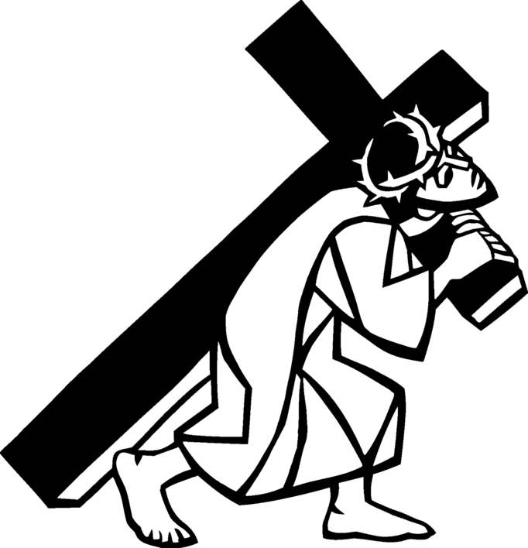

Good Friday Tenebrae Service
April 10, 2020
Opening Hymn “Beneath the Cross of Jesus” ELW 338

Opening Litany

Pastor: Were you there when they crucified our Lord?
People Yes, we were there.

Pastor: Were you there when they nailed him to the tree?
People: Yes, we were there.

Pastor: Were you there when they laid him in the tomb?
People: Yes, we were there.

Pastor: Where you there when they said, "This Jesus must die"?
People: Yes, we were there.

Prayer of the Day
Let us pray together.
Almighty God, look with loving mercy on your family, for whom our Lord Jesus Christ was willing to be betrayed, to be given over to the hands of sinners, and to suffer death on the cross; who now lives and reigns with you and the Holy Spirit, one God, forever and ever. Amen.

Prayer of Preparation and Lord's Prayer

Pastor: Lord, at times it causes us to tremble when we consider the sorrow, pain, and suffering you so freely took upon yourself for us. As we follow you to the cross, we can't help but ask why this horrible thing must happen. How is it that the shouts of "hosanna" have so quickly turned to shouts of "crucify him"? But deep down we know. Deep down we know whose sin causes your death. It is our sin, our rejection, and our treason that brought you to Calvary. Yes, we were truly there.

We humbly pray that your love, forgiveness, and mercy that so greatly offended us may now be extended to us. Grant that we may die to our sin and so be raised to new life with you. We ask all this, and everything else, in the words you taught us to pray...

ple: Our Father, who art in heaven,
hallowed be thy name,
thy kingdom come,
thy will be done,
on earth as it is in heaven.
Give us this day our daily bread;
and forgive us our trespasses,
as we forgive those
who trespass against us;
and lead us not into temptation,
but deliver us from evil.
For thine is the kingdom,
and the power, and the glory,
forever and ever. Amen.

Sermon Pastor Becky Ebb-Speese

First Reading Luke 23:32-38

³²Two others also, who were criminals, were led away to be put to death with him. ³³When they came to the place that is called The Skull, they crucified Jesus there with the criminals, one on his right and one on his left. [[ ³⁴Then Jesus said, "Father, forgive them; for they do not know what they are doing."]] And they cast lots to divide his clothing. ³⁵And the people stood by, watching; but the leaders scoffed at him, saying, "He saved others; let him save himself if he is the Messiah of God, his chosen one!" ³⁶The soldiers also mocked him, coming up and offering him sour wine, ³⁷and saying, "If you are the King of the Jews, save yourself!" ³⁸There was also an inscription over him, "This is the King of the Jews."

Hymn “Ah Holy Jesus” ELW 349

(First candle is extinguished)

Second Reading Luke 23:39-43

³⁹One of the criminals who were hanged there kept deriding him and saying, "Are you not the Messiah? Save yourself and us!" ⁴⁰But the other rebuked him, saying, "Do you not fear God, since you are under the same sentence of condemnation? ⁴¹And we indeed have been condemned justly, for we are getting what we deserve for our deeds, but this man has done nothing wrong." ⁴²Then he said, "Jesus, remember me when you come into your kingdom." ⁴³He replied, "Truly I tell you, today you will be with me in Paradise."

Hymn “What Wondrous Love is This” ELW 666

(Second candle is extinguished)

Third Reading John 19:25b-27

²⁵Meanwhile, standing near the cross of Jesus were his mother, and his mother's sister, Mary the wife of Clopas, and Mary Magdalene. ²⁶When Jesus saw his mother and the disciple whom he loved standing beside her, he said to his mother, "Woman, here is your son." ²⁷Then he said to the disciple, "Here is your mother." And from that hour the disciple took her into his own home.

Hymn “Jesus Keep Me Near the Cross” ELW 335

(Third candle is extinguished)

Fourth Reading Matthew 27:45-49

⁴⁵From noon on, darkness came over the whole land until three in the afternoon. ⁴⁶And about three o'clock Jesus cried with a loud voice, "Eli, Eli, lema sabachthani?" that is, "My God, my God, why have you forsaken me?" ⁴⁷When some of the bystanders heard it, they said, "This man is calling for Elijah." ⁴⁸At once one of them ran and got a sponge, filled it with sour wine, put it on a stick, and gave it to him to drink. ⁴⁹But the others said, "Wait, let us see whether Elijah will come to save him."

Hymn “O Sacred Head Now Wounded” ELW 351

(Fourth candle is extinguished)

Fifth Reading John 19:28-29

²⁸After this, when Jesus knew that all was now finished, he said (in order to fulfill the scripture), "I am thirsty." ²⁹A jar full of sour wine was standing there. So they put a sponge full of the wine on a branch of hyssop and held it to his mouth.

Hymn “Lamb of God” ELW 336

(Fifth candle is extinguished)

Sixth Reading John 19:30?

³⁰When Jesus had received the wine, he said, "It is finished." Then he bowed his head and gave up his spirit.

Hymn “When I Survey the Wondrous Cross” ELW 803

(Sixth candle is extinguished)

Seventh Reading Luke 23:44-47

⁴⁴It was now about noon, and darkness came over the whole land until three in the afternoon, ⁴⁵while the sun's light failed; and the curtain of the temple was torn in two. ⁴⁶Then Jesus, crying with a loud voice, said, "Father, into your hands I commend my spirit." Having said this, he breathed his last. ⁴⁷When the centurion saw what had taken place, he praised God and said, "Certainly this man was innocent."

(Seventh Candle is extinguished)

(The Christ Candle is removed from the sanctuary.)

A loud noise will be heard symbolizing the closing of the tomb. All leave in silence.

Tenebrae is a Latin word meaning “shadows”. It is the name given to the ancient prayer hours of Matins and Lauds used on the last three days of Holy Week. Seven candles are arranged on the altar. The Christ candle is placed in front. All eight candles are lighted before the service begins.

One by one, the candles are extinguished until, as the service progresses only one is left burning. After the dramatic Reading of the Passion of Jesus Christ, the Christ Candle is carried from the sanctuary.

The offering for Lent has been designated for World Hunger

