ZION LUTHERAN CHURCH, WOODLAND, MI
Nineteenth Sunday after Pentecost, October 11, 2020

ANNOUNCEMENTS & PRELUDE

GATHERING
The Holy Spirit calls us together as the people of God.

CONFESSION AND FORGIVENESS
In the name of the Father,
and of the ☩ Son,
and of the Holy Spirit.
Amen.

God of all mercy and consolation, come to the help of your people, turning us from our sin to live for you alone. Give us the power of your Holy Spirit that we may confess our sin, receive your forgiveness, and grow into the fullness of Jesus Christ, our Savior and Lord.
Amen.

Let us confess our sin in the presence of God and of one another. Most merciful God,
we confess that we are captive to sin and cannot free ourselves. We have sinned against you in thought, word, and deed, by what we have done and by what we have left undone. We have not loved you with our whole heart; we have not loved our neighbors as ourselves. For the sake of your Son, Jesus Christ, have mercy on us. Forgive us, renew us, and lead us, so that we may delight in your will and walk in your ways, to the glory of your holy name. Amen.

In the mercy of almighty God, Jesus Christ was given to die for us, and for his sake God forgives us all our sins. As a called and ordained minister of the church of Christ, and by his authority, I therefore declare to you the entire forgiveness of all your sins, in the name of the Father, and of the ☩ Son, and of the Holy Spirit.
Amen.

GATHERING SONG “As We Gather at Your Table” ELW 522

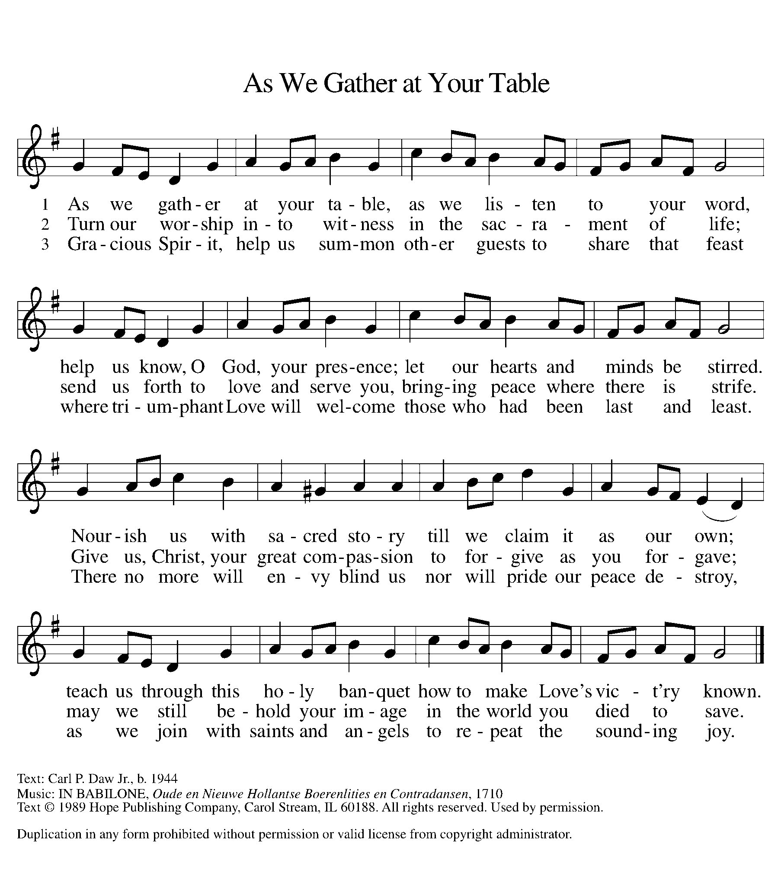

GREETING
The grace of our Lord Jesus Christ, the love of God, and the communion of the Holy Spirit be with you all.
And also with you.
PRAYER OF THE DAY
Let us pray together.
Lord of the feast, you have prepared a table before all peoples and poured out your life with abundance. Call us again to your banquet. Strengthen us by what is honorable, just, and pure, and transform us into a people of righteousness and peace, through Jesus Christ, our Savior and Lord. Amen.

FIRST READING Isaiah 25:1-9

A reading from Isaiah.

¹O Lord, you are my God;
I will exalt you, I will praise your name;
for you have done wonderful things,
plans formed of old, faithful and sure.
²For you have made the city a heap,
the fortified city a ruin;
the palace of aliens is a city no more,
it will never be rebuilt.
³Therefore strong peoples will glorify you;
cities of ruthless nations will fear you.
⁴For you have been a refuge to the poor,
a refuge to the needy in their distress,
a shelter from the rainstorm and a shade from the heat.
When the blast of the ruthless was like a winter rainstorm,
⁵the noise of aliens like heat in a dry place,
you subdued the heat with the shade of clouds; the song of the ruthless was stilled.
⁶On this mountain the Lord of hosts will make for all peoples
a feast of rich food, a feast of well-aged wines,
of rich food filled with marrow, of well-aged wines strained clear.
⁷And he will destroy on this mountain
the shroud that is cast over all peoples,
the sheet that is spread over all nations;
⁸he will swallow up death forever.
Then the Lord God will wipe away the tears from all faces,
and the disgrace of his people he will take away from all the earth,
for the Lord has spoken.
⁹It will be said on that day,
Lo, this is our God; we have waited for him, so that he might save us.
This is the Lord for whom we have waited;
let us be glad and rejoice in his salvation.

The word of the Lord.
Thanks be to God.

PSALM Psalm 23

¹The Lord| is my shepherd;
I shall not | be in want.
²The Lord makes me lie down | in green pastures
and leads me be- | side still waters.
³You restore my | soul, O Lord,
and guide me along right pathways | for your name’s sake.
⁴Though I walk through the valley of the shadow of death, I shall | fear no evil;
for you are with me; your rod and your staff, they | comfort me.
⁵You prepare a table before me in the presence | of my enemies;
you anoint my head with oil, and my cup is | running over.
⁶Surely goodness and mercy shall follow me all the days | of my life,
and I will dwell in the house of the | Lord forever.

SECOND READING Philippians 4:1-9
A reading from Philippians.

¹My brothers and sisters, whom I love and long for, my joy and crown, stand firm in the Lord in this way, my beloved.
²I urge Euodia and I urge Syntyche to be of the same mind in the Lord. ³Yes, and I ask you also, my loyal companion, help these women, for they have struggled beside me in the work of the gospel, together with Clement and the rest of my co-workers, whose names are in the book of life.
⁴Rejoice in the Lord always; again I will say, Rejoice. ⁵Let your gentleness be known to everyone. The Lord is near. ⁶Do not worry about anything, but in everything by prayer and supplication with thanksgiving let your requests be made known to God. ⁷And the peace of God, which surpasses all understanding, will guard your hearts and your minds in Christ Jesus.
⁸Finally, beloved, whatever is true, whatever is honorable, whatever is just, whatever is pure, whatever is pleasing, whatever is commendable, if there is any excellence and if there is anything worthy of praise, think about these things. ⁹Keep on doing the things that you have learned and received and heard and seen in me, and the God of peace will be with you.

The word of the Lord.
Thanks be to God.

GOSPEL ACCLAMATION

Alleluia, Lord, to whom shall we go?
Alleluia. You have the words of eternal life.
Alleluia, alleluia.

GOSPEL Matthew 22:1-14
The holy gospel according to Matthew.
Glory to you, O Lord.

¹Once more Jesus spoke to them in parables, saying: ²“The kingdom of heaven may be compared to a king who gave a wedding banquet for his son. ³He sent his slaves to call those who had been invited to the wedding banquet, but they would not come. ⁴Again he sent other slaves, saying, ‘Tell those who have been invited: Look, I have prepared my dinner, my oxen and my fat calves have been slaughtered, and everything is ready; come to the wedding banquet.’ ⁵But they made light of it and went away, one to his farm, another to his business, ⁶while the rest seized his slaves, mistreated them, and killed them. ⁷The king was enraged. He sent his troops, destroyed those murderers, and burned their city. ⁸Then he said to his slaves, ‘The wedding is ready, but those invited were not worthy. ⁹Go therefore into the main streets, and invite everyone you find to the wedding banquet.’ ¹⁰Those slaves went out into the streets and gathered all whom they found, both good and bad; so the wedding hall was filled with guests.
¹¹“But when the king came in to see the guests, he noticed a man there who was not wearing a wedding robe, ¹²and he said to him, ‘Friend, how did you get in here without a wedding robe?’ And he was speechless. ¹³Then the king said to the attendants, ‘Bind him hand and foot, and throw him into the outer darkness, where there will be weeping and gnashing of teeth.’ ¹⁴For many are called, but few are chosen.”

The gospel of the Lord.
Praise to you, O Christ.

SERMON Pastor Becky Ebb-Speese

HYMN OF THE DAY “Now We Join the Celebration” ELW 462

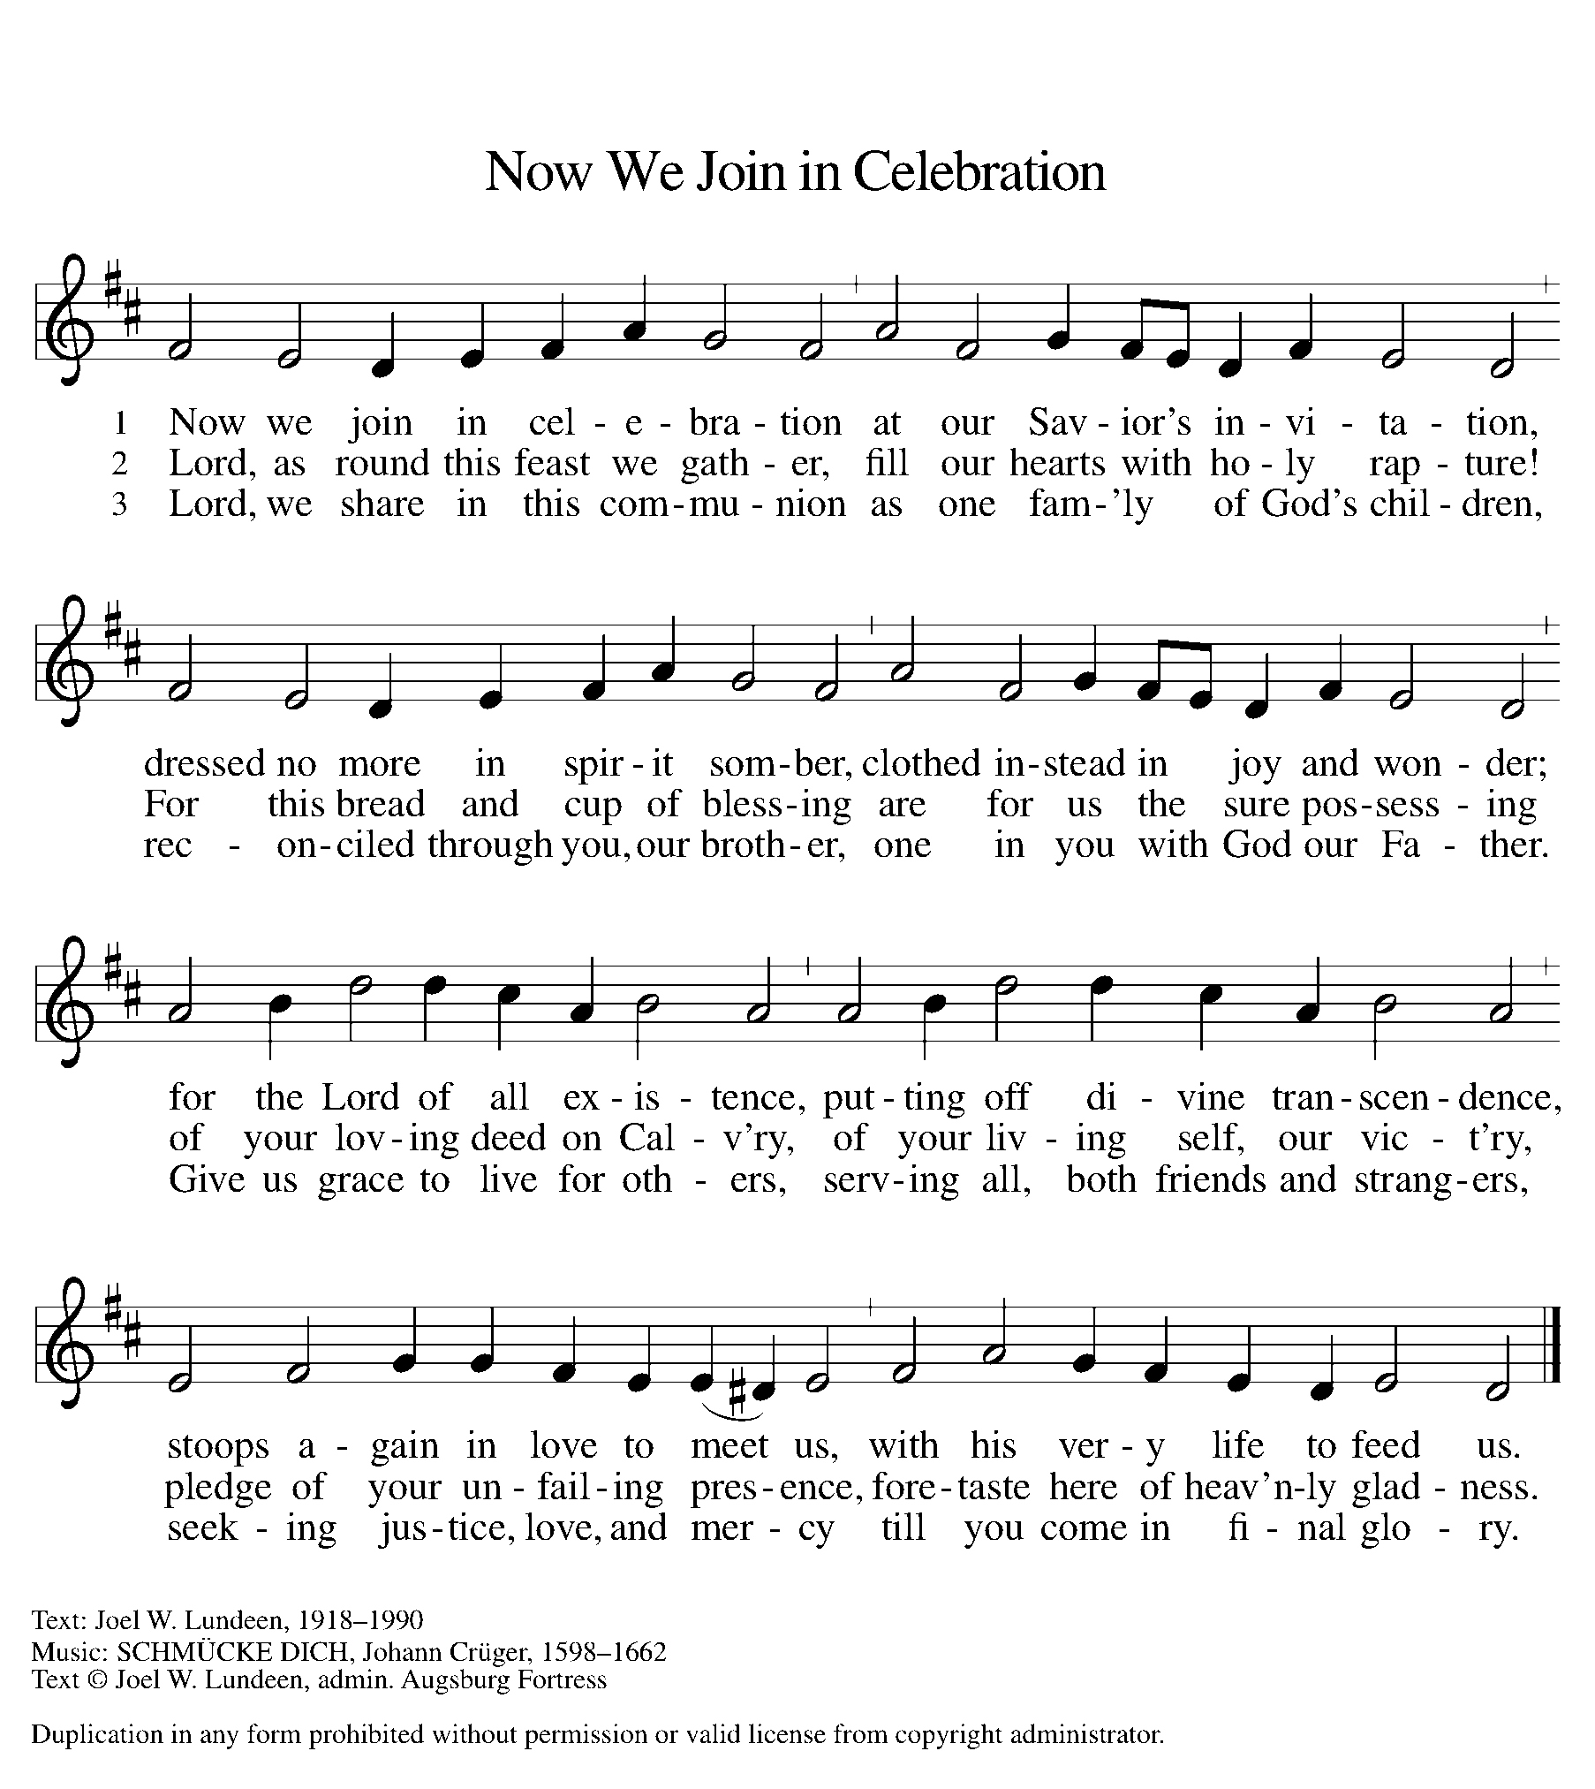

CREED
I believe in God, the Father almighty,
creator of heaven and earth.
I believe in Jesus Christ, God’s only Son, our Lord,
who was conceived by the Holy Spirit,
born of the virgin Mary,
suffered under Pontius Pilate,
was crucified, died, and was buried;
he descended to the dead.*
On the third day he rose again;
he ascended into heaven,
he is seated at the right hand of the Father,
and he will come to judge the living and the dead.
I believe in the Holy Spirit,
the holy catholic church,
the communion of saints,
the forgiveness of sins,
the resurrection of the body,
and the life everlasting. Amen.

*Or, “he descended into hell,” another translation of this text in widespread use.

PRAYERS OF INTERCESSION
With confidence in God’s grace and mercy, let us pray for the church, the world, and all those in need.
A brief silence.
Gracious host, fill your church with a spirit of joyous hospitality. We pray for bishops, teachers, church leaders, and all children of God as they invite others to your table of boundless grace. We pray especially for Immanuel Lutheran Church and Rev. Jonathon Reid. Lord, in your mercy,
hear our prayer.
Gracious host, as creation waits with eager longing for redemption, protect your creatures that are mistreated. Restore valleys, mountains and pastures, and still and running waters. Lord, in your mercy,
hear our prayer.
Gracious host, as you set a table in the presence of enemies, so bless the efforts of diplomats, international peace workers, and world leaders who navigate conflict. May they proceed with dialogue and understanding, so that justice and peace prevails. Lord, in your mercy,
hear our prayer.

Gracious host, let your gentleness be known among those who are weary or ill. Strengthen doctors, medical care workers, and caretakers who see to their needs. Lord, in your mercy,
hear our prayer.
Gracious host, when we are quick to judge outward appearance, remind us how you clothe all in your mercy. We pray for ministries that provide needed clothing and other personal care assistance in this community, especially Manna’s Market and the Woodland Shepherds. Lord, in your mercy,
hear our prayer.
Gracious host, as we remember those who have died and are gathered at the heavenly banquet, comfort us with your presence. Assure us of your peace at all times. Lord, in your mercy,
hear our prayer.
Listen as we call on you, O God, and enfold in your loving arms all for whom we pray, in the name of Jesus Christ our Lord.
Amen.

PEACE
The peace of Christ be with you always.
And also with you.

OFFERING & OFFERING PRAYER
Let us pray. God our provider, you have not fed us with bread alone, but with words of grace and life. Bless us and these your gifts, which we receive from your bounty, through Jesus Christ our Lord.
Amen.

THANKSGIVING AT THE TABLE
In the night in which he was betrayed,
our Lord Jesus took bread, and gave thanks;
broke it, and gave it to his disciples, saying:
Take and eat; this is my body, given for you.
Do this for the remembrance of me.
Again, after supper, he took the cup, gave thanks,
and gave it for all to drink, saying:
This cup is the new covenant in my blood,
shed for you and for all people for the forgiveness of sin.
Do this for the remembrance of me.

LORD’S PRAYER
Lord, remember us in your kingdom and teach us to pray.
Our Father, who art in heaven,
hallowed be thy name,
thy kingdom come,
thy will be done,
on earth as it is in heaven.
Give us this day our daily bread;
and forgive us our trespasses,
as we forgive those
who trespass against us;
and lead us not into temptation,
but deliver us from evil.
For thine is the kingdom,
and the power, and the glory,
forever and ever. Amen.

COMMUNION
The body and blood of our Lord Jesus Christ is given and shed for you. You may receive your communion elements.

SENDING
God blesses us and sends us in mission to the world.

BLESSING
The God of steadfastness and encouragement
grant you to live in harmony with one another,
in accordance with Christ Jesus.
Amen.
The God of hope fill you with all joy and peace in believing,
so that you may abound in hope by the power of the Holy Spirit.
Amen.
The God of all grace ☩ bless you now and forever.
Amen.

SENDING SONG “God Be with You Till We Meet Again” ELW 536

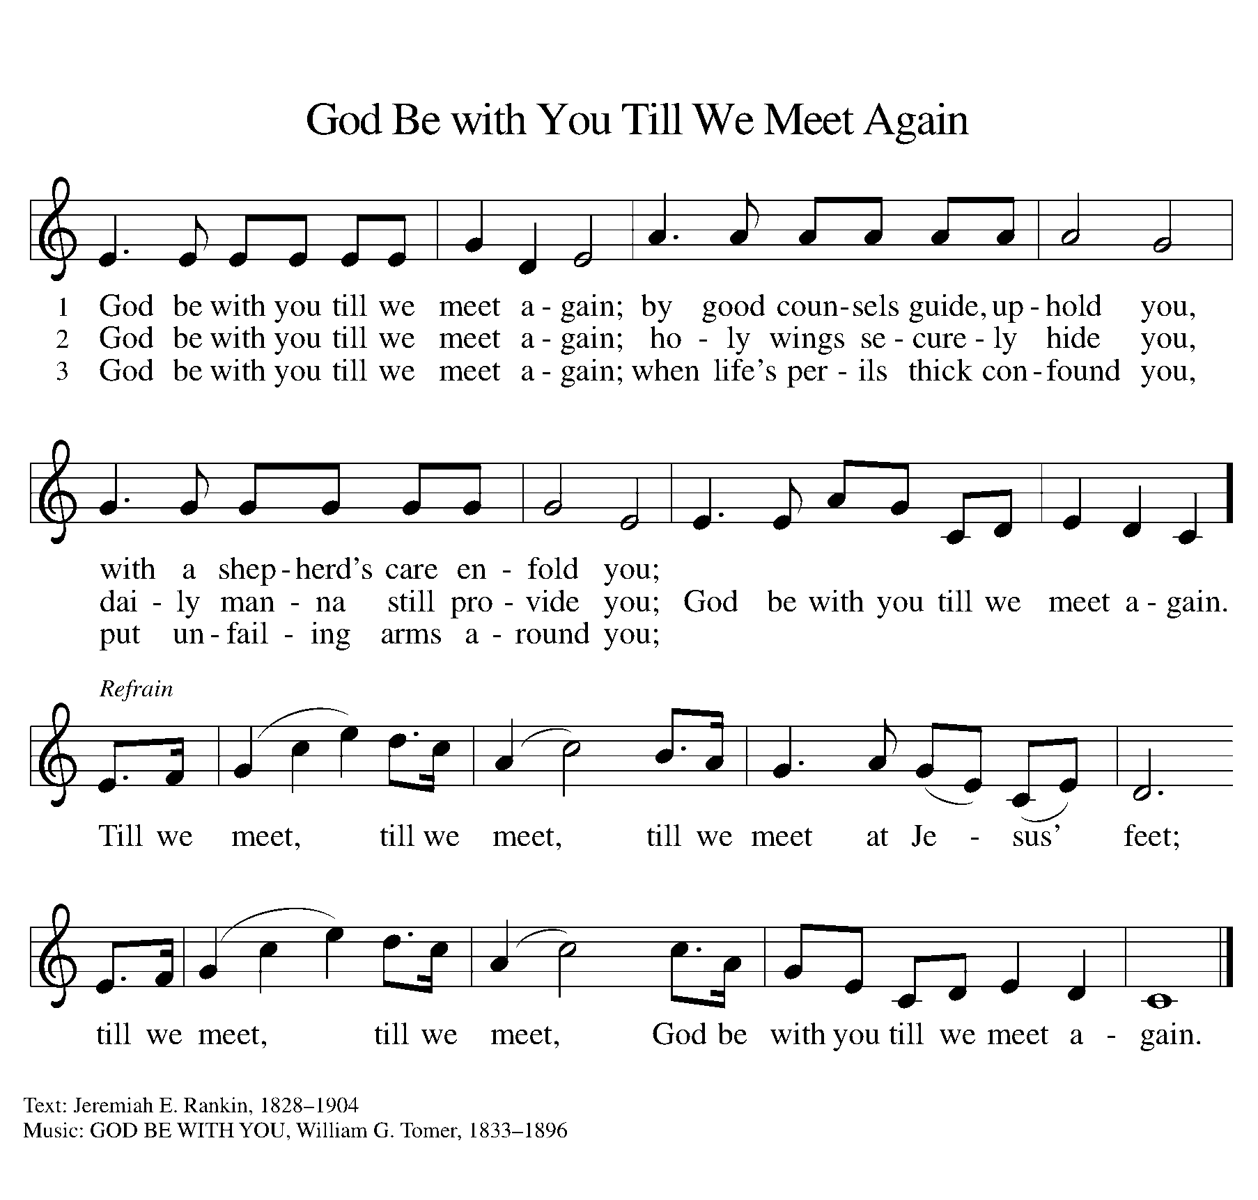
DISMISSAL
Go in peace. Christ is with you.
Thanks be to God.

From sundaysandseasons.com. Copyright © 2017 Augsburg Fortress. All rights reserved.

ANNOUNCEMENTS

- THANK YOU! Thank you to all of the people who have volunteered to be traffic assistants during this time of having church services in the parking lot. You have been very gracious in helping to make the service run smoothly and your help is greatly appreciated. Also, we have a couple of people that are passing out bulletins and communion kits. Thank you as well.
- The church has purchased two benches for the playground area, which can be
engraved with a dedication or a memorial in the name of a loved one or
family name. Each bench has the availability of three (3) engravings,
which will have an inlay the color of the playground. The cost per
dedication is $228.50 and is on a first come basis. If you would like
more information or are interested in purchasing a dedication, please
contact Karen Heise.
- Elder Change. At the September meeting council excepted with regret the resignation of Claudia Alderink-Smith as an elder. Jolene Griffin was appointed to fill the elder vacancy until the election at the January 2021 annual meeting. We thank Claudia for her wonderful service the past nearly 4 years. We thank Jolene for her willingness to step forward.
- Zion will have a Thrivent Action Team project for the month of October. Jolen Griffin and Carol Engle will be the leaders of this project. We are asking for donations of pajamas, socks and underwear for kids. We will take all donated items to Manna's Market for distribution. You may also give a monetary donation. We will have a display table in the Fellowship Hall. We will have several sizes of free red t-shirts available. Carol has been granted $250.00 from Thrivent to purchase some of the items requested.
  - Counters Needed. We are in need of a few more people to serve as volunteer counters for Sunday Offerings. If you are willing to serve in this role, please let Martha or Karen know. Thank you.

