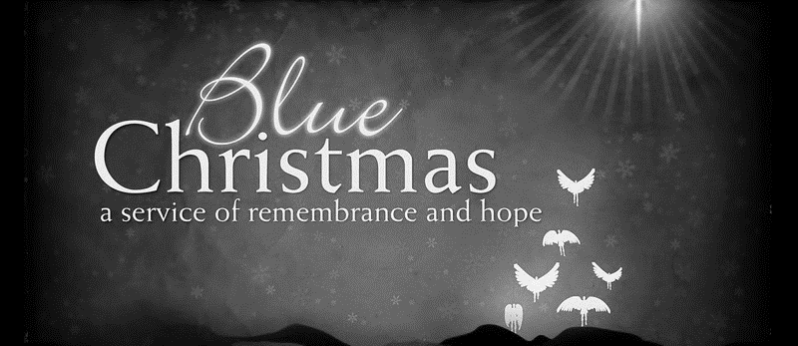

ZION LUTHERAN CHURCH, WOODLAND, MI
Longest Night Service
December 16, 2020

*To fully participate in the service at home, you might want to set out 4 candles (you can use your Advent wreath) and light your candles during the candle lighting portions of the service.

CALL TO WORSHIP

In the beginning was the Word, and the Word was with God, and the Word was God. All things were made by God, and without God nothing came to be. What came to be through God was life, and this life was the light of the world.
The Light shines in the darkness, and the darkness has not overcome it.

FIRST READING Ecclesiastes 3:1-11
A reading from Ecclesiastes.

1For everything there is a season, and a time for every matter under heaven:
2a time to be born, and a time to die;
a time to plant, and a time to pluck up what is planted;
3a time to kill, and a time to heal;
a time to break down, and a time to build up;
4a time to weep, and a time to laugh;
a time to mourn, and a time to dance;
5a time to throw away stones, and a time to gather stones together;
a time to embrace, and a time to refrain from embracing;
6a time to seek, and a time to lose;
a time to keep, and a time to throw away;
7a time to tear, and a time to sew;
a time to keep silence, and a time to speak;
8a time to love, and a time to hate;
a time for war, and a time for peace.
9What gain have the workers from their toil? 10I have seen the business that God has given to everyone to be busy with. 11He has made everything suitable for its time; moreover he has put a sense of past and future into their minds, yet they cannot find out what God has done from the beginning to the end.

The word of the Lord.
Thanks be to God.

PSALMS Psalm 22
¹My God, my God, why have you forsaken me?
Why are you so far from helping me, from the words of my groaning?
²O my God, I cry by day, but you do not answer;
and by night, but find no rest.
⁴In you our ancestors trusted;
they trusted, and you delivered them.
⁹It was you who brought me from the womb;
you who kept me safe on my mother's breast.
¹⁰Since my mother bore me you have been my God.
¹¹Do not be far from me, for trouble is near
and there is no one to help.
²⁴God does not despise the affliction of the afflicted;
God does not hide his face from me,
When I cry to God, God hears me,
Thanks be to God.

PSALMS Psalm 23
¹The LORD is my shepherd, I shall not want.
²He makes me lie down in green pastures;
he leads me beside still waters;
³he restores my soul.
He leads me in paths of righteousness for his name's sake.
⁴Even though I walk through the valley of the shadow of death,
I fear no evil;
for you are with me;
your rod and your staff, they comfort me.
⁵You prepare a table before me
in the presence of my enemies;
you anoint my head with oil;
my cup overflows.
⁶Surely goodness and mercy shall follow me
all the days of my life,
and I shall dwell in the house of the LORD forever.

LITANY OF REMEMBRANCE

We light this first candle to remember those whom we have loved and lost. We pause to remember clearly their faces, their voices, their bodies. We embrace and give thanks for the memories that bind them to us in this season of expectation, when all Creation waits for the Light.
We remember them with love. May God’s eternal love surround them.

Sing verse 1

A period of silent reflection

We light this second candle to remember the pain of loss; loss of relationships, loss of trust, loss of jobs, loss of health, loss of faith, loss of joy, loss to dementia. We acknowledge and embrace the pain of the past, O God, and we offer it to You, asking that into our wounded hearts and open hands You will place the gift of peace, shalom.
We remember that through You all things are possible. Refresh, restore, renew us, O God, and lead us into your future.
Sing verse 2

A period of silent reflection

We light this third candle to remember ourselves this Christmas time. We pause and remember the past weeks, months, and for some of us, years, that have been heavy with our burdens. We accept and lay before you, God, the sharpness of memory, the sadness and grief, the hurt and fear, the anger and pain.
We accept and lay before you the ways we feel we have fallen short, and the times we have spent blaming ourselves, and You, for all that we have suffered and the suffering of others. We accept and lay before you the time we have walked alone, in darkness; and in knowledge of our own mortality.
We remember that though we have journeyed far, and that, while lost, we may have turned away from the light, the light itself has not failed. We remember that though winter be upon us and though the night be dark, with the turning of the wheel dawn will come, and dawn defeats the darkness.

Sing verse 6
A period of silent reflection

We light this fourth candle to remember faith, the gift of light and hope that God offers to us in the stories of Hanukkah and of Christmas, which both also began in abandonment, insecurity, and humbleness, in a time of war and in a poor stable. We remember that the loving God who kept the light shining in the temple and who came to share in this life with us promises us comfort and peace.
We remember the One who shares our burdens, who shows us the way to the Light, and who journeys with us into all our tomorrows.

Sing verse 10 (See below)

Verse 10:
O come desire of nations, bind in one the hearts of all mankind
Bid then our sad divisions cease, and be thyself our King of Peace.
Rejoice, rejoice, Emmanuel, shall come to thee O Israel

A period of silent reflection

THE PRAYERS OF THE PEOPLE

God of wisdom, we come to you this Christmas Season tired, in turmoil, and in pain. As the nights have grown longer, so has darkness grown and wrapped itself around our hearts. In this season of longest night, we ask your healing blessings upon all that we carry in our hearts—sorrow we fear may never end, wounds we cannot even put into words. Lord, hear our prayer.
And in Your merciful love, answer.

God of grace, in the spirit of the season, grant us all that we need to comfort us as we
journey through this Christmas season. We ask that you shelter and sustain all of us, both here and throughout the world, who wander or want or weep or are heavy laden, that we may be lifted up in courage and journey on in Thy peace. Lord, hear our prayer.
And in Your merciful love, answer.

God of love, in this Christmas Season we embrace and offer up to you all that used to be, which is now lost to us, and cannot be again. With celebration all around us, memories of what was, and fears of what may be, weigh heavy on our hearts. Please hold us close in your embrace, be near to us, until the light returns and morning comes. Lord, hear our prayer.
And in Your merciful love, answer.

Keep watch, dear Lord, with those work, or watch, or weep, and give thine angels charge over those who sleep. Tend the sick, Lord; give rest to the weary, bless the dying, soothe the suffering, pity the afflicted, shield the joyous; and all for thy love’s sake.
Amen.

PSALMS Psalm 121
¹I lift up my eyes to the hills —
from where will my help come?
²My help comes from the LORD,
who made heaven and earth.
³He will not let your foot be moved;
he who keeps you will not slumber.
⁴He who keeps Israel
will neither slumber nor sleep.
⁵The LORD is your keeper;
the LORD is your shade at your right hand.
⁶The sun shall not strike you by day,
nor the moon by night.
⁷The LORD will keep you from all evil;
he will keep your life.
⁸The LORD will keep
your going out and your coming in
from this time on and forevermore.

PRAYER

Let us pray.
Almighty God, we thank you for your constant love and for the blessings of this day. We know that even when we cannot see or feel you, still you are there. Help us to remember you and to listen for your voice in the words of family, friends, and strangers. Kindle our hearts and awaken hope, that we may know you as you reveal yourself in the world and in our lives.
Let the light of your Holy Spirit shine like these candles in the darkness, lighting the way for all who feel despairing, lost, or forgotten, and grant that it may come to dwell so deeply in our hearts that when we leave this place it may shine on, for us and for those we meet along the way.
Amen.

CONCLUDING PRAYERS

Let us pray.
Another day will come, O God. I know not what it may bring forth, but make me ready, God for whatever it may be.
If I am to stand up, help me to stand bravely.
If I am to sit still, help me to sit quietly.
If am to lie low, help me to do so patiently.
And if I am to do nothing, help me to it gallantly.
Make these more than words, and give me the spirit of they peace.
Amen.

O God, support us all the day long in this troubled life, until the shadows lengthen and the evening come, and the busy world is hushed, and the fever of life is over, and our work is done. Then Lord, in thy mercy, grant us safe lodging, and a holy rest, and a peace at the last.
Amen.

BLESSING AND DISMISSAL

May the power and the mystery go before us, to show us the way. Shine above us to lighten our world, lie beneath us to bear us up, walk with us and give us companionship, and glow and flow within us to bring us joy.
Amen

The “Blue Christmas” service used today is based on an order developed and used at The Cathedral Church of Saint Andrew, in Honolulu, Hawaii.

