ZION LUTHERAN CHURCH, WOODLAND, MI
Third Sunday after Epiphany, January 24, 2021
*If you are listening in your car, please tune your radio to 1620 AM*

ANNOUNCEMENTS & PRELUDE

Gathering
The Holy Spirit calls us together as the people of God.

Confession and Forgiveness
In the name of the Father, and of the ☩ Son, and of the Holy Spirit.
Amen.

God of all mercy and consolation, come to the help of your people, turning us from our sin to live for you alone. Give us the power of your Holy Spirit that we may confess our sin, receive your forgiveness, and grow into the fullness of Jesus Christ, our Savior and Lord.
Amen.

Let us confess our sin in the presence of God and of one another. Most merciful God,
we confess that we are captive to sin and cannot free ourselves. We have sinned against you in thought, word, and deed, by what we have done and by what we have left undone. We have not loved you with our whole heart; we have not loved our neighbors as ourselves. For the sake of your Son, Jesus Christ, have mercy on us. Forgive us, renew us, and lead us, so that we may delight in your will and walk in your ways, to the glory of your holy name. Amen.

In the mercy of almighty God, Jesus Christ was given to die for us, and for his sake God forgives us all our sins. As a called and ordained minister of the church of Christ, and by his authority, I therefore declare to you the entire forgiveness of all your sins, in the name of the Father, and of the ☩ Son, and of the Holy Spirit.
Amen.

Gathering Song “Holy, Holy, Holy, Lord God Almighty!” ELW 413

GREETING
The grace of our Lord Jesus Christ, the love of God, and the communion of the Holy Spirit be with you all.
And also with you.

Prayer of the Day
Let us pray together.
Almighty God, by grace alone you call us and accept us in your service. Strengthen us by your Spirit, and make us worthy of your call, through Jesus Christ, our Savior and Lord. Amen.

First Reading Jonah 3:1-5,10
A reading from Jonah.

¹The word of the Lord came to Jonah a second time, saying, ²“Get up, go to Nineveh, that great city, and proclaim to it the message that I tell you.” ³So Jonah set out and went to Nineveh, according to the word of the Lord. Now Nineveh was an exceedingly large city, a three days’ walk across. ⁴Jonah began to go into the city, going a day’s walk. And he cried out, “Forty days more, and Nineveh shall be overthrown!” ⁵And the people of Nineveh believed God; they proclaimed a fast, and everyone, great and small, put on sackcloth.
¹⁰When God saw what they did, how they turned from their evil ways, God changed his mind about the calamity that he had said he would bring upon them; and he did not do it.

The word of the Lord.
Thanks be to God.

Psalm Psalm 62:5-12
⁵For God alone I | wait in silence;
truly, my hope | is in God.
⁶God alone is my rock and | my salvation,
my stronghold, so that I shall nev- | er be shaken.
⁷In God is my deliverance | and my honor;
God is my strong rock | and my refuge.
⁸Put your trust in God al- | ways, O people,
pour out your hearts before the one who | is our refuge.
⁹Those of high degree are but a fleeting breath; those of low estate can- | not be trusted.
Placed on the scales together they weigh even less | than a breath.
¹⁰Put no trust in extortion; in robbery take no | empty pride;
though wealth increase, set not your | heart upon it.
¹¹God has spoken once, twice | have I heard it,
that power be- | longs to God.
¹²Steadfast love belongs to | you, O Lord,
for you repay all according | to their deeds.

Second Reading 1 Corinthians 7:29-31
A reading from 1 Corinthians.

²⁹Brothers and sisters, the appointed time has grown short; from now on, let even those who have wives be as though they had none, ³⁰and those who mourn as though they were not mourning, and those who rejoice as though they were not rejoicing, and those who buy as though they had no possessions, ³¹and those who deal with the world as though they had no dealings with it. For the present form of this world is passing away.

The word of the Lord.
Thanks be to God.

Gospel Acclamation
Alleluia, Lord, to whom shall we go?
Alleluia. You have the words of eternal life.
Alleluia, alleluia.

Gospel Mark 1:14-20
The holy gospel according to Mark.
Glory to you, O Lord.

¹⁴Now after John was arrested, Jesus came to Galilee, proclaiming the good news of God, ¹⁵and saying, “The time is fulfilled, and the kingdom of God has come near; repent, and believe in the good news.”
¹⁶As Jesus passed along the Sea of Galilee, he saw Simon and his brother Andrew casting a net into the sea—for they were fishermen. ¹⁷And Jesus said to them, “Follow me and I will make you fish for people.” ¹⁸And immediately they left their nets and followed him. ¹⁹As he went a little farther, he saw James son of Zebedee and his brother John, who were in their boat mending the nets. ²⁰Immediately he called them; and they left their father Zebedee in the boat with the hired men, and followed him.

The gospel of the Lord.
Praise to you, O Christ.

SERMON Jolene Griffin

Hymn of the Day “Here I Am, Lord” ELW 574

cREED
I believe in God, the Father almighty,
creator of heaven and earth.
I believe in Jesus Christ, God’s only Son, our Lord,
who was conceived by the Holy Spirit,
born of the virgin Mary,
suffered under Pontius Pilate,
was crucified, died, and was buried;
he descended to the dead.*
On the third day he rose again;
he ascended into heaven,
he is seated at the right hand of the Father,
and he will come to judge the living and the dead.
I believe in the Holy Spirit,
the holy catholic church,
the communion of saints,
the forgiveness of sins,
the resurrection of the body,
and the life everlasting. Amen.

*Or, “he descended into hell,” another translation of this text in widespread use.

Prayers of Intercession
Guided by Christ made known to the nations, let us offer our prayers for the church, the world, and all people in need.
A brief silence.
For the church throughout the world, for pastors and teachers, for deacons and deaconesses, and for musicians and servers, that all proclaim the good news of God’s reconciling love. We pray especially for St. Paul Lutheran church and their supply pastors, let us pray.
Have mercy, O God.
For skies and seas, for birds and fish, for favorable weather and clean water, and for the well-being of creation, that God raise up advocates and scientists to guide our care for all the earth, let us pray.
Have mercy, O God.
For those who provide leadership in our cities and around the world, for nonprofit and nongovernmental organizations, for planning commissions and homeless advocates, that God inspire all people in the just use of wealth, let us pray.
Have mercy, O God.
For those who are sick, distressed, or grieving; for the outcast and all who await relief, that in the midst of suffering, God’s peace and mercy surround them, let us pray.
Have mercy, O God.
For our congregation and community, for families big and small, and for the organizations that meet here during the week, that God’s steadfast love serve as a model for all relationships, let us pray.
Have mercy, O God.
In thanksgiving for our ancestors in the faith whose lives serve as an example of gospel living, that they point us to salvation through Christ, let us pray.
Have mercy, O God.
Merciful God, hear the prayers of your people, spoken or silent, for the sake of the one who dwells among us, your Son, Jesus Christ our Savior.
Amen.

Peace
The peace of Christ be with you always.
And also with you.

Offering & Offering Prayer
Let us pray. God our provider, you have not fed us with bread alone, but with words of grace and life. Bless us and these your gifts, which we receive from your bounty, through Jesus Christ our Lord.
Amen.

Thanksgiving for the Word .
Let us pray.
Praise and thanks to you, holy God, for by your Word you made all things: you spoke light into darkness, called forth beauty from chaos, and brought life into being. For your Word of life, O God,
we give you thanks and praise.
By your Word you called your people Israel to tell of your wonderful gifts: freedom from captivity, water on the desert journey, a pathway home from exile, wisdom for life with you. For your Word of life, O God,
we give you thanks and praise.
Through Jesus, your Word made flesh, you speak to us and call us to witness: forgiveness through the cross, life to those entombed by death, the way of your self-giving love. For your Word of life, O God,
we give you thanks and praise.
Send your Spirit of truth, O God; rekindle your gifts within us: renew our faith, increase our hope, and deepen our love, for the sake of a world in need. Faithful to your Word, O God, draw near to all who call on you; through Jesus Christ, our Savior and Lord, to whom, with you and the Holy Spirit, be honor and glory forever.
Amen.

Lord’s Prayer
Lord, remember us in your kingdom and teach us to pray.
Our Father, who art in heaven,
hallowed be thy name,
thy kingdom come,
thy will be done,
on earth as it is in heaven.
Give us this day our daily bread;
and forgive us our trespasses,
as we forgive those
who trespass against us;
and lead us not into temptation,
but deliver us from evil.
For thine is the kingdom,
and the power, and the glory,
forever and ever. Amen.

Sending
God blesses us and sends us in mission to the world.

Blessing
The God of steadfastness and encouragement
grant you to live in harmony with one another,
in accordance with Christ Jesus.
Amen.
The God of hope fill you with all joy and peace in believing,
so that you may abound in hope by the power of the Holy Spirit.
Amen.
The God of all grace ☩ bless you now and forever.
Amen.

Sending SonG “Shine, Jesus, Shine” ELW 671
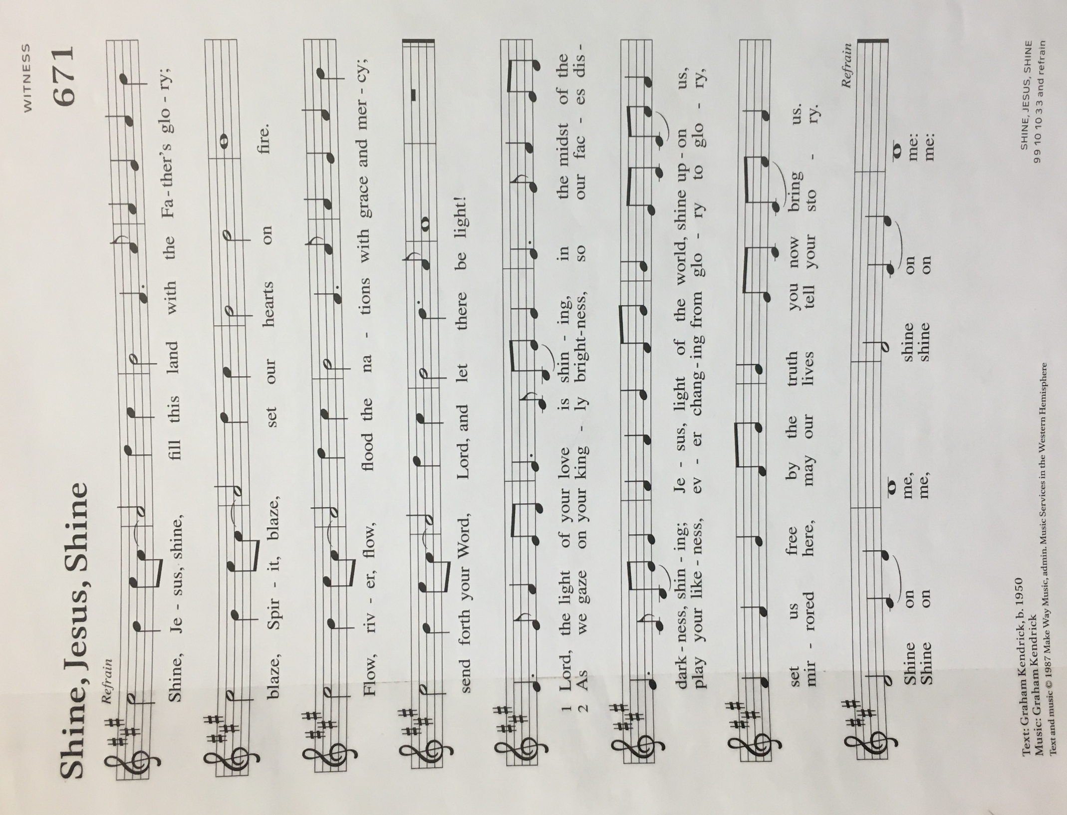
Dismissal
Go in peace. Christ is with you.
Thanks be to God.

From sundaysandseasons.com. Copyright © 2017 Augsburg Fortress. All rights reserved.

THANK YOU TO ALL WHO SERVED TODAY:

Presider: Jolene Griffin
Musician: Martha Yoder
Song Leader: Ruth Hindman
Elder: Dan Utterback
Trustee: Claude Smith
Offering Counters: Mary Makley and Martha Yoder

ANNOUNCEMENTS

  - The newsletter deadline is this Wednesday evening, January 27. Please have all articles submitted to Tara by then.
  - Zion is starting a tech team to do the live stream for our services. Paul Meade will be glad to train people. Please let Pastor Becky or Paul know if you would like to serve in this way.
  - We are still in need of a lay preacher for April 18. Please see Pastor Becky if you are interested.
  - Council has voted to suspend in-person services until the positivity rate drops to 3%. People may continue to listen to the service in the parking and the service will be streamed.
  - Counters Needed. We are in need of a few more people to serve as volunteer counters for Sunday Offerings. If you are willing to serve in this role, please let Martha or Karen know. Thank you.

ANNUAL MEETING
Thank you to everyone who returned your ballot. On the ballot for Council and Board members, there were 47 ballots returned and the slate was overwhelmingly approved. Our thanks to everyone who is willing to serve in 2021! Some members wrote in suggested delegates to Synod Assembly. Council will reach out to those individuals to see if they are interested in serving. Regarding the ballot for financial proposals, a total of 44 ballots were received. The proposals were all approved as follows:
Budget, Yes 43, no 1
AC Units, Yes 43, no 1
Lawnmower, Yes 43, no 1
Exterior paint and repair, Yes 44, no 0

Again, our thanks to all for your support and participation.

