ZION LUTHERAN CHURCH, WOODLAND, MI
Transfiguration Sunday, February 14, 2021
*If you are listening in your car, please tune your radio to 1620 AM*

ANNOUNCEMENTS & PRELUDE

Gathering
The Holy Spirit calls us together as the people of God.

Confession and Forgiveness
In the name of the Father, and of the ☩ Son, and of the Holy Spirit.
Amen.

God of all mercy and consolation, come to the help of your people, turning us from our sin to live for you alone. Give us the power of your Holy Spirit that we may confess our sin, receive your forgiveness, and grow into the fullness of Jesus Christ, our Savior and Lord.
Amen.

Let us confess our sin in the presence of God and of one another. Most merciful God,
we confess that we are captive to sin and cannot free ourselves. We have sinned against you in thought, word, and deed, by what we have done and by what we have left undone. We have not loved you with our whole heart; we have not loved our neighbors as ourselves. For the sake of your Son, Jesus Christ, have mercy on us. Forgive us, renew us, and lead us, so that we may delight in your will and walk in your ways, to the glory of your holy name. Amen.

In the mercy of almighty God, Jesus Christ was given to die for us, and for his sake God forgives us all our sins. As a called and ordained minister of the church of Christ, and by his authority, I therefore declare to you the entire forgiveness of all your sins, in the name of the Father, and of the ☩ Son, and of the Holy Spirit.
Amen.

Gathering Song “Immortal, Invisible God, Only Wise” ELW 834

GREETING
The grace of our Lord Jesus Christ, the love of God, and the communion of the Holy Spirit be with you all.
And also with you.

Prayer of the Day
Let us pray together.
Almighty God, the resplendent light of your truth shines from the mountaintop into our hearts. Transfigure us by your beloved Son, and illumine the world with your image, through Jesus Christ, our Savior and Lord, who lives and reigns with you and the Holy Spirit, one God, now and forever.
Amen.

First Reading 2 Kings 2:12
A reading from 2 Kings.

¹Now when the Lord was about to take Elijah up to heaven by a whirlwind, Elijah and Elisha were on their way from Gilgal. ²Elijah said to Elisha, “Stay here; for the Lord has sent me as far as Bethel.” But Elisha said, “As the Lord lives, and as you yourself live, I will not leave you.” So they went down to Bethel. ³The company of prophets who were in Bethel came out to Elisha, and said to him, “Do you know that today the Lord will take your master away from you?” And he said, “Yes, I know; keep silent.”
⁴Elijah said to him, “Elisha, stay here; for the Lord has sent me to Jericho.” But he said, “As the Lord lives, and as you yourself live, I will not leave you.” So they came to Jericho. ⁵The company of prophets who were at Jericho drew near to Elisha, and said to him, “Do you know that today the Lord will take your master away from you?” And he answered, “Yes, I know; be silent.”
⁶Then Elijah said to him, “Stay here; for the Lord has sent me to the Jordan.” But he said, “As the Lord lives, and as you yourself live, I will not leave you.” So the two of them went on. ⁷Fifty men of the company of prophets also went, and stood at some distance from them, as they both were standing by the Jordan. ⁸Then Elijah took his mantle and rolled it up, and struck the water; the water was parted to the one side and to the other, until the two of them crossed on dry ground.
⁹When they had crossed, Elijah said to Elisha, “Tell me what I may do for you, before I am taken from you.” Elisha said, “Please let me inherit a double share of your spirit.” ¹⁰He responded, “You have asked a hard thing; yet, if you see me as I am being taken from you, it will be granted you; if not, it will not.” ¹¹As they continued walking and talking, a chariot of fire and horses of fire separated the two of them, and Elijah ascended in a whirlwind into heaven. ¹²Elisha kept watching and crying out, “Father, father! The chariots of Israel and its horsemen!” But when he could no longer see him, he grasped his own clothes and tore them in two pieces.

The word of the Lord.
Thanks be to God.

Psalm Psalm 50:1-6
¹The mighty one, God the | Lord, has spoken;
calling the earth from the rising of the sun | to its setting.
²Out of Zion, perfect | in its beauty,
God shines | forth in glory.
³Our God will come and will | not keep silence;
with a consuming flame before, and round about a | raging storm.
⁴God calls the heavens and the earth | from above
to witness the judgment | of the people.
⁵“Gather before me my | loyal followers,
those who have made a covenant with me and sealed | it with sacrifice.”
⁶The heavens declare the rightness | of God’s cause,
for it is God | who is judge.

Second Reading 2 Corinthians 4:3-6
A reading from 2 Corinthians.

³Even if our gospel is veiled, it is veiled to those who are perishing. ⁴In their case the god of this world has blinded the minds of the unbelievers, to keep them from seeing the light of the gospel of the glory of Christ, who is the image of God. ⁵For we do not proclaim ourselves; we proclaim Jesus Christ as Lord and ourselves as your slaves for Jesus’ sake. ⁶For it is the God who said, “Let light shine out of darkness,” who has shone in our hearts to give the light of the knowledge of the glory of God in the face of Jesus Christ.

The word of the Lord.
Thanks be to God.

Gospel Acclamation
Alleluia, Lord, to whom shall we go?
Alleluia. You have the words of eternal life.
Alleluia, alleluia.

Gospel Mark 9:2-9
The holy gospel according to Mark.
Glory to you, O Lord.

²Six days later, Jesus took with him Peter and James and John, and led them up a high mountain apart, by themselves. And he was transfigured before them, ³and his clothes became dazzling white, such as no one on earth could bleach them. ⁴And there appeared to them Elijah with Moses, who were talking with Jesus. ⁵Then Peter said to Jesus, “Rabbi, it is good for us to be here; let us make three dwellings, one for you, one for Moses, and one for Elijah.” ⁶He did not know what to say, for they were terrified. ⁷Then a cloud overshadowed them, and from the cloud there came a voice, “This is my Son, the Beloved; listen to him!” ⁸Suddenly when they looked around, they saw no one with them any more, but only Jesus.
⁹As they were coming down the mountain, he ordered them to tell no one about what they had seen, until after the Son of Man had risen from the dead.

The gospel of the Lord.
Praise to you, O Christ.

SERMON Pastor Becky Ebb Speese

Hymn of the Day “Beautiful Savior” ELW 838
cREED
I believe in God, the Father almighty,
creator of heaven and earth.
I believe in Jesus Christ, God’s only Son, our Lord,
who was conceived by the Holy Spirit,
born of the virgin Mary,
suffered under Pontius Pilate,
was crucified, died, and was buried;
he descended to the dead.*
On the third day he rose again;
he ascended into heaven,
he is seated at the right hand of the Father,
and he will come to judge the living and the dead.
I believe in the Holy Spirit,
the holy catholic church,
the communion of saints,
the forgiveness of sins,
the resurrection of the body,
and the life everlasting. Amen.

*Or, “he descended into hell,” another translation of this text in widespread use.

of Intercession
Guided by Christ made known to the nations, let us offer our prayers for the church, the world, and all people in need.
A brief silence.
For the gospel proclaimed in word and deed, for communities of faith far and near, and for all who show the face of Christ throughout the world. We pray especially for St. John’s Lutheran Church and Rev. Jim Morgan, let us pray.
Have mercy, O God.
For creation: sun, moon and stars; life forming in the dark earth and ocean deep; mountains, clouds and storms, and creatures seen and unseen, and for the Holy Spirit’s guidance in our stewardship of God’s creation, let us pray.
Have mercy, O God.
For those responsible for safety and protection: for emergency responders and security guards, attorneys and advocates, civil servants and leaders of governments, that they witness to mercy and justice throughout the world, let us pray.
Have mercy, O God.

For all who suffer this day, that Christ our healer transform sickness into health, loneliness into companionship, bereavement into consolation, and suffering into peace, let us pray.
Have mercy, O God.
For companions on life’s journey in this worshiping community, for loved ones who cannot be with us this day, and for guidance during struggles we face, that God’s glory is revealed around and among us, let us pray.
Have mercy, O God.
In thanksgiving for the faithful departed who now rest from their earthly pilgrimage, that their lives of service and prayer inspire us in our living, let us pray.
Have mercy, O God.
Merciful God, hear the prayers of your people, spoken or silent, for the sake of the one who dwells among us, your Son, Jesus Christ our Savior.

Peace
The peace of Christ be with you always.
And also with you.

Offering & Offering Prayer
Let us pray. God our provider, you have not fed us with bread alone, but with words of grace and life. Bless us and these your gifts, which we receive from your bounty, through Jesus Christ our Lord.
Amen.

Thanksgiving at the Table
In the night in which he was betrayed,
our Lord Jesus took bread, and gave thanks;
broke it, and gave it to his disciples, saying:
Take and eat; this is my body, given for you.
Do this for the remembrance of me.
Again, after supper, he took the cup, gave thanks,
and gave it for all to drink, saying:
This cup is the new covenant in my blood,
shed for you and for all people for the forgiveness of sin.
Do this for the remembrance of me.

Lord’s Prayer
Lord, remember us in your kingdom and teach us to pray.
Our Father, who art in heaven,
hallowed be thy name,
thy kingdom come,
thy will be done,
on earth as it is in heaven.
Give us this day our daily bread;
and forgive us our trespasses,
as we forgive those
who trespass against us;
and lead us not into temptation,
but deliver us from evil.
For thine is the kingdom,
and the power, and the glory,
forever and ever. Amen.

COMMUNION
The body and blood of our Lord Jesus Christ is given and shed for you. You may receive your communion elements.

Sending
God blesses us and sends us in mission to the world.

Blessing
The God of steadfastness and encouragement
grant you to live in harmony with one another,
in accordance with Christ Jesus.
Amen.
The God of hope fill you with all joy and peace in believing,
so that you may abound in hope by the power of the Holy Spirit.
Amen.
The God of all grace ☩ bless you now and forever.
Amen.

Sending SonG “Shine, Jesus, Shine” ELW 671
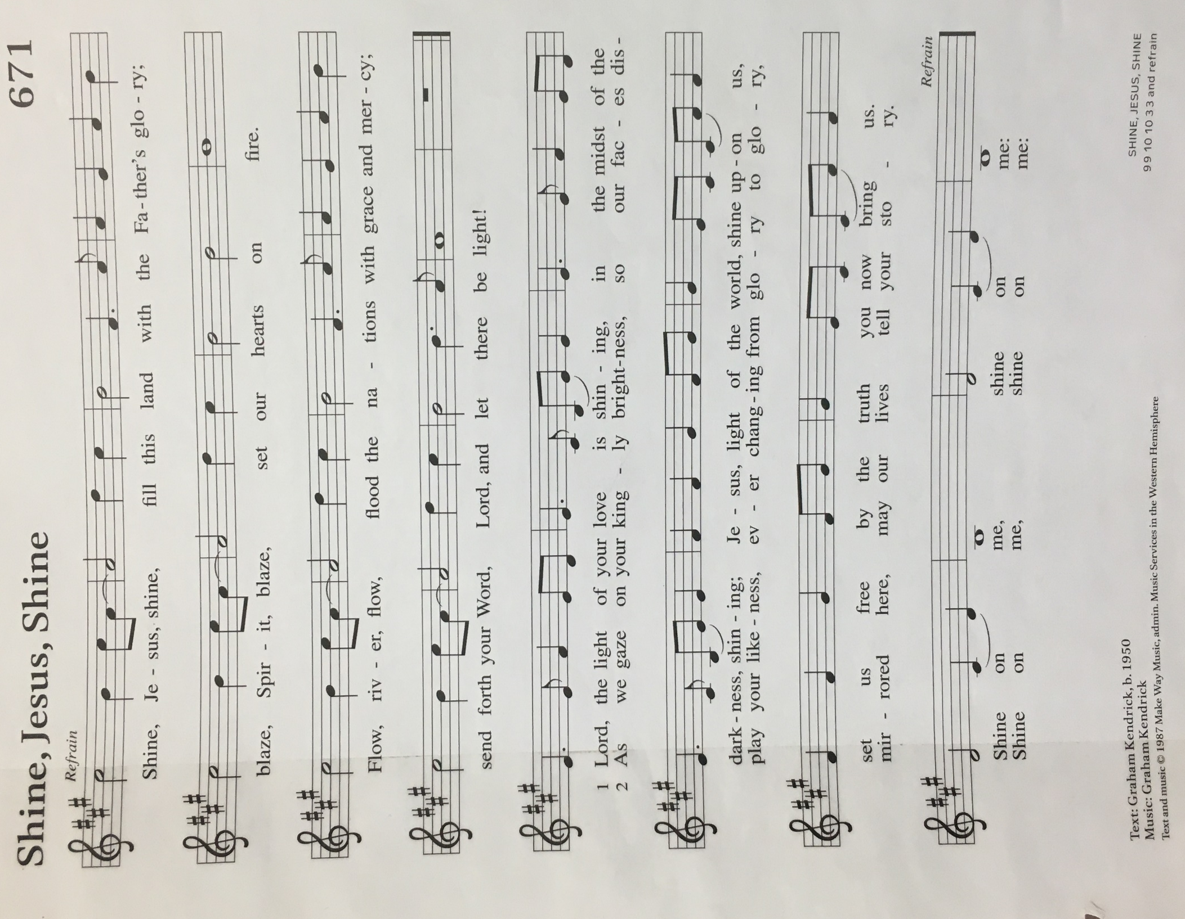

Dismissal
Go in peace. Christ is with you.
Thanks be to God.

From sundaysandseasons.com. Copyright © 2017 Augsburg Fortress. All rights reserved.

THANK YOU TO ALL WHO SERVED TODAY:

Presider: Rebecca Ebb-Speese
Musician: Martha Yoder
Elder: Dan Utterback
Trustee: Jerry Engle
Offering Counters: Diane Griffin and Carlotta Willard

ANNOUNCEMENTS

  - Grace Lutheran church will be offering a CPR class, a First Aid class, and an AED class. To register for any of these classes, or for more information, contact Kim Domke at 269-908-0024. Grace Lutheran’s address is 239 E North St, Hastings MI.
  - CPR Class: Fri, Feb 26 4:30 PM-9:30 PM, cost $60
  - First Aid Class: Sat, Feb 27 8:30 AM-1:00 PM, cost $50 (discount: if doing both CPR and First Aid, total cost is $80)
  - AED Class: Sun, Feb 28 12:15 PM-2:00 PM, cost: FREE
  - Zion is starting a tech team to do the live stream for our services. Paul Meade will be glad to train people. Please let Pastor Becky or Paul know if you would like to serve in this way.
  - Council has voted to suspend in-person services until the positivity rate drops to 3%. People may continue to listen to the service in the parking and the service will be streamed.

