ZION LUTHERAN CHURCH, WOODLAND, MI
Fourth Sunday of Lent, March 14, 2021
*If you are listening in your car, please tune your radio to 1620 AM*

ANNOUNCEMENTS & PRELUDE

Gathering
The Holy Spirit calls us together as the people of God.

Confession and Forgiveness
In the name of the Father, and of the ☩ Son, and of the Holy Spirit.
Amen.

God of all mercy and consolation, come to the help of your people, turning us from our sin to live for you alone. Give us the power of your Holy Spirit that we may confess our sin, receive your forgiveness, and grow into the fullness of Jesus Christ, our Savior and Lord.
Amen.

Let us confess our sin in the presence of God and of one another. Most merciful God,
we confess that we are captive to sin and cannot free ourselves. We have sinned against you in thought, word, and deed, by what we have done and by what we have left undone. We have not loved you with our whole heart; we have not loved our neighbors as ourselves. For the sake of your Son, Jesus Christ, have mercy on us. Forgive us, renew us, and lead us, so that we may delight in your will and walk in your ways, to the glory of your holy name. Amen.

In the mercy of almighty God, Jesus Christ was given to die for us, and for his sake God forgives us all our sins. As a called and ordained minister of the church of Christ, and by his authority, I therefore declare to you the entire forgiveness of all your sins, in the name of the Father, and of the ☩ Son, and of the Holy Spirit.
Amen.

Gathering Song “Lead Me, Guide Me” ELW 768
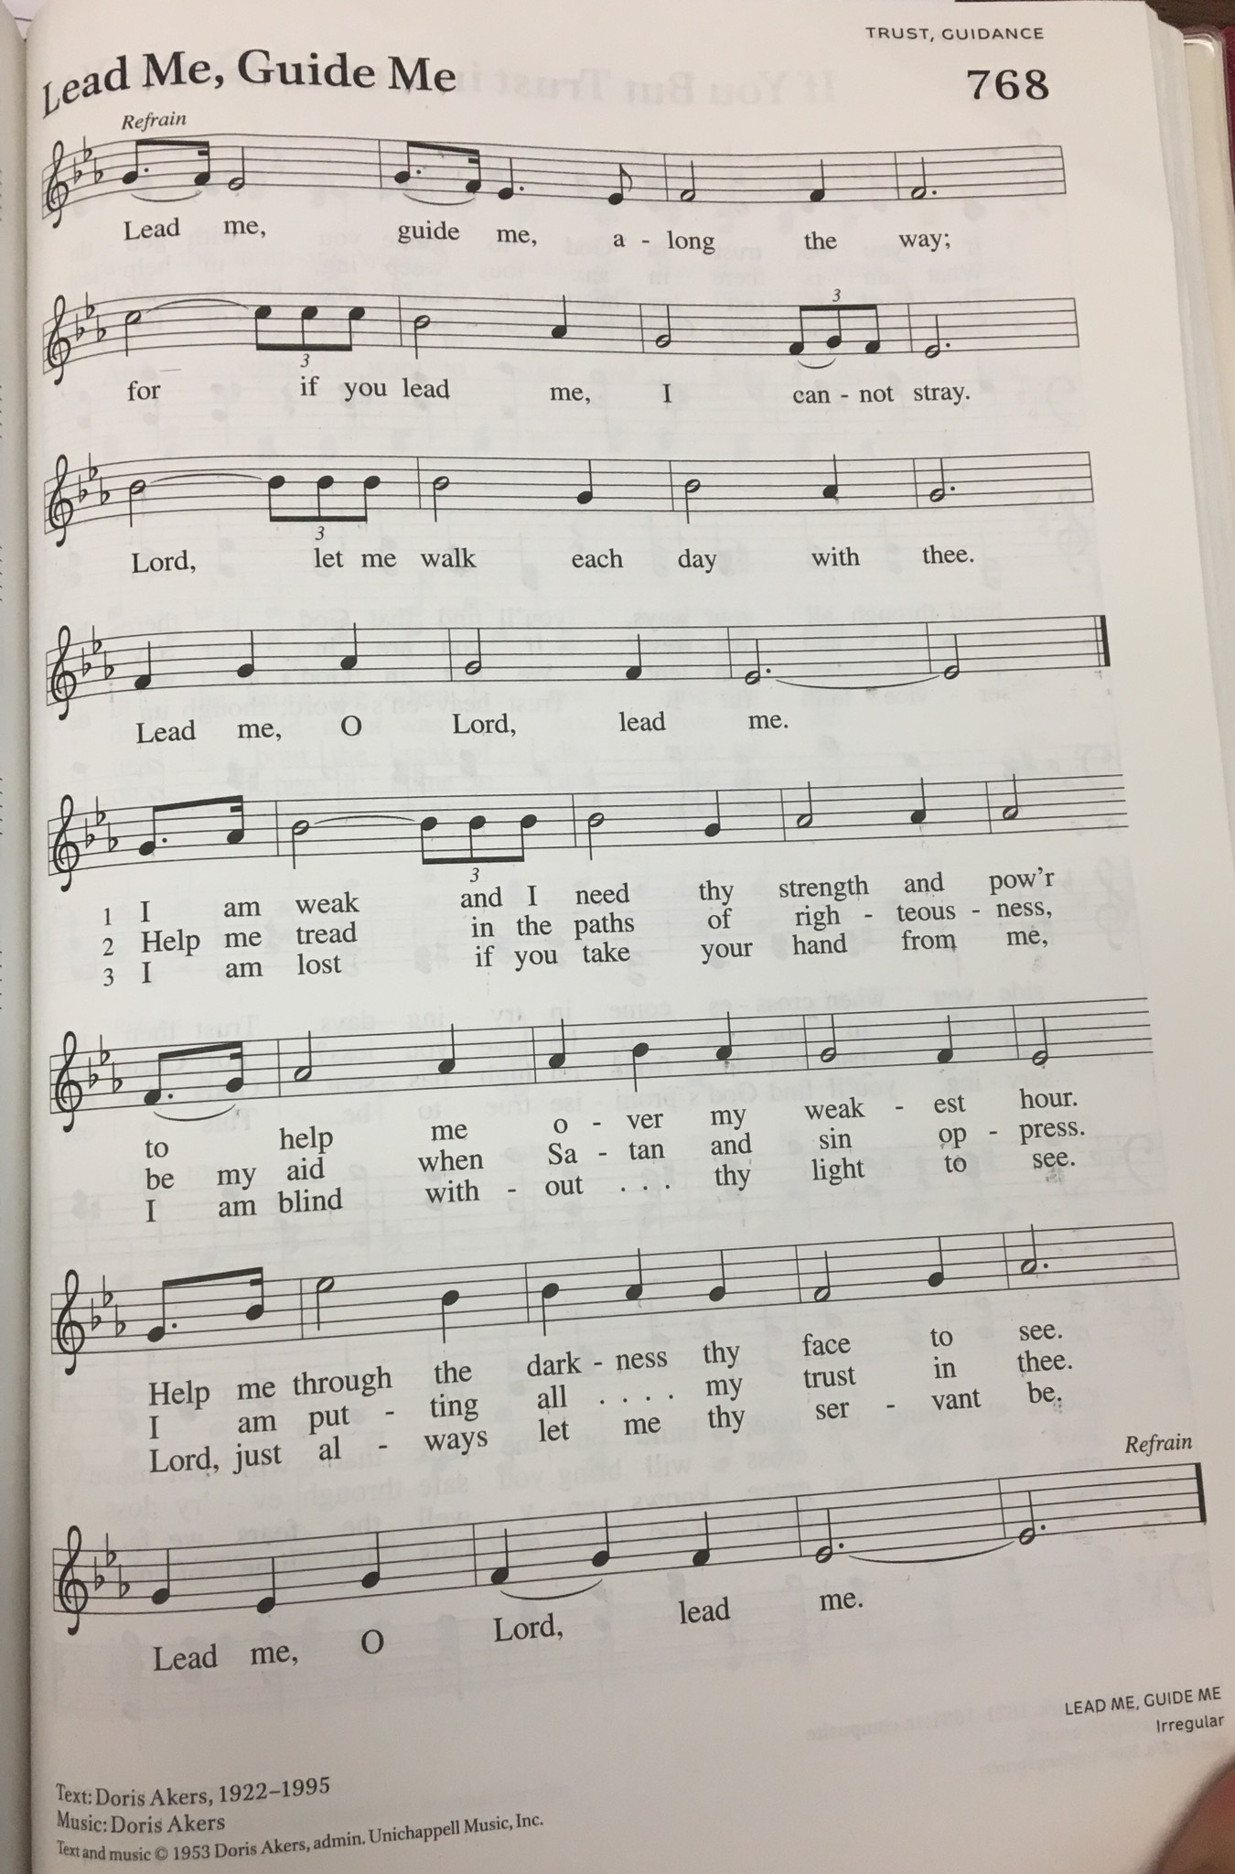
GREETING
The grace of our Lord Jesus Christ, the love of God, and the communion of the Holy Spirit be with you all.
And also with you.

Prayer of the Day
Let us pray together.
O God, rich in mercy, by the humiliation of your Son you lifted up this fallen world and rescued us from the hopelessness of death. Lead us into your light, that all our deeds may reflect your love, through Jesus Christ, our Savior and Lord, who lives and reigns with you and the Holy Spirit, one God, now and forever. Amen.

First Reading Numbers 21:4-9
A reading from Numbers.

⁴From Mount Hor [the Israelites] set out by the way to the Red Sea, to go around the land of Edom; but the people became impatient on the way. ⁵The people spoke against God and against Moses, “Why have you brought us up out of Egypt to die in the wilderness? For there is no food and no water, and we detest this miserable food.” ⁶Then the Lord sent poisonous serpents among the people, and they bit the people, so that many Israelites died. ⁷The people came to Moses and said, “We have sinned by speaking against the Lord and against you; pray to the Lord to take away the serpents from us.” So Moses prayed for the people. ⁸And the Lord said to Moses, “Make a poisonous serpent, and set it on a pole; and everyone who is bitten shall look at it and live.” ⁹So Moses made a serpent of bronze, and put it upon a pole; and whenever a serpent bit someone, that person would look at the serpent of bronze and live.

The word of the Lord.
Thanks be to God.

Psalm Psalm 107:1-3, 17-22
¹Give thanks to the Lord, for the | Lord is good,
for God’s mercy en- | dures forever.
²Let the redeemed of the | Lord proclaim
that God redeemed them from the hand | of the foe,
³gathering them in | from the lands;
from the east and from the west, from the north and | from the south.
¹⁷Some were fools and took re- | bellious paths;
through their sins they | were afflicted.
¹⁸They loathed all man- | ner of food
and drew near | to death’s door.
¹⁹Then in their trouble they cried | to the Lord
and you delivered them from | their distress.
²⁰You sent forth your | word and healed them
and rescued them | from the grave.
²¹Let them give thanks to you, Lord, for your | steadfast love
and your wonderful works | for all people.
²²Let them offer sacrifices | of thanksgiving
and tell of your deeds with | shouts of joy

Second Reading Ephesians 2:1-10
A reading from Ephesians.

¹You were dead through the trespasses and sins ²in which you once lived, following the course of this world, following the ruler of the power of the air, the spirit that is now at work among those who are disobedient. ³All of us once lived among them in the passions of our flesh, following the desires of flesh and senses, and we were by nature children of wrath, like everyone else. ⁴But God, who is rich in mercy, out of the great love with which he loved us ⁵even when we were dead through our trespasses, made us alive together with Christ—by grace you have been saved—⁶and raised us up with him and seated us with him in the heavenly places in Christ Jesus, ⁷so that in the ages to come he might show the immeasurable riches of his grace in kindness toward us in Christ Jesus. ⁸For by grace you have been saved through faith, and this is not your own doing; it is the gift of God—⁹not the result of works, so that no one may boast. ¹⁰For we are what he has made us, created in Christ Jesus for good works, which God prepared beforehand to be our way of life.

The word of the Lord.
Thanks be to God.

Gospel Acclamation

Return to the Lord, your God,
for he is gracious and merciful,
slow to anger, and abounding in steadfast love.

Gospel John 3:14-21
The holy gospel according to John.
Glory to you, O Lord.

[Jesus said:] ¹⁴“Just as Moses lifted up the serpent in the wilderness, so must the Son of Man be lifted up, ¹⁵that whoever believes in him may have eternal life.
¹⁶“For God so loved the world that he gave his only Son, so that everyone who believes in him may not perish but may have eternal life.
¹⁷“Indeed, God did not send the Son into the world to condemn the world, but in order that the world might be saved through him. ¹⁸Those who believe in him are not condemned; but those who do not believe are condemned already, because they have not believed in the name of the only Son of God. ¹⁹And this is the judgment, that the light has come into the world, and people loved darkness rather than light because their deeds were evil. ²⁰For all who do evil hate the light and do not come to the light, so that their deeds may not be exposed. ²¹But those who do what is true come to the light, so that it may be clearly seen that their deeds have been done in God.”

The gospel of the Lord.
Praise to you, O Christ.

SERMON Pastor Becky Ebb Speese “The Promise of Salvation Is Lifted Up”

Grace to you and peace from God our Father and Our Lord and Savior Jesus Christ. Amen
There are many descriptions of Jesus is the Bible. Jesus is the light of the world, Jesus is living water, Jesus is the bread of life.
Perhaps the most familiar and comforting is that Jesus is our good shepherd. And along with that, Jesus is the Lamb of God who takes away the sin of the world.
One that may tickle the hearts of some of you, is Jesus as a chicken! He referred to himself as a mother hen gathering her chicks when he wept over Jerusalem.
Today we get an image of Jesus that is a bit startling. Jesus as a serpent!
I don’t really care for this image. I really hate snakes so thinking of Jesus as a serpent does not feel right and it is certainly not a comforting description like the others.
Where does this image come from?
Let’s look at our Old Testament lesson from Numbers. This is quite a story. In reading the stories of things that happened to the people of Israel while they were wandering in the wilderness before they entered the promised land, one thing stands out. They really complain a lot! I guess I would complain a lot as well, if I were in their situation. It would be hard to camp in a desert wilderness for 40 years. One thing that they complained about much of the time was the food.
When they ran out of the food that they brought with them from their time of slavery in Egypt, they complained that they had no food and wanted to go back to Egypt because even though life was pretty terrible there, at least they had food. God provided food for them. They got manna every morning and they could make a lot of things with this odd substance. They got quail dropped into their camp every evening. But it didn’t take long, and they complained because they were tired of the same thing day after day. Can you blame them? I would certainly complain if I had to eat the same thing every day for many years. There is an amusing line in this story: “For there is no food and no water, and we detest this miserable food.” First the complaint is that they have no food or water, but in the next breath, say that they detest the miserable food that God gave them!
However, this had to get old for Moses and for God. Every time the people complained about their circumstances, they blamed Moses and ultimately blamed God.
We know how frustrating it is to do our best for people and yet they complain and want something different or better.
Finally, God had had enough, and he sent poisonous serpents into the camp. People who got bit, died. Then the people cried out to Moses to ask God to help them. God had not given up on these people. In response, God told Moses what to do to save them. Moses was to make a bronze serpent and put it on a pole in the center of the camp. Everyone who was bit by the serpents, could look at the bronze one on the pole and live.
This is the promise in this story. God loves and cares for his people. Though they complained about what God had provided for them, and though God punished them with the serpents, God, did not give up on them. God provided a way to save them and restore their relationship to God.
Fast forward to the Gospel. This passage in John, contains the most well-known and memorized verse in the Bible. ¹⁶“For God so loved the world that he gave his only Son, so that everyone who believes in him may not perish but may have eternal life.
But there is more around this verse! Right before this, Jesus, who is talking with Nicodemus, who came to him in the night, refers to himself as being like the serpent who was lifted up on the pole to save the people in the desert. Jesus himself, has taken on the role of the serpent and will be lifted up on the cross to save us.
Here is the promise of salvation again. This time, it is not a serpent, but it is Jesus himself who was lifted up on the cross to save us. When we find ourselves living in the pain of sin and feeling far from God, all that we need to do is look to the cross and see that we are forgiven, we are saved, we will be restored to new and eternal life.
We know John 3:16 so well. But do you know the next verse as well also? We need to know it and understand it to get why Jesus came into our world and died for us.
¹⁷“Indeed, God did not send the Son into the world to condemn the world, but in order that the world might be saved through him.”
God is not about condemnation. He did not leave his people in the desert alone to die of snake bites. He saved them. God is about saving people, not condemning them.

Christians, throughout history, have tended to pick and choose who gets to be saved and who does not. Christians have been known to be judgmental about certain kinds of people and certain kinds of sins. Too often, when a terrible tragedy occurs, people try to reconcile it with thinking that someone is being punished. I will never forget the mindset that I heard by some camps of Christians after 9-11. I heard it said that this event happened because of God’s judgment on homosexual people. That was then and still is a horrifying thought, that God would send a horrific tragedy to our country because of a certain group of people.
What might people be saying about our current pandemic? Do some see this as God punishing the whole world for some kind of sin?
My sisters and brothers in Christ, this is not the kind of God that we know from scripture, even though people can so easily twist Bible verses to prove all kinds of bad theology. God is about love. God loves the whole world, not just part of it! Not just certain kinds of people or certain kinds of belief systems.
Hear this again. God did not send his son into the world to condemn the world. God sent Jesus to be one of us, to die for us to save everyone! All of the world.
The condemnation that has happened in the name of Christianity has come from the people of God.
¹⁹And this is the judgment, that the light has come into the world, and people loved darkness rather than light because their deeds were evil. ²⁰For all who do evil hate the light and do not come to the light, so that their deeds may not be exposed.”
This past year has shown us a lot. But one thing that we have been shown is how much some people love darkness rather than light because their deeds are evil. We have seen the very evil underbelly of our country surface in so many ways as we have struggled with this pandemic and far too many lives were lost, as we have now gone well over a half a million people who had to die, and this did not have to be the case. We have seen that the evil of racism and white supremacy did not go away after the Civil War or the Civil rights era. It was under the surface all of this time and was given voice and power not just during this past year, but we saw so much more. We saw the evil of domestic terrorism run rampant. We have seen it nationally and we have seen it in our own state. When people want to kill certain political leaders because of hatred and differences of political stands, it has become clear that dark deeds and ideas have been exposed.
Christian people have been divided. Conservatives against liberals. Democrats against Republicans. It has even boiled down to maskers against anti maskers. I am very sad to see so much division and anger being expressed among our brothers and sisters in faith. This kind of division is the darkness.
God’s promise, given to us in our lessons today, is about love. If we do not treat one another in love, we are not living as God would have us live. If we want to judge other children of God, we are not living as God would have us live.

Yes, we do sin. Yes, we do need to repent. We need to ask for forgiveness every day. We have to take honest looks at ourselves and see the ways that we fall short of living in God’s love, the ways when we might prefer to live in darkness. But in our acts of repentance, we hear the words over and over again. You are beloved children of God. You are forgiven. Your sins have been wiped away. Look to the cross and be saved.
In the passage from Ephesians, we hear these words more than once, by grace you have been saved. This is the core of our Lutheran theology. This is what we experience when we look to the cross.
It is so tempting to be critical of others, to judge others because they may do things that offend us. It is so easy to harbor anger and resentment over those who have hurt us. But it is not up to us to judge others. That is left up to God. It is not up to us to condemn. People who chose to live in darkness condemn themselves. But even those people are covered under the blood of Jesus if they look to the cross and believe that Jesus died for them.
God message to us today is love. God loves us. God loves all of the world and everyone in it. God choses to save and not to condemn. We are called to live in the light of God’s love, believing that we are forgiven for all of our sins and extending that same love to others. Love has been lifted up on the cross for us.
The peace of God which passes all human understanding keep our hearts and minds in Christ Jesus. Amen

Hymn of the Day “Amazing Grace” ELW 779
cREED
I believe in God, the Father almighty,
creator of heaven and earth.
I believe in Jesus Christ, God’s only Son, our Lord,
who was conceived by the Holy Spirit,
born of the virgin Mary,
suffered under Pontius Pilate,
was crucified, died, and was buried;
he descended to the dead.*
On the third day he rose again;
he ascended into heaven,
he is seated at the right hand of the Father,
and he will come to judge the living and the dead.
I believe in the Holy Spirit,
the holy catholic church,
the communion of saints,
the forgiveness of sins,
the resurrection of the body,
and the life everlasting. Amen.

*Or, “he descended into hell,” another translation of this text in widespread use.

prayers of Intercession
Relying on the promises of God, we pray boldly for the church, the world, and all in need.
A brief silence.

You sent your Son that the world might be saved through him. Inspire the witness of the church throughout the world. Empower missionaries, Bible translators, and ministries of service in your name. Bless our partners in ministry, our ELCA global partner churches, and Young Adults in Global Mission. We pray especially for Messiah Lutheran Church and Rev. Andreas Teich. Hear us, O God.
Your mercy is great.
From east to west your steadfast love is shown. Nourish seas and deserts, wilderness areas and cities. Give water to thirsty lands; nurture spring growth that feeds hungry creatures; bless farmers as they prepare for the growing season. Hear us, O God.
Your mercy is great.
You sustained your people in the wilderness. Give courage to all who lead in times of crisis and scarce resources. Prosper the work of those who aid victims of famine and drought (especially). Bring peace in places where scarce resources cause violence. Hear us, O God.
Your mercy is great.
Your mercy endures forever. Deliver all who cry to you, especially those who are hungry or without homes. Give life in places where death seems triumphant; give healing to those who are sick and comfort to those who mourn. Hear us, O God.
Your mercy is great.
By grace we have been saved. Fill this congregation to overflowing with that grace, that we show mercy to others. Nourish any in our midst who are hungry, especially children, and bless our ministries of feeding and shelter. Hear us, O God.
Your mercy is great.
Your Son was lifted up that whoever believes might have eternal life. We praise you for all who have died in Christ. Bring us with all the saints into the fullness of your promises. Hear us, O God.
Your mercy is great.
We entrust ourselves and all our prayers to you, O faithful God, through Jesus Christ our Lord.
Amen.

Peace
The peace of Christ be with you always.
And also with you.

Offering & Offering Prayer
Let us pray. God our provider, you have not fed us with bread alone, but with words of grace and life. Bless us and these your gifts, which we receive from your bounty, through Jesus Christ our Lord.
Amen.

Thanksgiving at the Table
In the night in which he was betrayed,
our Lord Jesus took bread, and gave thanks;
broke it, and gave it to his disciples, saying:
Take and eat; this is my body, given for you.
Do this for the remembrance of me.
Again, after supper, he took the cup, gave thanks,
and gave it for all to drink, saying:
This cup is the new covenant in my blood,
shed for you and for all people for the forgiveness of sin.
Do this for the remembrance of me.

Lord’s Prayer
Lord, remember us in your kingdom and teach us to pray.
Our Father, who art in heaven,
hallowed be thy name,
thy kingdom come,
thy will be done,
on earth as it is in heaven.
Give us this day our daily bread;
and forgive us our trespasses,
as we forgive those
who trespass against us;
and lead us not into temptation,
but deliver us from evil.
For thine is the kingdom,
and the power, and the glory,
forever and ever. Amen.

COMMUNION
The body and blood of our Lord Jesus Christ is given and shed for you. You may receive your communion elements.

Sending
God blesses us and sends us in mission to the world.

Blessing
The God of steadfastness and encouragement
grant you to live in harmony with one another,
in accordance with Christ Jesus.
Amen.
The God of hope fill you with all joy and peace in believing,
so that you may abound in hope by the power of the Holy Spirit.
Amen.
The God of all grace ☩ bless you now and forever.
Amen.

Sending SonG “Give to Our God Immortal Praise” ELW 848
Dismissal
Go in peace. Christ is with you.
Thanks be to God.

From sundaysandseasons.com. Copyright © 2017 Augsburg Fortress. All rights reserved.

THANK YOU TO ALL WHO SERVED TODAY:

Presider: Pastor Becky Ebb Speese
Musician: Martha Yoder
Elder: Jolene Griffin
Trustee: Dan Zylstra
Offering Counters: Jerry Engle and Brenda Bite
ANNOUNCEMENTS

  - Zion’s church council has decided that drive in services will be held through Easter Sunday and are shooting for starting in church services on April 11 if the case numbers continue to stay in the same range.
  - Easter Flowers: It’s time to put in your orders for our Easter flower garden. Lilies are not going to be an option in the event that we are outside, as they will not hold up well if it’s chilly. Each flower costs $8.95 and comes in a 6 inch pot. The choices are Miniature daffodils, Red or White Tulips, and Blue, Purple or White Hyacinths.
  - Easter Egg Hunt: Zion will host an Easter Egg Hunt for our youth members (no age restrictions) immediately following the Easter morning service. We’re excited to bring some normalcy to a year that as affected us and our children.
We will be purchasing the candy and organizing a time for small groups of volunteers to fill the eggs at church. Please watch the bulletin for more updates or contact Martha or Jolene with questions.
  - Zion to host Christmas tree farm: As you start spring cleaning or visiting garage sales, be on the lookout for artificial Christmas trees and ornaments to donate. In conjunction with the Christmas Around the Town we will host a Christmas Tree Farm at Zion for those in need to get the decorations to bring some holiday cheer to their homes. We’ll share more details as it gets closer. Please contact Martha or Jolene with questions.
  - Zion is starting a tech team to do the live stream for our services. Paul Meade will be glad to train people. Please let Pastor Becky or Paul know if you would like to serve in this way.
  - The Lakewood Community Women are pleased to announce that there will be a short video study by Robyn Dykstra available on their Facebook page. This video can be used for small groups, zoom meetings or viewing individually. Robyn is a former Playboy Bunny turned Bible teacher. After surrendering her life to Jesus, she was widowed twice in four years, leaving her a single mom and an expert in the faithfulness of God. If you’ve experience loss or trial in your life- whether self-induced or thrust upon you, you’ll want to hear Robyn’s encouraging discoveries for how to energize your faith in God and find the strength to face life’s challenges. Check it out at https://www.facebook.com/LakewoodCommunityWomen.
  - Council has voted to suspend in-person services until the positivity rate drops to 3%. People may continue to listen to the service in the parking and the service will be streamed.

