ZION LUTHERAN CHURCH, WOODLAND, MI
Midweek Lenten Service, March 24, 2020

Week of Lent 5: Change of Plans
God’s ways are not our own. We expect a conquering king and hero, but Jesus instead leads us down the road to Jerusalem and humbles himself on the cross. God changes our plans and replaces them with a love broader and deeper than anything we could imagine.

OPENING DIALOGUE
We see Jesus walking ahead on the road.
He leads us toward Jerusalem.

We follow but are very afraid.
He says the Son of Man will be handed over.

We understand nothing about all these things.
He says the prophets’ words will be fulfilled.

We hear him talk of suffering and death.
Forbid it, Lord! This must never happen to you!

GATHERING SONG “Blessed Assurance” (ELW 638)

PRAYER
O God our surprise, you offer so much more than our own limited plans envision. You take our place, becoming our salvation through the cross. As we prepare for Holy Week, strengthen our hearts and minds to follow Jesus on the road to Jerusalem. When we betray like Judas, deny like Peter, and scatter like the disciples, forgive our frailties. Bring us the promise of resurrection and new life in you. In Jesus’ name we pray.
Amen.
PSALM Psalm 2
¹Why do the nations conspire,
and the peoples plot in vain?
²The kings of the earth set themselves,
and the rulers take counsel together,
against the LORD and his anointed, saying,
³"Let us burst their bonds asunder,
and cast their cords from us."
⁴He who sits in the heavens laughs;
the LORD has them in derision.
⁵Then he will speak to them in his wrath,
and terrify them in his fury, saying,
⁶"I have set my king on Zion, my holy hill."
⁷I will tell of the decree of the LORD:
He said to me, "You are my son;
today I have begotten you.
⁸Ask of me, and I will make the nations your heritage,
and the ends of the earth your possession.
⁹You shall break them with a rod of iron,
and dash them in pieces like a potter's vessel."
¹⁰Now therefore, O kings, be wise;
be warned, O rulers of the earth.
¹¹Serve the LORD with fear,
with trembling
¹²kiss his feet,
or he will be angry, and you will perish in the way;
for his wrath is quickly kindled.
Happy are all who take refuge in him.

READING Isaiah 52:13-15
A reading from Isaiah.

¹³See, my servant shall prosper;
he shall be exalted and lifted up, and shall be very high.
¹⁴Just as there were many who were astonished at him
— so marred was his appearance, beyond human semblance,
and his form beyond that of mortals —
¹⁵so he shall startle many nations; kings shall shut their mouths because of him;
for that which had not been told them they shall see,
and that which they had not heard they shall contemplate.

The word of the Lord.
Thanks be to God.
GOSPEL READING Mark 10:32-34
The holy gospel according to Mark.
Glory to you, O Lord.

³²They were on the road, going up to Jerusalem, and Jesus was walking ahead of them; they were amazed, and those who followed were afraid. He took the twelve aside again and began to tell them what was to happen to him, ³³saying, "See, we are going up to Jerusalem, and the Son of Man will be handed over to the chief priests and the scribes, and they will condemn him to death; then they will hand him over to the Gentiles; ³⁴they will mock him, and spit upon him, and flog him, and kill him; and after three days he will rise again."

The gospel of the Lord.
Praise to you, O Christ.

REFLECTION Pastor Becky Ebb-Speese

HYMN OF THE DAY “Lamb of God” (ELW 336)
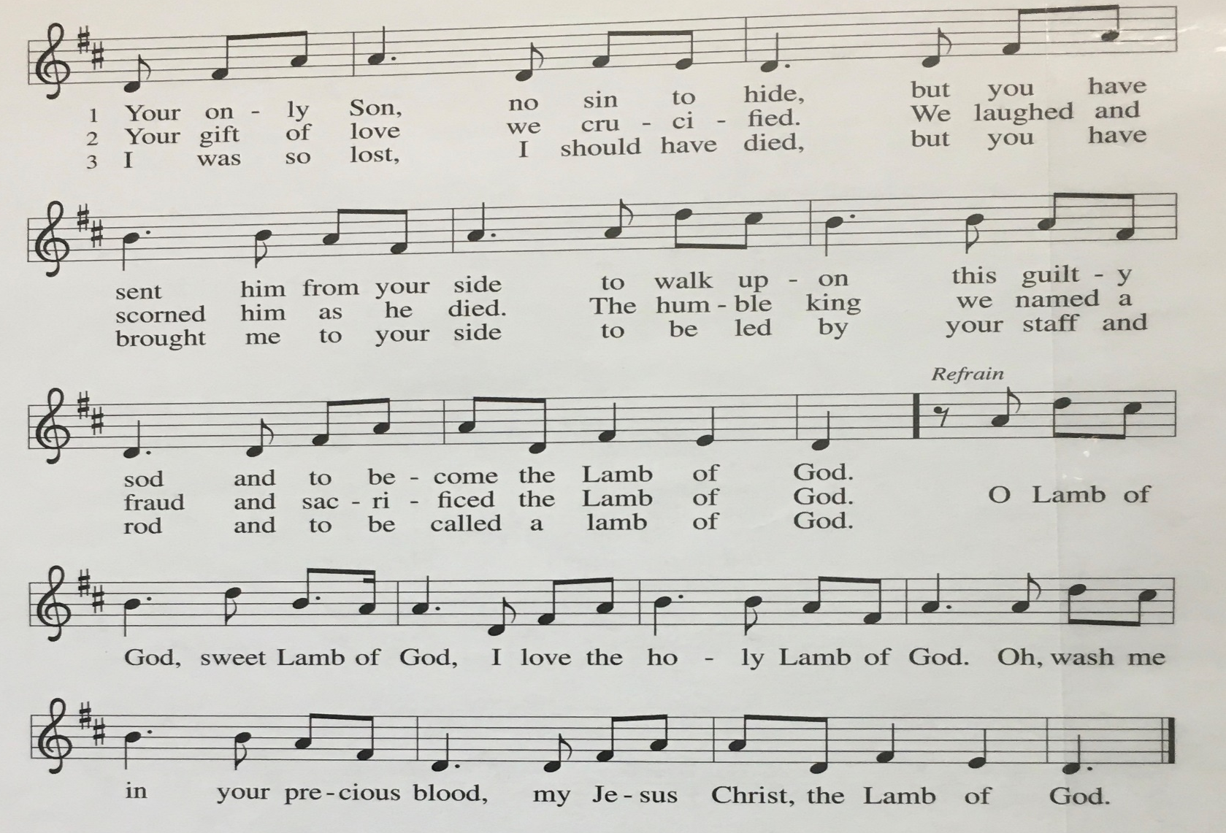
PRAYERS
O God our help,
you walk with us through all of life’s changes.
Grant us strength, patience, wisdom, and understanding.
O God our hope,
you come to us in the life, death, and resurrection of Christ.
Show us your salvation,
and lead us in the way of the cross.
O God our shelter,
you enfold us like a mother hen gathering her chicks.
Watch over all who are sick, grieving, lonely, and in need this day.
O God our home, you claim us as your beloved children.
Lord, remember us when you come into your kingdom.
All this we ask through the one who gave himself for us, Jesus Christ, our Lord.
Amen.

LORD’S PRAYER
Lord, remember us in your kingdom and teach us to pray.
Our Father, who art in heaven,
hallowed be thy name,
thy kingdom come,
thy will be done,
on earth as it is in heaven.
Give us this day our daily bread;
and forgive us our trespasses,
as we forgive those
who trespass against us;
and lead us not into temptation,
but deliver us from evil.
For thine is the kingdom,
and the power, and the glory,
forever and ever. Amen.

THE PRAYERS OF THE PEOPLE
Let us pray for the whole people of God in Christ Jesus,
and especially for all who are suffering or are in any affliction.
Merciful God, you sent your Son to be our peace.
Help all those who suffer any pain or grief, hopelessness or anxiety.
In your great mercy,
hear us, O God.
Mighty God,
mercifully grant strength to the weak
and comfort to those who suffer,
that their sickness and pain may be turned into health.
In your great mercy,
hear us, O God.
God of peace and reconciliation,
bring an end to the sickness of the world,
especially violence, terrorism, war, and their causes.
In your great mercy,
hear us, O God.
Holy God, Holy One,
your Son prayed that your people may be one.
May the gift of baptism be a power
for healing the church’s brokenness,
and bless all efforts for renewal and Christian unity.
In your great mercy,
hear us, O God.
Loving God,
mend broken relationships and bring peace
to our families, our congregation, this community, and the world.
In your great mercy,
hear us, O God.
Eternal God, we thank you for all the faithful departed. Heal the pain of all who grieve.
In your great mercy,
hear us, O God.

O God, we bring these intercessions before you,
knowing that you will hear us as you have promised,
and will answer according to the mercy shown in Jesus Christ, our Savior and Lord.
Amen.

BLESSING
The Lord of peace give you peace at all times and in all ways.
In the name of the Father, ☩ Son, and Holy Spirit.
Amen.

SENDING SONG “Go My Children with My Blessing” (ELW 543)

DISMISSAL
Go now in peace, for nothing can separate you from the love of God in Christ Jesus.
Thanks be to God.

Some of the prayers are based on the text of “O God, our help in ages past” (ELW 632; text by Isaac Watts) and Luke 23:42.
Text of the Lord’s Prayer from “Salvation unto us has come” (ELW 590). Text © 2006 Augsburg Fortress.
From sundaysandseasons.com. Copyright © 2020 Augsburg Fortress. All rights reserved.

