ZION LUTHERAN CHURCH, WOODLAND, MI
Fourth Sunday of Easter, April 25, 2021
*If you are listening in your car, please tune your radio to 1620 AM*

ANNOUNCEMENTS & PRELUDE

Gathering
The Holy Spirit calls us together as the people of God.

Confession and Forgiveness
In the name of the Father, and of the ☩ Son, and of the Holy Spirit.
Amen.

Almighty God, to whom all hearts are open, all desires known, and from whom no secrets are hid: cleanse the thoughts of our hearts by the inspiration of your Holy Spirit, that we may perfectly love you and worthily magnify your holy name, through Jesus Christ our Lord.
Amen.

Let us confess our sin in the presence of God and of one another. Gracious God,
have mercy on us. We confess that we have turned from you and given ourselves into the power of sin. We are truly sorry and humbly repent. In your compassion forgive us our sins, known and unknown, things we have done and things we have failed to do. Turn us again to you, and uphold us by your Spirit, so that we may live and serve you in newness of life through Jesus Christ, our Savior and Lord.
Amen.

God, who is rich in mercy, loved us even when we were dead in sin, and made us alive together with Christ. By grace you have been saved. In the name of ☩ Jesus Christ, your sins are forgiven. Almighty God strengthen you with power through the Holy Spirit, that Christ may live in your hearts through faith.
Amen.

Gathering Song “I Know That My Redeemer Lives” ELW 382
GREETING
The grace of our Lord Jesus Christ, the love of God, and the communion of the Holy Spirit be with you all.
And also with you.

Prayer of the Day
Let us pray. O Lord Christ, good shepherd of the sheep, you seek the lost and guide us into your fold. Feed us, and we shall be satisfied; heal us, and we shall be whole. Make us one with you, for you live and reign with the Father and the Holy Spirit, one God, now and forever.
Amen.

First Reading Acts 4:5-12
A reading from Acts.

⁵The next day [the] rulers, elders, and scribes assembled in Jerusalem, ⁶with Annas the high priest, Caiaphas, John, and Alexander, and all who were of the high-priestly family. ⁷When they had made the prisoners stand in their midst, they inquired, “By what power or by what name did you do this?” ⁸Then Peter, filled with the Holy Spirit, said to them, “Rulers of the people and elders, ⁹if we are questioned today because of a good deed done to someone who was sick and are asked how this man has been healed, ¹⁰let it be known to all of you, and to all the people of Israel, that this man is standing before you in good health by the name of Jesus Christ of Nazareth, whom you crucified, whom God raised from the dead. ¹¹This Jesus is
‘the stone that was rejected by you, the builders;
it has become the cornerstone.’
¹²There is salvation in no one else, for there is no other name under heaven given among mortals by which we must be saved.”

The word of the Lord.
Thanks be to God.

Psalm Psalm 23

¹The Lord| is my shepherd;
I shall not | be in want.
²The Lord makes me lie down | in green pastures
and leads me be- | side still waters.
³You restore my | soul, O Lord,
and guide me along right pathways | for your name’s sake.
⁴Though I walk through the valley of the shadow of death, I shall | fear no evil;
for you are with me; your rod and your staff, they | comfort me.
⁵You prepare a table before me in the presence | of my enemies;
you anoint my head with oil, and my cup is | running over.
⁶Surely goodness and mercy shall follow me all the days | of my life,
and I will dwell in the house of the | Lord forever.

Second Reading 1 John 3:16-24
A reading from 1 John.

¹⁶We know love by this, that [Jesus Christ] laid down his life for us—and we ought to lay down our lives for one another. ¹⁷How does God’s love abide in anyone who has the world’s goods and sees a brother or sister in need and yet refuses help?
¹⁸Little children, let us love, not in word or speech, but in truth and action. ¹⁹And by this we will know that we are from the truth and will reassure our hearts before him ²⁰whenever our hearts condemn us; for God is greater than our hearts, and he knows everything. ²¹Beloved, if our hearts do not condemn us, we have boldness before God; ²²and we receive from him whatever we ask, because we obey his commandments and do what pleases him.
²³And this is his commandment, that we should believe in the name of his Son Jesus Christ and love one another, just as he has commanded us. ²⁴All who obey his commandments abide in him, and he abides in them. And by this we know that he abides in us, by the Spirit that he has given us.

The word of the Lord.
Thanks be to God.

Gospel Acclamation

Alleluia. Lord, to whom shall we go?
You have the words of eternal life. Alleluia

Gospel John 10:11-18
The holy gospel according to John.
Glory to you, O Lord.

[Jesus said:] ¹¹“I am the good shepherd. The good shepherd lays down his life for the sheep. ¹²The hired hand, who is not the shepherd and does not own the sheep, sees the wolf coming and leaves the sheep and runs away—and the wolf snatches them and scatters them. ¹³The hired hand runs away because a hired hand does not care for the sheep. ¹⁴I am the good shepherd. I know my own and my own know me, ¹⁵just as the Father knows me and I know the Father. And I lay down my life for the sheep. ¹⁶I have other sheep that do not belong to this fold. I must bring them also, and they will listen to my voice. So there will be one flock, one shepherd. ¹⁷For this reason the Father loves me, because I lay down my life in order to take it up again. ¹⁸No one takes it from me, but I lay it down of my own accord. I have power to lay it down, and I have power to take it up again. I have received this command from my Father.”

The gospel of the Lord.
Praise to you, O Christ.

SERMON Pastor Becky Ebb-Speese

Hymn of the Day “Have No Fear Little Flock” ELW 764
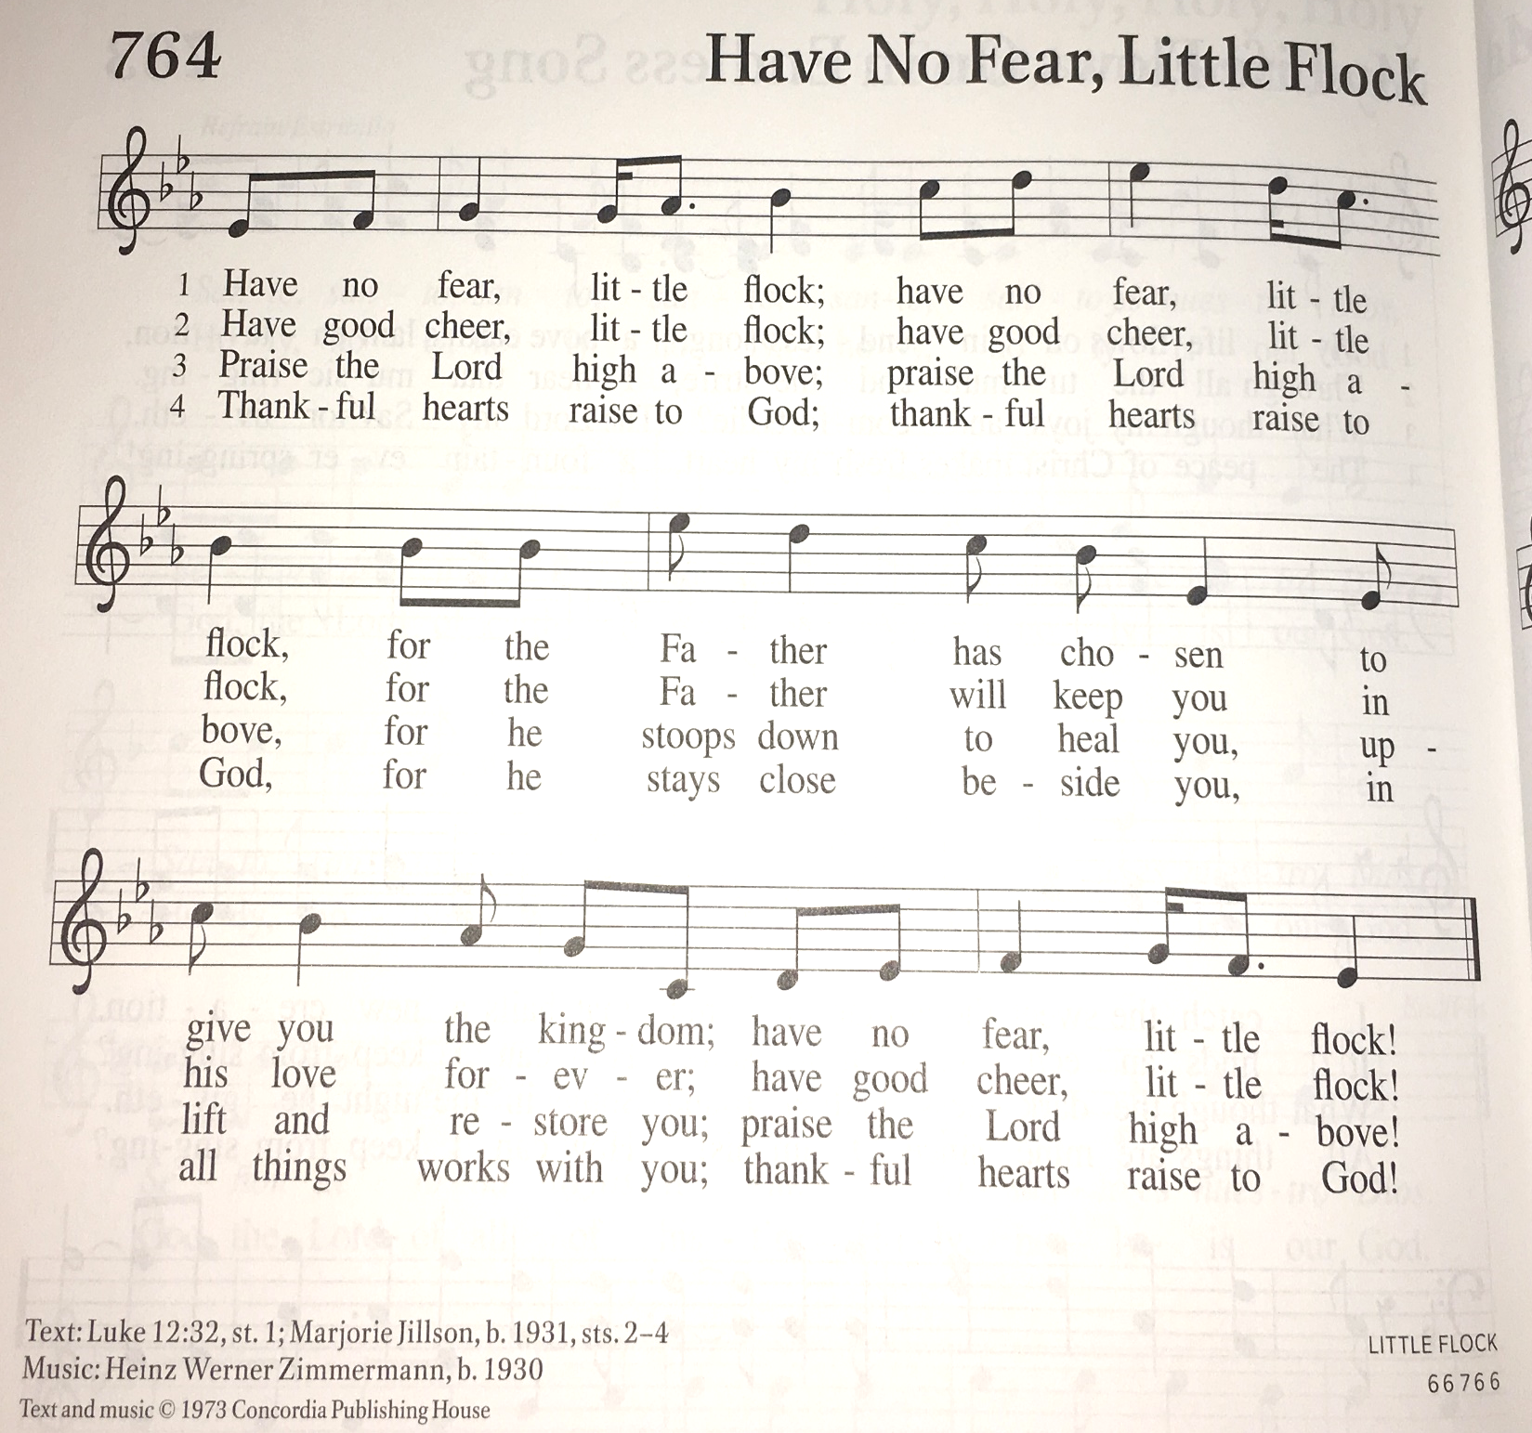

cREED
I believe in God, the Father almighty,
creator of heaven and earth.
I believe in Jesus Christ, God’s only Son, our Lord,
who was conceived by the Holy Spirit,
born of the virgin Mary,
suffered under Pontius Pilate,
was crucified, died, and was buried;
he descended to the dead.*
On the third day he rose again;
he ascended into heaven,
he is seated at the right hand of the Father,
and he will come to judge the living and the dead.
I believe in the Holy Spirit,
the holy catholic church,
the communion of saints,
the forgiveness of sins,
the resurrection of the body,
and the life everlasting. Amen.

*Or, “he descended into hell,” another translation of this text in widespread use.

prayers of Intercession
Alive in the risen Christ by the power of the Holy Spirit, we bring our prayers before God who promises to hear us and answer in steadfast love.
A brief silence.
Loving Shepherd, you know your own and your own know you. Your voice calls us to your loving embrace. Strengthen your church throughout the world that we bear witness to your expansive love. We pray especially for Zion Lutheran Church and Rev. Julie Schneider Thomas. Hear us, O God.
Your mercy is great.
Gracious Shepherd, you are generous with the gifts of goodness and mercy. Restore your creation to wholeness so that cities and towns, countryside and wilderness, may abound with life. Hear us, O God.
Your mercy is great.
Hope-giving Shepherd, the nations and peoples are your heritage. Place into the hearts of all leaders and rulers the passion to serve. Crucify any desire to overpower others and give leaders joy in lifting up the lowly. Hear us, O God.
Your mercy is great.
Abiding Shepherd, your love flows as we reach out to those around us. Move us with your Spirit, so that we lay down our lives for those in need. Help us love one another in truth and action. Hear us, O God.
Your mercy is great.
Saving Shepherd, you restore us to wholeness. Help our community in our life together and give us vigor as a people of faith. In the midst of challenges and opportunities, fill us anew with you Holy Spirit. Hear us, O God.
Your mercy is great.
Eternal Shepherd, you hold us securely in your loving hands. In the assurance of resurrection hope, we remember our loved ones who have died in you. Bring us, with them, to dwell in your house forever. Hear us, O God.
Your mercy is great.

In the hope of new life in Christ, we raise our prayers to you, trusting in your never-ending goodness and mercy; through Jesus Christ our Lord.
Amen.

Peace
The peace of Christ be with you always.
And also with you.

Offering & Offering Prayer
Let us pray. Blessed are you, O God, ruler of heaven and earth. Day by day you shower us with blessings. As you have raised us to new life in Christ, give us glad and generous hearts, ready to praise you and to respond to those in need, through Jesus Christ, our Savior and Lord.
Amen.

Thanksgiving at the Table
In the night in which he was betrayed,
our Lord Jesus took bread, and gave thanks;
broke it, and gave it to his disciples, saying:
Take and eat; this is my body, given for you.
Do this for the remembrance of me.
Again, after supper, he took the cup, gave thanks,
and gave it for all to drink, saying:
This cup is the new covenant in my blood,
shed for you and for all people for the forgiveness of sin.
Do this for the remembrance of me.

Lord’s Prayer
Gathered into one by the Holy Spirit, let us pray as Jesus taught us.
Our Father in heaven,
hallowed be your name,
your kingdom come,
your will be done,
on earth as in heaven.
Give us today our daily bread.
Forgive us our sins
as we forgive those
who sin against us.

Save us from the time of trial
and deliver us from evil.
For the kingdom, the power,
and the glory are yours,
now and forever. Amen.

COMMUNION
The body and blood of our Lord Jesus Christ is given and shed for you. You may receive your communion elements.

Sending
God blesses us and sends us in mission to the world.

Blessing
The Lord bless you and keep you.
The Lord’s face shine on you with grace and mercy.
The Lord look upon you with favor and ☩ give you peace.
Amen.

Sending SonG “Savior, Like a Shepherd Lead Us” ELW 789

Dismissal
Go in peace. Christ is with you.
Thanks be to God.

From sundaysandseasons.com. Copyright © 2017 Augsburg Fortress. All rights reserved.

THANK YOU TO ALL WHO SERVED TODAY:

Presider: Pastor Becky Ebb-Speese
Musician: Martha Yoder
Elder: Paul Meade
Trustee: Mike Johnson
Offering Counters: Jerry Engle & Carlotta Willard
Safety Person: Diane Griffin

ANNOUNCEMENTS

  - “Thank you for the beautiful geranium planter and gift card that was given for my birthday! I really appreciate your thoughtfulness!” ~ Pastor Becky
  - The 2021 Lakewood Area Crop Hunger Walk is once again virtual. In the past, Zion has been represented by many congregational members and collected donations at church prior to the walk. The need is more prevalent than ever. We’re participating in the 2021 CROP Hunger Walk to support CCWS and help families who are struggling with hunger. We’re asking you to join us – with your steps and your donations – to provide more meals for the growing number of people in our community who need them, and greater food security in communities around the world. Please prayerfully consider donating to our team either on our team web page at https://events.crophungerwalk.org/2021/team/zion-evangelical-lutheran-church or, if you prefer, designating your donation on your offering envelope. If you have any questions, please feel free to contact Karen Heise. Thank you.
  - In the month of May, Zion will be doing another collection for Manna's Market. This Action Team project is for supplies used in the bathroom. We all take for granted items we use in the bathroom every day. We can help Manna's Market provide free needed items for others in our community. Jerry Engle has been given a $250 grant from Thrivent Financial for Lutherans to purchase some of the supplies. The items most needed are toilet paper, facial tissue, paper towels and all sizes of garbage bags. Other items to donate are shampoo, cream rinse, soap, toothpaste, toothbrushes, deodorant, razors, shave gel, toilet bowl cleaner, cleaning wipes and any other items you know would be useful. You may also donate cash to be given to Manna's Market. A table will be set up in the Fellowship Hall for all donated items. Sunday, May 23rd. will be the last day to bring items. That week the action team will pack everything up and deliver it all to Manna's Market.
  - Zion to host Christmas tree farm: As you start spring cleaning or visiting garage sales, be on the lookout for artificial Christmas trees and ornaments to donate. In conjunction with the Christmas Around the Town we will host a Christmas Tree Farm at Zion for those in need to get the decorations to bring some holiday cheer to their homes. We’ll share more details as it gets closer. Please contact Martha or Jolene with questions.
  - Zion is starting a tech team to do the live stream for our services. Paul Meade will be glad to train people. Please let Pastor Becky or Paul know if you would like to serve in this way.

