ZION LUTHERAN CHURCH, WOODLAND, MI
Third Sunday after Pentecost, June 13, 2021
*If you are listening in your car, please tune your radio to FM 87.7*

ANNOUNCEMENTS & PRELUDE

Gathering
The Holy Spirit calls us together as the people of God.

Confession and Forgiveness
Blessed be the holy Trinity,
☩ one God,
who creates, redeems, and sustains us
and all of creation.
Amen.

Let us confess our sin in the presence of God and of one another.

To you, O God,
all hearts are open, to you all desires known. We come to you, confessing our sins. Forgive us in your mercy, and remember us in your love. Show us your ways; teach us your paths; and lead us in justice and truth, for the sake of your goodness in Jesus Christ our Savior.
Amen.

By water and the Holy Spirit God gives you a new birth, and through the death and resurrection of ☩ Jesus Christ, God forgives you all your sins. The God of mercy and might strengthen you in all goodness and keep you in eternal life.
Amen.

Gathering Song “For the Fruit of All Creation” ELW 679

GREETING
The grace of our Lord Jesus Christ, the love of God, and the communion of the Holy Spirit be with you all.
And also with you.

Prayer of the Day
Let us pray together.
O God, you are the tree of life, offering shelter to all the world. Graft us into yourself and nurture our growth, that we may bear your truth and love to those in need, through Jesus Christ, our Savior and Lord. Amen.

First Reading Ezekiel 17:22-24
A reading from Ezekiel.

²²Thus says the Lord God:
I myself will take a sprig
from the lofty top of a cedar;
I will set it out.
I will break off a tender one
from the topmost of its young twigs;
I myself will plant it
on a high and lofty mountain.
²³On the mountain height of Israel
I will plant it,
in order that it may produce boughs and bear fruit,
and become a noble cedar.
Under it every kind of bird will live;
in the shade of its branches will nest
winged creatures of every kind.
²⁴All the trees of the field shall know
that I am the Lord.
I bring low the high tree,
I make high the low tree;
I dry up the green tree
and make the dry tree flourish.
I the Lord have spoken;
I will accomplish it.

The word of the Lord.
Thanks be to God.

Psalm Psalm 92:1-4, 12-15
¹It is a good thing to give thanks | to the Lord,
to sing praise to your name, | O Most High;
²to herald your love | in the morning
and your faithful- | ness at night;
³on the psaltery, and | on the lyre,
and to the melody | of the harp.
⁴For you have made me glad by your | acts, O Lord;
and I shout for joy because of the works | of your hands.
¹²The righteous shall flourish | like a palm tree,
and shall spread abroad like a ce- | dar of Lebanon.
¹³Those who are planted in the house | of the Lord
shall flourish in the courts | of our God;
¹⁴they shall still bear fruit | in old age;
they shall be | green and succulent;
¹⁵that they may show how up- | right the Lord is,
my rock, in whom there is | no injustice.

Second Reading 2 Corinthians 5:6-17
A reading from 2 Corinthians.

⁶So we are always confident; even though we know that while we are at home in the body we are away from the Lord—⁷for we walk by faith, not by sight. ⁸Yes, we do have confidence, and we would rather be away from the body and at home with the Lord. ⁹So whether we are at home or away, we make it our aim to please him. ¹⁰For all of us must appear before the judgment seat of Christ, so that each may receive recompense for what has been done in the body, whether good or evil.
¹¹Therefore, knowing the fear of the Lord, we try to persuade others; but we ourselves are well known to God, and I hope that we are also well known to your consciences. ¹²We are not commending ourselves to you again, but giving you an opportunity to boast about us, so that you may be able to answer those who boast in outward appearance and not in the heart. ¹³For if we are beside ourselves, it is for God; if we are in our right mind, it is for you. ¹⁴For the love of Christ urges us on, because we are convinced that one has died for all; therefore all have died. ¹⁵And he died for all, so that those who live might live no longer for themselves, but for him who died and was raised for them.
¹⁶From now on, therefore, we regard no one from a human point of view; even though we once knew Christ from a human point of view, we know him no longer in that way. ¹⁷So if anyone is in Christ, there is a new creation: everything old has passed away; see, everything has become new!

The word of the Lord.
Thanks be to God.

Gospel Acclamation
Alleluia. Lord, to whom shall we go?
You have the words of eternal life. Alleluia

Gospel Mark 4:26-34
The holy gospel according to Mark.
Glory to you, O Lord.

²⁶[Jesus] said, “The kingdom of God is as if someone would scatter seed on the ground,²⁷and would sleep and rise night and day, and the seed would sprout and grow, he does not know how. ²⁸The earth produces of itself, first the stalk, then the head, then the full grain in the head. ²⁹But when the grain is ripe, at once he goes in with his sickle, because the harvest has come.”
³⁰He also said, “With what can we compare the kingdom of God, or what parable will we use for it? ³¹It is like a mustard seed, which, when sown upon the ground, is the smallest of all the seeds on earth; ³²yet when it is sown it grows up and becomes the greatest of all shrubs, and puts forth large branches, so that the birds of the air can make nests in its shade.”
³³With many such parables he spoke the word to them, as they were able to hear it; ³⁴he did not speak to them except in parables, but he explained everything in private to his disciples.

The gospel of the Lord.
Praise to you, O Christ.

SERMON Pastor Becky Ebb-Speese

Hymn of the Day “The Trees of the Field” W&P 138

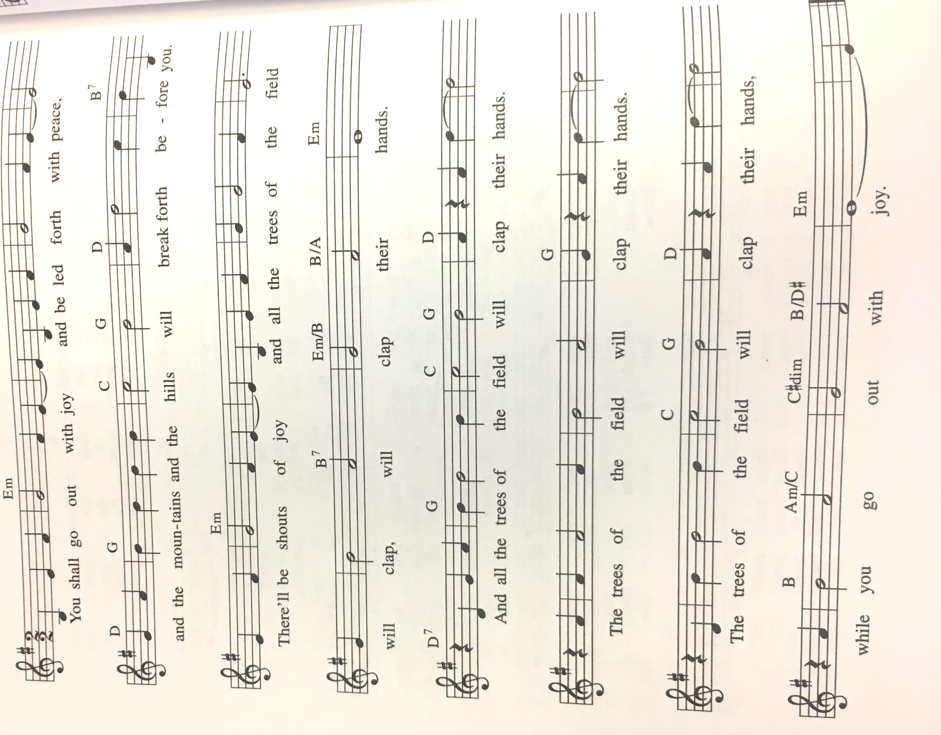

cREED
I believe in God, the Father almighty,
creator of heaven and earth.
I believe in Jesus Christ, God’s only Son, our Lord,
who was conceived by the Holy Spirit,
born of the virgin Mary,
suffered under Pontius Pilate,
was crucified, died, and was buried;
he descended to the dead.*
On the third day he rose again;
he ascended into heaven,
he is seated at the right hand of the Father,
and he will come to judge the living and the dead.
I believe in the Holy Spirit,
the holy catholic church,
the communion of saints,
the forgiveness of sins,
the resurrection of the body,
and the life everlasting. Amen.

*Or, “he descended into hell,” another translation of this text in widespread use.

prayers of Intercession
Let us come before the triune God in prayer.
A brief silence.
Holy God, you plant the seeds of faith in every nation. Enliven your church, so that the good news of your grace may root and grow throughout the world. We pray especially for Our Savior’s Lutheran Church. Lord, in your mercy,
hear our prayer.
Creator, even the trees, shrubs, and flowers delight in your goodness. From the depths of the soil to the highest mountain, bring forth new plants. Restore growth to places suffering drought. Lord, in your mercy,
hear our prayer.
Judge of nations, we pray for our leaders and those in power. Grant them the ability to regard those under their charge with humility, dedicating their lives in service to others. Lord, in your mercy,
hear our prayer.

Divine comforter, you show compassion to those in need and provide relief to those who call on you. Bless all who suffer, especially people trapped in cycles of poverty and homelessness. Lord, in your mercy,
hear our prayer.
Sovereign God, this house of worship belongs to you. We give thanks and pray for our church musician, Martha Yoder. We dedicate to you the joyful noise that comes from this place; the cries of children, the melody of voice and instruments, and the songs from our hearts. Lord, in your mercy,
hear our prayer.
Eternal God, we give thanks for our ancestors in the faith who are now at home with you. We look forward to that day when we are reunited in your new creation. Lord, in your mercy,
hear our prayer.
We lift our prayers to you, O God, trusting in your abiding grace.
Amen.

Peace
The peace of Christ be with you always.
And also with you.

Offering & Offering song

Offering Prayer
Let us pray. Gracious God, you bless us with gifts of guidance, new life, growth in grace, and fruitful labor. Accept the first fruits of time and toil, field and orchard we offer here. Bless and multiply these gifts to our nurture and the care of your creation; for the sake of your Son, our Savior Jesus Christ.
Amen.

Thanksgiving at the Table
In the night in which he was betrayed,
our Lord Jesus took bread, and gave thanks;
broke it, and gave it to his disciples, saying:
Take and eat; this is my body, given for you.
Do this for the remembrance of me.
Again, after supper, he took the cup, gave thanks,
and gave it for all to drink, saying:
This cup is the new covenant in my blood,
shed for you and for all people for the forgiveness of sin.
Do this for the remembrance of me.

Lord’s Prayer
Gathered into one by the Holy Spirit, let us pray as Jesus taught us.
Our Father in heaven,
hallowed be your name,
your kingdom come,
your will be done,
on earth as in heaven.
Give us today our daily bread.
Forgive us our sins
as we forgive those
who sin against us.
Save us from the time of trial
and deliver us from evil.
For the kingdom, the power,
and the glory are yours,
now and forever. Amen.

COMMUNION
The body and blood of our Lord Jesus Christ bless you and keep you in His grace.

Sending
God blesses us and sends us in mission to the world.

Blessing
The holy Three,
the holy One increase your hope,
strengthen your faith,
deepen your love,
and ☩ grant you peace.
Amen.

Sending SonG “We Plow the Fields and Scatter” ELW 681

Dismissal
Go in peace. Share the good news.
Thanks be to God.
From sundaysandseasons.com. Copyright © 2017 Augsburg Fortress. All rights reserved.

THANK YOU TO ALL WHO SERVED TODAY:

Presider: Pastor Becky Ebb-Speese
Musician: Martha Yoder
Elder: Jolene Griffin
Trustee: Dan Zylstra
Offering Counters: Diane Griffin and Carlotta Willard
Safety Person: Dan Zylstra

ANNOUNCEMENTS

  - Pastor Becky will be on vacation after church today through Monday, June 21. Pastor Kathy Smith will be oncall during that time. Her phone number is 616-293-7576.
  - Help Needed! We will be sealing the deck and front steps of the parsonage on Tuesday, June 15 beginning at 9 AM. If you can help with this project, let Mike Johnson know or be at the parsonage on Tuesday. The more help we have, the better! Thank you.
  - Semi-Annual Meeting: The Semi-annual meeting is fast approaching. It will be held on Sunday, July 18 after service. The report deadline will be Sunday, July 11. Please have all board reports to Tara by that time. (It is best if they are emailed to her at office@zionwoodlandmi.org)
  - Greeters: It is good news that we are at a point where we can resume having a greeter inside the church. At this time, we plan to have one greeter who will be located in the Narthex area. Watch for the list of greeters in the June newsletter. If you are unable to serve as a greeter on your assigned day, please trade with someone on the schedule to ensure we have a greeter each Sunday.
  - The Board of Education and Youth needs a few more people to help plan Christian education for our children, youth, and adults as we look to resume Christian education in the fall. Please consider volunteering to help with this important work of the church. See Pastor Becky or Jolene Griffin to volunteer or for more information.
  - Boards and Committees: Council is encouraging boards and committees to resume meeting and working on plans for their respective areas. Council is also encouraging all boards and committees to designate a contact person for Council to reach out to when needed. When meeting, remember that social distancing and mask requirements are still place.

Save the Date. Plan to Attend:

- July 18 - Semi-Annual Mtg.
- August 22 - Zion's 165 Birthday Party
- September 4 - Woodland Labor Day Games. Workers needed

