ZION LUTHERAN CHURCH, WOODLAND, MI
Second Sunday after Pentecost, June 6, 2021
*If you are listening in your car, please tune your radio to FM 87.7*

ANNOUNCEMENTS & PRELUDE

Gathering
The Holy Spirit calls us together as the people of God.

Confession and Forgiveness
In the name of the Father, and of the ☩ Son, and of the Holy Spirit.
Amen.

Almighty God, to whom all hearts are open, all desires known, and from whom no secrets are hid: cleanse the thoughts of our hearts by the inspiration of your Holy Spirit, that we may perfectly love you and worthily magnify your holy name, through Jesus Christ our Lord.
Amen.

Let us confess our sin in the presence of God and of one another. Gracious God,
have mercy on us. We confess that we have turned from you and given ourselves into the power of sin. We are truly sorry and humbly repent. In your compassion forgive us our sins, known and unknown, things we have done and things we have failed to do. Turn us again to you, and uphold us by your Spirit, so that we may live and serve you in newness of life through Jesus Christ, our Savior and Lord.
Amen.

God, who is rich in mercy, loved us even when we were dead in sin, and made us alive together with Christ. By grace you have been saved. In the name of ☩ Jesus Christ, your sins are forgiven. Almighty God strengthen you with power through the Holy Spirit, that Christ may live in your hearts through faith.
Amen.

Gathering Song “Rise, Shine, You People” ELW 665

GREETING
The grace of our Lord Jesus Christ, the love of God, and the communion of the Holy Spirit be with you all.
And also with you.

Prayer of the Day
Let us pray.
All-powerful God, in Jesus Christ you turned death into life and defeat into victory. Increase our faith and trust in him, that we may triumph over all evil in the strength of the same Jesus Christ, our Savior and Lord.
Amen.

First Reading Genesis 3:8-15
A reading from Genesis.

⁸[Adam and Eve] heard the sound of the Lord God walking in the garden at the time of the evening breeze, and the man and his wife hid themselves from the presence of the Lord God among the trees of the garden.⁹But the Lord God called to the man, and said to him, “Where are you?” ¹⁰He said, “I heard the sound of you in the garden, and I was afraid, because I was naked; and I hid myself.” ¹¹He said, “Who told you that you were naked? Have you eaten from the tree of which I commanded you not to eat?” ¹²The man said, “The woman whom you gave to be with me, she gave me fruit from the tree, and I ate.” ¹³Then the Lord God said to the woman, “What is this that you have done?” The woman said, “The serpent tricked me, and I ate.” ¹⁴The Lord God said to the serpent,
“Because you have done this,
cursed are you among all animals
and among all wild creatures;
upon your belly you shall go,
and dust you shall eat all the days of your life.
¹⁵I will put enmity between you and the woman,
and between your offspring and hers;
he will strike your head,
and you will strike his heel.”

The word of the Lord.
Thanks be to God.

Psalm Psalm 130
¹Out | of the depths
I cry to | you, O Lord;
²O Lord, | hear my voice!
Let your ears be attentive to the voice of my | supplication.
³If you were to keep watch | over sins,
O Lord, | who could stand?
⁴Yet with you | is forgiveness,
in order that you | may be feared.
⁵I wait for you, O Lord; | my soul waits;
in your word | is my hope.
⁶My soul waits for the Lord more than those who keep watch | for the morning,
more than those who keep watch | for the morning.
⁷O Israel, wait for the Lord, for with the Lord there is | steadfast love;
with the Lord there is plen- | teous redemption.
⁸For the Lord shall | redeem Israel
from | all their sins.

Second Reading 2 Corinthians 4:13-5:1
A reading from 2 Corinthians.

¹³Just as we have the same spirit of faith that is in accordance with scripture—“I believed, and so I spoke”—we also believe, and so we speak, ¹⁴because we know that the one who raised the Lord Jesus will raise us also with Jesus, and will bring us with you into his presence. ¹⁵Yes, everything is for your sake, so that grace, as it extends to more and more people, may increase thanksgiving, to the glory of God.
¹⁶So we do not lose heart. Even though our outer nature is wasting away, our inner nature is being renewed day by day. ¹⁷For this slight momentary affliction is preparing us for an eternal weight of glory beyond all measure, ¹⁸because we look not at what can be seen but at what cannot be seen; for what can be seen is temporary, but what cannot be seen is eternal.
^{5:1}For we know that if the earthly tent we live in is destroyed, we have a building from God, a house not made with hands, eternal in the heavens.

The word of the Lord.
Thanks be to God.

Gospel Acclamation
Alleluia. Lord, to whom shall we go?
You have the words of eternal life. Alleluia

Gospel Mark 3:20-35
The holy gospel according to Mark.
Glory to you, O Lord.

[Jesus went home;] ²⁰and the crowd came together again, so that [Jesus and the disciples] could not even eat. ²¹When his family heard it, they went out to restrain him, for people were saying, “He has gone out of his mind.” ²²And the scribes who came down from Jerusalem said, “He has Beelzebul, and by the ruler of the demons he casts out demons.” ²³And he called them to him, and spoke to them in parables, “How can Satan cast out Satan? ²⁴If a kingdom is divided against itself, that kingdom cannot stand. ²⁵And if a house is divided against itself, that house will not be able to stand. ²⁶And if Satan has risen up against himself and is divided, he cannot stand, but his end has come. ²⁷But no one can enter a strong man’s house and plunder his property without first tying up the strong man; then indeed the house can be plundered.
²⁸“Truly I tell you, people will be forgiven for their sins and whatever blasphemies they utter; ²⁹but whoever blasphemes against the Holy Spirit can never have forgiveness, but is guilty of an eternal sin”—³⁰for they had said, “He has an unclean spirit.”
³¹Then his mother and his brothers came; and standing outside, they sent to him and called him. ³²A crowd was sitting around him; and they said to him, “Your mother and your brothers and sisters are outside, asking for you.” ³³And he replied, “Who are my mother and my brothers?” ³⁴And looking at those who sat around him, he said, “Here are my mother and my brothers! ³⁵Whoever does the will of God is my brother and sister and mother.”

The gospel of the Lord.
Praise to you, O Christ.

SERMON Pastor Becky Ebb-Speese

Hymn of the Day “Lead Me, Guide Me” ELW 412
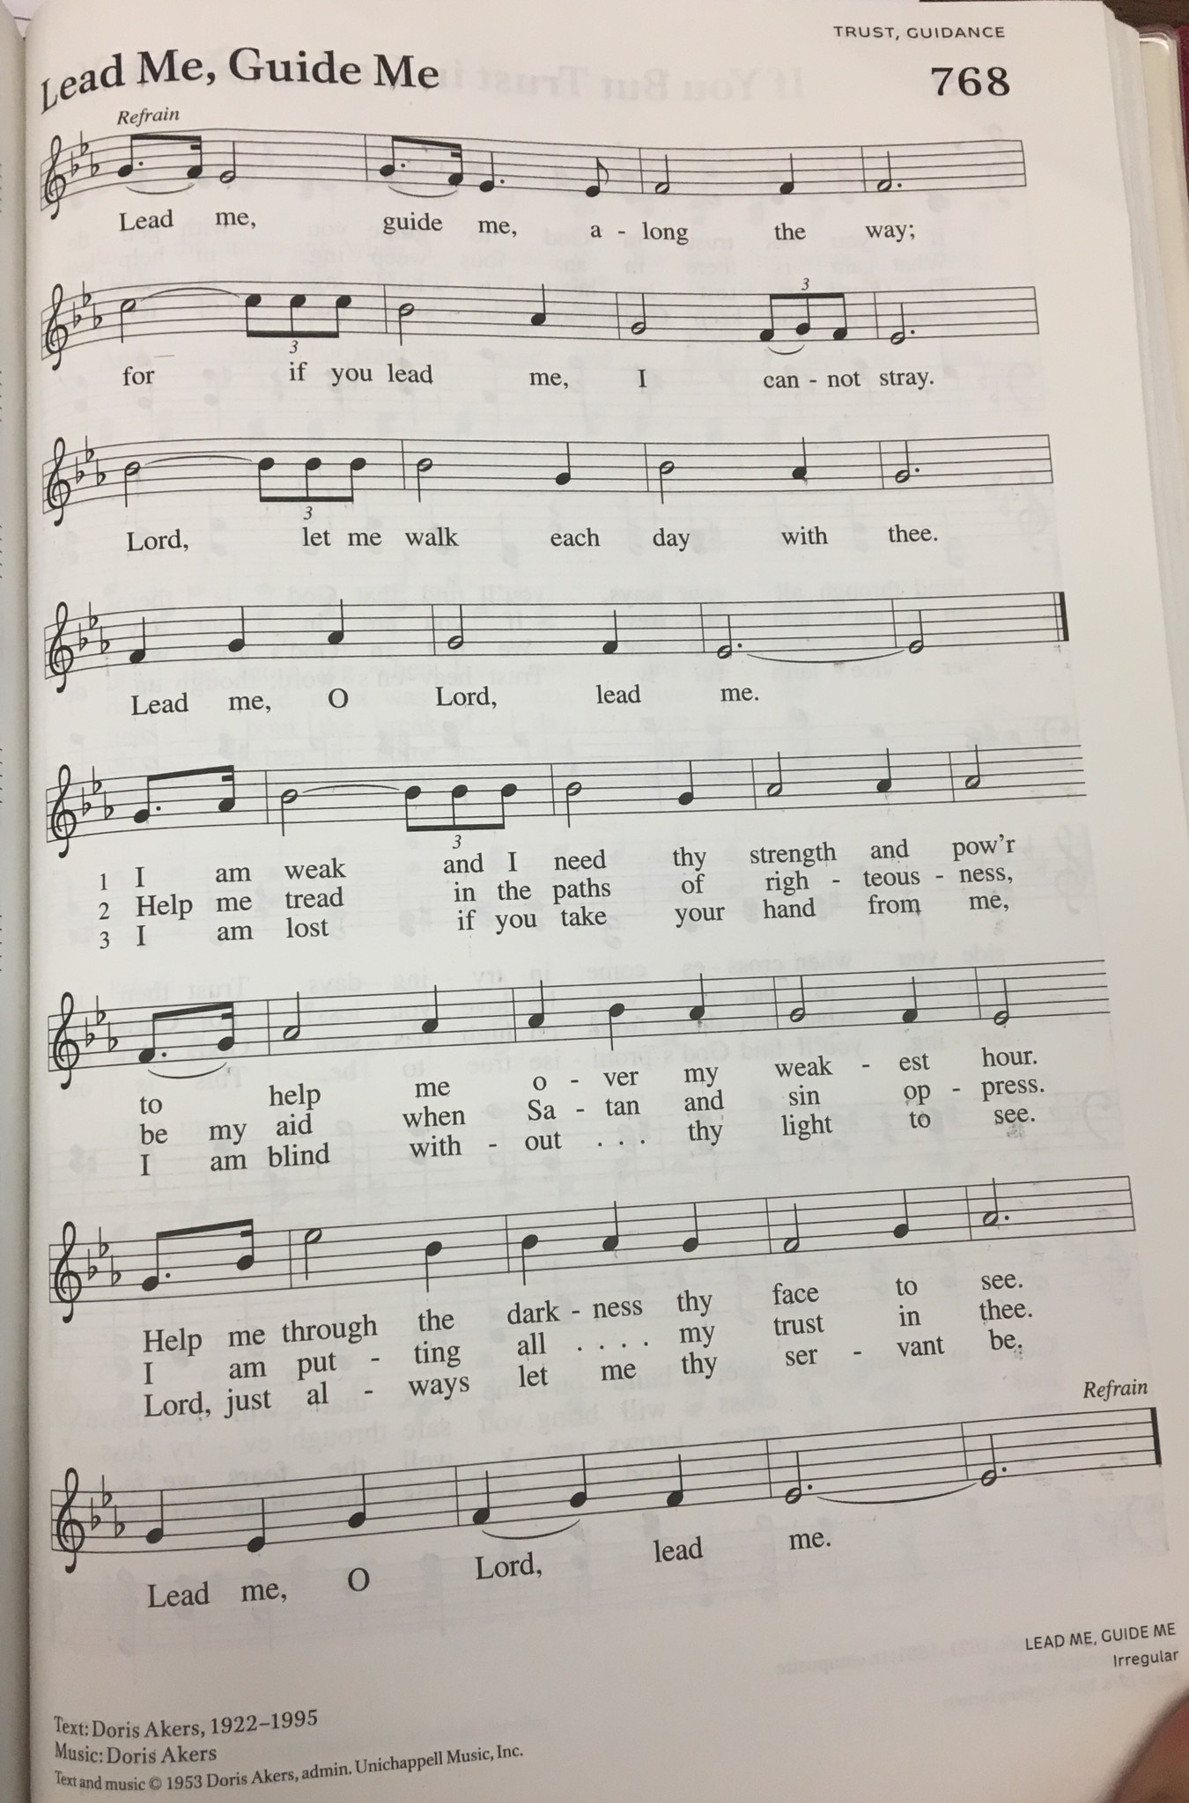
PRESENTATION FOR AFFIRMATION OF BAPTISM

I present these brother and sisters who desire to make public affirmation of their baptism.
- Janine Frizzell
- Jimmy Hindman
- Ruth Hindman

Let us pray. Merciful God, we thank you for these sisters and brother, whom you have made your own by water and the Word in baptism. You have called them to yourself,
enlightened them with the gifts of your Spirit, and nourished them in the community of faith. Uphold your servants in the gifts and promises of baptism, and unite the hearts of all whom you have brought to new birth. We ask this in the name of Christ.
Amen.

The assembly stands.
PROFESSION OF FAITH
I ask you to profess your faith in Christ Jesus, reject sin, and confess the faith of the church, the faith in which we baptize. Do you renounce all the forces of evil, the devil, and all his empty promises?
I do.

Do you believe in God the Father?
I believe in God, the Father almighty,
creator of heaven and earth.

Do you believe in Jesus Christ, the Son of God?
I believe in Jesus Christ, his only Son, our Lord.
He was conceived by the power of the Holy Spirit
and born of the virgin Mary.
He suffered under Pontius Pilate,
was crucified, died, and was buried.
He descended into hell.*
On the third day he rose again.
He ascended into heaven,
and is seated at the right hand of the Father.
He will come again to judge the living and the dead.

Do you believe in God the Holy Spirit?
I believe in the Holy Spirit,
the holy catholic church,
the communion of saints,
the forgiveness of sins,
the resurrection of the body,
and the life everlasting. Amen

Affirmation of Baptism
Sisters and brother who are affirming baptism today:
You have made public profession of your faith.
Do you intend to continue in the covenant God made with you in holy baptism:
to live among God’s faithful people,
to hear the word of God and share in the Lord’s supper,
to proclaim the good news of God in Christ through word and deed,
to serve all people, following the example of Jesus,
and to strive for justice and peace in all the earth?

Response: I do, and I ask God to help and guide me.

The minister addresses the assembly.
People of God, do you promise to support those who are baptized today, and those making public affirmation of their baptism, and to pray for them in their life in Christ?
We do, and we ask God to help and guide us.

Let us pray. We give you thanks, O God, that through water and the Holy Spirit you give us new birth, cleanse us from sin, and raise us to eternal life. Father in heaven, for Jesus’ sake, stir up in them the gift of your Holy Spirit; confirm their faith, guide their lives, empower them in their serving, give them patience in suffering, and bring them to everlasting life.
Amen.

Let us rejoice with these sisters and brothers in Christ.
We rejoice with you in the life of baptism. Together we will give thanks and praise to God and proclaim the good news to all the world.

WELCOME
Through Baptism and Affirmation of Baptism God has made these new brothers and sisters members of the priesthood we all share in Christ Jesus, that we may proclaim the praise of God and bear his creative and redeeming Word to all the world.

We welcome you into the Lord’s family. We receive you as fellow members of the
body of Christ, children of the same heavenly Father, and workers with us in the kingdom of God.

prayers of Intercession
Let us come before the triune God in prayer.
A brief silence.
God of wholeness, we pray for believers all over the globe. Unify us in service of the gospel, that we may work together as beloved siblings to share your love with all. We pray especially for Grace Lutheran Church and Rev. Max Miller and the people of Calvary Lutheran Church in Lansing. Lord, in your mercy,
hear our prayer.
God of the cosmos, we pray for creation; the gardens, waterways and creatures near to us and diverse forms of life that remain unseen. Teach us to treat the natural world with reverence, seeking restoration when human divisions have caused harm to your beloved creation. Lord, in your mercy,
hear our prayer.
God of all people, we pray for harmony among the nations. Cast out from us unclean spirits of greed and fear, that we may work in solidarity with one another for the common good. Lord, in your mercy,
hear our prayer.
God of abundance, we pray for those who are oppressed or in any need. Encourage those who have begun to lose heart. Strengthen and renew us with your Spirit. Lord, in your mercy,
hear our prayer.
God of righteousness, we pray for this holy house of worship. Set our gaze upon things eternal, that in thanksgiving for your mercy, we may extend grace to more and more people. Lord, in your mercy,
hear our prayer.
God of the ages, in your goodness you have sent us faithful witnesses for every time and place. We give you thanks for those saints who now rest in your eternal mercy. Lord, in your mercy,
hear our prayer.
We lift our prayers to you, O God, trusting in your abiding grace.
Amen.

Peace
The peace of Christ be with you always.
And also with you.

Offering & Offering Prayer
Let us pray. Blessed are you, O God, ruler of heaven and earth. Day by day you shower us with blessings. As you have raised us to new life in Christ, give us glad and generous hearts, ready to praise you and to respond to those in need, through Jesus Christ, our Savior and Lord.
Amen.

Thanksgiving at the Table
In the night in which he was betrayed,
our Lord Jesus took bread, and gave thanks;
broke it, and gave it to his disciples, saying:
Take and eat; this is my body, given for you.
Do this for the remembrance of me.
Again, after supper, he took the cup, gave thanks,
and gave it for all to drink, saying:
This cup is the new covenant in my blood,
shed for you and for all people for the forgiveness of sin.
Do this for the remembrance of me.

Lord’s Prayer
Gathered into one by the Holy Spirit, let us pray as Jesus taught us.
Our Father in heaven,
hallowed be your name,
your kingdom come,
your will be done,
on earth as in heaven.
Give us today our daily bread.
Forgive us our sins
as we forgive those
who sin against us.
Save us from the time of trial
and deliver us from evil.
For the kingdom, the power,
and the glory are yours,
now and forever. Amen.

COMMUNION
The body and blood of our Lord Jesus Christ is given and shed for you. You may receive your communion elements.

Sending
God blesses us and sends us in mission to the world.

Blessing
The Lord bless you and keep you.
The Lord’s face shine on you with grace and mercy.
The Lord look upon you with favor and ☩ give you peace.
Amen.

Sending SonG “A Mighty Fortress Is Our God” (ELW 504)

Dismissal
Go in peace. Christ is with you.
Thanks be to God.
From sundaysandseasons.com. Copyright © 2017 Augsburg Fortress. All rights reserved.

THANK YOU TO ALL WHO SERVED TODAY:

Presider: Pastor Becky Ebb-Speese
Musician: Martha Yoder
Elder: Paul Meade
Trustee: Mike Johnson
Offering Counters: Mary Makley and Martha Yoder
Safety Person: Ken Heise

ANNOUNCEMENTS

  - Greeters: It is good news that we are at a point where we can resume having a greeter inside the church. At this time, we plan to have one greeter who will be located in the Narthex area. Watch for the list of greeters in the June newsletter. If you are unable to serve as a greeter on your assigned day, please trade with someone on the schedule to ensure we have a greeter each Sunday.
  - The Board of Education and Youth needs a few more people to help plan Christian education for our children, youth, and adults as we look to resume Christian education in the fall. Please consider volunteering to help with this important work of the church. See Pastor Becky or Jolene Griffin to volunteer or for more information.
  - Boards and Committees: Council is encouraging boards and committees to resume meeting and working on plans for their respective areas. Council is also encouraging all boards and committees to designate a contact person for Council to reach out to when needed. When meeting, remember that social distancing and mask requirements are still place.

Save the Date. Plan to Attend:

- June 6 – End of the School Year “Summer Celebration”
- July 18 - Semi-Annual Mtg.
- August 22 - Zion's 165 Birthday Party
- September 4 - Woodland Labor Day Games. Workers needed

