LABOR DAY SERVICE IN THE PARK
September 5, 2021

CALL TO WORSHIP (Pastor Kathy Smith)
(Inspired by Romans 12:2, John 17:14-19) Gord Waldie

We are called to be people of faith in the midst of the world,
and so we mix our worship and our work,
our faith and our life.
We gather here as people who live in the world and yet,
we gather as people who have been called to see the world
from a different viewpoint.
God has called us together,
God has called us to be part of a community.
God challenges us to consider questions of priority
as we engage with the world.

In this time together,
may God open our hearts, minds and eyes,
allowing us to see deeper,
helping us to live in the world
while still offering a challenge to the ways of the world.
We pray in Jesus' name. Amen.

Gathering Song “For the Fruit of All Creation”

CALL TO CONFESSION (Pastor Becky Ebb-Speese):
On this Labor Day Sunday let us, in a special way, lift up all people who labor, either for pay or as volunteers, in jobs or at school, at home or in the workplace, in the U.S. and around the world.

UNISON PRAYER OF CONFESSION:
We are workers, God, just like you. But we confess that our actions do not always affirm and honor each other. Our work is not always done in a spirit that is pleasing to you. We confess that, on some occasions, we have blindly bought goods made by people who are paid too little or work in unsafe conditions. We admit that we have failed to end an unjust system in which some workers have jobs that provide good wages and benefits while others may have no job, or one that pays little and provides few benefits.

Creator God, help us to be your people, working for a world where all workers are valued. A world where those who clean houses are also able to buy houses to live in. A world where those who grow food can also afford to eat their fill. And one where those who serve and care for others — in stores, schools, hotels, restaurants, nursing homes, and many other places — are, themselves, also served and cared for. It will be a world where all workers everywhere share in the abundance that you have given us.

WORDS OF ASSURANCE
Our God is a God of grace and transformation. When we ask, God gives us the courage and strength to live out our faith in the workplace and the marketplace, as well as in the sanctuary.

PRAYER OF THE DAY (Pastor Kathy Smith)

from Carol Penner’s Leading in Worship blog.

Worker God,
whose hands built the earth,
molded our bodies,
and sowed the stars across the sky,
we gather in your presence this morning
with praise and thanksgiving for your mighty deeds.
Meet us here, Worker God;
strengthen our hearts and our hands to work with you
in the building of a world filled with justice and peace.

First Reading (Pastor Kathy Smith) Proverbs 3:21-35
A reading from Proverbs.

²¹My child, do not let these escape from your sight:
keep sound wisdom and prudence,
²²and they will be life for your soul
and adornment for your neck.
²³Then you will walk on your way securely
and your foot will not stumble.
²⁴If you sit down, you will not be afraid;
when you lie down, your sleep will be sweet.
²⁵Do not be afraid of sudden panic,
or of the storm that strikes the wicked;
²⁶for the LORD will be your confidence
and will keep your foot from being caught.
²⁷Do not withhold good from those to whom it is due,
when it is in your power to do it.
²⁸Do not say to your neighbor, "Go, and come again,
tomorrow I will give it" — when you have it with you.
²⁹Do not plan harm against your neighbor
who lives trustingly beside you.
³⁰Do not quarrel with anyone without cause,
when no harm has been done to you.
³¹Do not envy the violent
and do not choose any of their ways;
³²for the perverse are an abomination to the LORD,
but the upright are in his confidence.
³³The LORD's curse is on the house of the wicked,
but he blesses the abode of the righteous.
³⁴Toward the scorners he is scornful,
but to the humble he shows favor.
³⁵The wise will inherit honor,
but stubborn fools, disgrace.

The word of the Lord.
Thanks be to God.

Psalm Psalm 107:1-9
¹Give thanks to the Lord, for the | Lord is good,
for God's mercy en- | dures forever.
²Let the redeemed of the | Lord proclaim
that God redeemed them from the hand | of the foe,
³gathering them in | from the lands;
from the east and from the west, from the north and | from the south.
⁴Some wandered in | desert wastes;
they found no path to a city where | they might dwell.
⁵They were hun- | gry and thirsty;
their spirits lan- | guished within them.
⁶Then in their trouble they cried | to the Lord,
and you delivered them from | their distress.
⁷You led them | on a straight path
to go to a city where | they might dwell.
⁸Let them give thanks to you, Lord, for your | steadfast love
and your wonderful works | for all people.
⁹For you satisfy the | thirsty soul
and fill the hungry | with good things.

Second Reading (Pastor Kathy Smith) 1 Peter 4:10-11
A reading from 1 Peter.

¹⁰Like good stewards of the manifold grace of God, serve one another with whatever gift each of you has received. ¹¹Whoever speaks must do so as one speaking the very words of God; whoever serves must do so with the strength that God supplies, so that God may be glorified in all things through Jesus Christ. To him belong the glory and the power forever and ever. Amen.

The word of the Lord.
Thanks be to God.

Gospel Acclamation
Alleluia. Lord, to whom shall we go?
You have the words of eternal life. Alleluia

Gospel (Pastor Becky Ebb-Speese) Matthew 11:28-30
The holy gospel according to Matthew.
Glory to you, O Lord.

²⁸Come to me, all you that are weary and are carrying heavy burdens, and I will give you rest. ²⁹Take my yoke upon you, and learn from me; for I am gentle and humble in heart, and you will find rest for your souls. ³⁰For my yoke is easy, and my burden is light."

The gospel of the Lord.
Praise to you, O Christ.

SERMON Pastor Becky Ebb-Speese

Hymn of the Day “Take My Life, That I Might Be” ELW 685
Offering (Pastor Kathy Smith)

Offering SONG “We Are an Offering” ELW 692
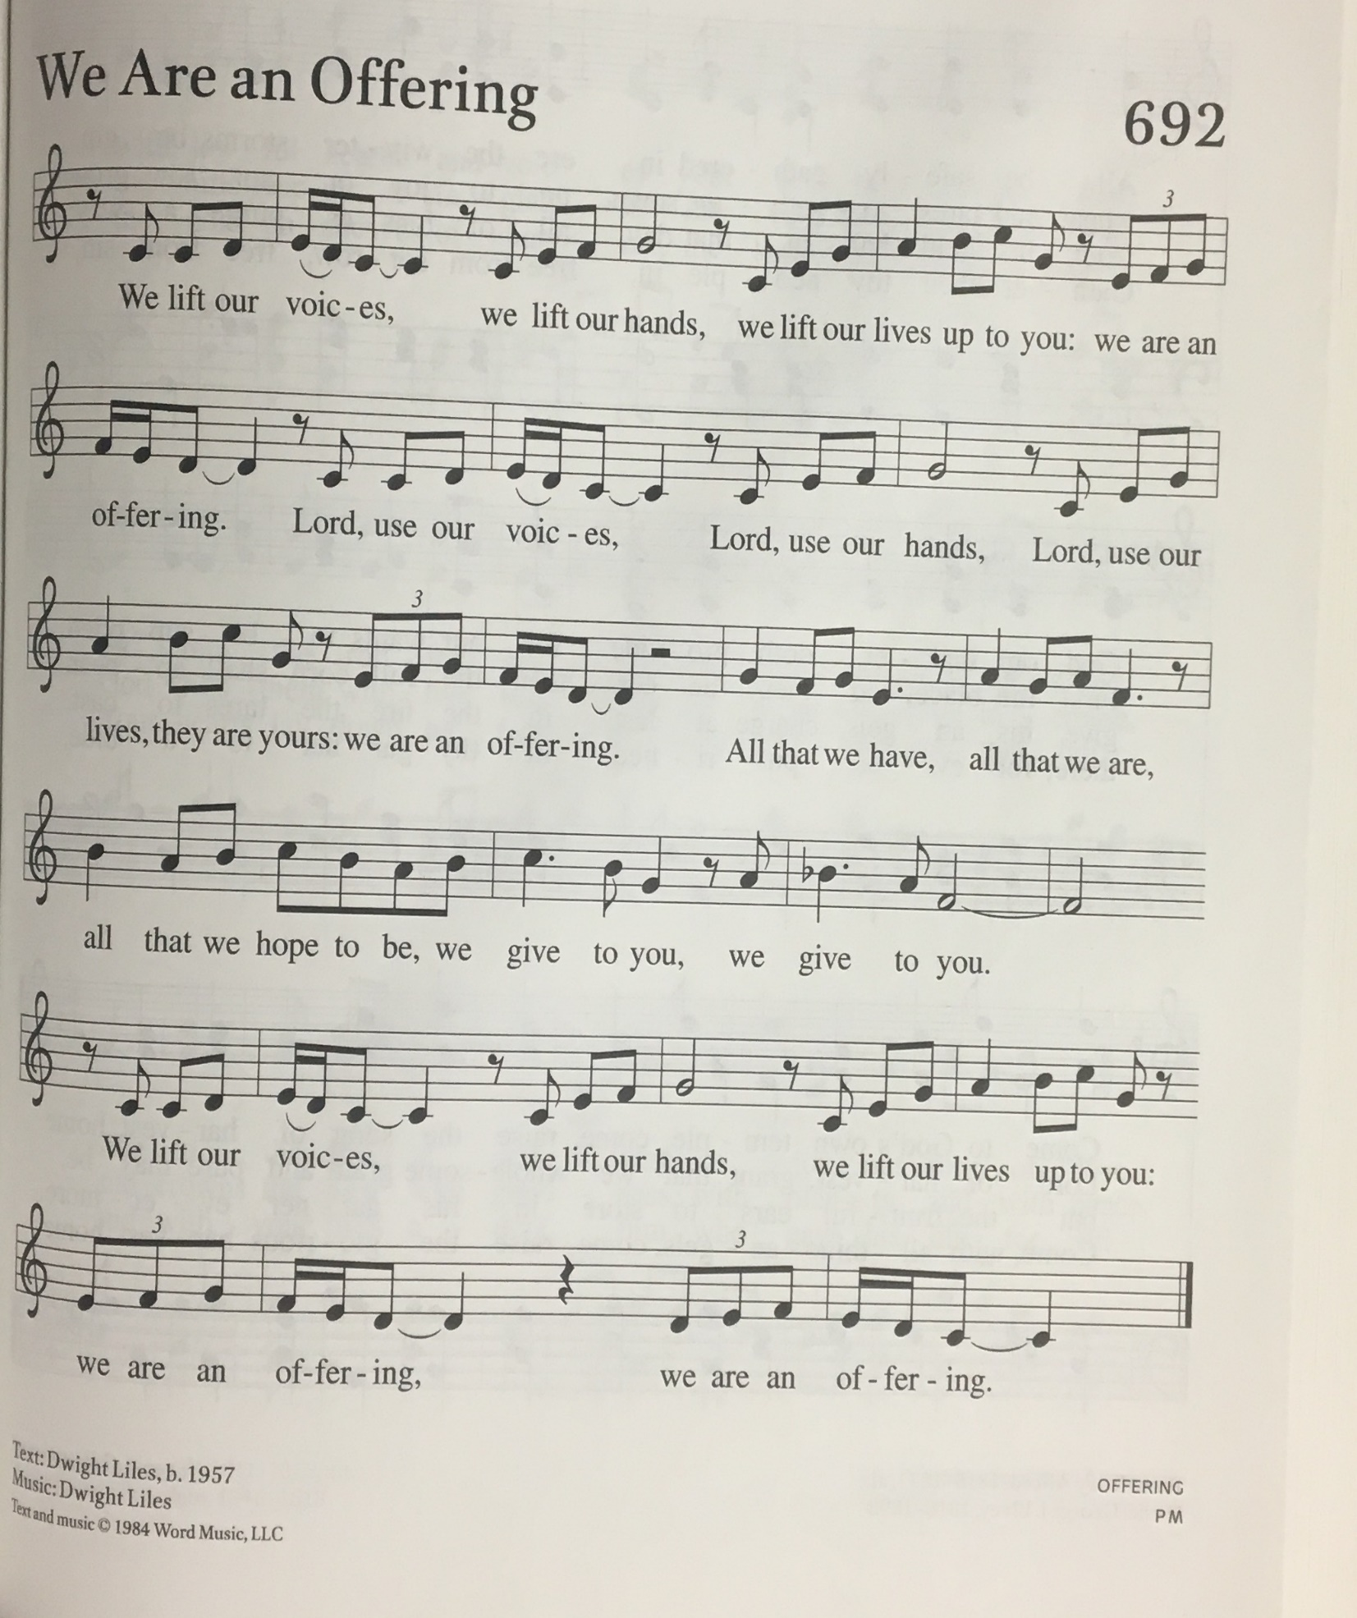
PRAYER OF THANKSGIVING (Pastor Becky Ebb-Speese)

Thanks for a Labouring God

Labouring God,
the sea and sky are your work,
every hill and plain, every valley and cliff
fashioned by your hands.
Towering trees and creeping plants,
blossoms, sweet and rare
or common as dandelions,
all created by you.
The creatures are your opus,
every fin, paw, wing and hand,
all that runs, swims, soars and wriggles,
your work.
The world cries out, “Good job!”
We join our voice to this chorus,
singing the world beautiful,
singing the Lord glorious,
singing our thanks for your labour of love.

~ written by Carol Penner, and posted on her
Leading in Worship blog. http://carolpenner.typepad.com/

cREED
I believe in God, the Father almighty,
creator of heaven and earth.
I believe in Jesus Christ, God’s only Son, our Lord,
who was conceived by the Holy Spirit,
born of the virgin Mary,
suffered under Pontius Pilate,
was crucified, died, and was buried;
he descended to the dead.*
On the third day he rose again;
he ascended into heaven,
he is seated at the right hand of the Father,
and he will come to judge the living and the dead.
I believe in the Holy Spirit,
the holy catholic church,
the communion of saints,
the forgiveness of sins,
the resurrection of the body,
and the life everlasting. Amen.

*Or, “he descended into hell,” another translation of this text in widespread use.

prayers for the people (Pastor Kathy Smith)
For the world of work in all its diversity:
hear us, good Lord.
For the industry and workplaces of this parish/community:
hear us, good Lord.
For the right ordering of work in time of technological change:
hear us, good Lord.
For communities that have lost traditional industries,
and for their regeneration:
hear us, good Lord.
For all expanding industries and for the promise of new jobs:
hear us, good Lord.
For small businesses and co-operatives:
hear us, good Lord.
For local trade and commerce:
hear us, good Lord.
For all service industries that provide for our daily needs:
hear us, good Lord.
For the unemployed and for those living in poverty:
hear us, good Lord.
For school leavers and all who are seeking to enter employment:
hear us, good Lord.
For the retired and those unable to work:
hear us, good Lord.
For all who work as volunteers:
hear us, good Lord.
We pray for all who are in need. (Prayer requests taken.)
hear us, good Lord.
Receive these prayers, O God, and those in our hearts known only to you; through Jesus Christ our Lord.
Amen.

— from Common Worship: Services and Prayers for the Church of England (2000), available on the Church of England website. http://www.churchofengland.org/

Lord’s Prayer
Gathered into one by the Holy Spirit, let us pray as Jesus taught us.
Our Father who art in heaven,
hallowed be thy name,
thy kingdom come,
thy will be done,
on earth as it is in heaven.
Give us today our daily bread.
Forgive us our trespasses
as we forgive those
who trespass against us.
And lead us not into temptation,
but deliver us from evil.
For the kingdom, the power,
and the glory are yours,
now and forever. Amen.

COMMISSION & BENEDICTION: Salt of the Earth (Pastor Becky Ebb-Speese)

The Spirit of God is upon you and has anointed you.
You are the salt of the earth and you bring light to the world.

You are not too young or too old,
you are not too rich or too needy
to bring good news to the impoverished,
to give a hand to the broken-hearted,
and to live out freedom and pardon
through the gifts you have been given.

So remember to pack peace in your toolbox,
hope in your briefcase,
love in your lunch box,
and may integrity, honesty, and joy be your designer wear of choice.

Do not be frightened, for you are never alone.
The God in whose image you are made
will walk with you and guide you today, tomorrow, and every day.

— Copyright © Connie Epp. Used by permission

Sending SonG “Great Is Thy Faithfulness” ELW 733

Dismissal
Go in peace. Share the good news.
Thanks be to God.

THANK YOU TO ALL WHO SERVED TODAY:
Presider: Pastor Becky Ebb Spesee
Presider: Pastor Kathy Smith

ZION LUTHERAN CHURCH’S

ANNOUNCEMENTS

- Table Showers: The ZLCW has Table Showers for both Ashley Griffin and Kayla Cole. Look for their lists of needed items on each of their tables, The tables will be left up until Sunday, September 26th.
- Church Cleaners Needed for end of September: Volunteers are needed to clean during the month of September. A sign-up sheet is in the Narthex. In addition, we will be going back to our schedule of volunteer s to clean the church soon. A copy of the previous list will be placed in the Narthex. Please review the cleaning assignments and note any changes. Thank you for helping us keep Zion clean and safe!

This week at Zion:
- Men’s Breakfast, Wednesday, September 1 at 8:00 AM

Save the Date. Plan to Attend:
- Sunday School Rally Day, 9:15 AM September 12. Church starts at 10:30 AM

