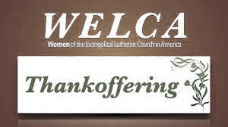

ZION LUTHERAN CHURCH, WOODLAND, MI
Women’s Thankoffering Sunday
November 21, 2021
*If you are listening in your car,
please tune your radio to FM 87.7*

ANNOUNCEMENTS & PRELUDE

Gathering
The Holy Spirit calls us together as the people of God.

Gathering Song “Gather Us In” ELW 532
GREETING
The grace of our Lord Jesus Christ, the love of God, and the communion of the Holy Spirit be with you all.
And also with you.

Prayer of the Day
Let us pray together.
O God of justice and love, you light our way through life with the words of your Son. Give us the light we need, and awaken us to the needs of others, through Jesus Christ, our Savior and Lord. Amen.

First Reading Daniel 7:9-10,13-14
A reading from Daniel.

⁹As I watched,
thrones were set in place,
and an Ancient One took his throne,
his clothing was white as snow,
and the hair of his head like pure wool;
his throne was fiery flames,
and its wheels were burning fire.
¹⁰A stream of fire issued
and flowed out from his presence.
A thousand thousands served him,
and ten thousand times ten thousand stood attending him.
The court sat in judgment,
and the books were opened.
¹³As I watched in the night visions,
I saw one like a human being
coming with the clouds of heaven.
And he came to the Ancient One
and was presented before him.
¹⁴To him was given dominion
and glory and kingship,
that all peoples, nations, and languages
should serve him.
His dominion is an everlasting dominion
that shall not pass away,
and his kingship is one
that shall never be destroyed.

The word of the Lord.
Thanks be to God.

Psalm Psalm 93

¹The Lord is king, robed in majesty; the Lord is robed in majesty and | armed with strength.
The Lord has made the world so sure that it can- | not be moved.
²Ever since the world began, your throne has | been established;
you are from | everlasting.
³The waters have lifted up, O Lord, the waters have lifted | up their voice;
the waters have lifted up their | pounding waves.
⁴Mightier than the sound of many waters, mightier than the breakers | of the sea,
mightier is the Lord who | dwells on high.
⁵Your testimonies are | very sure,
and holiness befits your house, O Lord, forever and for- | evermore.

Second Reading Revelations 1:4b-8
A reading from Revelations.

^{4b}Grace to you and peace from him who is and who was and who is to come, and from the seven spirits who are before his throne, ⁵and from Jesus Christ, the faithful witness, the firstborn of the dead, and the ruler of the kings of the earth.
To him who loves us and freed us from our sins by his blood, ⁶and made us to be a kingdom, priests serving his God and Father, to him be glory and dominion forever and ever. Amen.
⁷Look! He is coming with the clouds;
every eye will see him,
even those who pierced him;
and on his account all the tribes of the earth will wail.
So it is to be. Amen.
⁸“I am the Alpha and the Omega,” says the Lord God, who is and who was and who is to come, the Almighty.

The word of the Lord.
Thanks be to God.

Gospel Acclamation
Alleluia. Lord, to whom shall we go?
You have the words of eternal life. Alleluia

Gospel John 18:33-37
The holy gospel according to John.
Glory to you, O Lord.

³³Pilate entered the headquarters again, summoned Jesus, and asked him, “Are you the King of the Jews?” ³⁴Jesus answered, “Do you ask this on your own, or did others tell you about me?” ³⁵Pilate replied, “I am not a Jew, am I? Your own nation and the chief priests have handed you over to me. What have you done?” ³⁶Jesus answered, “My kingdom is not from this world. If my kingdom were from this world, my followers would be fighting to keep me from being handed over to the Jews. But as it is, my kingdom is not from here.” ³⁷Pilate asked him, “So you are a king?” Jesus answered, “You say that I am a king. For this I was born, and for this I came into the world, to testify to the truth. Everyone who belongs to the truth listens to my voice.”

The gospel of the Lord.
Praise to you, O Christ.

SKIT Together We’re Better…Or Is It Batter?

Hymn of the Day “Bind Us Together Lord”
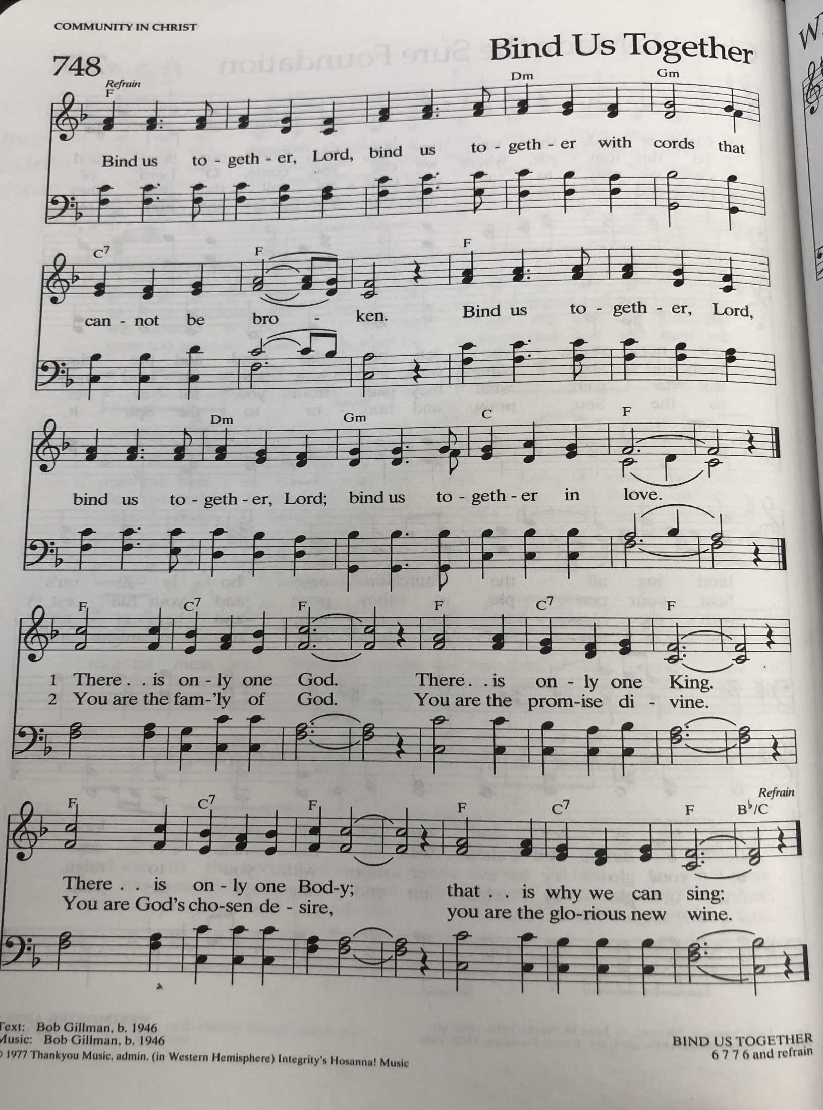
cREED
I believe in God, the Father almighty,
creator of heaven and earth.
I believe in Jesus Christ, God’s only Son, our Lord,
who was conceived by the Holy Spirit,
born of the virgin Mary,
suffered under Pontius Pilate,
was crucified, died, and was buried;
he descended to the dead.*
On the third day he rose again;
he ascended into heaven,
he is seated at the right hand of the Father,
and he will come to judge the living and the dead.
I believe in the Holy Spirit,
the holy catholic church,
the communion of saints,
the forgiveness of sins,
the resurrection of the body,
and the life everlasting. Amen.

*Or, “he descended into hell,” another translation of this text in widespread use.

prayers of Intercession
Called together in the Spirit’s embrace, let us pray for the renewal of the church, for those in need, and for all of God’s creation.
We pray, holy God, for the unity of the church universal: Draw your people together into one great company of disciples, together following our teacher Jesus Christ to carry out his holy mission, together sharing the good news of your justice and love wherever we are sent. We pray especially for Lutheran Church of the Savior and Rev. Nicole Smith. Christ, be our light.

(sing) Shine in your church gathered today.
We pray, omnipotent God, for the well-being of creation: We give you thanks for transforming the chaotic waters of creation into the saving waters that nourish and sustain all the earth. Renew us every day by your water and your word. Christ, be our light.

(sing) Shine in your church gathered today.
We pray, righteous God, for peace and justice in the world: Lead the nations of the world away from the stony wilderness of sin, and toward the holy light of love, justice, and peace. Christ, be our light.

(sing) Shine in your church gathered today.
We pray, compassionate God, for all in need: For those who hunger and thirst for peace, for belonging, for love, for righteousness, shine your light of justice. For those who mourn or suffer in any way, shine your light of comfort. Christ, be our light.

(sing) Shine in your church gathered today.
We pray, faithful God, for the renewal of all life: Refresh us with your living water and anoint us with your Holy Spirit. Embolden us with your promise and your presence. Christ, be our light.

(sing) Shine in your church gathered today.
Receive our thanksgiving, eternal God, for all who have died in the faith. May we know the fullness of the new life that you prepare for us in your kingdom. Christ, be our light.

(sing) Shine in your church gathered today.
All these things, and whatever else you see that we need, we entrust to your care through Jesus Christ.
Amen.

Lord’s Prayer
Gathered into one by the Holy Spirit, let us pray as Jesus taught us.
Our Father in heaven,
hallowed be your name,
your kingdom come,
your will be done,
on earth as in heaven.
Give us today our daily bread.
Forgive us our sins
as we forgive those who sin against us.
Save us from the time of trial
and deliver us from evil.
For the kingdom, the power,
and the glory are yours,
now and forever. Amen.

Peace
The peace of Christ be with you always.
And also with you.

Offering

Offering song

Offering Prayer
God of grace, you have showered us with gifts of grace and abundance, entrusting to us the ministries of Women of the ELCA. Help us to grow in faith, affirm our gifts, support one another in our callings, engage in ministry and action, and promote healing and wholeness in the church, the society, and the world.
Accept these gifts and our prayer that, nurtured by your Word, filled with your Spirit, and fed at your table, we may share with gladness all that you have shared with us, until all creation is satisfied.
Amen.

Sending
Our God calls us to do justice. May you find strength in God’s grace.

Amen.

Christ Jesus calls us to love kindness. May you find comfort in Christ’s gentleness.

Amen.

The Holy Spirit calls us to walk humbly with our triune God. May you always find joy in God’s love and justice.
Amen.

Holy Trinity + One God, bless you now and forever.

Amen.

Sending SonG “On Eagle’s Wings ” ELW 787

Dismissal
Rejoice and be glad in the light of God’s love! Let us go forth in peace to share the good news.
Thanks be to God.

From sundaysandseasons.com. Copyright © 2017 Augsburg Fortress. All rights reserved.

THANK YOU TO ALL WHO SERVED TODAY:
Presider: Buffy Meyers
Musician: Martha Yoder
Elder: Jolene Griffin
Trustee: Jerry Engle
Offering Counters: Mary Makley & Martha Yoder
Safety Person: Diane Griffin

This week at Zion:
- Bulletin and Newsletter deadline are this week Tuesday evening
- Tara and Pastor Becky will be in the office on Wednesday, November 24
- Men’s Coffee, Wednesday, November 24 at 8AM
- Thanksgiving, Thursday, November 25, Office closed
- Free Christmas Tree Farm Friday, Nov. 26 10-4; Saturday, Nov. 27 10-1

Save the date
- Dec 15: 2 service, Longest night, in person

ANNOUNCEMENTS

- Welcome to the ZLCW Thankoffering service. Donations collected will be sent to the Women of the ELCA to help with their many projects. Thank you to all the women helping with our service today. Thankoffering envelopes are in your mailbox and by the basket for the donations on the offering table.
- Dana Traub Memorial Hymn Sing: There will be a memorial hymn sing at the Sunfield museum, today at 3 PM memorial for Dana. All are welcome
- Heating: Now that we are in the heating season, please close all the doors to the sanctuary and fellowship hall when they are not in use. The Sunday School classroom doors need to stay open, as does the door from the Fireside Lounge to the Sunday School area. Thank you.
- Newsletter: Sorry for any confusion on last month’s newsletter. We are switching to a mainly email/online newsletter. If you need a November newsletter, there are extras in the narthex. There is a list in the narthex for those who would like to continue to receive a hard copy. If your name is not already on the list and you’d like to be added, please do so.
- Christmas Basket:s: Zion is once again participating in the Lakewood Community Council Christmas Basket Project. A Thrivent Grant has been received for Christmas gifts for 7 eight year old girls and for 6 seven year old boys. There will be limited money to purchase some hats, mittens and socks for children.
The need from Zion now is to purchase additional hats, mittens and socks for children. Additionally, money is needed to purchase other items for the Christmas boxes for needy families. Please give generously for the need is great.
The Christmas decorated donation boxes will be located either (on the east end of the Fellowship Hall, near the mailboxes, or on the east end of the steps as you enter from the east.) For more information, please look in the November Newsletter. Thank you for your generosity!
- Thank you! Thank you to the Willard family for donating the new basketball hoop in memory of Mark. It is able to change heights, so can be lowered for the younger children, as well as raised for the older youth and adults.
- Thank you! Terry and I thank you for the gift basket for pastor appreciation month! We love all of the goodies in it, and Foxy was very happy to be remembered as well. Thank you so much for all your love and generosity. We really appreciate it!
~Pastor Becky and Terry (and Foxy)

