ZION LUTHERAN CHURCH, WOODLAND, MI
Congregational Memorial Service
November 7, 2021
*If you are listening in your car, please tune your radio to FM 87.7*

WELCOME

INVOCATION
The grace of our Lord Jesus Christ, the love of God and the communion of the Holy Spirit be with you all.
And also with you

“Remember Me” by Margaret Mead

Read by Mary Smith

I cannot speak, but I can listen.
I cannot be seen, but I can be heard.
So as you stand upon a shore gazing at a beautiful sea,
As you look upon a flower and admire its simplicity,
Remember me.
Remember me in your heart:
Your thoughts, and your memories,
Of the times we loved,
The times we cried,
The times we fought,
The times we laughed.
For if you always think of me, I will never have gone.

GATHERING HYMN “Shall We Gather at the River” ELW 423

PRAYER OF THE DAY
My brothers and sisters, we believe that all the ties of family, friendship and affection which knit us together throughout our lives do not unravel in death. Confident of God’s love even in the face of death, let us pray.
(Order of Christian Funerals)

Lord Jesus, our saddened hearts wait for your comfort and peace. We do not accept death easily, and we are reluctant to surrender our loved ones and friends to the place that you have prepared for them. You know our sorrow, O Lord, you understand our tears; for you also wept at the death of a friend. Let the Holy Spirit, the comforter you promise, testify in our hearts to your loving presence. Be our constant companion, Lord, as we live through the days ahead, that as we mourn, we may give witness to our living faith in you. Through Jesus Christ our Lord. Amen
(Uniting Church Worship Services, adapted)

READING Psalm 23 (read responsively)
Led by Pastor Becky

¹The LORD is my shepherd, I shall not want.
²He makes me lie down in green pastures;
he leads me beside still waters;
³he restores my soul.
He leads me in right paths for his name's sake.
⁴Even though I walk through the darkest valley,
I fear no evil; for you are with me;
your rod and your staff, they comfort me.
⁵You prepare a table before me
in the presence of my enemies;
you anoint my head with oil;
my cup overflows.
⁶Surely goodness and mercy shall follow me
all the days of my life,
and I shall dwell in the house of the LORD
my whole life long.

Special Music: SPECIAL MUSIC “Children of the Heavenly Father”
Sung by Ruth Brecheisen and Pastor Becky

READING Revelation 7:7-17
Read by Karen Heise

⁷from the tribe of Simeon twelve thousand,
from the tribe of Levi twelve thousand,
from the tribe of Issachar twelve thousand,
⁸from the tribe of Zebulun twelve thousand,
from the tribe of Joseph twelve thousand,
from the tribe of Benjamin twelve thousand sealed.
⁹After this I looked, and there was a great multitude that no one could count, from every nation, from all tribes and peoples and languages, standing before the throne and before the Lamb, robed in white, with palm branches in their hands. ¹⁰They cried out in a loud voice, saying,
"Salvation belongs to our God who is seated on the throne, and to the Lamb!"
¹¹And all the angels stood around the throne and around the elders and the four living creatures, and they fell on their faces before the throne and worshiped God, ¹²singing,
"Amen! Blessing and glory and wisdom
and thanksgiving and honor
and power and might
be to our God forever and ever! Amen."
¹³Then one of the elders addressed me, saying, "Who are these, robed in white, and where have they come from?" ¹⁴I said to him, "Sir, you are the one that knows." Then he said to me, "These are they who have come out of the great ordeal ;they have washed their robes and made them white in the blood of the Lamb.
¹⁵For this reason they are before the throne of God,
and worship him day and night within his temple,
and the one who is seated on the throne will shelter them.
¹⁶They will hunger no more, and thirst no more;
the sun will not strike them,
nor any scorching heat;
¹⁷for the Lamb at the center of the throne will be their shepherd,
and he will guide them to springs of the water of life,
and God will wipe away every tear from their eyes."

SHARING OF MEMORIES
*After memories are shared for each person, a member of each family is invited to come forward to receive a memorial leaf from the tree. After the service, other family members can take a leaf as well.
- Chuck Bursley Claude Smith
- Betty Hynes Orie Murray, read by Buffy Meyers
- Mark Willard Jerry and Carol Engle, read by KarenHeise

HYMN “Precious Lord, Take My Hand” ELW 773

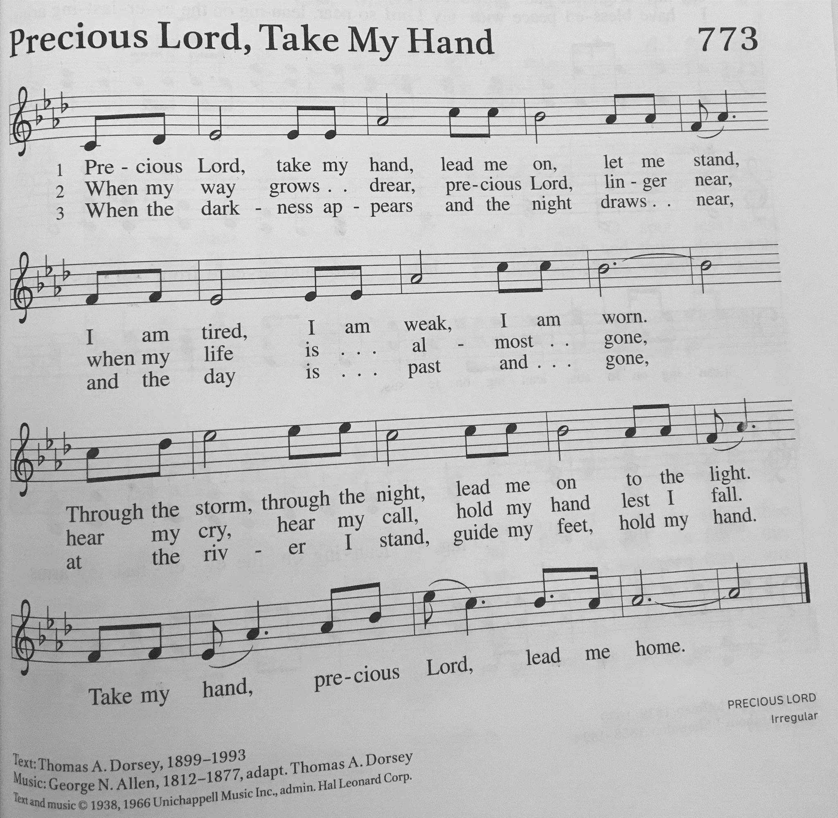

SHARING OF MEMORIES
- Irene Ames Carolyn Breheisen
- Dana Traub Marie Brodbeck
- Jerry Southgate Arlene Forman

HYMN OF THE DAY When We All Get to Heaven
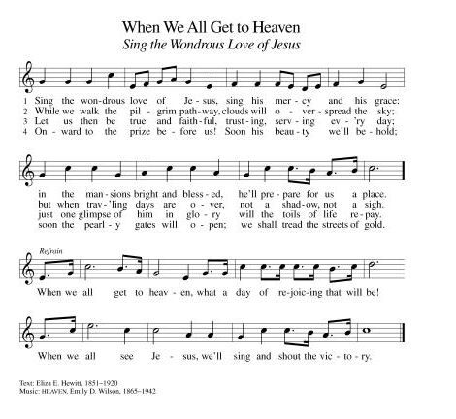

GOSPEL READING John 14: 1-6
Read by Pastor Becky
The holy gospel according to John.
Glory to you, O Lord.

¹Do not let your hearts be troubled. Believe in God, believe also in me. ²In my Father's house there are many dwelling places. If it were not so, would I have told you that I go to prepare a place for you? ³And if I go and prepare a place for you, I will come again and will take you to myself, so that where I am, there you may be also. ⁴And you know the way to the place where I am going." ⁵Thomas said to him, "Lord, we do not know where you are going. How can we know the way?" ⁶Jesus said to him, "I am the way, and the truth, and the life. No one comes to the Father except through me.

The gospel of the Lord.
Praise to you, O Christ.

SPECIAL MUSIC “Softly and Tenderly”
Sung by Dan and Cindy Utterback

RESPONSIVE PRAYER
Led by Dan Utterback

A Litany of Remembrance – We Remember Them
by Rabbi Sylvan Kamens and Rabbi Jack Riemer

In the rising of the sun and in its going down,
we remember them.
In the blowing of the wind and in the chill of winter,
we remember them.
In the opening of buds and in the rebirth of spring,
we remember them.
In the blueness of the sky and in the warmth of summer,
we remember them.
In the rustling of leaves and in the beauty of autumn
we remember them.
In the beginning of the year and when it ends,
we remember them.
When we are weary and in need of strength,
we remember them.

When we are lost and sick at heart,
we remember them.
When we have joys we yearn to share,
we remember them.
So long as we live, they too shall live, for they are now a part of us,
as we remember them.
( From Gates of Prayer, published by Central Conference of American Rabbis.)

Lord’s Prayer
Lord, remember us in your kingdom and teach us to pray.
Our Father, who art in heaven,
hallowed be thy name,
thy kingdom come,
thy will be done,
on earth as it is in heaven.
Give us this day our daily bread;
and forgive us our trespasses,
as we forgive those
who trespass against us;
and lead us not into temptation,
but deliver us from evil.
For thine is the kingdom,
and the power, and the glory,
forever and ever. Amen.

BLESSING
May the love of God and the peace of our Lord Jesus Christ bless and console us, and gently wipe every tear from our eyes, in the name of the Father and of the Son and of the Holy Spirit. Amen
(Order of Christian funerals)

SENDING HYMN “For All the Saints” ELW 422

Dismissal
Go in peace. Share the good news.
Thanks be to God.

From sundaysandseasons.com. Copyright © 2017 Augsburg Fortress. All rights reserved.

- Please join us in the fellowship hall following the service for refreshments.

- A big thank you to Dawn Brodbeck for making the memory leaves as mementos for the families!

