ZION LUTHERAN CHURCH, WOODLAND, MI
Second Sunday of Christmas, January 2, 2022
*If you are listening in your car, please tune your radio to FM 87.7*

ANNOUNCEMENTS & PRELUDE

Gathering
The Holy Spirit calls us together as the people of God.

Confession and Forgiveness
Blessed be the holy Trinity, ☩ one God, who looks upon us in compassion,
forgives our sin, and heals our lives.
Amen.

Let us confess our sin in the presence of God and of one another. Have mercy, O God,
against you, you alone, we have sinned.
In your compassion, cleanse us from our sin and take away our guilt.
Create in us a new heart and give us a steadfast spirit. Do not cast us away, but fill us with your Holy Spirit and restore your joy within us. Amen.

As tender as parent to child, so deep is God’s compassion for you.
As high as heaven is above earth, so vast is God’s love for you.
As far as east is from west, so far God removes your sin from you, renewing your life through Jesus Christ. Blessed be God who crowns us with mercy and love.
Blessed be God forever.

Gathering Song “The First Noel” ELW 300
GREETING
The grace of our Lord Jesus Christ, the love of God, and the communion of the Holy Spirit be with you all.
And also with you.

Prayer of the Day
Let us pray together.
Almighty God, you have filled all the earth with the light of your incarnate Word. By your grace empower us to reflect your light in all that we do, through Jesus Christ, our Savior and Lord, who lives and reigns with you and the Holy Spirit, one God, now and forever. Amen.

First Reading Jeremiah 31:7-14
A reading from Jeremiah.

⁷Thus says the Lord:
Sing aloud with gladness for Jacob,
and raise shouts for the chief of the nations;
proclaim, give praise, and say,
“Save, O Lord, your people,
the remnant of Israel.”
⁸See, I am going to bring them from the land of the north,
and gather them from the farthest parts of the earth,
among them the blind and the lame,
those with child and those in labor, together;
a great company, they shall return here.
⁹With weeping they shall come,
and with consolations I will lead them back,
I will let them walk by brooks of water,
in a straight path in which they shall not stumble;
for I have become a father to Israel,
and Ephraim is my firstborn.
¹⁰Hear the word of the Lord, O nations,
and declare it in the coastlands far away;
say, “He who scattered Israel will gather him,
and will keep him as a shepherd a flock.”
¹¹For the Lord has ransomed Jacob,
and has redeemed him from hands too strong for him.
¹²They shall come and sing aloud on the height of Zion,
and they shall be radiant over the goodness of the Lord,
over the grain, the wine, and the oil,
and over the young of the flock and the herd;
their life shall become like a watered garden,
and they shall never languish again.
¹³Then shall the young women rejoice in the dance,
and the young men and the old shall be merry.
I will turn their mourning into joy,
I will comfort them, and give them gladness for sorrow.
¹⁴I will give the priests their fill of fatness,
and my people shall be satisfied with my bounty,
says the Lord.

The word of the Lord.
Thanks be to God.

Psalm Psalm 147:12-20

¹²Worship the Lord, | O Jerusalem;
praise your | God, O Zion,
¹³who has strengthened the bars | of your gates
and has blessed your chil- | dren within you.
¹⁴God has established peace | on your borders
and satisfies you with the | finest wheat.
¹⁵God sends out a command | to the earth,
a word that runs | very swiftly. R
¹⁶God gives | snow like wool,
scattering | frost like ashes.
¹⁷God scatters | hail like bread crumbs.
Who can stand a- | gainst God’s cold?
¹⁸The Lord sends forth the | word and melts them;
the wind blows, and the | waters flow.
¹⁹God declares the | word to Jacob,
statutes and judg- | ments to Israel.
²⁰The Lord has not done so to any | other nation;
they do not know God’s judgments. | Hallelujah!

Second Reading Ephesians 1:3-14
A reading from Ephesians.

³Blessed be the God and Father of our Lord Jesus Christ, who has blessed us in Christ with every spiritual blessing in the heavenly places, ⁴just as he chose us in Christ before the foundation of the world to be holy and blameless before him in love. ⁵He destined us for adoption as his children through Jesus Christ, according to the good pleasure of his will, ⁶to the praise of his glorious grace that he freely bestowed on us in the Beloved. ⁷In him we have redemption through his blood, the forgiveness of our trespasses, according to the riches of his grace ⁸that he lavished on us. With all wisdom and insight ⁹he has made known to us the mystery of his will, according to his good pleasure that he set forth in Christ, ¹⁰as a plan for the fullness of time, to gather up all things in him, things in heaven and things on earth. ¹¹In Christ we have also obtained an inheritance, having been destined according to the purpose of him who accomplishes all things according to his counsel and will, ¹²so that we, who were the first to set our hope on Christ, might live for the praise of his glory. ¹³In him you also, when you had heard the word of truth, the gospel of your salvation, and had believed in him, were marked with the seal of the promised Holy Spirit; ¹⁴this is the pledge of our inheritance toward redemption as God’s own people, to the praise of his glory.

The word of the Lord.
Thanks be to God.

Gospel Acclamation
Alleluia. Lord, to whom shall we go?
You have the words of eternal life. Alleluia

Gospel John 1:[1-9] 10-18
The holy gospel according to John.
Glory to you, O Lord.

[¹In the beginning was the Word, and the Word was with God, and the Word was God. ²He was in the beginning with God. ³All things came into being through him, and without him not one thing came into being. What has come into being ⁴in him was life, and the life was the light of all people. ⁵The light shines in the darkness, and the darkness did not overcome it.
⁶There was a man sent from God, whose name was John. ⁷He came as a witness to testify to the light, so that all might believe through him. ⁸He himself was not the light, but he came to testify to the light. ⁹The true light, which enlightens everyone, was coming into the world.]
¹⁰He was in the world, and the world came into being through him; yet the world did not know him. ¹¹He came to what was his own, and his own people did not accept him. ¹²But to all who received him, who believed in his name, he gave power to become children of God, ¹³who were born, not of blood or of the will of the flesh or of the will of man, but of God.
¹⁴And the Word became flesh and lived among us, and we have seen his glory, the glory as of a father’s only son, full of grace and truth. ¹⁵(John testified to him and cried out, “This was he of whom I said, ‘He who comes after me ranks ahead of me because he was before me.’ ”) ¹⁶From his fullness we have all received, grace upon grace. ¹⁷The law indeed was given through Moses; grace and truth came through Jesus Christ. ¹⁸No one has ever seen God. It is God the only Son, who is close to the Father’s heart, who has made him known.

The gospel of the Lord.
Praise to you, O Christ.

SERMON Pastor Becky Ebb-Speese

Hymn of the Day “Song of the Camels”

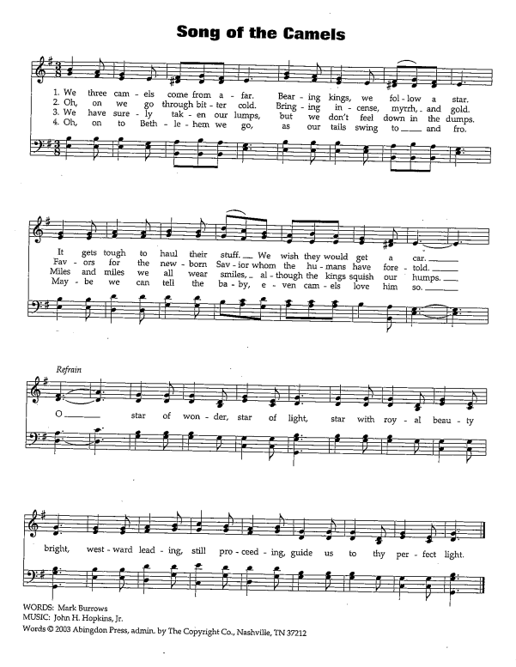
cREED
I believe in God, the Father almighty,
creator of heaven and earth.
I believe in Jesus Christ, God’s only Son, our Lord,
who was conceived by the Holy Spirit,
born of the virgin Mary,
suffered under Pontius Pilate,
was crucified, died, and was buried;
he descended to the dead.*
On the third day he rose again;
he ascended into heaven,
he is seated at the right hand of the Father,
and he will come to judge the living and the dead.
I believe in the Holy Spirit,
the holy catholic church,
the communion of saints,
the forgiveness of sins,
the resurrection of the body,
and the life everlasting. Amen.

*Or, “he descended into hell,” another translation of this text in widespread use.

prayers of Intercession
Joining our voices with the heavenly host and Christians throughout time and space, let us pray for the church, the world, and all in need.
A brief silence.
You make yourself known in the gift of language in diverse forms. Draw our attention to those who communicate through sign, braille, and technology. Make your church a place where all methods of communication are celebrated. We pray especially for St. John Lutheran church and Rev. Russell Logston. Merciful God,
receive our prayer.
Creating God, the sun greets us anew each morning. Thank you for waking us up today to witness and share your abundance. Awaken us always to your wisdom and deepen our care for your natural world. Merciful God,
receive our prayer.
Emmanuel, in your name we are assured that you are with us. Train nations and peoples to honor and respect one another, especially those whose names and identities have been mistreated, neglected, or oppressed. Merciful God,
receive our prayer.
You adopt us as your beloved ones. Accompany parents and children navigating the adoption process, especially those in the foster system. Sustain those struggling with infertility or pregnancy loss. Tenderly embrace all in need. Merciful God,
receive our prayer.
You journey with us through change. Guide those assuming new roles in this congregation or making transitions in their families, workplaces, or communities. As the seasons and the calendar change, equip us for unexpected challenges. Merciful God,
receive our prayer.
We give you thanks for all who modeled lives of loving service. Lead us in your grace until, with all your saints, we enter the fullness of your glory. Merciful God,
receive our prayer.
Rejoicing in your Word made flesh among us, we commend these prayers to you, confident of your grace and love made known to us in Jesus Christ, our Savior.
Amen.

Peace
The peace of Christ be with you always.
And also with you.

Offering & Offering song

Offering Prayer
Let us pray. God of goodness and growth, all creation is yours, and your faithfulness is sure. Word and water, wine and bread: these are signs of your abundant grace. Receive the gifts we bring, and nourish us to proclaim your abiding love in our communities and in the world, through Jesus Christ, our strength and our song.
Amen.

Thanksgiving at the Table
In the night in which he was betrayed,
our Lord Jesus took bread, and gave thanks;
broke it, and gave it to his disciples, saying:
Take and eat; this is my body, given for you.
Do this for the remembrance of me.
Again, after supper, he took the cup, gave thanks,
and gave it for all to drink, saying:
This cup is the new covenant in my blood,
shed for you and for all people for the forgiveness of sin.
Do this for the remembrance of me.

Lord’s Prayer
Gathered into one by the Holy Spirit, let us pray as Jesus taught us.
Our Father, who art in heaven,
hallowed be thy name,
thy kingdom come,
thy will be done,
on earth as it is in heaven.
Give us this day our daily bread;
and forgive us our trespasses,
as we forgive those
who trespass against us;
and lead us not into temptation,
but deliver us from evil.
For thine is the kingdom,
and the power, and the glory,
forever and ever. Amen.

COMMUNION
Taste and see that the Lord is good. You may receive your communion elements.

BLESSING AFTER COMMUNION
The body and blood of our Lord Jesus Christ bless you and keep you in His grace.

Sending
God blesses us and sends us in mission to the world.

Blessing
God, the Source of glory, God, the Word of life, God, the Spirit of truth
☩ bless you all, now and forever.
Amen.

Sending SonG “O Come All Ye Faithful” ELW 283

Dismissal
Go in peace. Christ is with you.
Thanks be to God.

From sundaysandseasons.com. Copyright © 2017 Augsburg Fortress. All rights reserved.

THANK YOU TO ALL WHO SERVED TODAY:

Presider: Pastor Becky Ebb-Speese
Musician: Cindy June
Elder: Paul Meade
Trustee: Mike Johnson
Offering Counters: Doug Mackenzie & Mike Johnson
Safety Person: Jerry Engle

This week at Zion:
- Confirmation class today at 11:30 AM
- Lakewood Ministerial Association, Wednesday, January 5 at 9 AM

Save the Date:
- Annual meeting: January 16, after service

ANNOUNCEMENTS

- Decorations: Hopefully everyone had a blessed Christmas, enjoying the true meaning of the season! As you start to take down or think about taking down your Christmas decorations, if there are any you no longer have room for or no longer want, please consider donating to our 2022 Free Christmas Tree Farm that we will host in November. This year the fellowship hall was full of trees, ornaments, decorations, wrapping paper and so much Christmas spirit. The items were free for those in our community who needed Christmas decorations. If you need someone to pick them up from your house, please let Jolene or Martha know, we can make arrangements to get them.
- Thank you: Thank you to everyone who contributed and helped deliver the packages for the Lakewood Community Council's annual Christmas Baskets this year. A special thank you to Claude and Mary Smith. They each applied for and received $250.00 grants from Thrivent Financial. Mary's $250.00 action team grant was used to purchase gifts for 7 girls and 6 boys. She had the Sunday School class help wrap the gifts on December 5th. With some remaining money, she purchased socks. Claude's action team $250.00 grant was to purchase a large crate of apples. He got the apples and met his team of men at Central United Methodist Church. The Co-0p Elevator used their forklift to get the large crate out of the truck and then the men bagged and put the apples in the boxes for each family. All the items collected at Zion were taken to Central the week of packing. Did you know that Claude is now the president of the LCC? Merry Christmas
- Men’s Coffee: Wednesday morning men’s coffee will not meet again until after the New Year.
- Heating: Now that we are in the heating season, please close all the doors to the sanctuary and fellowship hall when they are not in use. The Sunday School classroom doors need to stay open, as does the door from the Fireside Lounge to the Sunday School area. Thank you.

