ZION’S MESSENGER
December 2021 + Zion Lutheran Church + 269-367-4817
Pastor Becky Emergency Phone: 616-265-2862
Email Address: pastorbecky@zionwoodland.org

I really love hearing Handel’s Messiah, especially this time of year. And I am so thankful that I had a number of opportunities to sing in choirs that performed it over the years. Rather than listen to the mostly secular and often terrible renditions of Christmas carols that get played over and over again on the radio ( I will admit to being a Christmas music snob!) I often turn to my recording of the Messiah. So many of the words come from the prophet Isaiah, so when I read the many texts from Isaiah during the Advent season, I find myself singing the music from the Messiah. When I was a teen, I remember highlighting all the places where the words of the Messiah were located in my Bible. There are other scriptures included as well, but the bulk of the songs do come from Isaiah.
So, this Advent season, I encourage you to focus some time on the book of Isaiah. The words of this prophet offer much comfort and encouragement to be joyful in the midst of difficult and uncertain times. The book of Isaiah is full of prophecies about the coming of the Messiah, Jesus. This was true for the people of Israel, who were living in exile when Isaiah spoke God’s word to them, and it still true for us today. As we end a year with the pandemic still raging in Michigan at a time when we all hoped and imagined it would be over by now, in the midst of continued political and racial unrest, we need to be encouraged by the words from Isaiah and the music of the Messiah.

One of my favorite passages is Isaiah 40. It begins with words of comfort. “Comfort, O comfort my people, says your God. Speak tenderly to Jerusalem, and cry to her that she has served her term and her penalty is paid, that she has received from the Lord’s hand double for all her sins.” (vs.1-2). Then we hear about the words of John the Baptist who was called to prepare the way for the Lord as a voice crying out in the wilderness. (vs3-5). Then comes one of the most beautiful pieces in the Messiah, in my mind, “He will feed his flock like a shepherd; he will gather the lambs in his arms, and carry them in his bosom, and gently lead the mother sheep.” (vs. 11-12). And finally, I would like you to turn your attention to Isaiah 60:1-2 and hear these joyful words of promise that a better time is coming. “Arise, shine; for your light has come, and the glory of the Lord has risen upon you. For darkness shall cover the earth, and thick darkness the peoples; but the Lord will arise upon you, and his glory will appear over you.”
The message of Advent and Christmas is that God is with us. God brings comfort, peace and joy in the midst of our lives. Our light truly has come and let us rejoice in it this season in all that we do in our preparations and celebrations.

Pastor Becky +

HEATING SEASON
Now that we are in the heating season, please close the doors to the Sanctuary and Fellowship Hall when they are not in use. The Sunday School classroom doors need to stay open and the door from the Fireside Lounge to the Sunday School area. Thank you.

REQUEST FOR
LAY PREACHERS IN 2022
Pastor Becky is moving her Sundays off to the 4th Sunday of the month. For the first months of the year, lay preachers are needed for Jan. 23, Feb. 27. Please let Pastor Becky know of your availability. Thank you!

2022 ANNUAL MEETING
The 2022 Annual Meeting will be held on Sunday, January 16, 2022, immediately following worship service. Please mark your calendar and plan to attend this important meeting.

NOMINATIONS COMMITTE
The Nominations Committee is continuing its work to identify people who are willing to serve on council and boards. Of special need is someone to serve as president of our congregation. Please prayerfully consider how you might serve in the coming year and let contact any member of the Nominating Committee with your interest: Ken Heise, Lisa Krikke, Buffy Meyers, and Jill Plummer.

THANK YOU!
Thank you to the Willard family for donating the new basketball hoop in memory of Mark. It can be lowered for younger children and raised for older youth and adults.
THANK YOU!
The ZLCW would like to thank Jolene Griffin, Janine Frizzell, Karen Heise, Carlotta Willard, Dawn Brodbeck, and Martha Yoder for being a part of Zion's Thankoffering Service. A special thank you to Carol Engle for making sure that the Thankoffering monies get to the national organization. These offering go for programs and scholarships for women. We appreciate all the support we get every year.
Also, thank you so much for the generous donations. We collected a total of $441.The donations will be sent, in a couple of weeks, to the Women of the ELCA for their programs. If anyone wishes to receive a tax receipt for their donation, see Carol Engle, the ZLCW treasurer.

THANK YOU!
Thank you to all who have helped with the big job of lawn care this year. We have many willing helpers who trimmed bushes and trees, pulled weeds, weed whipped, changed parking lot light bulbs and other need tasks. A special thank you to Mike Johnson for mowing the parsonage and church lawns all season except for just a few times. Also, a special thank you to Laurie Krikke for providing summer and fall flowers, planting, weeding and watering them. Zion is blessed to have willing members that help keep our lawns looking nice.
THANK YOU!
Terry and I thank you for the gift basket for pastor appreciation month! We love all of the goodies in it and Foxy was very happy to be remembered as well.
Thank you so much for your generosity and love! We really appreciate it,
Pastor Becky and Terry
ZION CHRISTMAS TREE FARM AND MARKET
A heartfelt thank you to everyone who donated items, made cookies, helped with set-up/clean-up, and worked during the event. Our first-ever free Christmas store was a huge success. All of the Christmas trees and most of the ornaments and décor found new homes during the two-day event. There were people of all ages and many surrounding communities who participated. Their stories made us realize how much this mission project was needed. There are a sample of the stores we heard:
-An elderly man with cancer and a wife in ill health were no longer able to put of the big Christmas Tree and decorations that they had in the past. He was so happy to find a small Christmas tree to bring cheer into their home.
-A military wife from Hastings and her teen-age son were told of the event from a friend. Her husband is stationed in California and not able to come home for the holiday. She did not feeling like putting up a tree, but her son wanted one so she brought him to our event. She was given the last large tree and she spent considerable time picking out ornaments while her son had hot chocolate and cookies They both left with lots of nice Christmas items and smiles on both faces!
-A homebound woman who cared for her paralyzed partner called to asked if there was any way she could receive a small tree and ornaments. We delivered a tree, ornaments and décor including a nativity scene. The women was overjoyed and gave hugs, kisses, and lots of thanks.

-A Hispanic family consisting of a father, mother, and three small children from Middleville were told of our event and came for a tree and decorations. The mother could not speak English and one of the daughters translated for her. They picked out a tree, ornaments and some décor. The children enjoyed hot chocolate and cookies. They were very thankful for everything they received.
-A young father of six children picked out ornaments and décor for his family. He was extremely thankful for all the lovely things he was able to take home to his family.
-A young woman out on her own for the first year found a small tree and ornaments. She said she was “obsessed” with how pretty the tree was and how wonderful it was that we did this for the community.
There are lots more stores but this sample gives an idea of how much all of the items donated were appreciated. Thank you all again for your generosity. We want to hold this event again next year so as you as putting away your items after Christmas, if there are things that you cannot use, please bring them to the church and we will use them next year.
We were also so happy that WZZM Channel 13 from Grand Rapids sent two reporters to our event. Our Zion Christmas Tree Farm and Market was featured on both the Friday and Saturday news shows. If you missed the broadcast, you can go to their website to view the broadcasts. One featured Jolene Griffin and the other Martha Yoder.

LONGEST NIGHT
We will again hold a Longest Night service on Wed. Dec. 15 with a choice of times at 1:00 pm and 7:00 pm. This is a service, also known as Blue Christmas, to be held close to the date of the longest night, which is Dec. 21. It is a service to acknowledge losses that we deal with in our lives which can make being joyful difficult in this season that is so focused on being happy and excited. Christmas can be a very lonely and difficult holiday for those dealing with losses of loved ones and losses in life circumstances. This service is meant to bring quiet reflection, prayer and comfort. You are invited to bring pictures of loved ones no longer with you to set by the altar.

Diane Southgate has a new Temporary Address:
2414 Maple Road
Saginaw, MI 48601
989-220-8619

BOARD OF STEWARDSHIP INFORMATION
There have some inquiries about the item on the Offering envelope called "Benevolence". The Board of Stewardship thought it would be good to explain where the money goes and how much Zion pledged to give each year. The year 2021 we pledged $4,000. Where does it go?
Here is an example of the 2022 budget. We send in $4000, $2,000 stays in our North West Lower Michigan Synod and $2000 goes on to the ELCA Church Wide support.
Please see the following page for more specifics.

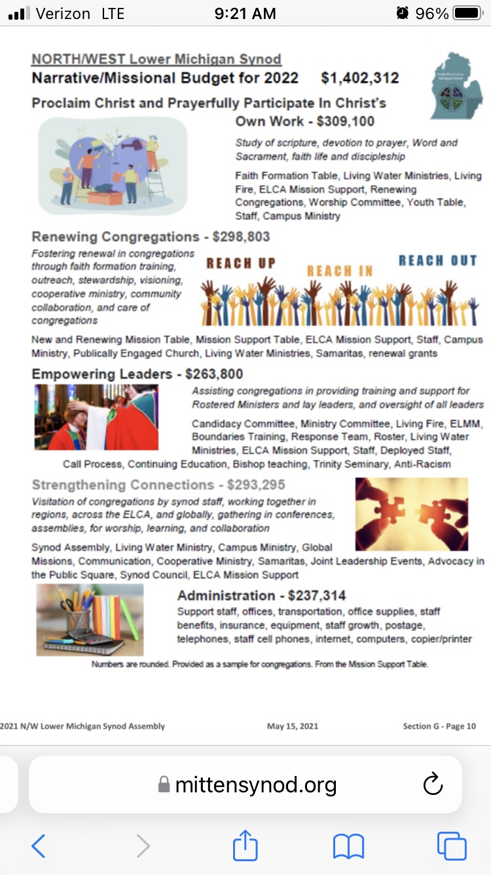

LAKEWOOD COMMUNITY COUNCIL CHRISTMAS BASKET PROJECT
Mary Smith received an Action Grant from Thrivent Financial to purchase the children's gifts and a limited number of hats, socks and mittens for children. You may contribute any size hats, warm winter mittens/gloves and socks. Also needed is cash to purchase meat certificates and food. You may add cash to your offering envelope and the office will get it to the Lakewood Community Council. There will be a box in the Fellowship Hall at Zion in which to put your gifts. Especially needed are water-resistant mittens/gloves. We will take Zion's contributions to Central United Methodist Church on Wednesday, December 8 before noon.

Volunteers are needed to help package, wrap, and deliver basket. It is not expected that the number of volunteers will be limited, but feel free to call ahead. Central UM Church, where we pack our boxes currently recommends wearing masks. We have not made a decision about masks at this point, so please plan to come prepared to wear one if requested. Delivery volunteers will leave the packages on doorsteps and not enter homes whenever possible.

Here is the Christmas Basket schedule:
- Sunday, December 5, Zion's Action Team will meet to wrap the gifts.
The Sunday School folks will be asked to help with this.
- Tuesday, December 7,
7 pm to 9 pm (This is tentative, please call ahead.)
- Wednesday, December 8,
9 am to 2:30 pm (Distribute food into boxes.)
- Thursday, December 9,
9 am to 2:30 pm (Pack boxes and gift bags)
- Friday, December 10
9 am to noon. (Wrap boxes and transfer gifts. This is tentative. Please call ahead.)
- Saturday, December 11
9 a.m. to noon. Deliver boxes to families.

SUNDAYS IN DECEMBER

December 5- In Sanctuary & Drive-in, Communion
Pastor Becky Ebb-Speese
Elder: Jolene Griffin
Trustee: Dan Zylstra
Safety Person: Dan Zylstra
Offering Counters: Jerry Engle, Carlotta Willard

December 12 In Sanctuary & Drive-in, Communion,, Cole Baptims
Pastor Becky Ebb-Speese
Elder: Dan Utterback
Trustee: Jerry Engle
Safety Person: Jerry Engle
Offering Counters: Doug Mackenzie, Mike Johnson

December 19- Sunday School Program
ZLCW Women
Elder: Paul Meade
Trustee: Mike Johnson
Safety Person: Diane Griffin
Offering Counters: Mary Makley, Martha Yoder

December 24- In Sanctuary & Drive-in, Communion,, 7:00 PM
Pastor Becky Ebb-Speese
Elder: Jolene Griffin
Trustee: Dan Zylstra
Safety Person: Ken Heise
Acolyte: Emil Meyers
Offering Counters: Diane Griffin & Carlotta Willard

December 26 – Service of Lessons and Carols
Elder: Dan Utterback
Trustee: Jerry Engle
Safety Person: Dan Zylstra
Offering Counters: Jerry Engle & Carlotta Willard

