ZION LUTHERAN CHURCH, WOODLAND, MI
Eighth Sunday after Epiphany, February 27, 2022
*If you are listening in your car, please tune your radio to FM 87.7*

ANNOUNCEMENTS & PRELUDE

Gathering
The Holy Spirit calls us together as the people of God.

Confession and Forgiveness
Blessed be the holy Trinity, ☩ one God, who looks upon us in compassion,
forgives our sin, and heals our lives.
Amen.

Let us confess our sin in the presence of God and of one another. Have mercy, O God,
against you, you alone, we have sinned.
In your compassion, cleanse us from our sin and take away our guilt.
Create in us a new heart and give us a steadfast spirit. Do not cast us away, but fill us with your Holy Spirit and restore your joy within us. Amen.

As tender as parent to child, so deep is God’s compassion for you.
As high as heaven is above earth, so vast is God’s love for you.
As far as east is from west, so far God removes your sin from you, renewing your life through Jesus Christ. Blessed be God who crowns us with mercy and love.
Blessed be God forever.

Gathering Song “How Good, Lord, to Be Here!” ELW 315
GREETING
The grace of our Lord Jesus Christ, the love of God, and the communion of the Holy Spirit be with you all.
And also with you.

Prayer of the Day
Let us pray together.
Holy God, mighty and immortal, you are beyond our knowing, yet we see your glory in the face of Jesus Christ. Transform us into the likeness of your Son, who renewed our humanity so that we may share in his divinity, Jesus Christ our Lord, who lives and reigns with you and the Holy Spirit, one God, now and forever. Amen.

First Reading Exodus 34:29-35
A reading from Exodus.

²⁹Moses came down from Mount Sinai. As he came down from the mountain with the two tablets of the covenant in his hand, Moses did not know that the skin of his face shone because he had been talking with God. ³⁰When Aaron and all the Israelites saw Moses, the skin of his face was shining, and they were afraid to come near him. ³¹But Moses called to them; and Aaron and all the leaders of the congregation returned to him, and Moses spoke with them. ³²Afterward all the Israelites came near, and he gave them in commandment all that the Lord had spoken with him on Mount Sinai. ³³When Moses had finished speaking with them, he put a veil on his face; ³⁴but whenever Moses went in before the Lord to speak with him, he would take the veil off, until he came out; and when he came out, and told the Israelites what he had been commanded, ³⁵the Israelites would see the face of Moses, that the skin of his face was shining; and Moses would put the veil on his face again, until he went in to speak with him.

The word of the Lord.
Thanks be to God.

Psalm Psalm 99

¹The Lord is king; let the | people tremble.
The Lord is enthroned upon the cherubim; let | the earth shake.
²The Lord, | great in Zion,
is high a- | bove all peoples.
³Let them confess God’s name, which is | great and awesome;
God is the | Holy One.
⁴O mighty king, lover of justice, you have es- | tablished equity;
you have executed justice and righteous- | ness in Jacob.
⁵Proclaim the greatness of the Lord and fall down be- | fore God’s footstool;
God is the | Holy One.
⁶Moses and Aaron among your priests, and Samuel among those who call upon your | name, O Lord,
they called upon you, and you | answered them,
⁷you spoke to them out of the pil- | lar of cloud;
they kept your testimonies and the decree | that you gave them.
⁸O Lord our God, you answered | them indeed;
you were a God who forgave them, yet punished them for their | evil deeds.
⁹Proclaim the greatness of the Lord and worship upon God’s | holy hill;
for the Lord our God is the | Holy One.
Second Reading 2 Corinthians 3:12-4:2
A reading from 2 Corinthians.

¹²Since, then, we have such a hope, we act with great boldness, ¹³not like Moses, who put a veil over his face to keep the people of Israel from gazing at the end of the glory that was being set aside. ¹⁴But their minds were hardened. Indeed, to this very day, when they hear the reading of the old covenant, that same veil is still there, since only in Christ is it set aside. ¹⁵Indeed, to this very day whenever Moses is read, a veil lies over their minds; ¹⁶but when one turns to the Lord, the veil is removed. ¹⁷Now the Lord is the Spirit, and where the Spirit of the Lord is, there is freedom. ¹⁸And all of us, with unveiled faces, seeing the glory of the Lord as though reflected in a mirror, are being transformed into the same image from one degree of glory to another; for this comes from the Lord, the Spirit.
^{4:1}Therefore, since it is by God’s mercy that we are engaged in this ministry, we do not lose heart. ²We have renounced the shameful things that one hides; we refuse to practice cunning or to falsify God’s word; but by the open statement of the truth we commend ourselves to the conscience of everyone in the sight of God.

The word of the Lord.
Thanks be to God.

Gospel Acclamation
Alleluia. Lord, to whom shall we go?
You have the words of eternal life. Alleluia

Gospel Luke 9:28-36 [37-43a]
The holy gospel according to Luke.
Glory to you, O Lord.

²⁸Now about eight days after these sayings Jesus took with him Peter and John and James, and went up on the mountain to pray. ²⁹And while he was praying, the appearance of his face changed, and his clothes became dazzling white. ³⁰Suddenly they saw two men, Moses and Elijah, talking to him. ³¹They appeared in glory and were speaking of his departure, which he was about to accomplish at Jerusalem. ³²Now Peter and his companions were weighed down with sleep; but since they had stayed awake, they saw his glory and the two men who stood with him. ³³Just as they were leaving him, Peter said to Jesus, “Master, it is good for us to be here; let us make three dwellings, one for you, one for Moses, and one for Elijah”—not knowing what he said. ³⁴While he was saying this, a cloud came and overshadowed them; and they were terrified as they entered the cloud. ³⁵Then from the cloud came a voice that said, “This is my Son, my Chosen; listen to him!” ³⁶When the voice had spoken, Jesus was found alone. And they kept silent and in those days told no one any of the things they had seen. [
³⁷On the next day, when they had come down from the mountain, a great crowd met him. ³⁸Just then a man from the crowd shouted, “Teacher, I beg you to look at my son; he is my only child. ³⁹Suddenly a spirit seizes him, and all at once he shrieks. It convulses him until he foams at the mouth; it mauls him and will scarcely leave him. ⁴⁰I begged your disciples to cast it out, but they could not.” ⁴¹Jesus answered, “You faithless and perverse generation, how much longer must I be with you and bear with you? Bring your son here.” ⁴²While he was coming, the demon dashed him to the ground in convulsions. But Jesus rebuked the unclean spirit, healed the boy, and gave him back to his father. ^{43a}And all were astounded at the greatness of God.]

The gospel of the Lord.
Praise to you, O Christ.

SERMON Paul Meade

Hymn of the Day “Shine, Jesus, Shine” ELW 671

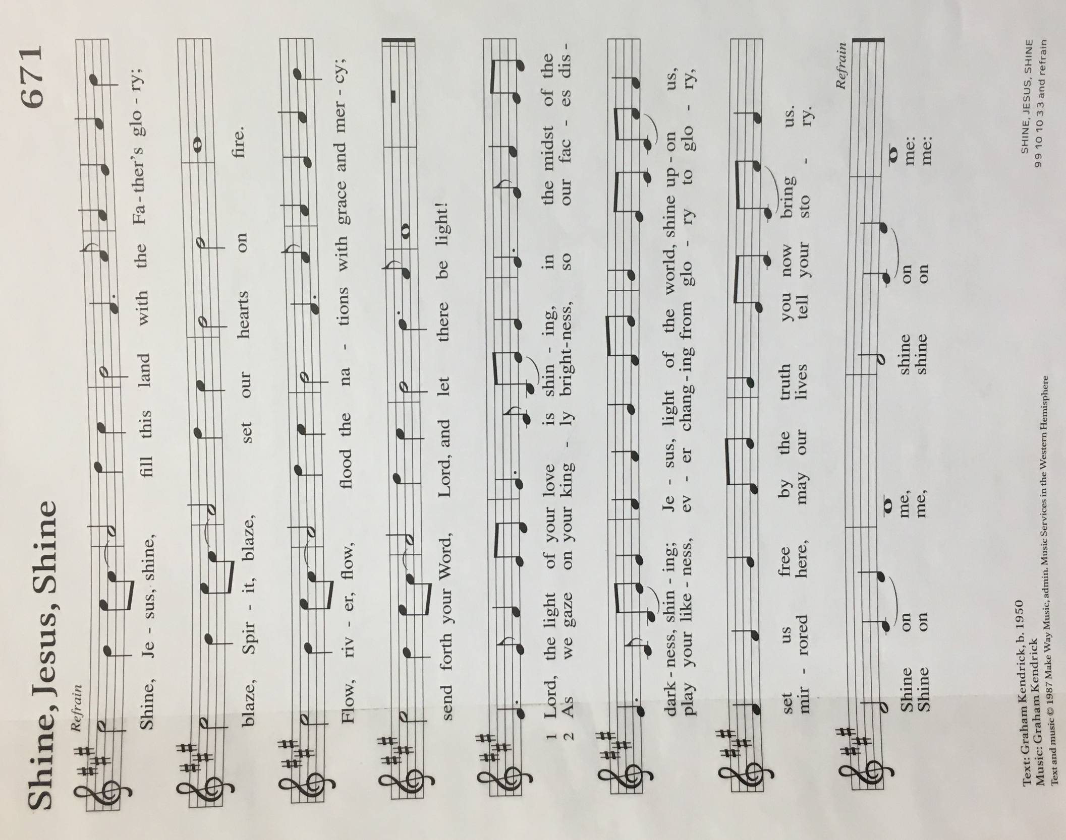
cREED
I believe in God, the Father almighty,
creator of heaven and earth.
I believe in Jesus Christ, God’s only Son, our Lord,
who was conceived by the Holy Spirit,
born of the virgin Mary,
suffered under Pontius Pilate,
was crucified, died, and was buried;
he descended to the dead.*
On the third day he rose again;
he ascended into heaven,
he is seated at the right hand of the Father,
and he will come to judge the living and the dead.
I believe in the Holy Spirit,
the holy catholic church,
the communion of saints,
the forgiveness of sins,
the resurrection of the body,
and the life everlasting. Amen.

*Or, “he descended into hell,” another translation of this text in widespread use.

prayers of Intercession
The Spirit of the Lord is poured out upon us in abundance; so we are bold to pray for the church, the world, and all that God has made.
A brief silence.
Transform us by your greatness, O God. Send us down the mountain to share joy with all people. Make us agents of change, confident that your hope will vanquish despair and your goodness will conquer evil. We pray especially for Trinity Lutheran Church and Rev. William Huether. God of grace,
hear our prayer.
The mountains and valleys sing your praise. Dazzle us with your presence in every landscape: bluffs built by ancient glaciers, canyons carved by flowing rivers, flat horizons with uninterrupted views, and sands shaped by ocean tides. God of grace,
hear our prayer.
You love justice and establish equity. Strengthen leaders of local governments, community nonprofits, and grassroots campaigns. Bless them with gifts of integrity, creativity, and sound conscience. Build up safe and joyful communities where all people may thrive. God of grace,
hear our prayer.

Heal those who are in distress. Give patience to those waiting for answers. Grant hope to those who have reached the limits of treatment. Give compassionate hearts to those who accompany loved ones through illness and uncertainty. God of grace,
hear our prayer.
Today we shout alleluia from the mountaintop; this week we enter the wilderness of Lent. Bless all who prepare and lead us in worship during this change of season: pastors, deacons, musicians, and all who contribute to our worship life (especially). God of grace,
hear our prayer.
Blessed are they who listened to Christ’s voice in this life and now rest with him. Transform us from glory into glory, and give us your peace, that we do not lose heart. God of grace,
hear our prayer.
Since we have such great hope in your promises, O God, we lift these and all of our prayers to you in confidence and faith; through Jesus Christ our Savior.
Amen.

Peace
The peace of Christ be with you always.
And also with you.

Offering & Offering song

Offering Prayer
Let us pray. God of goodness and growth, all creation is yours, and your faithfulness is sure. Word and water, wine and bread: these are signs of your abundant grace. Receive the gifts we bring, and nourish us to proclaim your abiding love in our communities and in the world, through Jesus Christ, our strength and our song.
Amen.

Thanksgiving for the Word
Let us pray.
Praise and thanks to you, holy God, for by your Word you made all things: you spoke light into darkness, called forth beauty from chaos, and brought life into being. For your Word of life, O God,
we give you thanks and praise.
By your Word you called your people Israel to tell of your wonderful gifts: freedom from captivity, water on the desert journey, a pathway home from exile, wisdom for life with you. For your Word of life, O God,
we give you thanks and praise.
Through Jesus, your Word made flesh, you speak to us and call us to witness: forgiveness through the cross, life to those entombed by death, the way of your self-giving love. For your Word of life, O God,
we give you thanks and praise.
Send your Spirit of truth, O God; rekindle your gifts within us: renew our faith, increase our hope, and deepen our love, for the sake of a world in need. Faithful to your Word, O God, draw near to all who call on you; through Jesus Christ, our Savior and Lord, to whom, with you and the Holy Spirit, be honor and glory forever.
Amen.

Lord’s Prayer
Gathered into one by the Holy Spirit, let us pray as Jesus taught us.
Our Father, who art in heaven,
hallowed be thy name,
thy kingdom come,
thy will be done,
on earth as it is in heaven.
Give us this day our daily bread;
and forgive us our trespasses,
as we forgive those
who trespass against us;
and lead us not into temptation,
but deliver us from evil.
For thine is the kingdom,
and the power, and the glory,
forever and ever. Amen.
Sending
God blesses us and sends us in mission to the world.

Blessing
God, the Source of glory, God, the Word of life, God, the Spirit of truth
☩ bless you all, now and forever. Amen.

Sending SonG “Beautiful Savior” ELW 838

Dismissal
Go in peace. Christ is with you.
Thanks be to God.

From sundaysandseasons.com. Copyright © 2017 Augsburg Fortress. All rights reserved.

THANK YOU TO ALL WHO SERVED TODAY:

Presider: Paul Meade
Musician: Martha Yoder
Elder: Paul Meade
Trustee: Dan Zylstra
Offering Counters: Doug Mackenzie & Mke Johnson
Safety Person: Jerry Engle

This week at Zion:
- Men’s Coffee, 8 AM Wednesday, March 2
- Ash Wednesday, March 2 at 7PM

ANNOUNCEMENTS
- Souper Bowl Finale: Our Souper Bowl collection was a huge success. Our goal was to collect at least 82 cans of soups as well as packs of crackers. The final tally was 203 cans of soup and 718 packs of crackers! All proceeds will be donated to Feed the Need.
- The Board of Fellowship will meet after coffee fellowship on today. We will discuss dinners during the Lent season and ways to bring more fellowship fun to our congregation.
- Men’s Group has resumed meeting on Wednesday morning at 8 AM.
- Easter Egg Hunt: Zion will host an Easter Egg Hunt following service on Easter morning, Sunday, April 17. We're asking the congregation to consider donating individually wrapped candy and coins for the eggs by April 3rd. Non-chocolate candy or gum are also requested. Please bring your kids, grandkids or any other kiddos to our Easter Egg Hunt!

Lenten Focus

Each week throughout lent, our Wednesday services will have a different focus. We will highlight each week’s theme and verse here as we continue through the Lenten season. Here is a list of the topics:
- March 9: Open My Eyes
- March 16: Open My Hands
- March 23: Open My Ears
- March 30: Open My Heart
- April 6: Open My Life

