ZION LUTHERAN CHURCH, WOODLAND, MI
Midweek Lent Service, March 16, 2022
*If you are listening in your car, please tune your radio to FM 87.7*

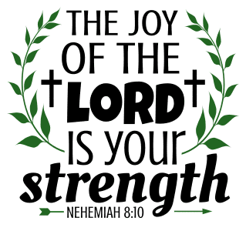

OPENING DIALOGUE

Into your hands, almighty God, we place ourselves:
our minds to know you, our hearts to love you,
our wills to serve you, for we are yours.
Into your hands, incarnate Savior, we place ourselves:
receive us and draw us after you,
that we may follow your steps.
Into your hands, O hovering Spirit, we place ourselves:
take us and fashion us after your image;
let your comfort strengthen us and your fire cleanse us.
Into your hands, almighty God, we place ourselves:
gather us in your light eternal.
(Based on the commitment prayer, ELW, p. 86)

GATHERING SONG “God, Whose Giving Knows No Ending” ELW 678
GREETING
The grace of our Lord Jesus Christ, the love of God,
and the communion of the Holy Spirit be with you all.
And also with you.

PRAYER OF THE DAY
Open our hands, Lord, to reach out to a world in need. May our arms enfold those who sorrow, our palms bear mercy and grace, and our fingers point to your love. In Jesus’ name we pray. Amen.

READING Deuteronomy 15:7-11
A reading from Deuteronomy.

⁷If there is among you anyone in need, a member of your community in any of your towns within the land that the LORD your God is giving you, do not be hard-hearted or tight-fisted toward your needy neighbor. ⁸You should rather open your hand, willingly lending enough to meet the need, whatever it may be. ⁹Be careful that you do not entertain a mean thought, thinking, "The seventh year, the year of remission, is near," and therefore view your needy neighbor with hostility and give nothing; your neighbor might cry to the LORD against you, and you would incur guilt. ¹⁰Give liberally and be ungrudging when you do so, for on this account the LORD your God will bless you in all your work and in all that you undertake. ¹¹Since there will never cease to be some in need on the earth, I therefore command you, "Open your hand to the poor and needy neighbor in your land."

The Word of the Lord.
Thanks be to God.

PSALM Psalm 139:1-10

¹O LORD, you have searched me
and known me.
²You know when I sit down and when I rise up;
you discern my thoughts from far away.
³You search out my path and my lying down,
and are acquainted with all my ways.
⁴Even before a word is on my tongue,
O LORD, you know it completely.
⁵You hem me in, behind and before,
and lay your hand upon me.
⁶Such knowledge is too wonderful for me;
it is so high that I cannot attain it.
⁷Where can I go from your spirit?
Or where can I flee from your presence?
⁸If I ascend to heaven, you are there;
if I make my bed in Sheol, you are there.
⁹If I take the wings of the morning
and settle at the farthest limits of the sea,
¹⁰even there your hand shall lead me,
and your right hand shall hold me fast.

READING Mark 6:1-5
A reading from Mark.

¹He left that place and came to his hometown, and his disciples followed him. ²On the sabbath he began to teach in the synagogue, and many who heard him were astounded. They said, "Where did this man get all this? What is this wisdom that has been given to him? What deeds of power are being done by his hands! ³Is not this the carpenter, the son of Mary and brother of James and Joses and Judas and Simon, and are not his sisters here with us?" And they took offense at him. ⁴Then Jesus said to them, "Prophets are not without honor, except in their hometown, and among their own kin, and in their own house." ⁵And he could do no deed of power there, except that he laid his hands on a few sick people and cured them.

The Word of the Lord.
Thanks be to God.

REFLECTION Pastor Becky Ebb-Speese

HYMN OF THE DAY “We Are an Offering” ELW 692
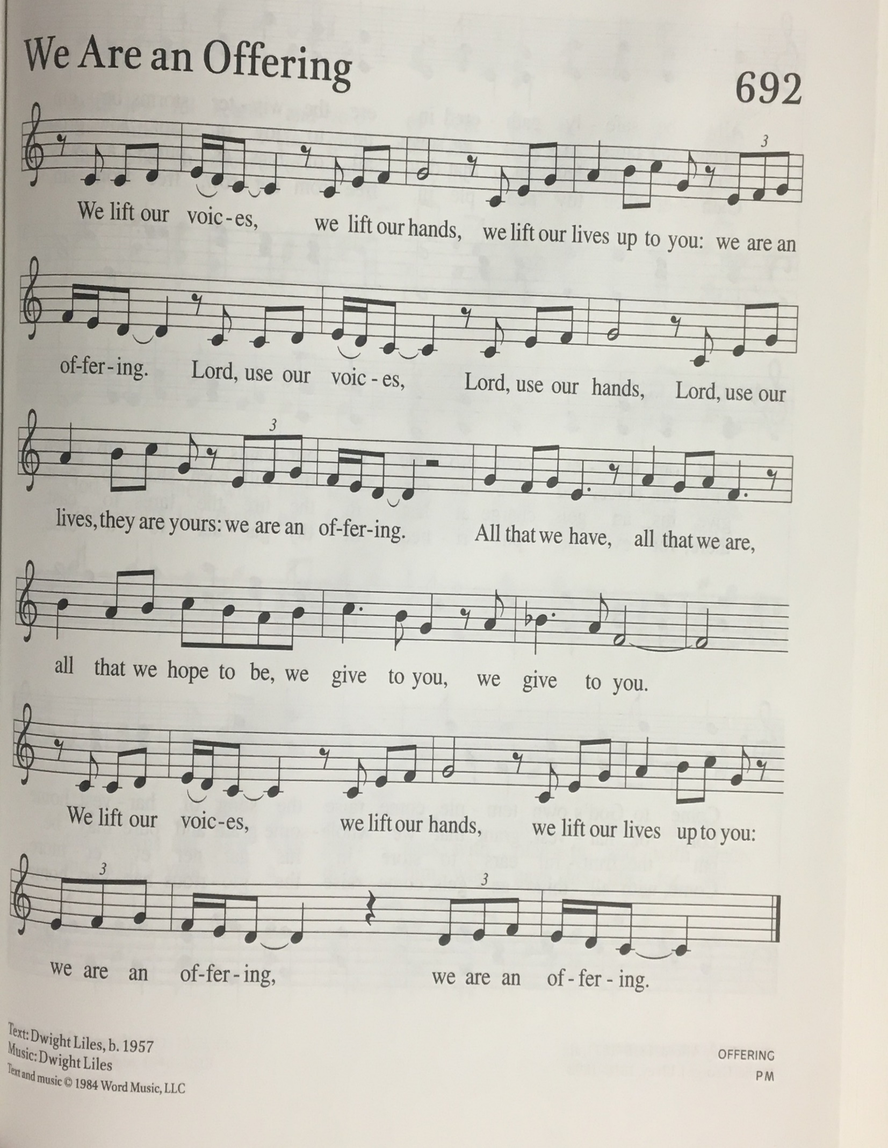
PRAYERS
Lord of all life,
when we cannot see the beauty of your creation,
open our eyes, that all living things thrive and grow.
When we neglect the poor, the sick, and the grieving,
open our hands to do your work in the world.
When we ignore the cries of injustice in our midst,
open our ears, that all will know your love.
When we are hardened against our neighbor,
open our hearts and heal our resentment.
When we are closed to the grace you long to give us,
open our lives and turn us to follow in the way of the cross.
Into your hands, gracious God, we commend all for whom we pray, trusting in your mercy; through Jesus Christ, our Savior.
Amen.

LORD’S PRAYER
Gathered into one by the Holy Spirit, let us pray as Jesus taught us.
Our Father, who art in heaven,
hallowed be thy name,
thy kingdom come,
thy will be done,
on earth as it is in heaven.
Give us this day our daily bread;
and forgive us our trespasses,
as we forgive those
who trespass against us;
and lead us not into temptation,
but deliver us from evil.
For thine is the kingdom,
and the power, and the glory,
forever and ever. Amen.

PEACE

PRAYER (ELW, p. 64, adapt.)
God of mercy and grace, the eyes of all wait upon you, and you open your hand in blessing. Fill us with good things that we may come to the help of all in need, through Jesus Christ, our redeemer and Lord. Amen.

BLESSING
Go into the world with eyes open to the transforming light of Christ, hands open to serve those you meet, ears open to the call of the Spirit, hearts open to the bountiful love of God, and lives open to follow Christ to the cross.
The God who opened for us the way of everlasting life ☩ bless you now and forever.
Amen.

SENDING SONG “The Spirit Sends Us Forth to Serve” ELW 551

DISMISSAL
Go in peace. Christ is with you.
Thanks be to God.

