ZION LUTHERAN CHURCH, WOODLAND, MI
First Sunday in Lent, March 6, 2022
*If you are listening in your car, please tune your radio to FM 87.7*

ANNOUNCEMENTS & PRELUDE

Gathering
The Holy Spirit calls us together as the people of God.

GREETING
The love of God poured into our hearts, the saving grace of Jesus Christ, and the abundant life of the Holy Spirit be with you all.
And also with you.

OPENING PRAYER
O God, rich in mercy, full of kindness, out of your great love, you raise us up from sin and death and make us alive together with Christ. Write your word upon our hearts and restore in us the image of your love that, by your Spirit, our way of life may become the way of Christ, through whom we pray.
Amen.

Confession and Forgiveness
Blessed be the holy Trinity, ☩ one God, who looks upon us in compassion,
forgives our sin, and heals our lives.
Amen.

Let us confess our sin in the presence of God and of one another. To you, O God,
all hearts are open, to you all desires known. We come to you, confessing our sins. Forgive us in your mercy, and remember us in your love. Show us your ways; teach us your paths; and lead us in justice and truth, for the sake of your goodness in Jesus Christ our Savior.
Amen.
By water and the Holy Spirit God gives you a new birth, and through the death and resurrection of ☩ Jesus Christ, God forgives you all your sins. The God of mercy and might strengthen you in all goodness and keep you in eternal life.
Amen.
Gathering Song “Lead Me, Guide Me” ELW 768
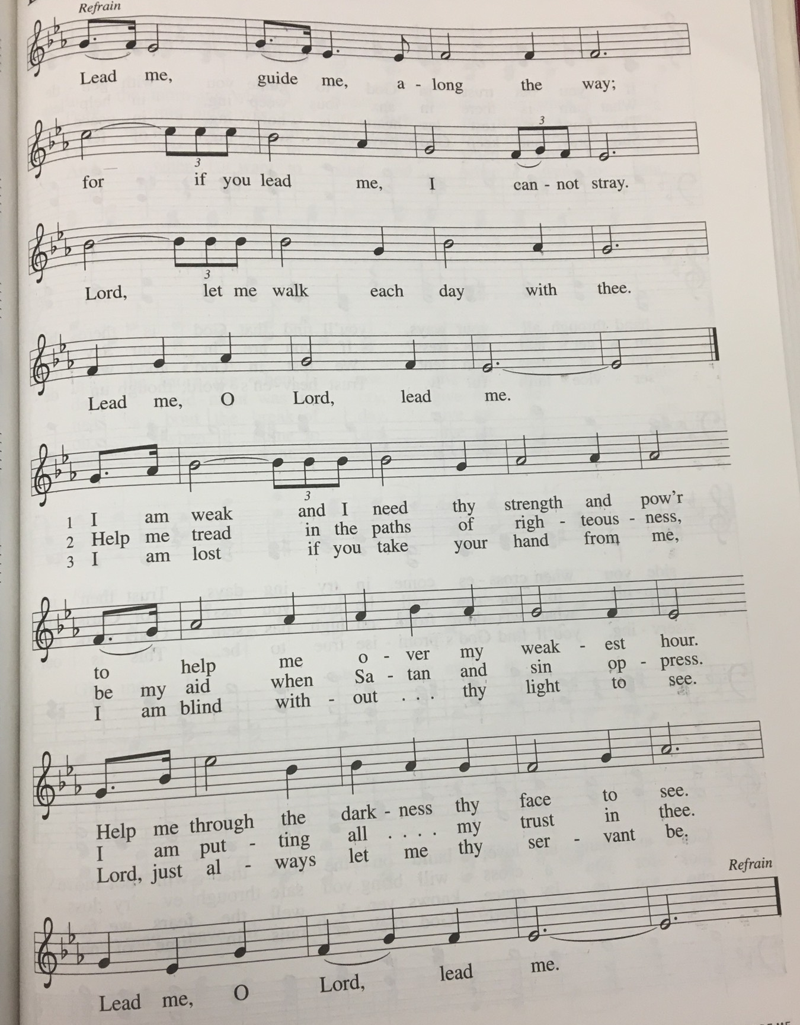
GREETING
The grace of our Lord Jesus Christ, the love of God, and the communion of the Holy Spirit be with you all.
And also with you.

Prayer of the Day
Let us pray together.
O Lord God, you led your people through the wilderness and brought them to the promised land. Guide us now, so that, following your Son, we may walk safely through the wilderness of this world toward the life you alone can give, through Jesus Christ, our Savior and Lord, who lives and reigns with you and the Holy Spirit, one God, now and forever. Amen.

First Reading Deuteronomy 26:1-11
A reading from Deuteronomy.

¹When you have come into the land that the Lord your God is giving you as an inheritance to possess, and you possess it, and settle in it, ²you shall take some of the first of all the fruit of the ground, which you harvest from the land that the Lord your God is giving you, and you shall put it in a basket and go to the place that the Lord your God will choose as a dwelling for his name. ³You shall go to the priest who is in office at that time, and say to him, “Today I declare to the Lord your God that I have come into the land that the Lord swore to our ancestors to give us.” ⁴When the priest takes the basket from your hand and sets it down before the altar of the Lord your God, ⁵you shall make this response before the Lord your God: “A wandering Aramean was my ancestor; he went down into Egypt and lived there as an alien, few in number, and there he became a great nation, mighty and populous. ⁶When the Egyptians treated us harshly and afflicted us, by imposing hard labor on us, ⁷we cried to the Lord, the God of our ancestors; the Lord heard our voice and saw our affliction, our toil, and our oppression. ⁸The Lord brought us out of Egypt with a mighty hand and an outstretched arm, with a terrifying display of power, and with signs and wonders; ⁹and he brought us into this place and gave us this land, a land flowing with milk and honey. ¹⁰So now I bring the first of the fruit of the ground that you, O Lord, have given me.” You shall set it down before the Lord your God and bow down before the Lord your God. ¹¹Then you, together with the Levites and the aliens who reside among you, shall celebrate with all the bounty that the Lord your God has given to you and to your house.

The word of the Lord.
Thanks be to God.

Psalm Psalm 91:1-2, 9-16
¹You who dwell in the shelter of | the Most High,
who abide in the shadow of | the Almighty—
²you will say to the Lord, “My refuge | and my stronghold,
my God in whom I | put my trust.” R
⁹Because you have made the | Lord your refuge,
and the Most High your | habitation,
¹⁰no evil | will befall you,
nor shall affliction come | near your dwelling.
¹¹For God will give the angels charge | over you,
to guard you in | all your ways.
¹²Upon their hands they will | bear you up,
lest you strike your foot a- | gainst a stone.
¹³You will tread upon the lion | cub and viper;
you will trample down the lion | and the serpent.
¹⁴I will deliver those who | cling to me;
I will uphold them, because they | know my name.
¹⁵They will call me, and I will | answer them;
I will be with them in trouble; I will rescue and | honor them.
¹⁶With long life will I | satisfy them,
and show them | my salvation.

Second Reading Romans 10:8b-13
A reading from Romans.

^{8b}“The word is near you,
on your lips and in your heart”
(that is, the word of faith that we proclaim); ⁹because if you confess with your lips that Jesus is Lord and believe in your heart that God raised him from the dead, you will be saved. ¹⁰For one believes with the heart and so is justified, and one confesses with the mouth and so is saved. ¹¹The scripture says, “No one who believes in him will be put to shame.” ¹²For there is no distinction between Jew and Greek; the same Lord is Lord of all and is generous to all who call on him. ¹³For, “Everyone who calls on the name of the Lord shall be saved.”

The word of the Lord.
Thanks be to God.

Gospel Acclamation
Let your steadfast love come to us, O Lord.
Let your steadfast love come to us, O Lord.
Save us as you promised; we will trust your word,
we will trust your word.
Gospel Luke 4:1-13
The holy gospel according to Luke.
Glory to you, O Lord.

¹Jesus, full of the Holy Spirit, returned from the Jordan and was led by the Spirit in the wilderness, ²where for forty days he was tempted by the devil. He ate nothing at all during those days, and when they were over, he was famished. ³The devil said to him, “If you are the Son of God, command this stone to become a loaf of bread.” ⁴Jesus answered him, “It is written, ‘One does not live by bread alone.’ ”
⁵Then the devil led him up and showed him in an instant all the kingdoms of the world. ⁶And the devil said to him, “To you I will give their glory and all this authority; for it has been given over to me, and I give it to anyone I please. ⁷If you, then, will worship me, it will all be yours.” ⁸Jesus answered him, “It is written,
‘Worship the Lord your God,
and serve only him.’ ”
⁹Then the devil took him to Jerusalem, and placed him on the pinnacle of the temple, saying to him, “If you are the Son of God, throw yourself down from here, ¹⁰for it is written,
‘He will command his angels concerning you,
to protect you,’
¹¹and
‘On their hands they will bear you up,
so that you will not dash your foot against a stone.’ ”
¹²Jesus answered him, “It is said, ‘Do not put the Lord your God to the test.’ ” ¹³When the devil had finished every test, he departed from him until an opportune time.

The gospel of the Lord.
Praise to you, O Christ.

SERMON Pastor Becky Ebb-Speese

Hymn of the Day “I Want Jesus to Walk with Me” ELW 325

cREED
I believe in God, the Father almighty,
creator of heaven and earth.
I believe in Jesus Christ, God’s only Son, our Lord,
who was conceived by the Holy Spirit,
born of the virgin Mary,
suffered under Pontius Pilate,
was crucified, died, and was buried;
he descended to the dead.*
On the third day he rose again;
he ascended into heaven,
he is seated at the right hand of the Father,
and he will come to judge the living and the dead.
I believe in the Holy Spirit,
the holy catholic church,
the communion of saints,
the forgiveness of sins,
the resurrection of the body,
and the life everlasting. Amen.

*Or, “he descended into hell,” another translation of this text in widespread use.

prayers of Intercession
Drawn close to the heart of God, we offer these prayers for the church, the world, and all who are in need.
A brief silence.
We pray for the church. Sharpen its proclamation of the word so that your people learn to reject voices of deception and distraction. Strengthen all who are tempted to believe lies about themselves or others. We pray especially for Hope Lutheran Church. Merciful God,
receive our prayer.
We pray for the earth and all its creatures. Protect wilderness places and all plant and animal species that call them home. Sustain farmers and all laborers who work the land and harvest the fruits of its abundance. Merciful God,
receive our prayer.
We pray for the nations of the world. Awaken elected leaders and government officials to the needs of those who are oppressed and grant them compassion to deal mercifully with immigrants and refugees who reside among us. We pray for the people of Ukraine and for a coming of peace. Merciful God,
receive our prayer.
We pray for those in need. Rescue those experiencing mental illness or contending with addiction. Ease the anxiety of those who live with dementia. Command your angels concerning all who are sick.
Merciful God,
receive our prayer.
We give thanks for those who have died. Gather them with all the saints into your heavenly dwelling place. Encourage us with the promise that all who call upon your name are saved. Merciful God,
receive our prayer.
Accept the prayers we bring, O God, on behalf of a world in need, for the sake of Jesus Christ.
Amen.

Peace
The peace of Christ be with you always.
And also with you.

Offering & Offering song “Create in Me a Clean Heart” ELW 186

Offering Prayer
Let us pray. Holy God, gracious and merciful, you bring forth food from the earth and nourish your whole creation. Turn our hearts toward those who hunger in any way, that all may know your care; and prepare us now to feast on the bread of life, Jesus Christ, our Savior and Lord.
Amen.

Thanksgiving at the Table
In the night in which he was betrayed,
our Lord Jesus took bread, and gave thanks;
broke it, and gave it to his disciples, saying:
Take and eat; this is my body, given for you.
Do this for the remembrance of me.
Again, after supper, he took the cup, gave thanks,
and gave it for all to drink, saying:
This cup is the new covenant in my blood,
shed for you and for all people for the forgiveness of sin.
Do this for the remembrance of me.

Lord’s Prayer
Gathered into one by the Holy Spirit, let us pray as Jesus taught us.
Our Father, who art in heaven,
hallowed be thy name,
thy kingdom come,
thy will be done,
on earth as it is in heaven.
Give us this day our daily bread;
and forgive us our trespasses,
as we forgive those
who trespass against us;
and lead us not into temptation,
but deliver us from evil.
For thine is the kingdom,
and the power, and the glory,
forever and ever. Amen.

COMMUNION
Taste and see that the Lord is good. You may receive your communion elements.

BLESSING AFTER COMMUNION
The body and blood of our Lord Jesus Christ bless you and keep you in His grace.

PRAYER AFTER COMMUNION
O God, in this holy communion you have welcomed us into your presence, nourished us with words of mercy, and fed us at your table. Amid the cares of this life, strengthen us to love you with all our heart, serve our neighbors with a willing spirit, and honor the earth you have made; through Christ our Lord.
Amen.

Sending
Go in peace. Christ is with you

Blessing
Christ Jesus dwell in our hearts through faith, as we are being rooted and grounded in love, strengthened by the Spirit, and filled with all the fullness of God.
Amen.

Sending SonG “A Mighty Fortress Is Our God” ELW 504

Dismissal
Go in peace. Christ is with you.
Thanks be to God.

From sundaysandseasons.com. Copyright © 2017 Augsburg Fortress. All rights reserved.

THANK YOU TO ALL WHO SERVED TODAY:

Presider: Paul Meade
Musician: Cindy June
Elder: Jolene Griffin
Trustee: Jerry Engle
Offering Counters: Mary Makley & Martha Yoder
Safety Person: Diane Griffin

This week at Zion:
- Council Meeting, 6:30 Pm Tuesday, March 8
- Men’s Coffee, 8 AM Wednesday, March 9
- Soup Supper, 6PM Wednesday, March 9
- Lent Service, 7PM Wednesday, March 9

ANNOUNCEMENTS
- Soup Supper: We will resume our Lent Suppers before service each Wednesday. There will be a sign up sheet for food each week. Please see a member of the Fellowship Committee with any questions.
- Men’s Group has resumed meeting on Wednesday morning at 8 AM.
- Easter Egg Hunt: Zion will host an Easter Egg Hunt following service on Easter morning, Sunday, April 17. We're asking the congregation to consider donating individually wrapped candy and coins for the eggs by April 3rd. Non-chocolate candy or gum are also requested. Please bring your kids, grandkids or any other kiddos to our Easter Egg Hunt!

Lenten Focus

Each week throughout lent, our Wednesday services will have a different focus. We will highlight each week’s theme and verse here as we continue through the Lenten season. This week’s focus is Open My Eyes.

In Acts 26:12-18, Paul tells the story of having his eyes opened by God.
¹²With this in mind, I was traveling to Damascus with the authority and commission of the chief priests, ¹³when at midday along the road, your Excellency, I saw a light from heaven, brighter than the sun, shining around me and my companions. ¹⁴When we had all fallen to the ground, I heard a voice saying to me in the Hebrew language, 'Saul, Saul, why are you persecuting me? It hurts you to kick against the goads.' ¹⁵I asked, 'Who are you, Lord?' The Lord answered, 'I am Jesus whom you are persecuting. ¹⁶But get up and stand on your feet; for I have appeared to you for this purpose, to appoint you to serve and testify to the things in which you have seen me and to those in which I will appear to you. ¹⁷I will rescue you from your people and from the Gentiles — to whom I am sending you ¹⁸to open their eyes so that they may turn from darkness to light and from the power of Satan to God, so that they may receive forgiveness of sins and a place among those who are sanctified by faith in me.'

Paul saw the light of Christ shining around him on the road to Damascus. As individuals and communities, what do we have difficulty seeing? How does our perspective change when we view the world through the eyes of Christ?

