ZION LUTHERAN CHURCH, WOODLAND, MI
Midweek Lent Service, March 9, 2022
*If you are listening in your car, please tune your radio to FM 87.7*

OPENING DIALOGUE

We look but do not see.
Lord, open our eyes.
We stumble at noon as in the twilight.
Lord, open our eyes.
God turns our darkness into light.
Lord, open our eyes.
We are not forsaken: look up and see!
Lord, open our eyes.
(Based on Isaiah 59:10; 42:16-18)

GATHERING SONG “Be Thou My Vision” ELW 793

GREETING
The grace of our Lord Jesus Christ, the love of God,
and the communion of the Holy Spirit be with you all.
And also with you.

PRAYER OF THE DAY
Open our eyes, Lord, to perceive your desire for the world. Remove those things that block our vision and widen our gaze to encompass all you would have us see. In Jesus’ name we pray. Amen.

READING Isaiah 42:5-9
A reading from Isaiah.

⁵Thus says God, the LORD,
who created the heavens and stretched them out,
who spread out the earth and what comes from it,
who gives breath to the people upon it
and spirit to those who walk in it:
⁶I am the LORD, I have called you in righteousness,
I have taken you by the hand and kept you;
I have given you as a covenant to the people,
a light to the nations,
⁷to open the eyes that are blind,
to bring out the prisoners from the dungeon,
from the prison those who sit in darkness.
⁸I am the LORD, that is my name;
my glory I give to no other,
nor my praise to idols.
⁹See, the former things have come to pass,
and new things I now declare;
before they spring forth,
I tell you of them.

The Word of the Lord.
Thanks be to God.

PSALM Psalm 119:17-24
¹⁷Deal bountifully with your servant,
so that I may live and observe your word.
¹⁸Open my eyes, so that I may behold
wondrous things out of your law.
¹⁹I live as an alien in the land;
do not hide your commandments from me.
²⁰My soul is consumed with longing
for your ordinances at all times.
²¹You rebuke the insolent, accursed ones,
who wander from your commandments;
²²take away from me their scorn and contempt,
for I have kept your decrees.
²³Even though princes sit plotting against me,
your servant will meditate on your statutes.
²⁴Your decrees are my delight,
they are my counselors.

READING Acts 26:4-18
A reading from Acts.

⁴All the Jews know my way of life from my youth, a life spent from the beginning among my own people and in Jerusalem. ⁵They have known for a long time, if they are willing to testify, that I have belonged to the strictest sect of our religion and lived as a Pharisee. ⁶And now I stand here on trial on account of my hope in the promise made by God to our ancestors, ⁷a promise that our twelve tribes hope to attain, as they earnestly worship day and night. It is for this hope, your Excellency, that I am accused by Jews! ⁸Why is it thought incredible by any of you that God raises the dead?
⁹Indeed, I myself was convinced that I ought to do many things against the name of Jesus of Nazareth. ¹⁰And that is what I did in Jerusalem; with authority received from the chief priests, I not only locked up many of the saints in prison, but I also cast my vote against them when they were being condemned to death. ¹¹By punishing them often in all the synagogues I tried to force them to blaspheme; and since I was so furiously enraged at them, I pursued them even to foreign cities.
¹²With this in mind, I was traveling to Damascus with the authority and commission of the chief priests, ¹³when at midday along the road, your Excellency, I saw a light from heaven, brighter than the sun, shining around me and my companions. ¹⁴When we had all fallen to the ground, I heard a voice saying to me in the Hebrew language, 'Saul, Saul, why are you persecuting me? It hurts you to kick against the goads.' ¹⁵I asked, 'Who are you, Lord?' The Lord answered, 'I am Jesus whom you are persecuting. ¹⁶But get up and stand on your feet; for I have appeared to you for this purpose, to appoint you to serve and testify to the things in which you have seen me and to those in which I will appear to you. ¹⁷I will rescue you from your people and from the Gentiles — to whom I am sending you ¹⁸to open their eyes so that they may turn from darkness to light and from the power of Satan to God, so that they may receive forgiveness of sins and a place among those who are sanctified by faith in me.'

The Word of the Lord.
Thanks be to God.

REFLECTION Pastor Becky Ebb-Speese

HYMN OF THE DAY “Open Our Eyes, Lord” 113 (Worship and Praise)

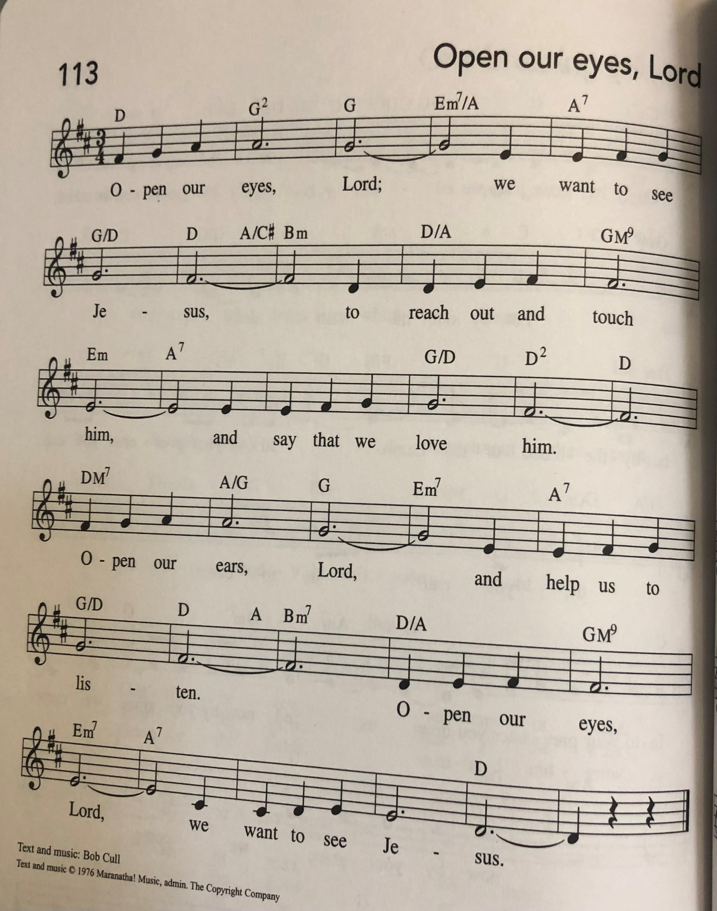

PRAYERS
Lord of all life,
when we cannot see the beauty of your creation,
open our eyes, that all living things thrive and grow.
When we neglect the poor, the sick, and the grieving,
open our hands to do your work in the world.
When we ignore the cries of injustice in our midst,
open our ears, that all will know your love.
When we are hardened against our neighbor,
open our hearts and heal our resentment.
When we are closed to the grace you long to give us,
open our lives and turn us to follow in the way of the cross.
Into your hands, gracious God, we commend all for whom we pray, trusting in your mercy; through Jesus Christ, our Savior.
Amen.

LORD’S PRAYER

PEACE

OFFERING

OFFERING PRAYER (ELW, p. 64, adapt.)
God of mercy and grace, the eyes of all wait upon you, and you open your hand in blessing. Fill us with good things that we may come to the help of all in need, through Jesus Christ, our redeemer and Lord. Amen.

BLESSING
Go into the world with eyes open to the transforming light of Christ, hands open to serve those you meet, ears open to the call of the Spirit, hearts open to the bountiful love of God, and lives open to follow Christ to the cross.
The God who opened for us the way of everlasting life ☩ bless you now and forever.
Amen.

SENDING SONG “Amazing Grace” ELW 448

DISMISSAL
Go in peace. Christ is with you.
Thanks be to God.

