ZION LUTHERAN CHURCH, WOODLAND, MI
Midweek Lent Service, April 6, 2022
*If you are listening in your car, please tune your radio to FM 87.7*

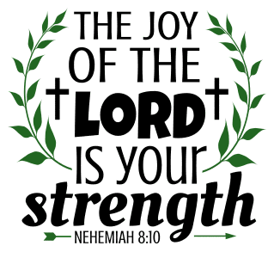

OPENING DIALOGUE

When our lives are joyous and laughter abounds,
Christ is dwelling there.
When the news is grim and we have nowhere to turn,
Christ is dwelling there.
In the water and word, the bread and wine,
Christ is dwelling there.
In our life and our death, in the new life to come,
Christ is dwelling there.

GATHERING SONG “Take My Life, That I May Be” ELW 685

GREETING
The grace of our Lord Jesus Christ, the love of God,
and the communion of the Holy Spirit be with you all.
And also with you.

PRAYER OF THE DAY
Open our lives, Lord, to reflect your glory. Lead us to the cross, to the grave, to the empty tomb, and into the world as imitators of Christ. In Jesus’ name we pray. Amen.

READING Deuteronomy 30:15-20
A reading from Deuteronomy.

¹⁵See, I have set before you today life and prosperity, death and adversity. ¹⁶If you obey the commandments of the LORD your God that I am commanding you today, by loving the LORD your God, walking in his ways, and observing his commandments, decrees, and ordinances, then you shall live and become numerous, and the LORD your God will bless you in the land that you are entering to possess. ¹⁷But if your heart turns away and you do not hear, but are led astray to bow down to other gods and serve them, ¹⁸I declare to you today that you shall perish; you shall not live long in the land that you are crossing the Jordan to enter and possess. ¹⁹I call heaven and earth to witness against you today that I have set before you life and death, blessings and curses. Choose life so that you and your descendants may live, ²⁰loving the LORD your God, obeying him, and holding fast to him; for that means life to you and length of days, so that you may live in the land that the LORD swore to give to your ancestors, to Abraham, to Isaac, and to Jacob.

The Word of the Lord.
Thanks be to God.

PSALM Psalm 16

¹Protect me, O God, for in you I take refuge.
²I say to the LORD, "You are my LORD;
I have no good apart from you."
³As for the holy ones in the land, they are the noble,
in whom is all my delight.
⁴Those who choose another god multiply their sorrows;
their drink offerings of blood I will not pour out
or take their names upon my lips.
⁵The LORD is my chosen portion and my cup;
you hold my lot.
⁶The boundary lines have fallen for me in pleasant places;
I have a goodly heritage.
⁷I bless the LORD who gives me counsel;
in the night also my heart instructs me.
⁸I keep the LORD always before me;
because he is at my right hand, I shall not be moved.
⁹Therefore my heart is glad, and my soul rejoices;
my body also rests secure.
¹⁰For you do not give me up to Sheol,
or let your faithful one see the Pit.
¹¹You show me the path of life. In your presence there is fullness of joy;
in your right hand are pleasures forevermore.

READING Galatians 2:15-21
A reading from Galatians.

¹⁵We ourselves are Jews by birth and not Gentile sinners; ¹⁶yet we know that a person is justified not by the works of the law but through faith in Jesus Christ. And we have come to believe in Christ Jesus, so that we might be justified by faith in Christ, and not by doing the works of the law, because no one will be justified by the works of the law. ¹⁷But if, in our effort to be justified in Christ, we ourselves have been found to be sinners, is Christ then a servant of sin? Certainly not! ¹⁸But if I build up again the very things that I once tore down, then I demonstrate that I am a transgressor. ¹⁹For through the law I died to the law, so that I might live to God. I have been crucified with Christ; ²⁰and it is no longer I who live, but it is Christ who lives in me. And the life I now live in the flesh I live by faith in the Son of God, who loved me and gave himself for me. ²¹I do not nullify the grace of God; for if justification comes through the law, then Christ died for nothing.

The Word of the Lord.
Thanks be to God.

REFLECTION Pastor Becky Ebb-Speese

HYMN OF THE DAY “Open My Eyes, Lord ELW 113
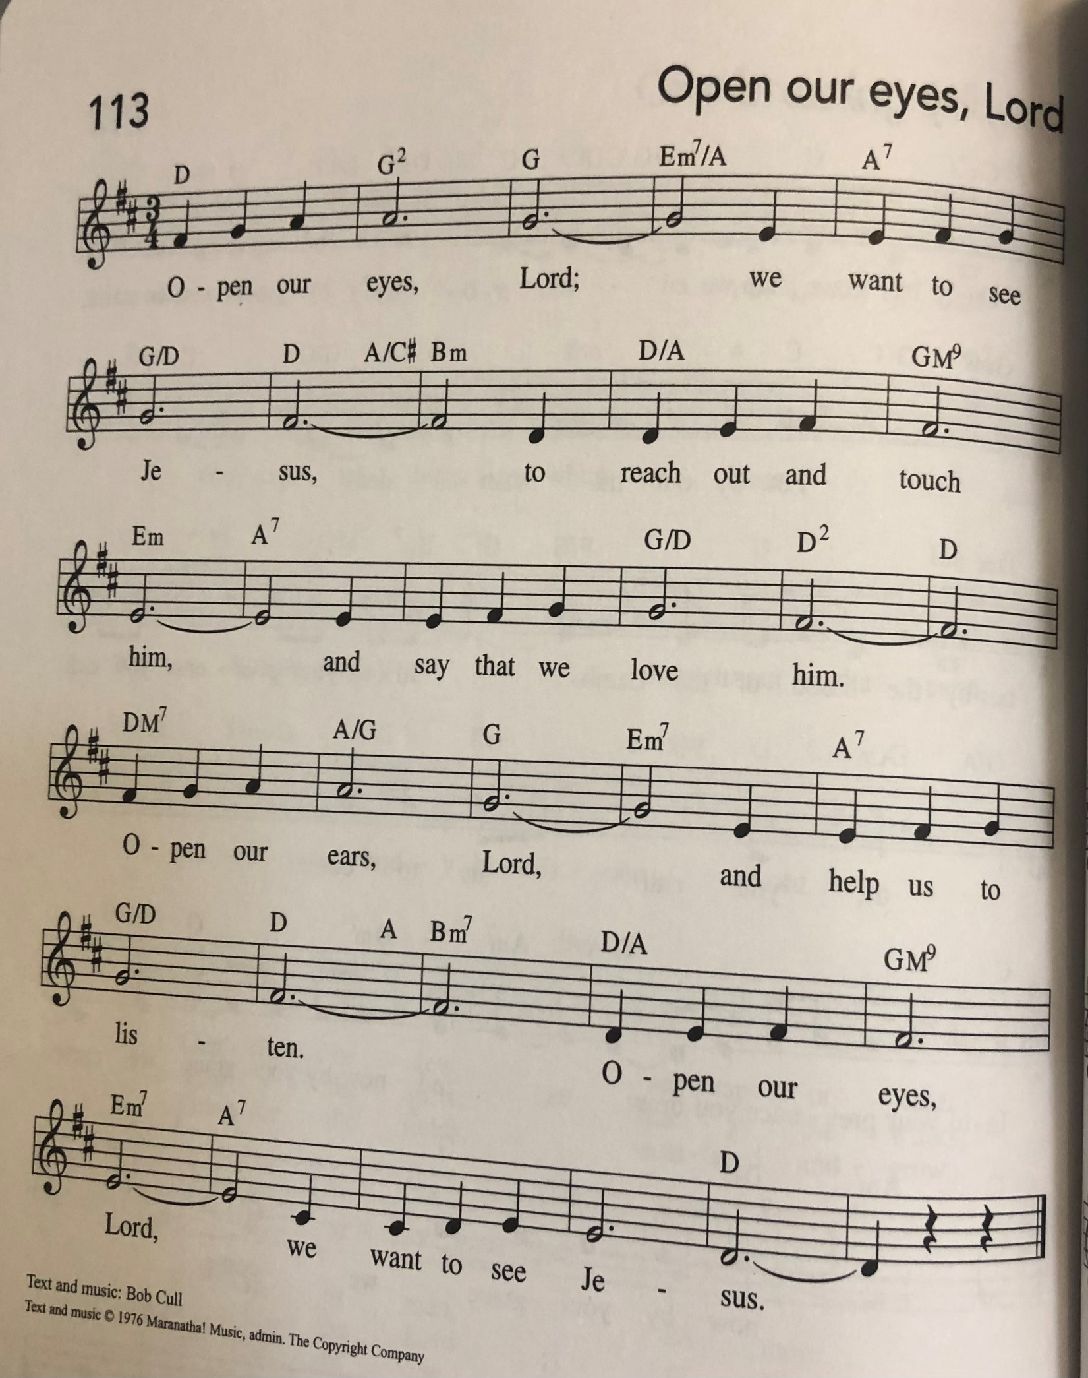
PRAYERS
Lord of all life, when we cannot see the beauty of your creation,
open our eyes, that all living things thrive and grow.
When we neglect the poor, the sick, and the grieving,
open our hands to do your work in the world.
When we ignore the cries of injustice in our midst,
open our ears, that all will know your love.
When we are hardened against our neighbor,
open our hearts and heal our resentment.
When we are closed to the grace you long to give us,
open our lives and turn us to follow in the way of the cross.
Into your hands, gracious God, we commend all for whom we pray, trusting in your mercy; through Jesus Christ, our Savior.
Amen.

LORD’S PRAYER
Gathered into one by the Holy Spirit, let us pray as Jesus taught us.
Our Father, who art in heaven,
hallowed be thy name,
thy kingdom come,
thy will be done,
on earth as it is in heaven.
Give us this day our daily bread;
and forgive us our trespasses,
as we forgive those
who trespass against us;
and lead us not into temptation,
but deliver us from evil.
For thine is the kingdom,
and the power, and the glory,
forever and ever. Amen.

PEACE & PRAYER (ELW, p. 64, adapt.)
God of mercy and grace, the eyes of all wait upon you, and you open your hand in blessing. Fill us with good things that we may come to the help of all in need, through Jesus Christ, our redeemer and Lord. Amen.

BLESSING
Go into the world with eyes open to the transforming light of Christ, hands open to serve those you meet, ears open to the call of the Spirit, hearts open to the bountiful love of God, and lives open to follow Christ to the cross.
The God who opened for us the way of everlasting life ☩ bless you now and forever.
Amen.
SENDING SONG “Let Us Ever Walk with Jesus” ELW 802
DISMISSAL
Go in peace. Christ is with you.
Thanks be to God.

