ZION LUTHERAN CHURCH, WOODLAND, MI
Fourth Sunday after Easter, May 8, 2022
*If you are listening in your car, please tune your radio to FM 87.7*

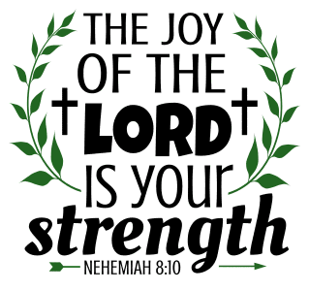
ANNOUNCEMENTS

PRELUDE

Gathering
The Holy Spirit calls us together as the people of God.

Confession and Forgiveness
In the name of the Father, and of the ☩ Son, and of the Holy Spirit.
Amen.

God of all mercy & consolation, come to the help of your people, turning us from our sin to live for you alone. Give us the power of your Holy Spirit that we may confess our sin, receive your forgiveness, and grow into the fullness of Jesus Christ, our Savior and Lord.
Amen.

Let us confess our sin in the presence of God and of one another. Most merciful God,
we confess that we are captive to sin and cannot free ourselves. We have sinned against you in thought, word, and deed, by what we have done and by what we have left undone. We have not loved you with our whole heart; we have not loved our neighbors as ourselves. For the sake of your Son, Jesus Christ, have mercy on us. Forgive us, renew us, and lead us, so that we may delight in your will and walk in your ways, to the glory of your holy name. Amen.

God, who is rich in mercy, loved us even when we were dead in sin, and made us alive together with Christ. By grace you have been saved. In the name of ☩ Jesus Christ, your sins are forgiven. Almighty God strengthen you with power through the Holy Spirit, that Christ may live in your hearts through faith.
Amen.

Gathering Song “Christ the Lord Is Risen Today; Alleluia!” ELW 369

GREETING
The grace of our Lord Jesus Christ, the love of God, and the communion of the Holy Spirit be with you all.
And also with you.
Prayer of the Day
Let us pray together.
O God of peace, you brought again from the dead our Lord Jesus Christ, the great shepherd of the sheep. By the blood of your eternal covenant, make us complete in everything good that we may do your will, and work among us all that is well-pleasing in your sight, through Jesus Christ, our Savior and Lord, who lives and reigns with you and the Holy Spirit, one God, now and forever. Amen.

First Reading Acts 9:36-43
A reading from Acts.

³⁶Now in Joppa there was a disciple whose name was Tabitha, which in Greek is Dorcas. She was devoted to good works and acts of charity. ³⁷At that time she became ill and died. When they had washed her, they laid her in a room upstairs. ³⁸Since Lydda was near Joppa, the disciples, who heard that Peter was there, sent two men to him with the request, “Please come to us without delay.” ³⁹So Peter got up and went with them; and when he arrived, they took him to the room upstairs. All the widows stood beside him, weeping and showing tunics and other clothing that Dorcas had made while she was with them. ⁴⁰Peter put all of them outside, and then he knelt down and prayed. He turned to the body and said, “Tabitha, get up.” Then she opened her eyes, and seeing Peter, she sat up. ⁴¹He gave her his hand and helped her up. Then calling the saints and widows, he showed her to be alive. ⁴²This became known throughout Joppa, and many believed in the Lord. ⁴³Meanwhile he stayed in Joppa for some time with a certain Simon, a tanner.

The word of the Lord.
Thanks be to God.
Psalm Psalm 23

¹The Lord| is my shepherd;
I shall not | be in want.
²The Lord makes me lie down | in green pastures
and leads me be- | side still waters.
³You restore my | soul, O Lord,
and guide me along right pathways | for your name’s sake.
⁴Though I walk through the valley of the shadow of death, I shall | fear no evil;
for you are with me; your rod and your staff, they | comfort me.
⁵You prepare a table before me in the presence | of my enemies;
you anoint my head with oil, and my cup is | running over.
⁶Surely goodness and mercy shall follow me all the days | of my life,
and I will dwell in the house of the | Lord forever.

Second Reading Revelation 7:9-17
A reading from Revelation.

⁹After this I looked, and there was a great multitude that no one could count, from every nation, from all tribes and peoples and languages, standing before the throne and before the Lamb, robed in white, with palm branches in their hands. ¹⁰They cried out in a loud voice, saying,
“Salvation belongs to our God who is seated on the throne, and to the Lamb!”
¹¹And all the angels stood around the throne and around the elders and the four living creatures, and they fell on their faces before the throne and worshiped God, ¹²singing,
“Amen! Blessing and glory and wisdom
and thanksgiving and honor
and power and might
be to our God forever and ever! Amen.”
¹³Then one of the elders addressed me, saying, “Who are these, robed in white, and where have they come from?” ¹⁴I said to him, “Sir, you are the one that knows.” Then he said to me, “These are they who have come out of the great ordeal; they have washed their robes and made them white in the blood of the Lamb.
¹⁵For this reason they are before the throne of God,
and worship him day and night within his temple,
and the one who is seated on the throne will shelter them.
¹⁶They will hunger no more, and thirst no more;
the sun will not strike them,
nor any scorching heat;
¹⁷for the Lamb at the center of the throne will be their shepherd,
and he will guide them to springs of the water of life,
and God will wipe away every tear from their eyes.”

The word of the Lord.
Thanks be to God.

Gospel Acclamation
Gospel John 10:22-30
The holy gospel according to John.
Glory to you, O Lord.

²²At that time the festival of the Dedication took place in Jerusalem. It was winter, ²³and Jesus was walking in the temple, in the portico of Solomon. ²⁴So the Jews gathered around him and said to him, “How long will you keep us in suspense? If you are the Messiah, tell us plainly.” ²⁵Jesus answered, “I have told you, and you do not believe. The works that I do in my Father’s name testify to me; ²⁶but you do not believe, because you do not belong to my sheep. ²⁷My sheep hear my voice. I know them, and they follow me. ²⁸I give them eternal life, and they will never perish. No one will snatch them out of my hand. ²⁹What my Father has given me is greater than all else, and no one can snatch it out of the Father’s hand. ³⁰The Father and I are one.”

The gospel of the Lord.
Praise to you, O Christ.

children’s Sermon Pastor Becky Ebb-Speese

Sermon Pastor Becky Ebb-Speese

Hymn of the Day “Have No Fear Little Flock” ELW 764
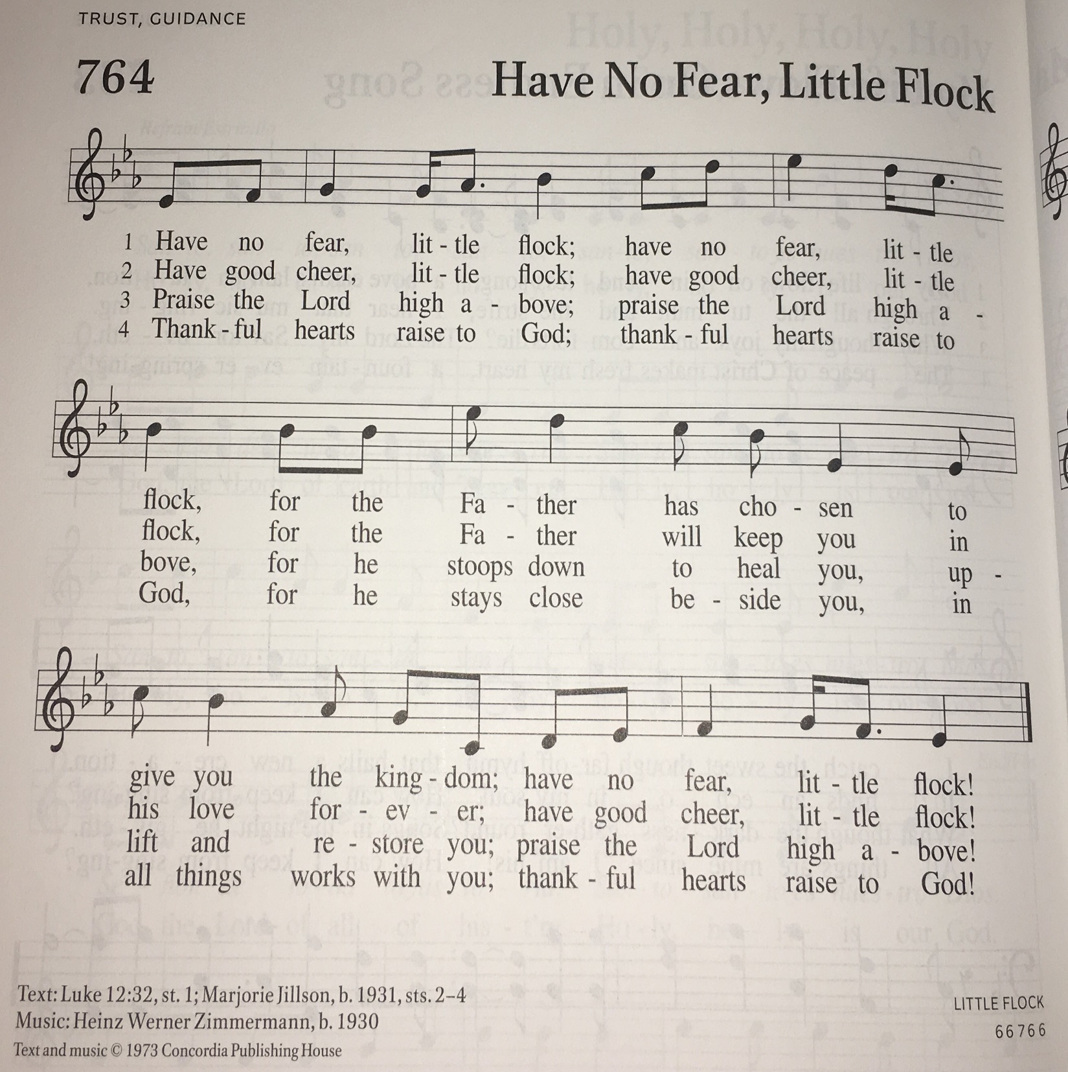

Creed
We believe in one God,
the Father, the Almighty,
maker of heaven and earth,
of all that is, seen and unseen.
We believe in one Lord, Jesus Christ,
the only Son of God,
eternally begotten of the Father,
God from God, Light from Light,
true God from true God,
begotten, not made,
of one Being with the Father;
through him all things were made.
For us and for our salvation
he came down from heaven,
was incarnate of the Holy Spirit and the virgin Mary
and became truly human.
For our sake he was crucified under Pontius Pilate;
he suffered death and was buried.
On the third day he rose again
in accordance with the scriptures;
he ascended into heaven
and is seated at the right hand of the Father.
He will come again in glory to judge the living and the dead,
and his kingdom will have no end.
We believe in the Holy Spirit, the Lord, the giver of life,
who proceeds from the Father and the Son,*
who with the Father and the Son is worshiped and glorified,
who has spoken through the prophets.
We believe in one holy catholic and apostolic church.
We acknowledge one baptism for the forgiveness of sins.
We look for the resurrection of the dead,
and the life of the world to come. Amen.

*Or, “who proceeds from the Father.” The phrase “and the Son” is a later addition to the creed.

Prayers of Intercession
Set free from captivity to sin and death, we pray to the God of resurrection for the church, people in need, and all of creation.
A brief silence.
Gentle Shepherd, enable your church to respond to the voice of Jesus. Give us unfailing trust, unafraid to join in Jesus’ work of renewing all things. We pray especially for Bethany Lutheran Church and Rev. Chrysanne Timm. God, in your mercy,
hear our prayer.
Feed your people at the table of creation. Prepare a safe place for those whose environments are dangerous or unhealthy, especially those making difficult journeys. We pray especially for the people of Ukraine. Prosper your creation for the sake of every living thing. God, in your mercy,
hear our prayer.

Warm the hearts of all who celebrate and all who mourn on Mother’s Day. Accompany those yearning to be mothers. Help us to heal from broken family relationships and open us to receive your nurturing love from all who serve mothering roles in our lives. God, in your mercy,
hear our prayer.
Seek out those who weep while they await healing or consolation. Set people in their path who can provide the care they need, and wipe away every tear from their eyes. God, in your mercy,
hear our prayer.
Inspire the words of prophets and saints who employ innovative imagery to stretch our understanding. Send Christ to instruct us with motherly care. God, in your mercy,
hear our prayer.
Enfold us in the great multitude of saints from every nation, from all tribes and peoples and languages. Wash us in your saving grace every day, guiding us to your waters of life. God, in your mercy,
hear our prayer.
In your mercy, O God, respond to these prayers, and renew us by your life-giving Spirit; through Jesus Christ, our Savior.
Amen.

Peace
The peace of Christ be with you always.
And also with you.

OFFERtory SONG
The joy of the Lord is my strength,
The joy of the Lord is my strength,
The joy of the Lord is my strength,
The joy of the Lord is my strength.

Offering Prayer
Let us pray.
God our provider, you have not fed us with bread alone, but with words of grace and life. Bless us and these your gifts, which we receive from your bounty, through Jesus Christ our Lord.
Amen.

Great Thanksgiving

Dialogue
The Lord be with you.
And also with you.
Lift up your hearts.
We lift them to the Lord.
Let us give thanks to the Lord our God.
It is right to give our thanks and praise.

Holy, Holy, Holy

Thanksgiving at the Table
In the night in which he was betrayed,
our Lord Jesus took bread, and gave thanks;
broke it, and gave it to his disciples, saying:
Take and eat; this is my body, given for you.
Do this for the remembrance of me.
Again, after supper, he took the cup, gave thanks,
and gave it for all to drink, saying:
This cup is the new covenant in my blood,
shed for you and for all people for the forgiveness of sin.
Do this for the remembrance of me.

Lord’s Prayer
Lord, remember us in your kingdom and teach us to pray.
Our Father, who art in heaven,
hallowed be thy name,
thy kingdom come,
thy will be done,
on earth as it is in heaven.
Give us this day our daily bread;
and forgive us our trespasses,
as we forgive those
who trespass against us;
and lead us not into temptation,
but deliver us from evil.
For thine is the kingdom,
and the power, and the glory,
forever and ever. Amen.

Invitation to Communion
Come to the banquet, for all is now ready.

communion
*continuous

SongS During Communion

“O Living Bread from Heaven” ELW 542
“The King of Love My Shepherd Is” ELW 502
“Good Christian Friends Rejoice and Sing” ELW 385

Prayer after Communion
Let us pray. Life-giving God, in the mystery of Christ’s resurrection you send light to conquer darkness, water to give new life, and the bread of life to nourish your people. Send us forth as witnesses to your Son’s resurrection, that we may show your glory to all the world, through Jesus Christ, our risen Lord.
Amen.

Sending
God blesses us and sends us in mission to the world.
Blessing
The Lord bless you and keep you.
The Lord’s face shine on you with grace and mercy.
The Lord look upon you with favor and ☩ give you peace.
Amen.

Sending SonG “Savior Like a Shepherd Lead Us” ELW 789
Dismissal
Almighty God, Father, ☩ Son, and Holy Spirit, bless you now and forever.
Amen.

From sundaysandseasons.com. Copyright © 2017 Augsburg Fortress. All rights reserved.

Thank you to all who served in worship today!

Presider: Pastor Becky Ebb-Speese
Musician: Martha Yoder
Elder: Dan Utterback
Trustee: Dan Zylstra
Offering Counters: Doug Mackenzie & Mike Johnson
Safety Person: Ken Heise

Save the Date:
- VBS: HayDay VBS: Growing in Friendship with Jesus on Thursday June 30
  - 11:30-12:30: Registration and Lunch
  - 12:30-5:00: VBS
  - 5:00: Family Dinner and Fun

This week at Zion:
- Coffee Fellowship Today after service
- Council meeting, 6:30 PM Tuesday, May 10
- Men’s Coffee, 8 AM Wednesday, May 11
- Synod Assembly Virtual, Saturday, May 14

ANNOUNCEMENTS

- School Staff Appreciation: We would like to show our appreciation to the Lakewood Public School Teachers and Support Staff by treating them to morning break treats. We are collecting donations line individual oatmeal, mini muffins, fruit cups, and breakfast bars. Please place all items in the Fellowship Hall by May 22.
- Hearing Devices: We have hearing devises that are now working! They are in the narthex. Ask the usher to get one for you!
- Table Shower: There will be a table shower to welcome Fred Hokanson and Shana Griffin’s newest child: Aiden Atlas Hokanson (grandchild of Mike & Rocky Johnson). Since he was born during Covid, we weren’t able to have a shower for him. The shower will run through May. Please watch for more details.
- Fellowship Fun! On the 4th Sundays of the month, the fellowship committee would like to encourage members to bring their board games or card games to play and teach other members. There will be also coffee fellowship these days.
- Lutheran World Relief challenge: Lutheran World Relief is already at work in helping the people of Ukraine. Any offerings designated to this agency through your offerings (there is a place to designate to LWR on your offering envelopes) will be matched up to $258,000. We will be designating those offerings to go specifically to Ukraine from March through May. Watch the thermometer in the narthex to see our progress in donations!
- Free Camping Available at Camp Living Waters. This year camping experiences are available to our kids tuition free . If there are kids (children, grandchildren, nieces/nephews or others) in your family who would enjoy a camping experience, you are encouraged to get them registered. You may also want to have your kids invite a friend to go with them to camp. Please talk with the Pastor for information on how to register. Dates for camping are:
Grade School (2-5): June 19-21, June 19-24, July 17-22
Junior High: June 12-17, June 26-July 1
Senior High: July 10-15

