ZION LUTHERAN CHURCH, WOODLAND, MI
Third Sunday after Pentecost, June 26, 2022
*If you are listening in your car, please tune your radio to FM 87.7*

ANNOUNCEMENTS

PRELUDE

Gathering
The Holy Spirit calls us together as the people of God.

Confession and Forgiveness
Blessed be the holy Trinity, ☩ one God, who looks upon us in compassion, forgives our sin, and heals our lives.
Amen.

Let us confess our sin in the presence of God and of one another. Have mercy, O God,
against you, you alone, we have sinned. In your compassion, cleanse us from our sin and take away our guilt. Create in us a new heart and give us a steadfast spirit. Do not cast us away but fill us with your Holy Spirit and restore your joy within us. Amen.

As tender as parent to child, so deep is God’s compassion for you. As high as heaven is above earth, so vast is God’s love for you. As far as east is from west, so far God removes your sin from you, renewing your life through Jesus Christ. Blessed be God who crowns us with mercy and love.
Blessed be God forever.

Gathering Song “Just a Closer Walk with Thee” ELW 697

GREETING
The grace of our Lord Jesus Christ, the love of God, and the communion of the Holy Spirit be with you all.
And also with you.

Prayer of the Day
Let us pray together.
Sovereign God, ruler of all hearts, you call us to obey you, and you favor us with true freedom. Keep us faithful to the ways of your Son, that, leaving behind all that hinders us, we may steadfastly follow your paths, through Jesus Christ, our Savior and Lord. Amen.

First Reading 1 Kings 19:15-16, 19-21
A reading from 1 Kings.

¹⁵Then the Lord said to [Elijah,] “Go, return on your way to the wilderness of Damascus; when you arrive, you shall anoint Hazael as king over Aram. ¹⁶Also you shall anoint Jehu son of Nimshi as king over Israel; and you shall anoint Elisha son of Shaphat of Abel-meholah as prophet in your place.
¹⁹So he set out from there, and found Elisha son of Shaphat, who was plowing. There were twelve yoke of oxen ahead of him, and he was with the twelfth. Elijah passed by him and threw his mantle over him. ²⁰He left the oxen, ran after Elijah, and said, “Let me kiss my father and my mother, and then I will follow you.” Then Elijah said to him, “Go back again; for what have I done to you?” ²¹He returned from following him, took the yoke of oxen, and slaughtered them; using the equipment from the oxen, he boiled their flesh, and gave it to the people, and they ate. Then he set out and followed Elijah, and became his servant.
.

The word of the Lord.
Thanks be to God.

Psalm Psalm 16

¹Protect me, O God, for I take ref- | uge in you;
I have said to the Lord, “You are my Lord, my good a- | bove all other.”
²All my delight is in the godly that are | in the land,
upon those who are noble a- | mong the people.
³But those who run after | other gods
shall have their troubles | multiplied.
⁴I will not pour out drink offerings | to such gods,
never take their names up- | on my lips.
⁵O Lord, you are my portion | and my cup;
it is you who up- | hold my lot.
⁶My boundaries enclose a | pleasant land;
indeed, I have a | rich inheritance.
⁷I will bless the Lord who | gives me counsel;
my heart teaches me night | after night.
⁸I have set the Lord al- | ways before me;
because God is at my right hand, I shall | not be shaken.
⁹My heart, therefore, is glad, and my spir- | it rejoices;
my body also shall | rest in hope.
¹⁰For you will not abandon me | to the grave,
nor let your holy one | see the pit.
¹¹You will show me the | path of life;
in your presence there is fullness of joy, and in your right hand are pleasures for- | evermore.

Second Reading Galatians 5:1,13-25
A reading from Galatians.

¹For freedom Christ has set us free. Stand firm, therefore, and do not submit again to a yoke of slavery.
¹³For you were called to freedom, brothers and sisters; only do not use your freedom as an opportunity for self-indulgence, but through love become slaves to one another. ¹⁴For the whole law is summed up in a single commandment, “You shall love your neighbor as yourself.” ¹⁵If, however, you bite and devour one another, take care that you are not consumed by one another.
¹⁶Live by the Spirit, I say, and do not gratify the desires of the flesh. ¹⁷For what the flesh desires is opposed to the Spirit, and what the Spirit desires is opposed to the flesh; for these are opposed to each other, to prevent you from doing what you want. ¹⁸But if you are led by the Spirit, you are not subject to the law. ¹⁹Now the works of the flesh are obvious: fornication, impurity, licentiousness, ²⁰idolatry, sorcery, enmities, strife, jealousy, anger, quarrels, dissensions, factions, ²¹envy, drunkenness, carousing, and things like these. I am warning you, as I warned you before: those who do such things will not inherit the kingdom of God.
²²By contrast, the fruit of the Spirit is love, joy, peace, patience, kindness, generosity, faithfulness, ²³gentleness, and self-control. There is no law against such things. ²⁴And those who belong to Christ Jesus have crucified the flesh with its passions and desires. ²⁵If we live by the Spirit, let us also be guided by the Spirit.

The word of the Lord.
Thanks be to God.

Gospel Acclamation

Gospel Luke 9:51-62
The holy gospel according to Luke.
Glory to you, O Lord.

⁵¹When the days drew near for [Jesus] to be taken up, he set his face to go to Jerusalem. ⁵²And he sent messengers ahead of him. On their way they entered a village of the Samaritans to make ready for him; ⁵³but they did not receive him, because his face was set toward Jerusalem. ⁵⁴When his disciples James and John saw it, they said, “Lord, do you want us to command fire to come down from heaven and consume them?” ⁵⁵But he turned and rebuked them. ⁵⁶Then they went on to another village.
⁵⁷As they were going along the road, someone said to him, “I will follow you wherever you go.” ⁵⁸And Jesus said to him, “Foxes have holes, and birds of the air have nests; but the Son of Man has nowhere to lay his head.” ⁵⁹To another he said, “Follow me.” But he said, “Lord, first let me go and bury my father.” ⁶⁰But Jesus said to him, “Let the dead bury their own dead; but as for you, go and proclaim the kingdom of God.” ⁶¹Another said, “I will follow you, Lord; but let me first say farewell to those at my home.” ⁶²Jesus said to him, “No one who puts a hand to the plow and looks back is fit for the kingdom of God.”

The gospel of the Lord.
Praise to you, O Christ.

Sermon Buffy Meyers
Hymn of the Day “O Jesus, I Have Promised” ELW 810

Creed
I believe in God, the Father almighty,
creator of heaven and earth.
I believe in Jesus Christ, God’s only Son, our Lord,
who was conceived by the Holy Spirit,
born of the virgin Mary,
suffered under Pontius Pilate,
was crucified, died, and was buried;
he descended to the dead.*
On the third day he rose again;
he ascended into heaven,
he is seated at the right hand of the Father,
and he will come to judge the living and the dead.
I believe in the Holy Spirit,
the holy catholic church,
the communion of saints,
the forgiveness of sins,
the resurrection of the body,
and the life everlasting. Amen.

*Or, “he descended into hell,” another translation of this text in widespread use.

Prayers of Intercession
United in Christ and guided by the Spirit, we pray for the church, the creation, and all in need.
A brief silence.
God of faithfulness, set the face of your church firmly on you. Rooted in your self-giving love, may the church find freedom in loving our neighbors. We pray especially for Prince of Peace Lutheran Church and Rev. Rachel Laughlin. God of grace,
hear our prayer.
God of gentleness, strengthen the earth’s ability to heal. Where there are dangerous storms, bring calm. Where there are destructive fires, bring rain. Protect homes, habitats, and livelihoods threatened by climate disasters. God of grace,
hear our prayer.
God of peace, guide all who govern, that they place the good of their citizens above self-promotion. Anoint leaders of nations with your Spirit of neighborly love. Protect refugees and all who live under tyranny or conflict. God of grace,
hear our prayer.
God of kindness, reveal your healing presence to all who are sick or dying.
We also pray for the people of Ukraine and the people suffering from recent mass shootings and gun violence. Uphold those who grieve. Support the needs of any who are unemployed, hungry, or have nowhere to lay their heads. God of grace,
hear our prayer.
God of love, attend to those struggling with addiction, depression, or uncontrolled anger. Provide support systems and loving companions as they work toward health, that they may rest in hope and know the fullness of joy in your presence. God of grace,
hear our prayer.
God of joy, we give thanks for all who have died and now celebrate the inheritance of life in you. Keep their examples of faithfulness always before us, that we trust your promises in life and in death. God of grace,
hear our prayer.
God of every time and place, in Jesus’ name and filled with your Holy Spirit, we entrust these spoken prayers and those in our hearts into your holy keeping.
Amen.

Peace
The peace of Christ be with you always.
And also with you.

OFFERtory SONG
The joy of the Lord is my strength,
The joy of the Lord is my strength,
The joy of the Lord is my strength,
The joy of the Lord is my strength.

Offering Prayer
Let us pray.
God our provider, you have not fed us with bread alone, but with words of grace and life. Bless us and these your gifts, which we receive from your bounty, through Jesus Christ our Lord.
Amen.

Thanksgiving for the Word
Let us pray.
Praise and thanks to you, holy God, for by your Word you made all things: you spoke light into darkness, called forth beauty from chaos, and brought life into being. For your Word of life, O God,
we give you thanks and praise.
By your Word you called your people Israel to tell of your wonderful gifts: freedom from captivity, water on the desert journey, a pathway home from exile, wisdom for life with you. For your Word of life, O God,
we give you thanks and praise.
Through Jesus, your Word made flesh, you speak to us and call us to witness: forgiveness through the cross, life to those entombed by death, the way of your self-giving love. For your Word of life, O God,
we give you thanks and praise.
Send your Spirit of truth, O God; rekindle your gifts within us: renew our faith, increase our hope, and deepen our love, for the sake of a world in need. Faithful to your Word, O God, draw near to all who call on you; through Jesus Christ, our Savior and Lord, to whom, with you and the Holy Spirit, be honor and glory forever.
Amen.

Lord’s Prayer
Gathered into one by the Holy Spirit, let us pray as Jesus taught us.
Our Father in heaven,
hallowed be your name,
your kingdom come,
your will be done,
on earth as in heaven.
Give us today our daily bread.
Forgive us our sins
as we forgive those
who sin against us.
Save us from the time of trial
and deliver us from evil.
For the kingdom, the power,
and the glory are yours,
now and forever. Amen.

Sending
God blesses us and sends us in mission to the world.

Blessing
God, the Source of glory, God, the Word of life, God, the Spirit of truth
☩ bless you all, now and forever.
Amen.

Sending SonG “Lead Me, Guide Me” ELW 768
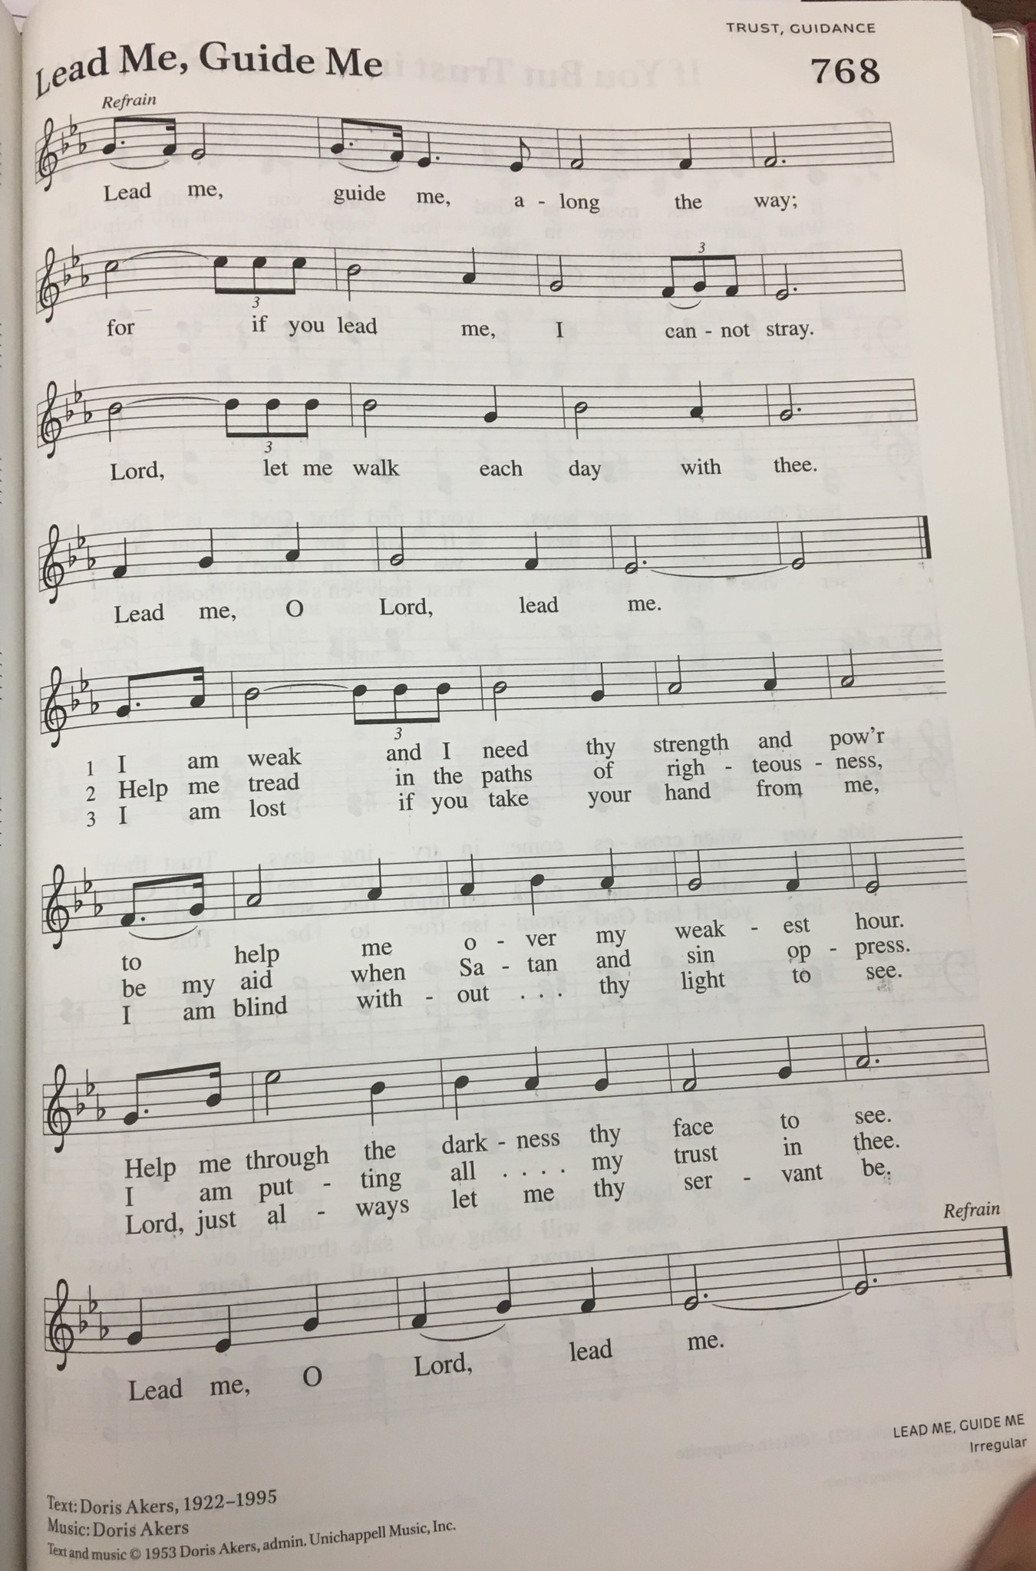
Dismissal
Go in peace. Christ is with you.
Thanks be to God.

From sundaysandseasons.com. Copyright © 2017 Augsburg Fortress. All rights reserved.

Thank you to all who served in worship today!

Presider: Buffy Meyers
Musician: Martha Yoder
Elder: Jolene Griffin
Trustee: Jerry Engle
Offering Counters: Jerry Engle & Martha Yoder
Safety Person: Dan Zylstra

This week at Zion:
- Confirmation camp June 28-30
- Newsletter deadline TUESDAY, June 28
- Men’s Coffee, 8 AM Wednesday, June 29
- Tara in office 10-12, Wednesday, June 29
- VBS: HayDay VBS: Growing in Friendship with Jesus on Thursday June 30
  - 11:30-12:30: Registration and Lunch
  - 12:30-5:00: VBS
  - 5:00: Family Dinner and Fun

ANNOUNCEMENTS

.
- Register now for VBS! Online registration for VBS is now open at www.myvbs.org/ZionWoodlandMI/register/
- Hearing Devices: We have hearing devises that are now working! They are in the narthex. Ask the usher to get one for you!

