ZION LUTHERAN CHURCH, WOODLAND, MI
Ninth Sunday after Pentecost, Aug 7 2022
*If you are listening in your car, please tune your radio to FM 87.7*

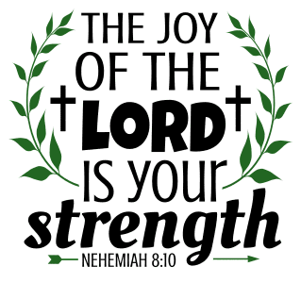

ANNOUNCEMENTS

PRELUDE

Gathering
The Holy Spirit calls us together as the people of God.

Confession and Forgiveness
Blessed be the holy Trinity, ☩ one God, who looks upon us in compassion, forgives our sin, and heals our lives.
Amen.

Let us confess our sin in the presence of God and of one another. Have mercy, O God,
against you, you alone, we have sinned. In your compassion, cleanse us from our sin and take away our guilt. Create in us a new heart and give us a steadfast spirit. Do not cast us away but fill us with your Holy Spirit and restore your joy within us. Amen.

As tender as parent to child, so deep is God’s compassion for you. As high as heaven is above earth, so vast is God’s love for you. As far as east is from west, so far God removes your sin from you, renewing your life through Jesus Christ. Blessed be God who crowns us with mercy and love.
Blessed be God forever.

Gathering Song “Joyful, Joyful, We Adore Thee” ELW 836
GREETING
The grace of our Lord Jesus Christ, the love of God, and the communion of the Holy Spirit be with you all.
And also with you.
Prayer of the Day
Let us pray together.
Almighty God, you sent your Holy Spirit to be the life and light of your church. Open our hearts to the riches of your grace, that we may be ready to receive you wherever you appear, through Jesus Christ, our Savior and Lord. Amen.

First Reading Genesis 15:1-6
A reading from Genesis.

¹After these things the word of the Lord came to Abram in a vision, “Do not be afraid, Abram, I am your shield; your reward shall be very great.” ²But Abram said, “O Lord God, what will you give me, for I continue childless, and the heir of my house is Eliezer of Damascus?” ³And Abram said, “You have given me no offspring, and so a slave born in my house is to be my heir.” ⁴But the word of the Lord came to him, “This man shall not be your heir; no one but your very own issue shall be your heir.” ⁵He brought him outside and said, “Look toward heaven and count the stars, if you are able to count them.” Then he said to him, “So shall your descendants be.” ⁶And he believed the Lord; and the Lord reckoned it to him as righteousness.

The word of the Lord.
Thanks be to God.

Psalm Psalm 33:12-22

¹²Happy is the nation whose God | is the Lord!
Happy the people chosen to | be God’s heritage!
¹³The Lord looks | down from heaven,
and sees all | humankind.
¹⁴God sits firmly en- | throned and watches
all who dwell | on the earth.
¹⁵God fashions | all their hearts
and observes | all their deeds. R
¹⁶A king is not saved by the size | of the army,
nor are warriors rescued by | their great strength.
¹⁷The horse gives vain | hope for victory;
despite its great strength it | cannot save.
¹⁸Truly, your eye is upon those who fear | you, O Lord,
upon those who wait for your | steadfast love,
¹⁹to deliver their | lives from death,
and to keep them alive in | time of famine.
²⁰Our innermost being waits for | you, O Lord,
our helper | and our shield.
²¹Surely, our heart rejoic- | es in you,
for in your holy name we | put our trust.
²²Let your lovingkindness, O Lord, | be upon us,
even as we place our | hope in you.

Second Reading Hebrews 11:1-3, 8-16
A reading from Hebrews.

¹Now faith is the assurance of things hoped for, the conviction of things not seen. ²Indeed, by faith our ancestors received approval. ³By faith we understand that the worlds were prepared by the word of God, so that what is seen was made from things that are not visible.
⁸By faith Abraham obeyed when he was called to set out for a place that he was to receive as an inheritance; and he set out, not knowing where he was going. ⁹By faith he stayed for a time in the land he had been promised, as in a foreign land, living in tents, as did Isaac and Jacob, who were heirs with him of the same promise. ¹⁰For he looked forward to the city that has foundations, whose architect and builder is God. ¹¹By faith he received power of procreation, even though he was too old—and Sarah herself was barren—because he considered him faithful who had promised. ¹²Therefore from one person, and this one as good as dead, descendants were born, “as many as the stars of heaven and as the innumerable grains of sand by the seashore.”
¹³All of these died in faith without having received the promises, but from a distance they saw and greeted them. They confessed that they were strangers and foreigners on the earth, ¹⁴for people who speak in this way make it clear that they are seeking a homeland. ¹⁵If they had been thinking of the land that they had left behind, they would have had opportunity to return. ¹⁶But as it is, they desire a better country, that is, a heavenly one. Therefore God is not ashamed to be called their God; indeed, he has prepared a city for them.

The word of the Lord.
Thanks be to God.

Gospel Acclamation

Gospel Luke 12:32-40
The holy gospel according to Luke.
Glory to you, O Lord.

[Jesus said:] ³²“Do not be afraid, little flock, for it is your Father’s good pleasure to give you the kingdom. ³³Sell your possessions, and give alms. Make purses for yourselves that do not wear out, an unfailing treasure in heaven, where no thief comes near and no moth destroys. ³⁴For where your treasure is, there your heart will be also.
³⁵“Be dressed for action and have your lamps lit; ³⁶be like those who are waiting for their master to return from the wedding banquet, so that they may open the door for him as soon as he comes and knocks. ³⁷Blessed are those slaves whom the master finds alert when he comes; truly I tell you, he will fasten his belt and have them sit down to eat, and he will come and serve them. ³⁸If he comes during the middle of the night, or near dawn, and finds them so, blessed are those slaves.
³⁹“But know this: if the owner of the house had known at what hour the thief was coming, he would not have let his house be broken into. ⁴⁰You also must be ready, for the Son of Man is coming at an unexpected hour.”

The gospel of the Lord.
Praise to you, O Christ.

CHILDREN’S SERMON Pastor Becky Ebb-Speese

Sermon Pastor Becky Ebb-Speese
Hymn of the Day “Blessed Assurance” ELW 638
Creed
I believe in God, the Father almighty,
creator of heaven and earth.
I believe in Jesus Christ, God’s only Son, our Lord,
who was conceived by the Holy Spirit,
born of the virgin Mary,
suffered under Pontius Pilate,
was crucified, died, and was buried;
he descended to the dead.*
On the third day he rose again;
he ascended into heaven,
he is seated at the right hand of the Father,
and he will come to judge the living and the dead.
I believe in the Holy Spirit,
the holy catholic church,
the communion of saints,
the forgiveness of sins,
the resurrection of the body,
and the life everlasting. Amen.

*Or, “he descended into hell,” another translation of this text in widespread use.

Prayers of Intercession
Trusting in God’s extraordinary love, let us come near to the Holy One in prayer.
A brief silence.
Let your lovingkindness be upon your church. Fill all who proclaim the gospel with your Spirit. Equip your flock to speak your word of promise and hope in the midst of fear and uncertainty. We pray especially for St. James Lutheran Church and Rev. Mary Hughes. Merciful God,
receive our prayer.
Let your lovingkindness be upon your creation. Dwell among us and sustain our earthly home. In places of famine, provide nourishment. In places of plenty, fashion us to be good stewards of your bounty. Merciful God,
receive our prayer.
Let your lovingkindness be upon your world. Be our helper and our shield in places torn by strife and violence. Raise up courageous leaders to govern with compassion and justice. Merciful God,
receive our prayer.
Let your lovingkindness be upon your children. Look upon all who wait for your steadfast love. Console those who grieve and embrace those who cry out to you. We also pray for the people of Ukraine and the people suffering from recent mass shootings and gun violence Help us to trust your promise and not be afraid. Merciful God,
receive our prayer.
Let your lovingkindness be upon this community. Fashion our hearts to strive for the way of peace. Strengthen the outreach ministries of this congregation and all who care for those in need. Merciful God,
receive our prayer.
With thanksgiving we remember all who have died in faith and now rest in you. As they placed their hope in you, so strengthen us to trust in your promise of new life. Merciful God,
receive our prayer.
Receive the prayers of your children, merciful God, and hold us forever in your steadfast love; through Jesus Christ, our holy Wisdom.
Amen.

Peace
The peace of Christ be with you always.
And also with you.

OFFERtory SONG
The joy of the Lord is my strength,
The joy of the Lord is my strength,
The joy of the Lord is my strength,
The joy of the Lord is my strength.

Offering Prayer
Let us pray.
God our provider, you have not fed us with bread alone, but with words of grace and life. Bless us and these your gifts, which we receive from your bounty, through Jesus Christ our Lord.
Amen.

Great Thanksgiving

Dialogue
The Lord be with you.
And also with you.
Lift up your hearts.
We lift them to the Lord.
Let us give thanks to the Lord our God.
It is right to give our thanks and praise.

Holy, Holy, Holy
Thanksgiving at the Table
In the night in which he was betrayed,
our Lord Jesus took bread, and gave thanks;
broke it, and gave it to his disciples, saying:
Take and eat; this is my body, given for you.
Do this for the remembrance of me.
Again, after supper, he took the cup, gave thanks,
and gave it for all to drink, saying:
This cup is the new covenant in my blood,
shed for you and for all people for the forgiveness of sin.
Do this for the remembrance of me.

Lord’s Prayer
Gathered into one by the Holy Spirit, let us pray as Jesus taught us.
Our Father in heaven,
hallowed be your name,
your kingdom come,
your will be done,
on earth as in heaven.
Give us today our daily bread.
Forgive us our sins
as we forgive those
who sin against us.
Save us from the time of trial
and deliver us from evil.
For the kingdom, the power,
and the glory are yours,
now and forever. Amen.

Invitation to Communion
Come to the banquet, for all is now ready.

communion
*continuous

SongS During Communion

“How Great Thou Art” ELW 856

“Have No Fear Little Flock” ELW 764
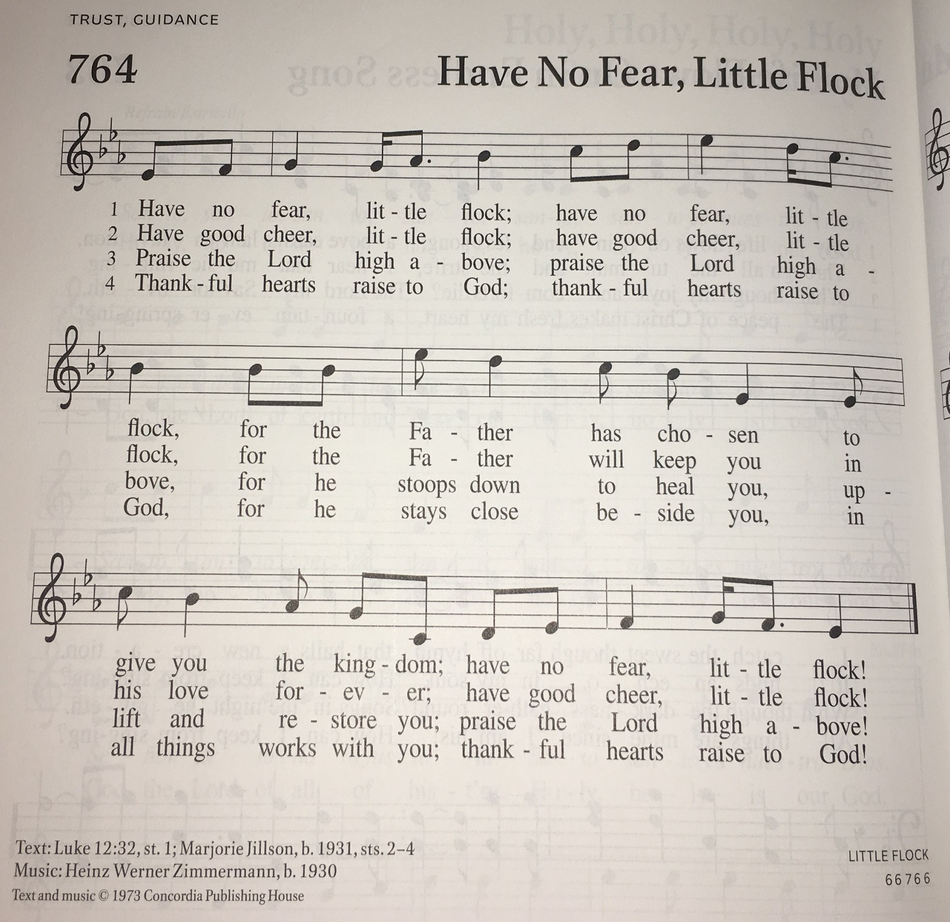

Prayer after Communion
Let us pray. We thank you, O God, that you have strengthened our hearts through this feast of life and salvation. Shine the light of Christ on our path, that we may do justice, love kindness, and walk humbly with you, now and forever.
Amen.

Sending
God blesses us and sends us in mission to the world.

Blessing
God, the Source of glory, God, the Word of life, God, the Spirit of truth
☩ bless you all, now and forever.
Amen.

Sending SonG “Faith of Our Fathers” ELW 812
Dismissal
Go in peace. Christ is with you.
Thanks be to God.

From sundaysandseasons.com. Copyright © 2017 Augsburg Fortress. All rights reserved.

Thank you to all who served in worship today!

Presider: Pastor Becky Ebb Speese
Musician: Martha Yoder
Elder: Jolene Griffin
Trustee: Jerry Engle
Offering Counters: Mary Makley & Martha Yoder
Safety Person: Diane Griffin

This week at Zion:
- Council Meeting, 6:30 PM Tuesday, August 9
- Men’s Coffee, 8 AM Wednesday, August 10
- Worship Planning, 4:30 PM, August 11

ANNOUNCEMENTS
.
- Free Community Meals will be held every Thursday at Central United Methodist Church from 4-6. All are welcome to attend. Volunteers are needed for the community meal at Central United Methodist Church for August. Please let Pastor Becky know what week(s) in August that you could help.
- VBS Supplies: Our mission partner congregation, Trinity Lutheran, Battle Creek, is having an intergenerational VBS from August 15-18 from 3:45-6:00. They would love a few people from Zion to come and take part as well as assist with their collection of items. Here is a list of items that are needed. Please bring them to church by August 7 so I can tell them what we have collected and have time to make arrangements to deliver them.
  - Paper Cups
  - Potting soil
  - Green beans seeds
  - Pony beans in red, white, black, green, blue, and yellow, 300+ each
  - Beads with opening at least 2mm in diameter, could be more pony beads
  - 8 oz bottles of water
  - Sidewalk chalk
- Run for Your Life 5K and Family Walk on August 13 to support the new Alpha Care Center on 4th Ave in Lake Odessa. For more information, contact Robin Morehouse at robinm@alphacarecenter.org or visit their website at https://alphacarecenter.org

