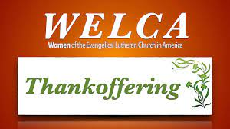

ZION LUTHERAN CHURCH, WOODLAND, MI
Women’s Thankoffering Sunday
November 20, 2022
*If you are listening in your car, please tune your radio to FM 87.7*

ANNOUNCEMENTS & PRELUDE

Gathering
Confession and Forgiveness
Blessed be the holy Trinity, + one God, who forgives all our sin, whose mercy endures forever.
Amen.

God of all mercy and consolation, come to the help of your people, turning us from our sin to live for you alone. Give us the power of your Holy Spirit that we may confess our sin, receive your forgiveness, and grow into the fullness of Jesus Christ, our Savior and Lord.
Amen.

Have mercy on us. We confess that we turned from and given ourselves into the power of sin. We are truly sorry and humbly repent. In your compassion forgive us our sins, known and unknown, things we done and things we have failed to do. Turn us again to you, and uphold us by your Spirit, so that we may live and serve you in newness of life through Jesus Christ, our Savior and lord.
Amen.

God, who is rich in mercy, loved us even when we were dead in sin, and made us alive together with Christ. By grace you have been saved. In the name of +Jesus Christ, your sins are forgiven. Almighty God, strengthen you with power through the Holy Spirit, that Christ may live in your hearts through faith.
Amen.

Gathering Song “Gather Us In” ELW 532

GREETING
The grace of our Lord Jesus Christ, the love of God, and the communion of the Holy Spirit be with you all.
And also with you.

Prayer of the Day
Let us pray:
O God, with our whole hearts, we give you thanks.
For your loving kindness and tender mercies, we give you thanks.
For the bounty of the harvest, we give you thanks..
In the name of the Father, + Son, and Holy Spirit, we give you thanks.

First Reading Ezra 3:8-13
A reading from Ezra.

⁸In the second year after their arrival at the house of God at Jerusalem, in the second month, Zerubbabel son of Shealtiel and Jeshua son of Jozadak made a beginning, together with the rest of their people, the priests and the Levites and all who had come to Jerusalem from the captivity. They appointed the Levites, from twenty years old and upward, to have the oversight of the work on the house of the LORD. ⁹And Jeshua with his sons and his kin, and Kadmiel and his sons, Binnui and Hodaviah along with the sons of Henadad, the Levites, their sons and kin, together took charge of the workers in the house of God.
¹⁰When the builders laid the foundation of the temple of the LORD, the priests in their vestments were stationed to praise the LORD with trumpets, and the Levites, the sons of Asaph, with cymbals, according to the directions of King David of Israel; ¹¹and they sang responsively, praising and giving thanks to the LORD,
"For he is good,
for his steadfast love endures forever toward Israel."
And all the people responded with a great shout when they praised the LORD, because the foundation of the house of the LORD was laid. ¹²But many of the priests and Levites and heads of families, old people who had seen the first house on its foundations, wept with a loud voice when they saw this house, though many shouted aloud for joy, ¹³so that the people could not distinguish the sound of the joyful shout from the sound of the people's weeping, for the people shouted so loudly that the sound was heard far away.

The word of the Lord.
Thanks be to God.

Psalm Psalm 111

¹Hallelujah! I will give thanks to the Lord with | my whole heart,
in the assembly of the upright, in the | congregation.
²Great are your | works, O Lord,
pondered by all who de- | light in them.
³Majesty and splendor | mark your deeds,
and your righteousness en- | dures forever.
⁴You cause your wonders to | be remembered;
you are gracious and full | of compassion.
⁵You give food to | those who fear you,
remembering forev- | er your covenant.
⁶You have shown your people the power | of your works
in giving them the lands | of the nations.
⁷The works of your hands are faithful- | ness and justice;
all of your pre- | cepts are sure.
⁸They stand fast forev- | er and ever,
because they are done in | truth and equity.
⁹You sent redemption to your people and commanded your cove- | nant forever;
holy and awesome | is your name.
¹⁰The fear of the Lord is the begin- | ning of wisdom;
all who practice this have a good understanding. God's praise en- | dures forever.

Second Reading 1 Thessalonians 5:12-24
A reading from 1 Thessalonians

¹²But we appeal to you, brothers and sisters, to respect those who labor among you, and have charge of you in the Lord and admonish you; ¹³esteem them very highly in love because of their work. Be at peace among yourselves. ¹⁴And we urge you, beloved, to admonish the idlers, encourage the fainthearted, help the weak, be patient with all of them. ¹⁵See that none of you repays evil for evil, but always seek to do good to one another and to all. ¹⁶Rejoice always, ¹⁷pray without ceasing, ¹⁸give thanks in all circumstances; for this is the will of God in Christ Jesus for you. ¹⁹Do not quench the Spirit. ²⁰Do not despise the words of prophets, ²¹but test everything; hold fast to what is good; ²²abstain from every form of evil.
²³May the God of peace himself sanctify you entirely; and may your spirit and soul and body be kept sound and blameless at the coming of our Lord Jesus Christ. ²⁴The one who calls you is faithful, and he will do this.

The word of the Lord.
Thanks be to God.
Gospel Acclamation

Gospel John 6:25-35
The holy gospel according to John.
Glory to you, O Lord.

²⁵When they found him on the other side of the sea, they said to him, "Rabbi, when did you come here?" ²⁶Jesus answered them, "Very truly, I tell you, you are looking for me, not because you saw signs, but because you ate your fill of the loaves. ²⁷Do not work for the food that perishes, but for the food that endures for eternal life, which the Son of Man will give you. For it is on him that God the Father has set his seal." ²⁸Then they said to him, "What must we do to perform the works of God?" ²⁹Jesus answered them, "This is the work of God, that you believe in him whom he has sent." ³⁰So they said to him, "What sign are you going to give us then, so that we may see it and believe you? What work are you performing? ³¹Our ancestors ate the manna in the wilderness; as it is written, 'He gave them bread from heaven to eat.'" ³²Then Jesus said to them, "Very truly, I tell you, it was not Moses who gave you the bread from heaven, but it is my Father who gives you the true bread from heaven. ³³For the bread of God is that which comes down from heaven and gives life to the world." ³⁴They said to him, "Sir, give us this bread always."
³⁵Jesus said to them, "I am the bread of life. Whoever comes to me will never be hungry, and whoever believes in me will never be thirsty.

The gospel of the Lord.
Praise to you, O Christ.
SPEAKER ON MENTAL HEALTH ISSUES

Hymn of the Day “Bind Us Together Lord”
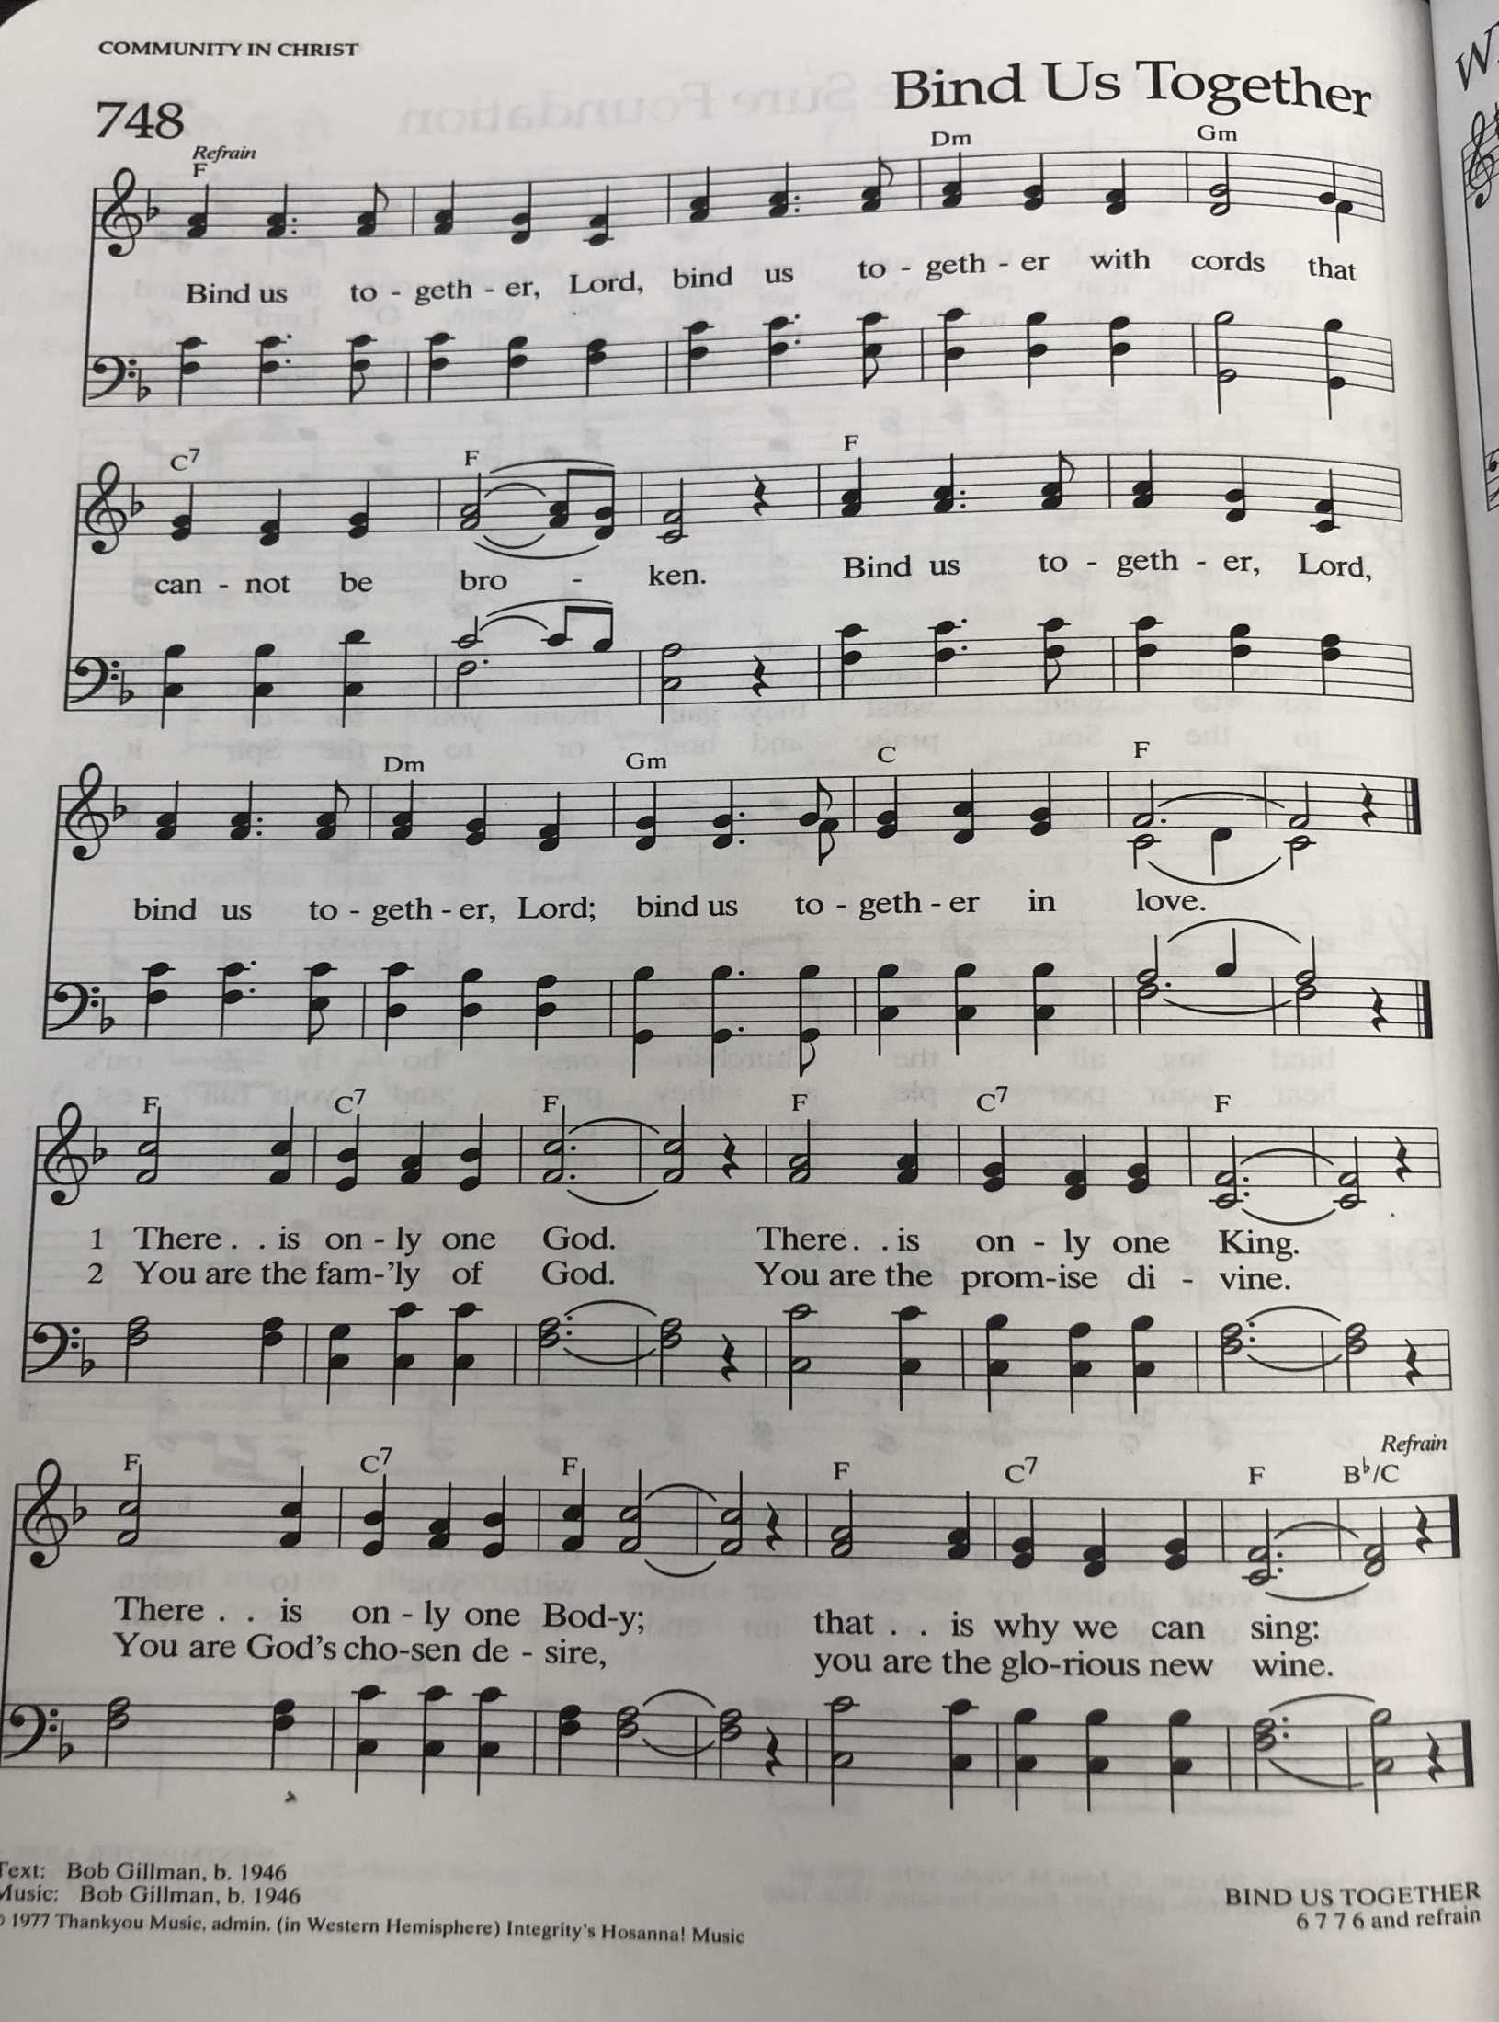
cREED
I believe in God, the Father almighty,
creator of heaven and earth.
I believe in Jesus Christ, God’s only Son, our Lord,
who was conceived by the Holy Spirit,
born of the virgin Mary,
suffered under Pontius Pilate,
was crucified, died, and was buried;
he descended to the dead.*
On the third day he rose again;
he ascended into heaven,
he is seated at the right hand of the Father,
and he will come to judge the living and the dead.
I believe in the Holy Spirit,
the holy catholic church,
the communion of saints,
the forgiveness of sins,
the resurrection of the body,
and the life everlasting. Amen.

*Or, “he descended into hell,” another translation of this text in widespread use.

prayers of Intercession

Called together as the body of Christ, we pray for the church, those in need, and for all of God’s Creation.

For the church universal, and the whole body of Christ, called, gathered, and sent in your holy name. We pray, with thanksgiving in our hearts.

For the beauty of creation, from the largest blue whale to the smallest bacteria and all that lives or breathes between. We pray, with thanksgiving in our hearts.

For peace in the all the world, for leaders and activists who labor for justice, for the beloved community that pursues love at all costs. We pray, with thanksgiving in our hearts.

For the opportunity to follow the way of Jesus, as we compassionately hear the cries of our siblings who are poor or oppressed in any way, give us courage to share the abundance of your earth, with all. We pray with thanksgiving, in our hearts.

For the ELCA, its synods, and local congregations that all members may be the hands, feet, and smile of Jesus in a world that so desperately needs him. We pray, with thanksgiving in our hearts.

For the ministry of the Women of the ELCA, the bold women who aspire to the organization’s Purpose Statement every day, and the varied ministries carried out by participants across the church. We pray, with thanksgiving in our hearts.

For the faithful departed who now rest from their labors in eternal communion with you, especially those women who were active in Women of the ELCA and have died in this past year. We pray, with thanksgiving in our hearts.

Into your hands, gracious God, we commend all for whom we pray, trusting in your mercy, through Jesus Christ, our Savior. Amen. For the faithful departed who now rest from their labors in eternal communion with you, especially those women who were active in Women of the ELCA and have died in this past year. We pray, with thanksgiving in our hearts.

Into your hands, gracious God, we commend all for whom we pray, trusting in your mercy, through Jesus Christ, our Savior. Amen.

Lord’s Prayer
Gathered into one by the Holy Spirit, let us pray as Jesus taught us.
Our Father in heaven,
hallowed be your name,
your kingdom come,
your will be done,
on earth as in heaven.
Give us today our daily bread.
Forgive us our sins
as we forgive those who sin against us.
Save us from the time of trial
and deliver us from evil.
For the kingdom, the power,
and the glory are yours,
now and forever. Amen.

Peace
The peace of Christ be with you always.
And also with you.

Let us share a sign of this peace, with one another.
Offering/Thankoffering

Offering song

The joy of the Lord is my strength,
The joy of the Lord is my strength,
The joy of the Lord is my strength,
The joy of the Lord is my strength.

Offering Prayer
God of grace, you have showered us with gifts of grace and abundance, entrusting to us the ministries of Women of the ELCA. Help us to grow in faith, affirm our gifts, support one another in our callings, engage in ministry and action, and promote healing and wholeness in the church, the society, and the world.
Accept these gifts and our prayer that, nurtured by your Word, filled with your Spirit, and fed at your table, we may share with gladness all that you have shared with us, until all creation is satisfied.
Amen.

Sending

We give thanks to God with our hearts. Hallelujah!
Great are the works of our God. Hallelujah!
Gracious and merciful id God. Hallelujah!
God sent redemption to the people; holy and awesome is God’s name..
Hallelujah! Hallelujah! Hallelujah!

Holy Trinity + One God, bless you now and forever.

Amen.

Sending SonG

Hallelujah We sing your praises ELW 535

Dismissal
Go now to love and serve the Lord. Go in peace.
Amen. We go in the name of Christ.

Thank you to all who served in worship today!

Speaker
Musician: Cindy June
Elder: Jolene Griffin
Trustee: Dan Zylstra
Offering Counters: Jerry Engle & Carlotta Willard
Safety Person: Dan Zylstra

PRAYERS OF THE FAITHFUL

With thanks for all God’s blessings and his love for all people. Our Bishops, Craig Satterlee Elizabeth Eaton, and the congregations of the North/West Lower Michigan Synod. Saron Lutheran Church in St. Joseph and Rev. Joan Oleson

Prayers for our friends, especially Austin Thomas, the family of Marjorie Wichern,, Chloe Makley, Erik Anderson, Janine Kaufman, Brian Smith, Cort Zylstra, Vi Aho, Chris and Charles Farlee. All those members of Zion’s family traveling; all those homebound or in frail health; all those suffering with quiet, unknown needs or worries.
For those who serve on our behalf: public safety, utility workers, medical personnel, military personnel. For those who might be forgotten.

This week at Zion:
- Charity Circle, 1 PM Tuesday, November 15 at Marie Brodbeck’s new home
- Men’s Coffee, 8 AM Wednesday, November 9
- Women’s Thankoffering Service, Next Sunday, November 20

ANNOUNCEMENTS
.
- A big thank you to Claude and Mary Smith for hosting our hayride and bonfire on Oct.29th. We roasted hot dogs and had many other great snacks to enjoy. We were blessed with a beautiful evening for a party. We all had a fun time and some even saw deer. Thanks so much!
- The ZLCW Thankoffering service will be on Sunday, Nov. 20th with the women and girls of Zion leading worship. There are special envelopes in your mailboxes for this collection. The donations go to the Women of the ELCA to help with their many projects. Please write checks out to ZLCW. There will be a basket at the offering table that day for the donations.
- It is time to order Christmas Poinsettias. The cost is $14.95 each. Please sign up by November 20th in the Narthex. If you have any questions, please see Mary Makley.
- Community Thanksgiving Service: Sunday, November 20 at 7:00 PM at Harvest Community Church in Lake Odessa
- Zion's Undie Sunday-The Board of Evangelism has a new project collecting socks and underwear of all sizes (kids to adults) for Manna's Market Clothes Closet. Jayne Flanigan said there is always a big need for these items because they must be new. Jerry Engle has received a grant from Thrivent Financial for $250.00 to purchase some of them. The Board of Evangelism members are the Thrivent Action Team. There is a table in the Fellowship Hall for all donations. Zion will be collecting donations until Sunday, Nov. 27th.
- Lost Water Bottle. If you come across a stainless steel water bottle with a teal lid, Contigo brand, please give it to Martha. Thank you!
- Christmas Around the World: For the Christmas program this year we are going to explore how others around the world celebrate Christmas. During the program we will hear how it’s celebrated in other countries and we want to hear any traditions your family has for celebrating that have been passed down. Are there certain foods you enjoy? Tell us and bring those to our potluck! Are there special gifts you give? Are there special traditions? We want to hear about them. Feel free to share with Pastor Becky or Jolene.

