ZION LUTHERAN CHURCH, WOODLAND, MI
Fourth Sunday of Advent, December 18, 2022
Children’s Christmas Program
*If you are listening in your car, please tune your radio to FM 87.7*

ANNOUNCEMENTS & PRELUDE

Gathering
The Holy Spirit calls us together as the people of God.

LIGHTING OF THE ADVENT WREATH: Love
Read by: The Griffin Family
Last Sunday we lit the candle of Hope, remembering the hope which comes in Christ, the candle of Peace, remembering God’s dream of a peaceful world, and the candle of Joy, remembering the Spirit within us who brings joy. Today we light the fourth candle of Advent, the candle of Love.
Scripture tells us “There is no fear in love, for perfect love casts out fear.” (1 John 4:18). God created this world in love and this world will end in the love of God. God’s love pervades all aspects of this life. From birth to death, pain to delight, strangers to lovers, God’s love is there. We light this candle in Love.
On this day, we remember God is Love.
(Verse Four)

Gathering Song “Hark! The Herald Angels Sing” ELW 270 vs 1

GREETING
The grace of our Lord Jesus Christ, the love of God, and the communion of the Holy Spirit be with you all.
And also with you.
Prayer of the Day
Let us pray together.
Stir up your power, Lord Christ, and come. With your abundant grace and might, free us from the sin that hinders our faith, that eagerly we may receive your promises, for you live and reign with the Father and the Holy Spirit, one God, now and forever.
Amen.

Gospel Luke 2:1-20
The holy gospel according to Luke.
Glory to you, O Lord.

¹In those days a decree went out from Emperor Augustus that all the world should be registered. ²This was the first registration and was taken while Quirinius was governor of Syria. ³All went to their own towns to be registered. ⁴Joseph also went from the town of Nazareth in Galilee to Judea, to the city of David called Bethlehem, because he was descended from the house and family of David. ⁵He went to be registered with Mary, to whom he was engaged and who was expecting a child. ⁶While they were there, the time came for her to deliver her child. ⁷And she gave birth to her firstborn son and wrapped him in bands of cloth, and laid him in a manger, because there was no place for them in the inn.
⁸In that region there were shepherds living in the fields, keeping watch over their flock by night. ⁹Then an angel of the Lord stood before them, and the glory of the Lord shone around them, and they were terrified. ¹⁰But the angel said to them, "Do not be afraid; for see — I am bringing you good news of great joy for all the people: ¹¹to you is born this day in the city of David a Savior, who is the Messiah, the Lord. ¹²This will be a sign for you: you will find a child wrapped in bands of cloth and lying in a manger." ¹³And suddenly there was with the angel a multitude of the heavenly host, praising God and saying,
¹⁴"Glory to God in the highest heaven,
and on earth peace among those whom he favors!"
¹⁵When the angels had left them and gone into heaven, the shepherds said to one another, "Let us go now to Bethlehem and see this thing that has taken place, which the Lord has made known to us." ¹⁶So they went with haste and found Mary and Joseph, and the child lying in the manger. ¹⁷When they saw this, they made known what had been told them about this child; ¹⁸and all who heard it were amazed at what the shepherds told them. ¹⁹But Mary treasured all these words and pondered them in her heart. ²⁰The shepherds returned, glorifying and praising God for all they had heard and seen, as it had been told them.

The gospel of the Lord.
Praise to you, O Christ.

Hymn “Away In a Manger” ELW 278, vs 1

Christmas Program
Christians around the world are uniting to celebrate the birth of Jesus. Our youth will be sharing traditions from various countries. A few of our members will also share their traditions with the youth. If you’d like to share yours today, we welcome them!
HYMN “Children, Go Where I Send Thee”
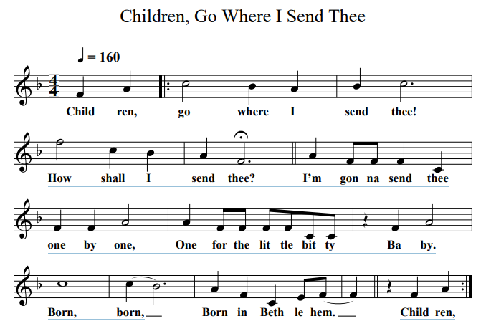

Argentina
“He shall be called John” Luke 1:60
Hi! My name is Juan, and my siter’s name is Marta. We live in the country of Argentina. Our Christmas weather is warm, so we decorate our homes with wreaths of gold, red and white flowers. We put cotton balls on our Christmas trees to look like snow. The pesebre, or Nativity scene, is set up close to the Christmas tree and is our most important decoration. On Christmas Eve we float globos, colorful tissue-paper balloons lit from inside. Fireworks can be heard everywhere; it’s Jesus’ birthday! We greet each other with Feliz Navidad!

Australia
“Glory to God in the highest and on earth peace among those with whom he is pleased.” Luke 2:13-14
Christmas comes to Australia in the middle of our summer, so you might find our family at the beach during the Christmas holidays. It can be 100 degrees, so our Christmas dinner of cold chicken, fruit salad and ice cream might sound like your 4th of July celebration. My name is Charlotte, and I live in the city of Melbourne, where thousands of people gather for a Christmas Eve service at the Music Bowl. We sit on blankets, light candles, and sing Christmas carols.

Bethlehem
“From you [O Bethlehem] shall come a ruler who will shepherd my people.” Matthew 2:6
Have you ever wondered what it would be like to celebrate Jesus’ birthday here in the little town where he was born? My name is Shira and I live in Bethlehem. We have a big Church of the Nativity in Manger Square built over the place where people believe Mary sang Baby Jesus to sleep. Next door is St. Catherine’s church and during the Christmas season, thousands of tourists come to look and pray. But those of us who live here feel sad because many tourists tell us that is the only day they go to church during the whole year. Please pray for Christians who live in Bethlehem and all over the world.

Brazil
“And an angel of the Lord appeared to them and the glory of the Lord shone around them.” Luke 2:9
Hi, I’m Gabriel! I’m Maria! Welcome to Christmas in Brazil, the happiest day in the whole year. We put up Christmas trees and decorate them with lights and glass balls. In Brazil, our huge trees that are made out of electric lights are visible everywhere against the night sky. But our favorite decoration is the presipio, our Nativity scenes, seen in every home, church and store. We have a legend that the first presipio ever made was in a small town in Brazil three hundred years ago. Brazil loves Christmas and Jesus! Boas Festas e Feliz from Gabriel and Maria!

Ecuador
“[Jesus] was known to them in the breaking of the bread.” Luke 24:35
Feliz Navidad! We speak Spanish in my country of Ecuador, so we say Merry Christmas like our Mexican and Argentinean cousins. My name is Adolfo. You might e backing cookies for Christmas, but we back and share many kinds of bread. Whether in the grandest hacienda (house) or the most humble hut in Ecuador, you will find a pesebre, or nativity scene. Besides Mary and Joseph and the rest, we have llamas and burros in our pesebres, and they are all made out of bread dough. No we don’t eat the llamas and burros after Christmas. We crumble the bread and feed it to the aves (birds).

Germany
“And she gave birth to her firstborn son and wrapped him in swaddling cloths and laid him in a manger.” Luke 2:7
Froehliche Weihnachten! I’m Maximillian, but call me Max. We begin our Christmas preparation with the season of Advent, which means “coming” – Jesus’ coming at Christmas and at the end of time. We set up an Advent wreath with four candles and light a new one each Sunday. We also use Advent calendars with little windows to open each day. December 6th is St. Nicholas Day. He is the patron saint of children, and we leave our shoes out, hoping they will be filled with treats. On Christmas Eve, we read the story of Jesus’ birth from the Bible, sing Christmas carols, and finally get to open our gifts.

Haiti
“Rejoice in that day, and leap for joy.” Luke 6:23
My name is Andre and I’ll tell you about a Haitian Christmas. We cut pine branches or fresh trees and decorate them like you do. We always have a large nativity scene, which might fill most of our living area. On Christmas Eve, we clean up our shoes, fill them with hay, and put them on our porch. We hope Papa Noel will take the straw and leave presents around our shoes. Many people stay up all night going to midnight service, launching homemade fireworks, and singing carols. Then we join family and friends for reveillon, a big feast that might last until the sun comes up on Christmas Day.

Iraq
“My peace I give to you.” John 14:27
My name is Sara, and I live in the country of Iraq. Most of the people in Iraq are Muslims, but there are still a few of us who are Christians. In 2008, the government declared Christmas an official holiday for the first time. That made us happy! On Christmas Eve, the children read the Nativity story from an Arabic Bible while the older family members hold candles. On Christmas day, our church service ends with the touch of peace: our pastor blesses us and touches one person who touches one more person until everyone has received the touch of peace. In our country that has seen so much war, we constantly pray for peace. Will you pray for us, too?

Kenya
“And the shepherds returned, glorifying and praising God for all they had heard and seen.” Luke 2:20
Sikukuu njema ya Krismasi, Merry Christmas from Mehdi in Kenya. Can you find Kenya in Africa on a world map? Just like the shepherds hurried to see the baby Jesus, Kenyans who live in the cities grab a bus and hurry to visit relatives who live out in the country. Our bus stations are the busiest ever during the Christmas season. On the farms, chickens, goats, sheep, and cow are prepared for Christmas feasting. Many of us gather for all-night prayer and services on Christmas Ever and then we eat! Kenyans also greet each other with, “May the Lord be born within you this Christmas.”

Mexico
“There was no place for him in the inn.” Luke 2:7
Hola (Hi!) from Miguel and Angel. We live in Mexico, and our Christmas celebration centers on the birth of Jesus. We build Nacimiento, nativity scenes, but we don’t put the figure of baby Jesus in the crib until Christmas Eve. Las Posadas is my favorite celebration. Groups of people wander from house to house pretending to look for a warm place to stay, like Mary and Joseph did when they came to Bethlehem. Everywhere we are turned away until finally we find a huge nativity scene. Then we have a big party with a piñata full of sweets. We love to celebrate our Savior’s birthday. Feliz Cumpleaños Jesus – Happy birthday, Jesus!

The Netherlands
“The kingdom of heaven is like a net that was thrown into the sea and gathered fish of every kind.” Matthew 13:47
My country has long been a country of sailors. We have a special feast on December 6 to honor St. Nicholas, the patron saint of sailors. We pretend that St. Nicholas fills our wooden shoes with gifts. Does that sound like your Santa Claus? Most of our friends and relatives know Christmas is really Jesus’ birthday and our church are very full on Christmas day. Because we are a seafaring country, we have lots salmon, fish and even eel for our Christmas dinner. I’ll bet you never ate eel on Christmas Day! Vrolijk Kerstfeest from Emma in the Netherlands.

Nigeria
“Jesus loves me, this I know, for the Bible tells me so.”
Hi! Welcome to Christmas in Nigeria. English is our official language, so you might hear “Merry Christmas” when you visit us. But we are a country of 250 tribal groups, so most of us also speak one or two dialects. If I said, Yesu yana Kaunacce Ni, it means “Jesus loves me.” Many Nigerians follow Jesus, and we celebrate with pageants that tell the Christmas story. They might last several hours! Could you sit still that long? The drum is called the heartbeat of our country, so you will hear many drums on Christmas Eve welcoming the baby Jesus who came to be our Savior.

Romania
“Many who are first will be last, and the last first.” Matthew 19:30
Hello! We are two brothers, Andrei and Alexandru and two sisters, Ana-Maria and Alexadra. We think our Mom wanted us always to be the first in line at school so she gave us all names beginning with “A”! For many years, the government in our country would not let Christians celebrate Christmas, but now we can! Now we walk through town singing Christmas carols behind a big wooden star covered with metal foil with a picture of the Nativity pasted in the middle, and carried on a broomstick. We four are always first in line! Craciun Fericit from Romania.

Spain
“opening their treasures, they offered him gifts, gold, frankincense, and myrrh.” Matthew 2:11
Welcome to Christmas in Spain! My name is Alejandro, and we begin our Christmas preparation on December 8. We have Christmas trees and we exchange gifts, but our celebration is more about Jesus’ birth. In fact, we don’t get our gifts until January 6, Epiphany, and we say they are brought by the Wise Men who brought gifts to the baby Jesus. After church and our Christmas Day feast with lots of visiting family members, we go out and swing! We hang Christmas swings in our courtyards and parks, and everyone swings and sings Christmas carols. Try this at your house!

Sweden
“For I was hungry and you gave me food.” Matthew 25:35
I’m Emma! I’m Maja! We are twins and every year we compete to see who will wear the Saint Lucia crown. Lucy was a young woman who carried food to those in need. Her arms were so full that she carried candles on her head. On December 13, the youngest girl in each family puts on a white robe with a red sash and a crown of evergreens and candles. Then we wake our parents and bring them coffee and Lucia buns. We sing Christmas carols and make plans to invite someone who is lonely to our Christmas dinner. On Christmas Day, we attend Church, and then we open gifts and eat – a lot!

Ukraine
“Jesus spoke to them, saying ‘I am the light of the world.’” John 8:12
Srozhdestvom Kirstovym, Merry Christmas from Vikor and Maksym in Ukraine. We use two different calendars in our country, and that can be confusing. Some Christians celebrate Christmas on December 25 just like you, and other celebrate it on January 7. We think we should celebrate Christmas twice! One of our customs is to put a loaf of bread with a candle in the middle of our Christmas Eve dinner table to show that Christ is the light of the world. We also scatter stalks of wheat on our table to remind us of the manger where Jesus lay. Mnohiya Lita, Jesus!

Venezuela
“And they went with haste and found Mary and Joseph and the baby lying in a manger.” Luke 2:16
Christmas celebrations in our country begin on December 16 with a special, early morning church service. Each morning until December 24, firecrackers explode and bells ring to call us to church. How do we get there? On roller skates! My name is Erneso and I am FAST! We go to sleep early and tie a long piece of string around our big toe then let the other end hang out the window. Roller skaters give a tug to any string they see to wake their friends. After church, everyone has tostados and coffee. Every home has a nativity scene with mountains, valleys, and a farm with sheep and goats.

Wales
“Sing to the Lord a new song, his praise from the end of the earth.” Isaiah 42:10
Wales is one of the four countries that make up the United Kingdom. We speak the Welsh language here – Nadolig Llawen to you! – but many of our names sound like yours: Jack, Dylan, Oliver, Ruby, Olivia, Megan. Welsh people love music and many of us go to our local churches to sing Christmas carols, often to the sound of a harp. We sing in our homes and in the streets, even in the early morning. We even have a contest each year to see who can write the best new Christmas carol. We love to sing about the birth of our Savior. Penblwydd Hapus Iesu Grist!

HYMN “Joy to the World” ELW 267 vs 1
congregation members are invited to share their stories

hymn “O Holy Night” vs 1
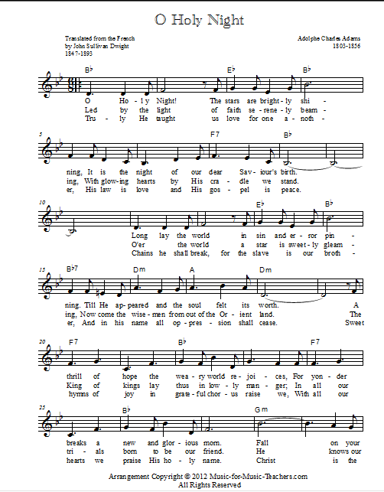
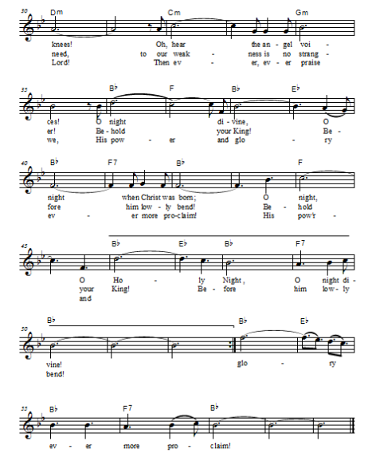
Offering & Offering song

Offering Prayer
Let us pray. God of goodness and growth, all creation is yours, and your faithfulness is sure. Word and water, wine and bread: these are signs of your abundant grace. Receive the gifts we bring, and nourish us to proclaim your abiding love in our communities and in the world, through Jesus Christ, our strength and our song.
Amen.

Lord’s Prayer
Gathered into one by the Holy Spirit, let us pray as Jesus taught us.
Our Father, who art in heaven,
hallowed be thy name,
thy kingdom come,
thy will be done,
on earth as it is in heaven.
Give us this day our daily bread;
and forgive us our trespasses,
as we forgive those
who trespass against us;
and lead us not into temptation,
but deliver us from evil.
For thine is the kingdom,
and the power, and the glory,
forever and ever. Amen.

Invitation to Communion
Come to the banquet, for all is now ready.

Sending
God blesses us and sends us in mission to the world.
Blessing
Soon, the angel will announce to the shepherds, “Fear not! I bring you good news of great joy.” As we await the coming of Christ, may the God of our salvation grant you peace and joy, hope and gladness.
Amen.

Sending SonG “We Wish You a Merry Christmas ”
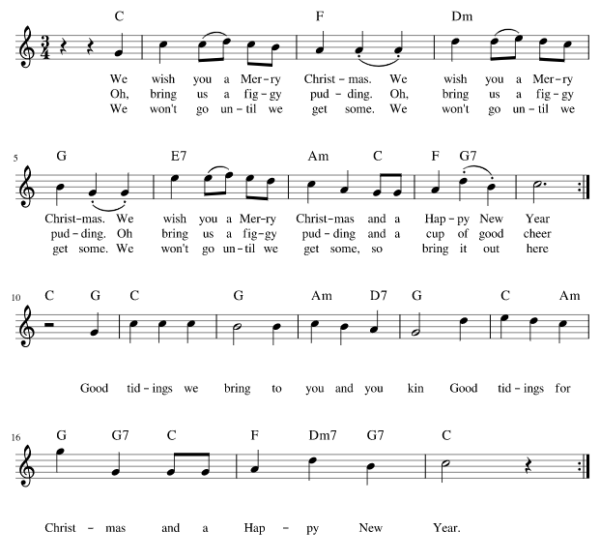
Dismissal
Fear not! Christ is coming soon.
Amen! Come, Lord Jesus!

From sundaysandseasons.com. Copyright © 2017 Augsburg Fortress. All rights reserved.

THANK YOU TO ALL WHO SERVED TODAY:
Presider: Jolene Griffin
Musician: Martha Yoder
Elder: Jolene Griffin
Trustee: Jerry Engle
Offering Counters: Jerry Engle & Carlotta Willard
Safety Person: Dan Zylstra

This week at Zion:

- Potluck after service today!
- Women’s Circle, 1 PM Tuesday, December 20
- Men’s Coffee, 8 AM Wednesday, December 21
- Christmas Eve Candlelight Service, 5 PM, Saturday, December 24
- Christmas Day Service, 10:30 AM, Sunday, December 25 (no Sunday School)

ANNOUNCEMENTS
.
- Reminder: During the heating season, please leave the Sunday School classroom doors open when not in use otherwise the opening area will be very cold. Please close the doors to the Sanctuary and Fellowship Hall when they are not in use. Thank you.
- ELCA Good Gifts - The Christmas tree in the Fellowship Hall is decorated with a variety of Good Gift ornaments of animals and other needs. You may take any of the ornaments you want. You may include your donation on your offering envelopes and write what it is for. Thank you
- Annual Meeting: Please plan to attend the Annual Meeting on January 15th. This is an important meeting to elect officers and board members as well as other items requiring congregational approval. One item for congregational consideration is approving an expenditure to upgrade and improve church signage. There will be a potluck dinner following the meeting. Mark your calendars and plan to be at Zion on January 15th.
- All gifts given through the congregation to Lutheran World Relief (you can indicate your gift on your offering envelope) will be doubled up to $200,00 through December 31.

