ZION LUTHERAN CHURCH, WOODLAND, MI
Sixth Sunday after Epiphany, February 12, 2023
*If you are listening in your car, please tune your radio to FM 87.7*

ANNOUNCEMENTS

PRELUDE

Gathering
The Holy Spirit calls us together as the people of God.

Confession and Forgiveness
Blessed be the holy Trinity, ☩ one God, who looks upon us in compassion, forgives our sin, and heals our lives.
Amen.

Let us confess our sin in the presence of God and of one another. Have mercy, O God,
against you, you alone, we have sinned. In your compassion, cleanse us from our sin and take away our guilt. Create in us a new heart and give us a steadfast spirit. Do not cast us away but fill us with your Holy Spirit and restore your joy within us. Amen.

As tender as parent to child, so deep is God’s compassion for you. As high as heaven is above earth, so vast is God’s love for you. As far as east is from west, so far God removes your sin from you, renewing your life through Jesus Christ. Blessed be God who crowns us with mercy and love.
Blessed be God forever.

Gathering Song “Joyful, Joyful, We Adore Thee” ELW 836
GREETING
The grace of our Lord Jesus Christ, the love of God, and the communion of the Holy Spirit be with you all.
And also with you.

Prayer of the Day
Let us pray together.
O God, the strength of all who hope in you, because we are weak mortals we accomplish nothing good without you. Help us to see and understand the things we ought to do, and give us grace and power to do them, through Jesus Christ, our Savior and Lord. Amen.

First Reading Deuteronomy 30:15-20
A reading from Deuteronomy.

[Moses said to the people:] ¹⁵See, I have set before you today life and prosperity, death and adversity. ¹⁶If you obey the commandments of the Lord your God that I am commanding you today, by loving the Lord your God, walking in his ways, and observing his commandments, decrees, and ordinances, then you shall live and become numerous, and the Lord your God will bless you in the land that you are entering to possess. ¹⁷But if your heart turns away and you do not hear, but are led astray to bow down to other gods and serve them, ¹⁸I declare to you today that you shall perish; you shall not live long in the land that you are crossing the Jordan to enter and possess. ¹⁹I call heaven and earth to witness against you today that I have set before you life and death, blessings and curses. Choose life so that you and your descendants may live, ²⁰loving the Lord your God, obeying him, and holding fast to him; for that means life to you and length of days, so that you may live in the land that the Lord swore to give to your ancestors, to Abraham, to Isaac, and to Jacob.

The word of the Lord.
Thanks be to God.

Psalm Psalm 119:1-8

¹Happy are they whose | way is blameless,
who follow the teaching | of the Lord!
²Happy are they who observe | your decrees
and seek you with | all their hearts,
³who never do | any wrong,
but always walk | in your ways.
⁴You laid down | your commandments,
that we should | fully keep them.
⁵Oh, that my ways were made | so direct
that I might | keep your statutes!
⁶Then I should not be | put to shame,
when I regard all | your commandments.
⁷I will thank you with | a true heart,
when I have learned your | righteous judgments.
⁸I will | keep your statutes;
do not utter- | ly forsake me.

Second Reading 1 Corinthians 3:1-9
A reading from 1 Corinthians.

¹Brothers and sisters, I could not speak to you as spiritual people, but rather as people of the flesh, as infants in Christ. ²I fed you with milk, not solid food, for you were not ready for solid food. Even now you are still not ready, ³for you are still of the flesh. For as long as there is jealousy and quarreling among you, are you not of the flesh, and behaving according to human inclinations? ⁴For when one says, “I belong to Paul,” and another, “I belong to Apollos,” are you not merely human?
⁵What then is Apollos? What is Paul? Servants through whom you came to believe, as the Lord assigned to each. ⁶I planted, Apollos watered, but God gave the growth. ⁷So neither the one who plants nor the one who waters is anything, but only God who gives the growth. ⁸The one who plants and the one who waters have a common purpose, and each will receive wages according to the labor of each. ⁹For we are God’s servants, working together; you are God’s field, God’s building.

The word of the Lord.
Thanks be to God.

Gospel Acclamation

Gospel Matthew 5:21-37

The holy gospel according to Matthew.
Glory to you, O Lord.

[Jesus said to the disciples:] ²¹“You have heard that it was said to those of ancient times, ‘You shall not murder’; and ‘whoever murders shall be liable to judgment.’ ²²But I say to you that if you are angry with a brother or sister, you will be liable to judgment; and if you insult a brother or sister, you will be liable to the council; and if you say, ‘You fool,’ you will be liable to the hell of fire. ²³So when you are offering your gift at the altar, if you remember that your brother or sister has something against you, ²⁴leave your gift there before the altar and go; first be reconciled to your brother or sister, and then come and offer your gift. ²⁵Come to terms quickly with your accuser while you are on the way to court with him, or your accuser may hand you over to the judge, and the judge to the guard, and you will be thrown into prison. ²⁶Truly I tell you, you will never get out until you have paid the last penny.
²⁷“You have heard that it was said, ‘You shall not commit adultery.’ ²⁸But I say to you that everyone who looks at a woman with lust has already committed adultery with her in his heart. ²⁹If your right eye causes you to sin, tear it out and throw it away; it is better for you to lose one of your members than for your whole body to be thrown into hell. ³⁰And if your right hand causes you to sin, cut it off and throw it away; it is better for you to lose one of your members than for your whole body to go into hell.
³¹“It was also said, ‘Whoever divorces his wife, let him give her a certificate of divorce.’ ³²But I say to you that anyone who divorces his wife, except on the ground of unchastity, causes her to commit adultery; and whoever marries a divorced woman commits adultery.
³³“Again, you have heard that it was said to those of ancient times, ‘You shall not swear falsely, but carry out the vows you have made to the Lord.’ ³⁴But I say to you, Do not swear at all, either by heaven, for it is the throne of God, ³⁵or by the earth, for it is his footstool, or by Jerusalem, for it is the city of the great King. ³⁶And do not swear by your head, for you cannot make one hair white or black. ³⁷Let your word be ‘Yes, Yes’ or ‘No, No’; anything more than this comes from the evil one.”

The gospel of the Lord.
Praise to you, O Christ.

CHILDREN’S Sermon Pastor Becky Ebb-Speese

Sermon Pastor Becky Ebb-Speese

Hymn of the Day “Oh, That the Lord Would Guide My Way” ELW 772

Creed
I believe in God, the Father almighty,
creator of heaven and earth.
I believe in Jesus Christ, God’s only Son, our Lord,
who was conceived by the Holy Spirit,
born of the virgin Mary,
suffered under Pontius Pilate,
was crucified, died, and was buried;
he descended to the dead.*
On the third day he rose again;
he ascended into heaven,
he is seated at the right hand of the Father,
and he will come to judge the living and the dead.
I believe in the Holy Spirit,
the holy catholic church,
the communion of saints,
the forgiveness of sins,
the resurrection of the body,
and the life everlasting. Amen.

*Or, “he descended into hell,” another translation of this text in widespread use.
Prayers of Intercession
Called together to follow Jesus, we pray for the church, the world, and all in need.
A brief silence.
Inspire your church that it may be a sign of life throughout the world. From the exploration of faith with children and new believers to missionaries and bishops, shape lives of faithfulness, so that all find abundant life in your ways. We pray especially for Grace Evangelical Lutheran Church in Alpena and Rev. Tom Orth. Merciful God,
receive our prayer.
Nourish your creation. Accompany all who plant and water. Bless the work of farmers; provide for subsistence farmers facing drought and climate change. Guide the work of agricultural scientists toward sustainable ways to feed the world. Merciful God,
receive our prayer.
Give growth where there seems to be no hope for life. In nations and regions where reconciliation seems impossible, empower peacemakers with your Spirit. Where death holds sway through violence, disease, and hunger, equip relief workers to bring hope. Merciful God,
receive our prayer.
Nurture all in need. Bring healing to all who experience trauma caused by systems of injustice and destructive relationships. Give courage to those struggling to repent and those seeking reconciliation. Sustain all who work for restoration. Merciful God,
receive our prayer.
Encourage this congregation. Call us to a common purpose and keep us from quarrelling. Turn our hearts toward you and guide our leaders, so that our choices may be lifegiving for all. Merciful God,
receive our prayer.
Thanks be to you for the lives of all who have died in Christ. Teach us to follow them in your ways and gather us with them into the promise of eternal life with you. Merciful God,
receive our prayer.
We bring to you our needs and hopes, O God, trusting your wisdom and power revealed in Christ crucified.
Amen.

Peace
The peace of Christ be with you always.
And also with you.

OFFERtory SONG

Offering Prayer
Let us pray.
God our provider, you have not fed us with bread alone, but with words of grace and life. Bless us and these your gifts, which we receive from your bounty, through Jesus Christ our Lord.
Amen.

Great Thanksgiving

Dialogue
The Lord be with you.
And also with you.
Lift up your hearts.
We lift them to the Lord.
Let us give thanks to the Lord our God.
It is right to give our thanks and praise.

Holy, Holy, Holy

Thanksgiving at the Table
In the night in which he was betrayed,
our Lord Jesus took bread, and gave thanks;
broke it, and gave it to his disciples, saying:
Take and eat; this is my body, given for you.
Do this for the remembrance of me.
Again, after supper, he took the cup, gave thanks,
and gave it for all to drink, saying:
This cup is the new covenant in my blood,
shed for you and for all people for the forgiveness of sin.
Do this for the remembrance of me.

Lord’s Prayer
Gathered into one by the Holy Spirit, let us pray as Jesus taught us.
Our Father, who art in heaven,
hallowed be thy name,
thy kingdom come,
thy will be done,
on earth as it is in heaven.
Give us this day our daily bread;
and forgive us our trespasses,
as we forgive those
who trespass against us;
and lead us not into temptation,
but deliver us from evil.
For thine is the kingdom,
and the power, and the glory,
forever and ever. Amen.

Invitation to Communion
Come to the banquet, for all is now ready.

communion
*continuous
*People are welcome to kneel at the altar rail for a time of prayer after they receive their communion elements

SongS During Communion

“One Bread, One Body” ELW 496

“Here Is Bread” ELW 483
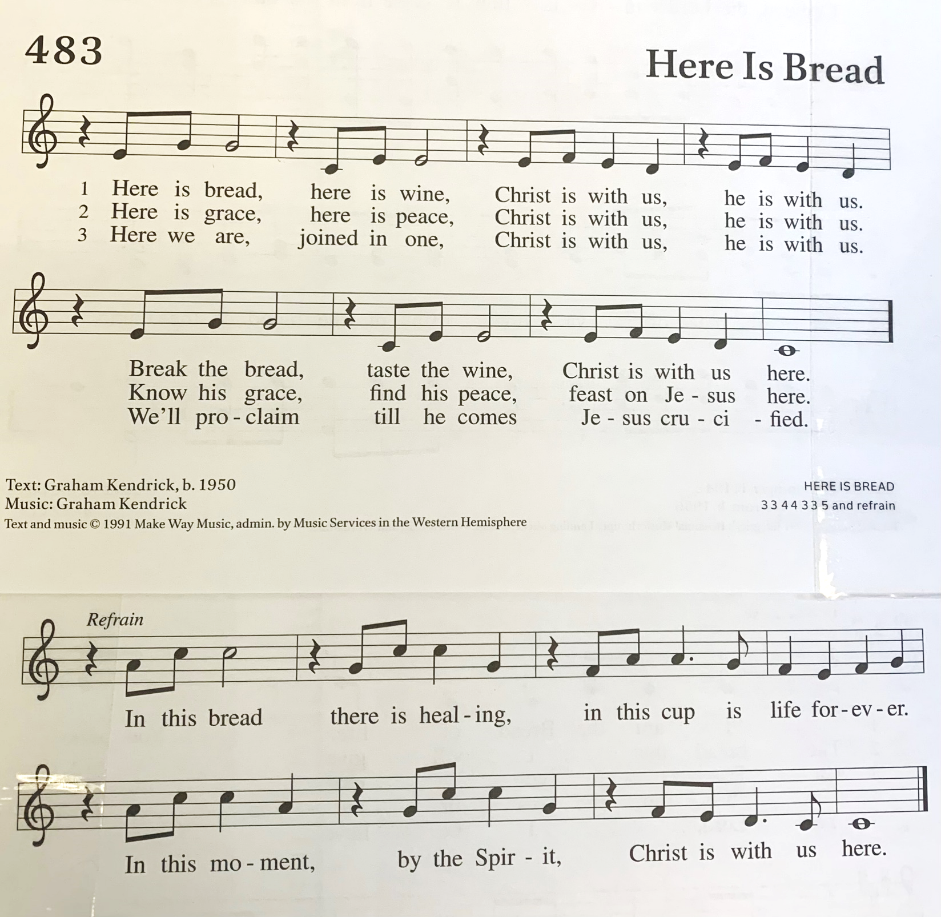

Prayer after Communion
Let us pray. We thank you, O God, that you have strengthened our hearts through this feast of life and salvation. Shine the light of Christ on our path, that we may do justice, love kindness, and walk humbly with you, now and forever.
Amen.

Sending
God blesses us and sends us in mission to the world.

Blessing
God, the Source of glory, God, the Word of life, God, the Spirit of truth
☩ bless you all, now and forever.
Amen.

Sending SonG “O Master Let Me Walk with You” ELW 818

Dismissal
Go in peace. Christ is with you.
Thanks be to God.

From sundaysandseasons.com. Copyright © 2017 Augsburg Fortress. All rights reserved.

Thank you to all who served in worship today!

Presider: Pastor Beck Ebb-Speese
Musician: Martha Yoder
Acolyte: Lexi Griffin
Elder: Buffy Meyers
Trustee: Martha Yoder
Offering Counters: Diane Griffin & Carlotta Willard
Safety Person: Dan Zylstra

This week at Zion:
- Confirmation class today after church! February 12
- Council Meeting, 6:30 PM Tuesday, February 14
- Men’s Coffee, 8 AM Wednesday, February 15
- Serve at Community Dinner, 4-6 PM Thursday, February 16

ANNOUNCEMENTS

- Reminder: During the heating season, please leave the Sunday School classroom doors open when not in use otherwise the opening area will be very cold. Please close the doors to the Sanctuary and Fellowship Hall when they are not in use. Thank you.

