ZION LUTHERAN CHURCH, WOODLAND, MI
Transfiguration of Our Lord, February 19, 2023
*If you are listening in your car, please tune your radio to FM 87.7*

ANNOUNCEMENTS

PRELUDE

Gathering
The Holy Spirit calls us together as the people of God.

Confession and Forgiveness
Blessed be the holy Trinity, ☩ one God, who looks upon us in compassion, forgives our sin, and heals our lives.
Amen.

Let us confess our sin in the presence of God and of one another. Have mercy, O God,
against you, you alone, we have sinned. In your compassion, cleanse us from our sin and take away our guilt. Create in us a new heart and give us a steadfast spirit. Do not cast us away but fill us with your Holy Spirit and restore your joy within us. Amen.

As tender as parent to child, so deep is God’s compassion for you. As high as heaven is above earth, so vast is God’s love for you. As far as east is from west, so far God removes your sin from you, renewing your life through Jesus Christ. Blessed be God who crowns us with mercy and love.
Blessed be God forever.

Gathering Song “O, Morning Star, How Fair and Bright” ELW 308
GREETING
The grace of our Lord Jesus Christ, the love of God, and the communion of the Holy Spirit be with you all.
And also with you.

Prayer of the Day
Let us pray together.
O God, in the transfiguration of your Son you confirmed the mysteries of the faith by the witness of Moses and Elijah, and in the voice from the bright cloud declaring Jesus your beloved Son, you foreshadowed our adoption as your children. Make us heirs with Christ of your glory, and bring us to enjoy its fullness, through Jesus Christ, our Savior and Lord, who lives and reigns with you and the Holy Spirit, one God, now and forever. Amen.

First Reading Exodus 24:12-18
A reading from Exodus.

¹²The Lord said to Moses, “Come up to me on the mountain, and wait there; and I will give you the tablets of stone, with the law and the commandment, which I have written for their instruction.” ¹³So Moses set out with his assistant Joshua, and Moses went up into the mountain of God. ¹⁴To the elders he had said, “Wait here for us, until we come to you again; for Aaron and Hur are with you; whoever has a dispute may go to them.”
¹⁵Then Moses went up on the mountain, and the cloud covered the mountain. ¹⁶The glory of the Lord settled on Mount Sinai, and the cloud covered it for six days; on the seventh day he called to Moses out of the cloud. ¹⁷Now the appearance of the glory of the Lord was like a devouring fire on the top of the mountain in the sight of the people of Israel. ¹⁸Moses entered the cloud, and went up on the mountain. Moses was on the mountain for forty days and forty nights.

The word of the Lord.
Thanks be to God.

Psalm Psalm 2

¹Why are the nations | in an uproar?
Why do the peoples mutter | empty threats?
²Why do the kings of the earth rise up in revolt, and the princes | plot together,
against the Lord and against the | Lord’s anointed?
³“Let us break their | yoke,” they say;
“let us cast off their | bonds from us.”
⁴God whose throne is in heav- | en is laughing;
the Lord holds them | in derision.
⁵Then in wrath God | speaks to them,
and in rage fills | them with terror.
⁶“As for me, I have anoint- | ed my king
upon Zion, my | holy mountain.”
⁷Let me announce the decree | of the Lord,
who said to me, “You are my son; this day have I be- | gotten you.
⁸Ask of me, and I will give you the nations for | your inheritance
and the ends of the earth for | your possession.
⁹You shall crush them with an | iron rod
and shatter them like a | piece of pottery.”
¹⁰And now, you | kings, be wise;
be warned, you rulers | of the earth.
¹¹Submit to the | Lord with fear,
and with trembling | bow in worship;
¹²lest the Lord be angry, and you perish in a sudden | blaze of wrath.
Happy are all who take ref- | uge in God!

Second Reading 2 Peter 1:16-21
A reading from 1 Peter.

¹⁶For we did not follow cleverly devised myths when we made known to you the power and coming of our Lord Jesus Christ, but we had been eyewitnesses of his majesty. ¹⁷For he received honor and glory from God the Father when that voice was conveyed to him by the Majestic Glory, saying, “This is my Son, my Beloved, with whom I am well pleased.” ¹⁸We ourselves heard this voice come from heaven, while we were with him on the holy mountain.
¹⁹So we have the prophetic message more fully confirmed. You will do well to be attentive to this as to a lamp shining in a dark place, until the day dawns and the morning star rises in your hearts. ²⁰First of all you must understand this, that no prophecy of scripture is a matter of one’s own interpretation, ²¹because no prophecy ever came by human will, but men and women moved by the Holy Spirit spoke from God.

The word of the Lord.
Thanks be to God.

Gospel Acclamation

Gospel Matthew 17:1-9
The holy gospel according to Matthew.
Glory to you, O Lord.

¹Jesus took with him Peter and James and his brother John and led them up a high mountain, by themselves. ²And he was transfigured before them, and his face shone like the sun, and his clothes became dazzling white. ³Suddenly there appeared to them Moses and Elijah, talking with him. ⁴Then Peter said to Jesus, “Lord, it is good for us to be here; if you wish, I will make three dwellings here, one for you, one for Moses, and one for Elijah.” ⁵While he was still speaking, suddenly a bright cloud overshadowed them, and from the cloud a voice said, “This is my Son, the Beloved; with him I am well pleased; listen to him!” ⁶When the disciples heard this, they fell to the ground and were overcome by fear. ⁷But Jesus came and touched them, saying, “Get up and do not be afraid.” ⁸And when they looked up, they saw no one except Jesus himself alone.
⁹As they were coming down the mountain, Jesus ordered them, “Tell no one about the vision until after the Son of Man has been raised from the dead.”

The gospel of the Lord.
Praise to you, O Christ.

CHILDREN’S Sermon Pastor Becky Ebb-Speese

Sermon Pastor Becky Ebb-Speese

Hymn of the Day “Shine, Jesus, Shine” ELW 671
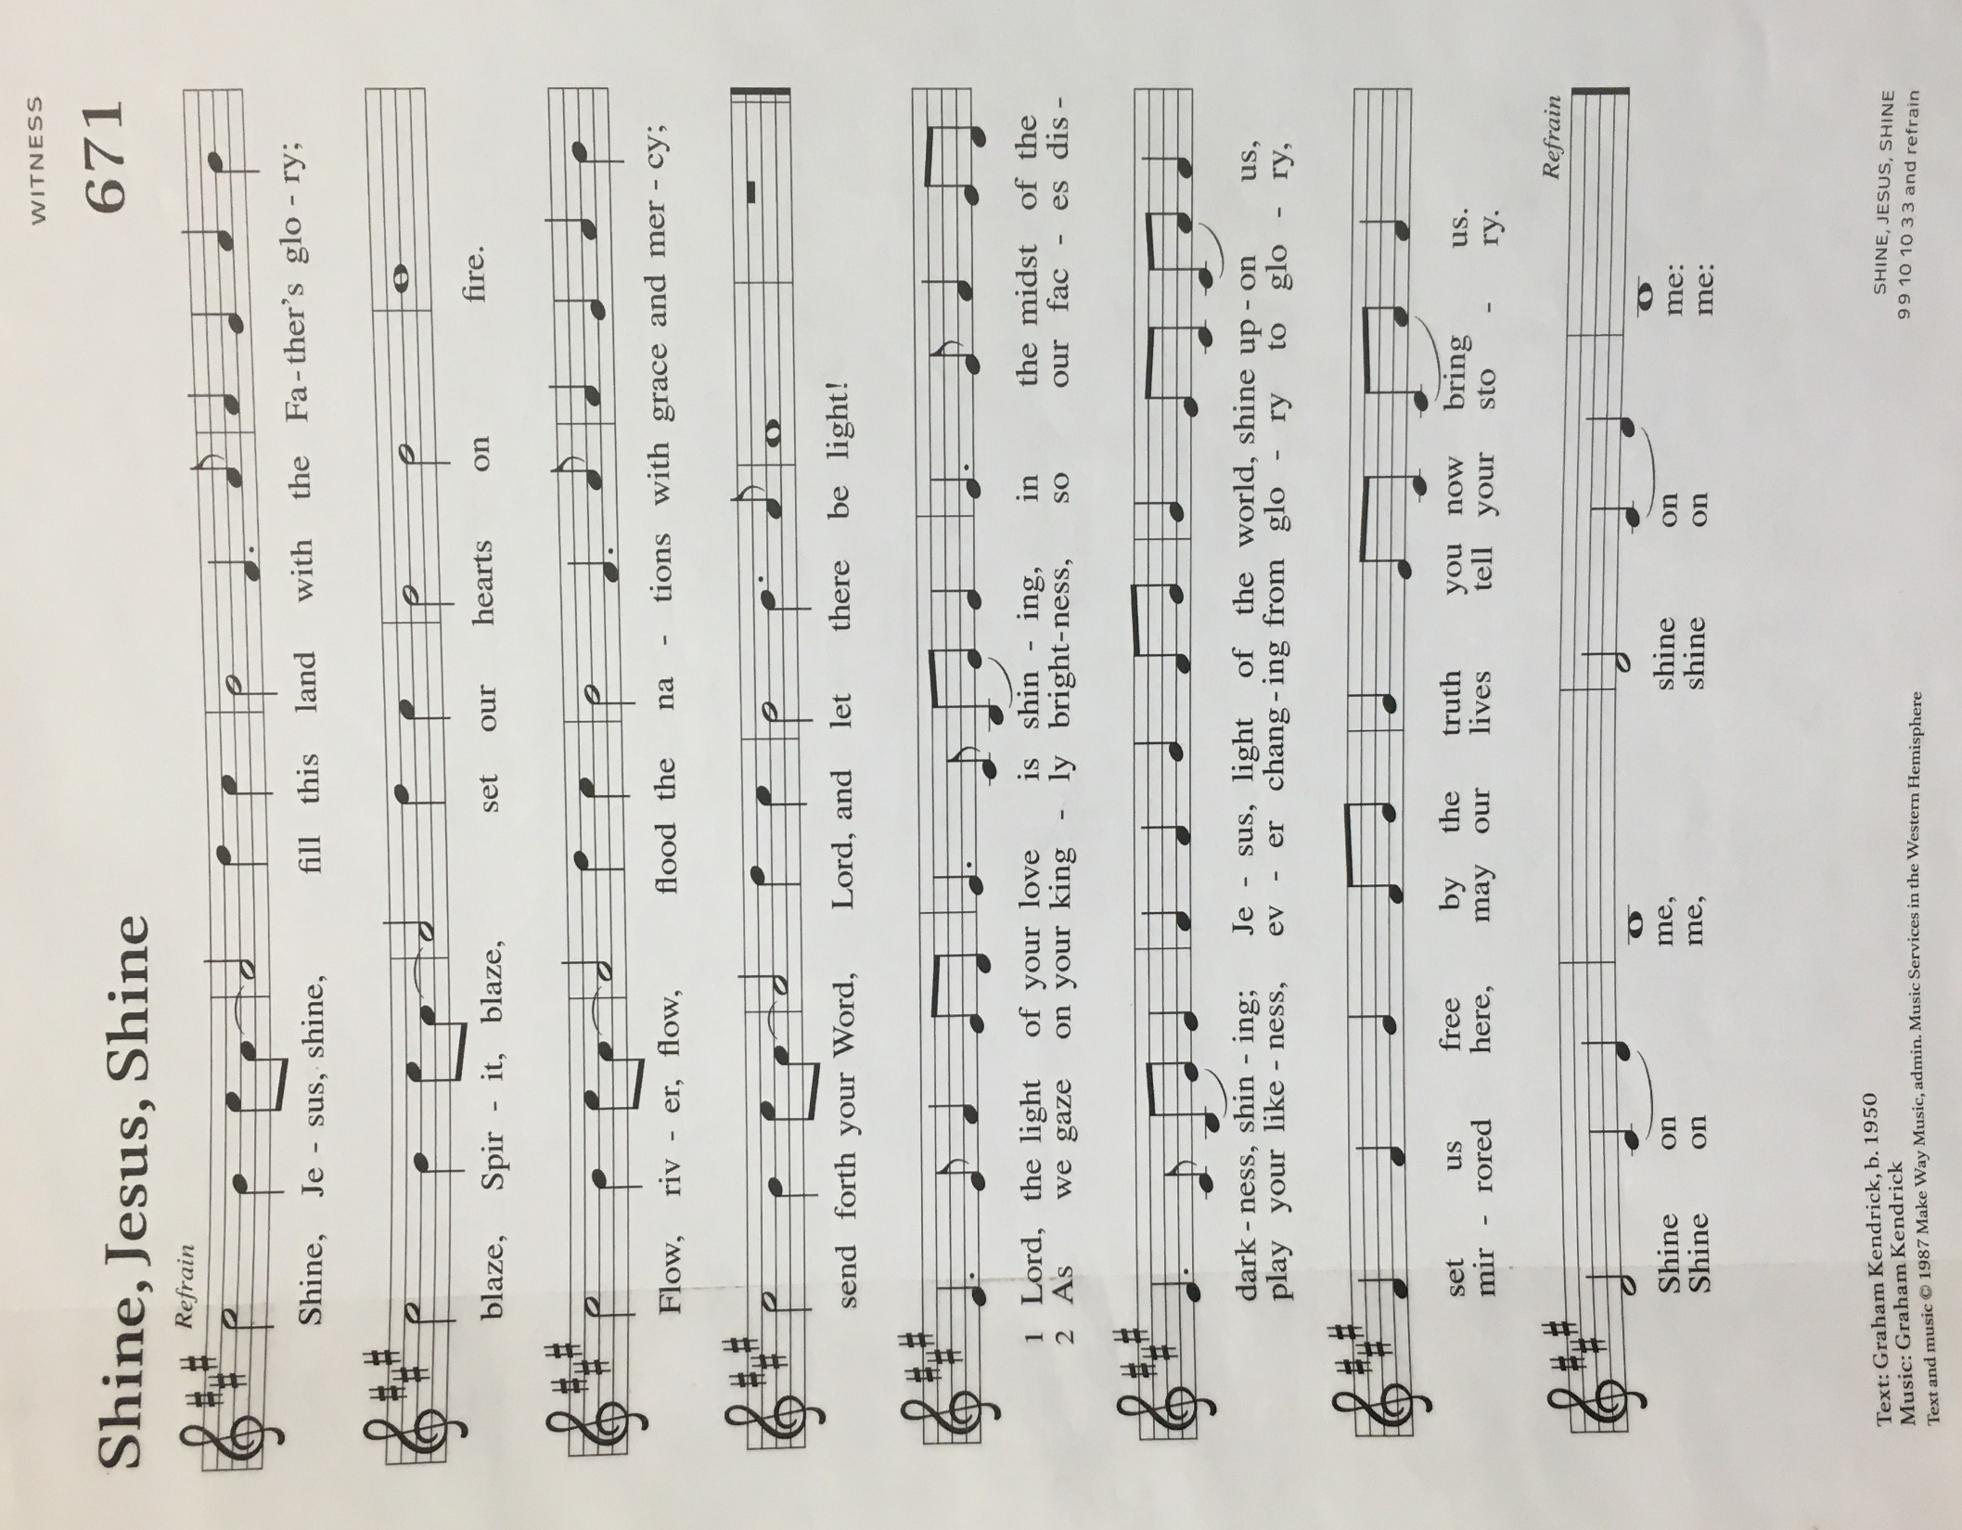

Creed
I believe in God, the Father almighty,
creator of heaven and earth.
I believe in Jesus Christ, God’s only Son, our Lord,
who was conceived by the Holy Spirit,
born of the virgin Mary,
suffered under Pontius Pilate,
was crucified, died, and was buried;
he descended to the dead.*
On the third day he rose again;
he ascended into heaven,
he is seated at the right hand of the Father,
and he will come to judge the living and the dead.
I believe in the Holy Spirit,
the holy catholic church,
the communion of saints,
the forgiveness of sins,
the resurrection of the body,
and the life everlasting. Amen.

*Or, “he descended into hell,” another translation of this text in widespread use.

Prayers of Intercession
Called together to follow Jesus, we pray for the church, the world, and all in need.
A brief silence.
Embolden your church as it witnesses to the majesty and mercy of your Son. Equip lay preachers, deacons, and pastors. Move us to share our stories of your faithfulness and forgiveness; may our lives proclaim your greatness. We pray especially for St. Paul Lutheran Church in Alpena and Rev. John Shipman. Merciful God,
receive our prayer.
Dwell with your whole creation, from the tallest mountain peak to the deepest valley. Bless the work of conservation organizations and protect vital habitats. Support the work of disaster relief agencies around the world. Merciful God,
receive our prayer.
Guide and give wisdom to all in authority: our mayor and local leaders, our governor and state legislators, our president and national legislators. Bring freedom and justice to all nations. Merciful God,
receive our prayer.
Give shelter to those lacking safe homes. Spur communities to work for fair housing for all. Protect our neighbors whose dwellings do not keep out dangerous cold or heat; accompany with your touch those who are homebound, sick, or isolated.

We pray especially for the MSU community, and for the people of Ukraine, Turkey, and Syria. Merciful God,
receive our prayer.
Make us eager to receive your Word in scripture. Help us recognize Jesus’ voice in the needs of our neighbors; make us confident to follow the way of the cross. Merciful God,
receive our prayer.
Receive our thanksgiving for the holy ones who have guided us in faithfulness and gathered even the unlikely as your people. With our forebears in faith and all who have hoped in you, teach us to wait with courage until the promised day dawns. Merciful God,
receive our prayer.
We bring to you our needs and hopes, O God, trusting your wisdom and power revealed in Christ crucified.
Amen.

Peace
The peace of Christ be with you always. And also with you.

OFFERtory SONG

Offering Prayer
Let us pray.
God our provider, you have not fed us with bread alone, but with words of grace and life. Bless us and these your gifts, which we receive from your bounty, through Jesus Christ our Lord.
Amen.

Great Thanksgiving

Dialogue
The Lord be with you.
And also with you.
Lift up your hearts.
We lift them to the Lord.
Let us give thanks to the Lord our God.
It is right to give our thanks and praise.

Holy, Holy, Holy

Thanksgiving at the Table
In the night in which he was betrayed,
our Lord Jesus took bread, and gave thanks;
broke it, and gave it to his disciples, saying:
Take and eat; this is my body, given for you.
Do this for the remembrance of me.
Again, after supper, he took the cup, gave thanks,
and gave it for all to drink, saying:
This cup is the new covenant in my blood,
shed for you and for all people for the forgiveness of sin.
Do this for the remembrance of me.

Lord’s Prayer
Gathered into one by the Holy Spirit, let us pray as Jesus taught us.
Our Father, who art in heaven,
hallowed be thy name,
thy kingdom come,
thy will be done,
on earth as it is in heaven.
Give us this day our daily bread;
and forgive us our trespasses,
as we forgive those
who trespass against us;
and lead us not into temptation,
but deliver us from evil.
For thine is the kingdom,
and the power, and the glory,
forever and ever. Amen.

Invitation to Communion
Come to the banquet, for all is now ready.

communion
*continuous
*People are welcome to kneel at the altar rail for a time of prayer after they receive their communion elements

SongS During Communion

“Beautiful Savior” ELW 838

“Love Divine, All Loves Excelling” ELW 631

Prayer after Communion
Let us pray. We thank you, O God, that you have strengthened our hearts through this feast of life and salvation. Shine the light of Christ on our path, that we may do justice, love kindness, and walk humbly with you, now and forever.
Amen.

Sending
God blesses us and sends us in mission to the world.

Blessing
God, the Source of glory, God, the Word of life, God, the Spirit of truth
☩ bless you all, now and forever.
Amen.

Sending SonG “I Want to Walk as a Child of the Light” ELW 815

Dismissal
Go in peace. Christ is with you.
Thanks be to God.

From sundaysandseasons.com. Copyright © 2017 Augsburg Fortress. All rights reserved.

Thank you to all who served in worship today!

Presider: Pastor Beck Ebb-Speese
Musician: Martha Yoder
Acolyte: Anna Zylstra
Elder: Jolene Griffin
Trustee: Mike Johnson
Offering Counters: Mike Johnson & Diane Griffin
Safety Person: Jerry Engle

PRAYERS OF THE FAITHFUL

With thanks for all God’s blessings and his love for all people. Our Bishops, Craig Satterlee Elizabeth Eaton, and the congregations of the North/West Lower Michigan Synod. St. Paul Lutheran Church in Alpena and Rev. John Shipman

Prayers for our friends, especially for the MSU community, and for the people of Ukraine, Turkey, and Syria. All those members of Zion’s family traveling; all those homebound or in frail health; all those suffering with quiet, unknown needs or worries.
For those who serve on our behalf: public safety, utility workers, medical personnel, military personnel. For those who might be forgotten.
This week at Zion:
- Coffee fellowship today after church! February 19
- Circle Meeting, 1 PM on Tuesday, February 21
- Council Meeting (Zoom), 6:30 PM Tuesday, February 21
- Men’s Coffee, 8 AM Wednesday, February 22
- Newsletter deadline, 8 PM, Wednesday, February 22
- Ash Wednesday Service, 7 PM Thursday, February 23

ANNOUNCEMENTS

- Thank You! Caroline Brecheisen and Alice Morrow want to thank everyone who came to our birthday celebration and for all the beautiful cards and best wishes. Thanks to everyone who made this day so special. We truly enjoyed everything!
- Ballot Update: Ballots for the proposal to lock doors during worship service and to use a bell/buzzer/camera system to determine who should be allowed in were due back on February 12th. The ballots were counted prior to the Council meeting on February 14th. There were 22 yes votes and 21 no votes. Council discussed next steps at its meeting and will be working with the Safety Committee to determine a plan of action to implement a new safety plan for worship services. If you have questions or feedback, please feel free to speak with any member of Council or the Safety Committee. Thank you for everyone who voted on this important issue.
- Reminder: During the heating season, please leave the Sunday School classroom doors open when not in use otherwise the opening area will be very cold. Please close the doors to the Sanctuary and Fellowship Hall when not in use. Thank you.
- Ash Wednesday, February 22nd: Zion’s Ash Wednesday Service will be at 7:00 pm. If you are looking for a daytime service, the Woodland United Methodist Church is having a service at 11:00 am followed by a potluck lunch.
- Help for the People of Turkey and Syria: You can help the people of Turkey and Syria following the devastating earthquake this week by designating your giving to Lutheran Disaster Response.
- Coffee Fellowship: Now that coffee fellowship is back to normal, the revised schedule is on the table in the Narthex, posted on the bulletin board, and included each month in the newsletter. The changes that were marked on the sheet in the narthex were included in this new document. If you have any additional edits or want to volunteer for the three months we don't have anyone signed up, please let Jolene know. The Fellowship Committee has decided coffee fellowship will be on the 2nd and 4th Sunday of the month. If you need to switch a Sunday, please find someone to switch with and let Tara know so the correct name is in the bulletin and newsletter. When hosting, you are welcome to provide what's best for you. Cookies, juice and coffee are great, so are small appetizers and so are meals. We appreciate anything you provide! Thank you for hosting these important gatherings!
- Easter Egg Hunt: Zion will host an Easter Egg Hunt following service on Easter morning, Sunday, April 9. We're asking the congregation to consider donating candy and coins for the eggs by March 26. Non-chocolate candy or gum are also requested. Please provide small items that can fit into the eggs. Please bring your kids, grandkids or any other kiddos to our Easter Egg Hunt!
- Welcome Bishop Satterlee: On March 12th, Bishop Satterlee will worship with us, preach, and hold a meeting in the sanctuary following service to explain the call process and answer questions. We will have a coffee fellowship lunch following the meeting.
- Directory updates: Chris Farlee’s correct cell number is 517-231-4533, and Kevin Brodbeck’s correct address is 12313 N Clinton Trail, Sunfield, MI 48890

