ZION LUTHERAN CHURCH, WOODLAND, MI
Midweek Lent Service, March 22, 2023
*If you are listening in your car, please tune your radio to FM 87.7*

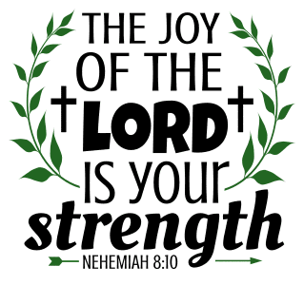

OPENING DIALOGUE

Long ago God spoke to our ancestors in many and various ways, by the prophets,
but in these last days God has spoken to us by the Son.
He is the reflection of God’s glory and the exact imprint of God’s very being,
and he sustains all things by his powerful word.
Since we have confidence by the new and living way opened for us by Jesus,
let us approach with a true heart in full assurance of faith.

GATHERING SONG “Faith of Our Fathers” ELW 812

GREETING
The grace of our Lord Jesus Christ, the love of God,
and the communion of the Holy Spirit be with you all.
And also with you.

READING Hebrews 11:1, 29-40
A reading from Hebrews.

¹Now faith is the assurance of things hoped for, the conviction of things not seen
²⁹By faith the people passed through the Red Sea as if it were dry land, but when the Egyptians attempted to do so they were drowned. ³⁰By faith the walls of Jericho fell after they had been encircled for seven days. ³¹By faith Rahab the prostitute did not perish with those who were disobedient, because she had received the spies in peace.
³²And what more should I say? For time would fail me to tell of Gideon, Barak, Samson, Jephthah, of David and Samuel and the prophets — ³³who through faith conquered kingdoms, administered justice, obtained promises, shut the mouths of lions, ³⁴quenched raging fire, escaped the edge of the sword, won strength out of weakness, became mighty in war, put foreign armies to flight. ³⁵Women received their dead by resurrection. Others were tortured, refusing to accept release, in order to obtain a better resurrection. ³⁶Others suffered mocking and flogging, and even chains and imprisonment. ³⁷They were stoned to death, they were sawn in two, they were killed by the sword; they went about in skins of sheep and goats, destitute, persecuted, tormented — ³⁸of whom the world was not worthy. They wandered in deserts and mountains, and in caves and holes in the ground.
³⁹Yet all these, though they were commended for their faith, did not receive what was promised, ⁴⁰since God had provided something better so that they would not, apart from us, be made perfect.

The Word of the Lord.
Thanks be to God.

REFLECTION Pastor Becky Ebb-Speese

The reflection will conclude with:

Now faith is the assurance of things hoped for,
the conviction of things not seen.

HYMN OF THE DAY “If You But Trust in God to Guide You” ELW 769

PRAYERS
Surrounded by a great cloud of witnesses, let us pray for the church, those in need, and all of God’s creation.
A brief silence.
Faithful God, shower the world with your lovingkindness,
that all may know your peace.

Open our eyes to the needs of our neighbors,
that all may know your love.

Comfort the sick and dying,
that all may know your mercy.

Guide our leaders in the way of truth,
that all may know your justice.

Focus our hearts on the way of the cross,
that all may have faith in you.

Let us pray in the words of Martin Luther:
Behold, Lord, an empty vessel that needs to be filled.
My Lord, fill it. I am weak in the faith; strengthen me.
I am cold in love; warm me and make me fervent, that
my love may go out to my neighbor. I do not have a
strong and firm faith; at times I doubt and am unable
to trust you altogether. O Lord, help me. Strengthen
my faith and trust in you. In you I have sealed the treasure
of all I have. I am poor; you are rich and came to
be merciful to the poor. I am a sinner; you are upright.
With me, there is an abundance of sin; in you is the
fullness of righteousness. Therefore I will remain with
you, of whom I can receive, but to whom I may not give.
Amen.
(Evangelical Lutheran Worship, p. 87)

LORD’S PRAYER
Finally, let us pray with the words our Savior gave us:
Our Father, who art in heaven,
hallowed be thy name,
thy kingdom come,
thy will be done,
on earth as it is in heaven.
Give us this day our daily bread;
and forgive us our trespasses,
as we forgive those
who trespass against us;
and lead us not into temptation,
but deliver us from evil.
For thine is the kingdom,
and the power, and the glory,
forever and ever. Amen.
BLESSING
The God of peace,
who brought back from the dead our Lord Jesus,
the great shepherd of the sheep,
make you complete in everything good
so that you may do God’s will,
through Jesus Christ, to whom be the glory forever and ever.
Amen.

SENDING SONG “Lead Me, Guide Me” ELW 768
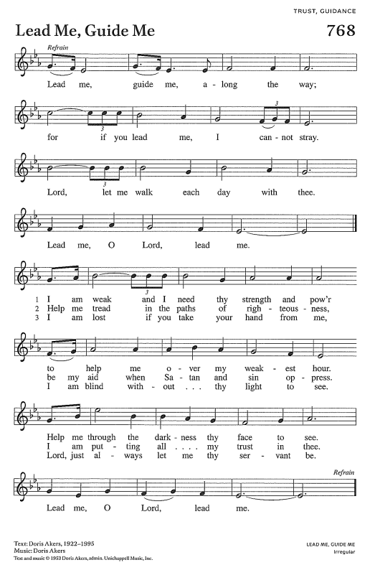

DISMISSAL
Go in peace. Christ is with you.
Thanks be to God.

