Zion Lutheran Church, Woodland, Michigan
Good Friday Tenebrae Service
April 7, 2023
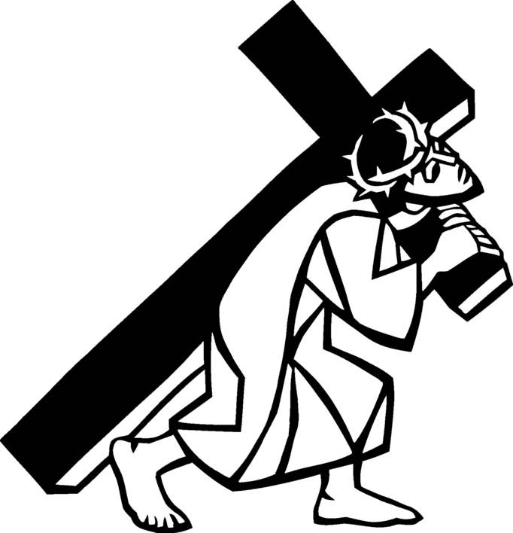

PRELUDE

CALL TO WORSHIP

Come, let us gather again in the shadow
of the Cross of Christ.
We gather to remember the overwhelming evidence
of Love’s ultimate sacrifice.
Who would have guessed that the height and depth,
the length and width of God’s love might look like this:
a forsaken savior on a cross?
Certainly not us. Not us, who are too often lost
amid the world’s distractions and responsibilities.
Not us, for whom such love was offered without cost.
Let us gather again in the shadow of the Cross of Christ
and commit ourselves to remember the price paid.
Let us live our lives in a way that indicates why
this Friday is called “Good.”
Thanks be to God, who opened the gates of heaven,
that we might have the faith, hope, and love,
witnessed in Christ’s sacrifice for our salvation.

OPENING HYMN

PRAYER OF THE DAY
Let us pray together.
Almighty God, look with loving mercy on your family, for whom our Lord Jesus Christ was willing to be betrayed, to be given over to the hands of sinners, and to suffer death on the cross; who now lives and reigns with you and the Holy Spirit, one God, forever and ever. Amen.

MEDITATION Pastor Becky Ebb-Speese

SPECIAL MUSIC “Softly and Tenderly” Dan & Cindy Utterback

Third Station: Jesus is Condemned by the Sanhedrin
Reader:
⁶⁶When day came, the assembly of the elders of the people, both chief priests and scribes, gathered together, and they brought him to their council. ⁶⁷They said, "If you are the Messiah, tell us." He replied, "If I tell you, you will not believe; ⁶⁸and if I question you, you will not answer. ⁶⁹But from now on the Son of Man will be seated at the right hand of the power of God." ⁷⁰All of them asked, "Are you, then, the Son of God?" He said to them, "You say that I am." ⁷¹Then they said, "What further testimony do we need? We have heard it ourselves from his own lips!"
(Luke 22: 66-71)

(Extinguish candle)

Fourth Station: Jesus is Denied by Peter
Reader: ⁶⁹Now Peter was sitting outside in the courtyard. A servant-girl came to him and said, "You also were with Jesus the Galilean." ⁷⁰But he denied it before all of them, saying, "I do not know what you are talking about." ⁷¹When he went out to the porch, another servant-girl saw him, and she said to the bystanders, "This man was with Jesus of Nazareth." ⁷²Again he denied it with an oath, "I do not know the man." ⁷³After a little while the bystanders came up and said to Peter, "Certainly you are also one of them, for your accent betrays you." ⁷⁴Then he began to curse, and he swore an oath, "I do not know the man!" At that moment the cock crowed. ⁷⁵Then Peter remembered what Jesus had said: "Before the cock crows, you will deny me three times." And he went out and wept bitterly.
. (Matthew 26: 69-75)

(Extinguish candle)

HYMN

Fifth Station: Jesus is Judged by Pilate
Reader: ¹As soon as it was morning, the chief priests held a consultation with the elders and scribes and the whole council. They bound Jesus, led him away, and handed him over to Pilate. ²Pilate asked him, "Are you the King of the Jews?" He answered him, "You say so." ³Then the chief priests accused him of many things. ⁴Pilate asked him again, "Have you no answer? See how many charges they bring against you." ⁵But Jesus made no further reply, so that Pilate was amazed.
¹⁵So Pilate, wishing to satisfy the crowd, released Barabbas for them; and after flogging Jesus, he handed him over to be crucified.
(Mark 15: 1-5, 15)

(Extinguish candle)

Sixth Station: Jesus is Scourged and Crowned with Thorns
Reader: ¹Then Pilate took Jesus and had him flogged. ²And the soldiers wove a crown of thorns and put it on his head, and they dressed him in a purple robe. ³They kept coming up to him, saying, "Hail, King of the Jews!" and striking him on the face.
(John 19: 1-3)

(Extinguish candle)

Seventh Station: Jesus Bears the Cross
Reader: ⁶When the chief priests and the police saw him, they shouted, "Crucify him! Crucify him!" Pilate said to them, "Take him yourselves and crucify him; I find no case against him." ¹⁵They cried out, "Away with him! Away with him! Crucify him!" Pilate asked them, "Shall I crucify your King?" The chief priests answered, "We have no king but the emperor." ¹⁶Then he handed him over to them to be crucified. So they took Jesus; ¹⁷and carrying the cross by himself, he went out to what is called The Place of the Skull, which in Hebrew is called Golgotha.
(John 19: 6, 15-17)
(Extinguish candle)

Eighth Station: Jesus is Helped by Simon the Cyrenian to Carry the Cross
Reader: ²¹They compelled a passer-by, who was coming in from the country, to carry his cross; it was Simon of Cyrene, the father of Alexander and Rufus.
. (Mark 15: 21)

(Extinguish candle)

Ninth Station: Jesus Meets the Women of Jerusalem
Reader: ²⁷A great number of the people followed him, and among them were women who were beating their breasts and wailing for him. ²⁸But Jesus turned to them and said, "Daughters of Jerusalem, do not weep for me, but weep for yourselves and for your children. ²⁹For the days are surely coming when they will say, 'Blessed are the barren, and the wombs that never bore, and the breasts that never nursed.' ³⁰Then they will begin to say to the mountains, 'Fall on us'; and to the hills, 'Cover us.' ³¹For if they do this when the wood is green, what will happen when it is dry?"
(Luke 23: 27-31)

(Extinguish candle)

Tenth Station: Jesus is Crucified

Reader: ³³When they came to the place that is called The Skull, they crucified Jesus there with the criminals, one on his right and one on his left. [[ ³⁴Then Jesus said, "Father, forgive them; for they do not know what they are doing."]] And they cast lots to divide his clothing.
(Luke 23: 33-34)

(Extinguish candle)

Eleventh Station: Jesus Promises His Kingdom to the Good Thief
Reader: ³⁹One of the criminals who were hanged there kept deriding him and saying, "Are you not the Messiah? Save yourself and us!" ⁴⁰But the other rebuked him, saying, "Do you not fear God, since you are under the same sentence of condemnation? ⁴¹And we indeed have been condemned justly, for we are getting what we deserve for our deeds, but this man has done nothing wrong." ⁴²Then he said, "Jesus, remember me when you come into your kingdom." ⁴³He replied, "Truly I tell you, today you will be with me in Paradise."
(Luke 23: 39-43)

(Extinguish candle)

HYMN

Twelfth Station: Jesus Speaks to His Mother and the Disciple
Reader: . ²⁵And that is what the soldiers did.
Meanwhile, standing near the cross of Jesus were his mother, and his mother's sister, Mary the wife of Clopas, and Mary Magdalene. ²⁶When Jesus saw his mother and the disciple whom he loved standing beside her, he said to his mother, "Woman, here is your son." ²⁷Then he said to the disciple, "Here is your mother." And from that hour the disciple took her into his own home. (John 19: 25-26)

(Extinguish candle)

Thirteenth Station: Jesus Dies on the Cross
Reader: ⁴⁴It was now about noon, and darkness came over the whole land until three in the afternoon, ⁴⁵while the sun's light failed; and the curtain of the temple was torn in two. ⁴⁶Then Jesus, crying with a loud voice, said, "Father, into your hands I commend my spirit." Having said this, he breathed his last.
(Luke 23: 44-46)

(Extinguish candle)

Fourteenth Station: Jesus is Placed in the Tomb
Reader: ⁵⁷When it was evening, there came a rich man from Arimathea, named Joseph, who was also a disciple of Jesus. ⁵⁸He went to Pilate and asked for the body of Jesus; then Pilate ordered it to be given to him. ⁵⁹So Joseph took the body and wrapped it in a clean linen cloth ⁶⁰and laid it in his own new tomb, which he had hewn in the rock. He then rolled a great stone to the door of the tomb and went away.
(Matthew 27: 57-60)

(Christ Candle is extinguished and removed.

(A loud noise will be heard symbolizing the closing of the tomb.)

HYMN

All leave in silence.

Tenebrae is a Latin word meaning “shadows”. It is the name given to the ancient prayer hours of Matins and Lauds used on the last three days of Holy Week. Twelve candles are arranged on the altar. The Christ candle is placed in front. All candles are lighted before the service begins.

One by one, the candles are extinguished until, as the service progresses only one is left burning. After the dramatic Reading of the Passion of Jesus Christ, the Christ Candle is carried from the sanctuary.

Thank you to all who served in worship today!

Presider: Pastor Becky Ebb-Speese
Musician: Martha Yoder
Elder: Buffy Meyers
Trustee: Mike Johnson
Acolyte: Emil Meyers

