ZION LUTHERAN CHURCH, WOODLAND, MI
Fifteenth Sunday after Pentecost, September 10, 2023
*If you are listening in your car, please tune your radio to FM 87.7*

ANNOUNCEMENTS

PRELUDE

Gathering
The Holy Spirit calls us together as the people of God.

Confession and Forgiveness
In the name of the Father, and of the ☩ Son, and of the Holy Spirit.
Amen.

God of all mercy & consolation, come to the help of your people, turning us from our sin to live for you alone. Give us the power of your Holy Spirit that we may confess our sin, receive your forgiveness, and grow into the fullness of Jesus Christ, our Savior and Lord.
Amen.

Let us confess our sin in the presence of God and of one another. Most merciful God,
we confess that we are captive to sin and cannot free ourselves. We have sinned against you in thought, word, and deed, by what we have done and by what we have left undone. We have not loved you with our whole heart; we have not loved our neighbors as ourselves. For the sake of your Son, Jesus Christ, have mercy on us. Forgive us, renew us, and lead us, so that we may delight in your will and walk in your ways, to the glory of your holy name. Amen.

God, who is rich in mercy, loved us even when we were dead in sin, and made us alive together with Christ. By grace you have been saved. In the name of ☩ Jesus Christ, your sins are forgiven. Almighty God strengthen you with power through the Holy Spirit, that Christ may live in your hearts through faith.
Amen.

Gathering Song “Borning Cry” ELW 732
GREETING
The grace of our Lord Jesus Christ, the love of God, and the communion of the Holy Spirit be with you all. And also with you.
KYRIE
In peace, let us pray to the Lord.
Lord, have mercy.
For the peace from above, and for our salvation, let us pray to the Lord.
Lord, have mercy.
For the peace of the whole world, for the well-being of the Church of God,
and for the unity of all, let us pray to the Lord.
Lord, have mercy.
For this holy house, and for all who offer here their worship and praise,
let us pray to the Lord.
Lord, have mercy.
Help, save, comfort, and defend us, gracious Lord.
Amen.

GLORY TO GOD

Prayer of the Day
Let us pray together.
O Lord God, enliven and preserve your church with your perpetual mercy. Without your help, we mortals will fail; remove far from us everything that is harmful, and lead us toward all that gives life and salvation, through Jesus Christ, our Savior and Lord. Amen.

First Reading Ezekiel 33:7-11
A reading from Ezekiel.

⁷So you, mortal, I have made a sentinel for the house of Israel; whenever you hear a word from my mouth, you shall give them warning from me. ⁸If I say to the wicked, “O wicked ones, you shall surely die,” and you do not speak to warn the wicked to turn from their ways, the wicked shall die in their iniquity, but their blood I will require at your hand. ⁹But if you warn the wicked to turn from their ways, and they do not turn from their ways, the wicked shall die in their iniquity, but you will have saved your life.
¹⁰Now you, mortal, say to the house of Israel, Thus you have said: “Our transgressions and our sins weigh upon us, and we waste away because of them; how then can we live?” ¹¹Say to them, As I live, says the Lord God, I have no pleasure in the death of the wicked, but that the wicked turn from their ways and live; turn back, turn back from your evil ways; for why will you die, O house of Israel?

The word of the Lord.
Thanks be to God.

Psalm Psalm 119:33-40

³³Teach me, O Lord, the way | of your statutes,
and I shall keep it | to the end.
³⁴Give me understanding, and I shall | keep your teaching;
I shall keep it with | all my heart.
³⁵Lead me in the path of | your commandments,
for that is | my desire.
³⁶Incline my heart to | your decrees
and not to | unjust gain.
³⁷Turn my eyes from be- | holding falsehood;
give me life | in your way.
³⁸Fulfill your promise | to your servant,
which is for | those who fear you.
³⁹Turn away the reproach | that I dread,
because your judg- | ments are good.
⁴⁰Behold, I long for | your commandments;
by your righteousness en- | liven me.

Second Reading Romans 13:8-14
A reading from Romans.

⁸Owe no one anything, except to love one another; for the one who loves another has fulfilled the law. ⁹The commandments, “You shall not commit adultery; You shall not murder; You shall not steal; You shall not covet”; and any other commandment, are summed up in this word, “Love your neighbor as yourself.” ¹⁰Love does no wrong to a neighbor; therefore, love is the fulfilling of the law.
¹¹Besides this, you know what time it is, how it is now the moment for you to wake from sleep. For salvation is nearer to us now than when we became believers; ¹²the night is far gone, the day is near. Let us then lay aside the works of darkness and put on the armor of light; ¹³let us live honorably as in the day, not in reveling and drunkenness, not in debauchery and licentiousness, not in quarreling and jealousy. ¹⁴Instead, put on the Lord Jesus Christ, and make no provision for the flesh, to gratify its desires.

The word of the Lord.
Thanks be to God.
Gospel Acclamation

Gospel Matthew 18:15-20
The holy gospel according to Matthew.
Glory to you, O Lord.

[Jesus said to the disciples:] ¹⁵“If another member of the church sins against you, go and point out the fault when the two of you are alone. If the member listens to you, you have regained that one. ¹⁶But if you are not listened to, take one or two others along with you, so that every word may be confirmed by the evidence of two or three witnesses. ¹⁷If the member refuses to listen to them, tell it to the church; and if the offender refuses to listen even to the church, let such a one be to you as a Gentile and a tax collector. ¹⁸Truly I tell you, whatever you bind on earth will be bound in heaven, and whatever you loose on earth will be loosed in heaven. ¹⁹Again, truly I tell you, if two of you agree on earth about anything you ask, it will be done for you by my Father in heaven. ²⁰For where two or three are gathered in my name, I am there among them.”

The gospel of the Lord.
Praise to you, O Christ.

Sermon Pastor Mike Kemper

Hymn of the Day “Bind Us Together Lord”
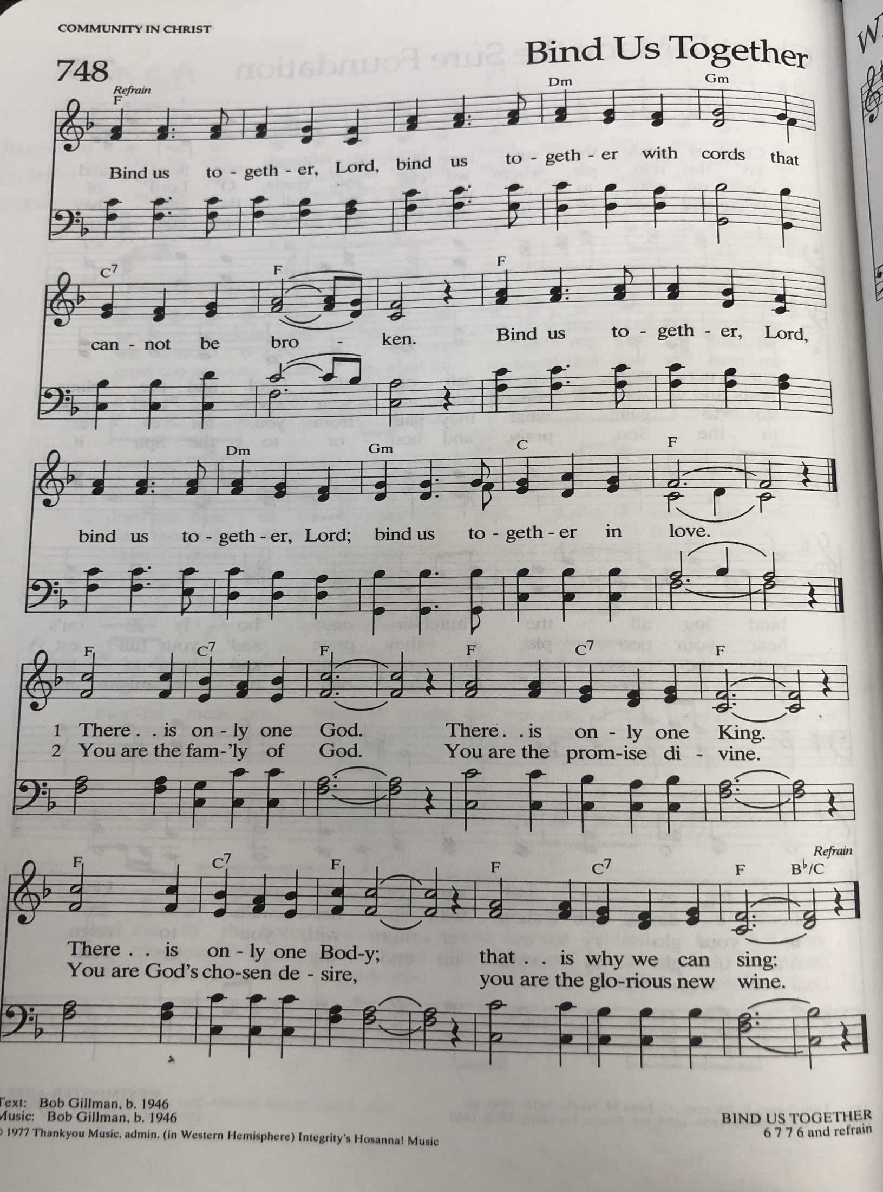
CREED
I believe in God, the Father almighty,
creator of heaven and earth.
I believe in Jesus Christ, God’s only Son, our Lord,
who was conceived by the Holy Spirit,
born of the virgin Mary,
suffered under Pontius Pilate,
was crucified, died, and was buried;
he descended to the dead.*
On the third day he rose again;
he ascended into heaven,
he is seated at the right hand of the Father,
and he will come to judge the living and the dead.
I believe in the Holy Spirit,
the holy catholic church,
the communion of saints,
the forgiveness of sins,
the resurrection of the body,
and the life everlasting. Amen.

*Or, “he descended into hell,” another translation of this text in widespread use.

Prayers of Intercession
Confident that God receives our joys and concerns, let us offer our prayers for the church, those in need, and all of creation.
A brief silence.
Hold us accountable, O God. Show your church where repentance is needed and lead us in paths of intentional compassion and listening. Help us extend hands of reconciliation and care, especially in relationships with other Christians and people of other faiths. We pray especially for Trinity Lutheran Church in Grand Rapids and Rev. Bob Lindstrom, Rev. Daniel Schewe, and Rev. Kari Fast. Merciful God,
receive our prayer.
Reveal your miracles to us, O God. Move us to cherish you as we behold the wonders of creation. Renew the seas and the soil, the forests and the creatures that live in them. Turn us to ways of living that seek Earth’s thriving. Merciful God,
receive our prayer.
Inspire us to lead with honor, O God. Guide judges and legislators, police, and government officials to create and uphold just laws. Move us to treat all people with dignity and guide our conversations with one another. Merciful God,
receive our prayer.
Help us comfort those who suffer, O God. Reassure any who are harmed by the wicked acts of others. Bring peace to all who are vulnerable, frightened, despairing, or sick.
We pray especially for all those affected by gun violence, Ukraine, Sudan, Turkey, and Syria. Guard their waking and their sleeping. Merciful God,
receive our prayer.
Awaken us, O God. Challenge and encourage your people to value the vocation to which each is called. We pray for all discerning new possibilities or changing employment. In all our diverse callings, teach us to love our neighbor above all else. Merciful God,
receive our prayer.
Be our hope, O God. We remember with thanksgiving your disciples who died in faith. May their trust in your promise be our protection and our hope. Merciful God,
receive our prayer.
Remember us according to your steadfast love as we offer these and the prayers of our heart, trusting in your compassion made known through Jesus Christ.
Amen.

Peace
The peace of Christ be with you always.
And also with you.

Offering & OFFERING SONG
The joy of the Lord is my strength,
The joy of the Lord is my strength,
The joy of the Lord is my strength,
The joy of the Lord is my strength.

Offering Prayer
Let us pray.
Blessed are you, O God, ruler of heaven and earth. Day by day you shower us with blessings. As you have raised us to new life in Christ, give us glad and generous hearts, ready to praise you and to respond to those in need, through Jesus Christ, our Savior and Lord.
Amen.

Great Thanksgiving

Dialogue
The Lord be with you.
And also with you.
Lift up your hearts.
We lift them to the Lord.
Let us give thanks to the Lord our God.
It is right to give our thanks and praise.

Holy, Holy, Holy

Thanksgiving at the Table
In the night in which he was betrayed,
our Lord Jesus took bread, and gave thanks;
broke it, and gave it to his disciples, saying:
Take and eat; this is my body, given for you.
Do this for the remembrance of me.
Again, after supper, he took the cup, gave thanks,
and gave it for all to drink, saying:
This cup is the new covenant in my blood,
shed for you and for all people for the forgiveness of sin.
Do this for the remembrance of me.

Lord’s Prayer
Lord, remember us in your kingdom and teach us to pray.
Our Father, who art in heaven,
hallowed be thy name,
thy kingdom come,
thy will be done,
on earth as it is in heaven.
Give us this day our daily bread;
and forgive us our trespasses,
as we forgive those
who trespass against us;
and lead us not into temptation,
but deliver us from evil.
For thine is the kingdom,
and the power, and the glory,
forever and ever. Amen.

Invitation to Communion
Come to the banquet, for all is now ready.

communion *continuous
*People are welcome to kneel at the altar rail for a time of prayer after they receive their communion elements

SongS During Communion

“Break Now the Bread of Life” ELW 515
“You Satisfy the Hungry Heart” ELW 496

Prayer after Communion
Let us pray. Life-giving God, in the mystery of Christ’s resurrection you send light to conquer darkness, water to give new life, and the bread of life to nourish your people. Send us forth as witnesses to your Son’s resurrection, that we may show your glory to all the world, through Jesus Christ, our risen Lord.
Amen.

Sending
God blesses us and sends us in mission to the world.

Blessing
The Lord bless you and keep you.
The Lord’s face shine on you with grace and mercy.
The Lord look upon you with favor and ☩ give you peace.
Amen.

Sending SonG “God Be with You Till We Meet Again” ELW 536

Dismissal
Almighty God, Father, ☩ Son, and Holy Spirit, bless you now and forever.
Amen.

From sundaysandseasons.com. Copyright © 2017 Augsburg Fortress. All rights reserved.

Thank you to all who served in worship today!

Presider: Pastor Mike Kemper
Musician: Jayne Flanigan
Acolyte:
Elder: Dan Utterback
Trustee: Mike Johnson
Offering Counters: Mary Makley & Martha Yoder
Safety Person:

PRAYERS OF THE FAITHFUL

With thanks for all God’s blessings and his love for all people. Our Bishops, Craig Satterlee Elizabeth Eaton, and the congregations of the North/West Lower Michigan Synod. Trinity Lutheran Church in Grand Rapids and Rev. Bob Lindstrom, Rev. Daniel Schewe, and Rev. Kari Fast

Prayers for our friends, for all who are sick or hospitalized and for all health care workers who care for them. We pray especially for all those affected by gun violence, Ukraine, Sudan, Turkey, and Syria. All those members of Zion’s family traveling; all those homebound or in frail health; all those suffering with quiet, unknown needs or worries.
For those who serve on our behalf: public safety, utility workers, medical personnel, military personnel. For those who might be forgotten.
This week at Zion:
- Potluck after service today to celebrate Sunday School Kickoff
- Men’s Coffee, 8 AM Wednesday, September 13

ANNOUNCEMENTS
- Door Locking Policy: Our door locking policy relies on having a volunteer(s) each Sunday to serve as the Safety Person of the Day. On Sundays where no one has volunteered, if someone arrives at church and is willing to be the Safety Person of the Day, we will follow the door locking policy. If no one steps forward to serve as the Safety Person of the Day, the doors will not be locked as there will be no one to monitor the church cell phone and let late arrivals into the church. Please consider volunteering for this important duty
ANNOUNCEMENTS CONTINUED
- Sunday School Kick off: As a congregation we will celebrate after church with a potluck. Drinks and tableware will be provided. Please bring a dish to pass. Throughout the school year, we encourage the congregation to join Sunday School to lead a craft, story time or our music time. It doesn’t have to be every Sunday, we want our youth to get to interact with as many church members as possible. Thank you for considering!
- LWR Action Team Project : Thank you to everyone who donated items or money for personal care kits for Lutheran World Relief. Also thank you to all who helped assemble the 49 kits and to Thrivent Financial for the $250 grant. In October, the kits will be displayed in our sanctuary and then packed and taken to a Lutheran School in Wyoming where they will be loaded onto a semi-truck and taken to Maryland. They are then sent overseas to many different countries. There are Live Generously t-shirts on a table in the Fellowship Hall. They are also from Thrivent. Please help yourselves to them. We have been making kits for many years and are blessed we could make them again this year too.
- Lawnmower Bids Due September 10th: If you are interested in purchasing the old riding John Deere lawnmower, sealed bids may be submitted until September 10th. The lawnmower will be sold to the highest bidder. Sealed bids should be give to Martha Yoder or Jerry Engle. If you have questions or would like to inspect the lawnmower, please see Martha, Jerry or Paul Meade. Thank you.
- Labor Day Weekend Thank You: Zion went above and beyond this past weekend to help our community celebrate the Labor Day Weekend. A tremendous thank you to everyone who helped with all the events. It could not have happened without everyone’s involvement. Our float, “God Cares “fur” You,” was well received, we won first place and $25 for our Evangelism budget. Doug and Judy MacKenzie were honored during a lovely reception following the parade. Kids flocked to shoot cross-bows and try their hand at putt-putt golf. On Sunday, we served up Rootbeer floats earning $320 to benefit the Woodland Youth Basement Association. Again, thank you all for helping to make this happen.
- Call Committee Update: The Call Committee has interviewed one candidate. This candidate is no longer available. Our search will continue as the Synod Office sends us candidates, who show interest.
- ZLCW Vote It was an unanimous vote to send $5000 for a refrigerator. It was a very close vote on what to purchase, but more votes were for the purchase of a commercial refrigerator. The Board will be acting on this.
- Lakewood Community Dinner, September 28th Zion’s next turn to host the community dinner is September 28th. We will need helpers to set-up, serve, clean-up and provide desserts. If you can help, there will be a sign-up sheet in the Narthex or let Martha know. The last time Zion hosted, they had a record turnout of 80 people served. Every enjoyed the food and the desserts provided by Zion. Thank you!

