ZION LUTHERAN CHURCH, WOODLAND, MI
Sixth Sunday After Pentecost July 20, 2025
*If you are listening in your car, please tune your radio to FM 87.7*
(Please silence your cell phones while in the sanctuary. Thank you.)


WELCOME AND ANNOUNCEMENTS

Gathering
The Holy Spirit calls us together as the people of God.

Confession and Forgiveness
In the name of the Father,
and of the ☩ Son,
and of the Holy Spirit.
Amen.

Almighty God, to whom all hearts are open, all desires known, and from whom no secrets are hid: cleanse the thoughts of our hearts by the inspiration of your Holy Spirit, that we may perfectly love you and worthily magnify your holy name, through Jesus Christ our Lord.
Amen.

Let us confess our sin in the presence of God and of one another. Most merciful God,
we confess that we are captive to sin and cannot free ourselves. We have sinned against you in thought, word, and deed, by what we have done and by what we have left undone. We have not loved you with our whole heart; we have not loved our neighbors as ourselves. For the sake of your Son, Jesus Christ, have mercy on us. Forgive us, renew us, and lead us, so that we may delight in your will and walk in your ways, to the glory of your holy name.
Amen.

God, who is rich in mercy, loved us even when we were dead in sin, and made us alive together with Christ. By grace you have been saved. In the name of ☩ Jesus Christ, your sins are forgiven. Almighty God strengthen you with power through the Holy Spirit, that Christ may live in your hearts through faith.
Amen.

Gathering Song “Immortal, Invisible, God Only Wise” #834

GREETING
The grace of our Lord Jesus Christ, the love of God, and the communion of the Holy Spirit be with you all.
And also with you.

Prayer of the Day
Let us pray together.
Eternal God, you draw near to us in Christ, and you make yourself our guest. Amid the cares of our lives, make us attentive to your presence, that we may treasure your word above all else, through Jesus Christ, our Savior and Lord.
Amen.

First Reading Genesis 18:1-10a
A reading from Genesis.
¹ The Lord appeared to Abraham by the oaks of Mamre, as he sat at the entrance of his tent in the heat of the day. ² He looked up and saw three men standing near him. When he saw them, he ran from the tent entrance to meet them and bowed down to the ground. ³ He said, “My lord, if I find favor with you, do not pass by your servant. ⁴ Let a little water be brought, and wash your feet, and rest yourselves under the tree. ⁵ Let me bring a little bread, that you may refresh yourselves, and after that you may pass on—since you have come to your servant.” So they said, “Do as you have said.” ⁶ And Abraham hastened into the tent to Sarah and said, “Make ready quickly three measures of choice flour, knead it, and make cakes.” ⁷ Abraham ran to the herd and took a calf, tender and good, and gave it to the servant, who hastened to prepare it. ⁸ Then he took curds and milk and the calf that he had prepared and set it before them, and he stood by them under the tree while they ate.
⁹ They said to him, “Where is your wife Sarah?” And he said, “There, in the tent.” ^{10a} Then one said, “I will surely return to you in due season, and your wife Sarah shall have a son.”
Thanks be to God.

Psalm Psalm 15

¹ Lord, who may dwell in your | tabernacle?
Who may abide upon your | holy hill?
² Those who lead a blameless life and do | what is right,
who speak the truth | from their heart;
³ they do not slander with the tongue, they do no evil | to their friends;
they do not cast discredit up- | on a neighbor.
⁴ In their sight the wicked are rejected, but they honor those who | fear the Lord.
They have sworn upon their health and do not take | back their word.
⁵ They do not give their money in hope of gain, nor do they take bribes a- | gainst the innocent.
Those who do these things shall never be | overthrown.

Second Reading Colossians 1:15-28

A reading from Colossians.
¹⁵ [Christ Jesus] is the image of the invisible God, the firstborn of all creation,¹⁶ for in him all things in heaven and on earth were created, things visible and invisible, whether thrones or dominions or rulers or powers—all things have been created through him and for him. ¹⁷ He himself is before all things, and in him all things hold together. ¹⁸ He is the head of the body, the church; he is the beginning, the firstborn from the dead, so that he might come to have first place in everything. ¹⁹ For in him all the fullness of God was pleased to dwell, ²⁰ and through him God was pleased to reconcile to himself all things, whether on earth or in heaven, by making peace through the blood of his cross.
²¹ And you who were once estranged and hostile in mind, doing evil deeds, ²² he has now reconciled in his fleshly body through death, so as to present you holy and blameless and irreproachable before him, ²³ provided that you continue securely established and steadfast in the faith, without shifting from the hope promised by the gospel that you heard, which has been proclaimed to every creature under heaven. I, Paul, became a minister of this gospel.
²⁴ I am now rejoicing in my sufferings for your sake, and in my flesh I am completing what is lacking in Christ’s afflictions for the sake of his body, that is, the church. ²⁵ I became its minister according to God’s commission that was given to me for you, to make the word of God fully known, ²⁶ the mystery that has been hidden throughout the ages and generations but has now been revealed to his saints. ²⁷ To them God chose to make known how great among the gentiles are the riches of the glory of this mystery, which is Christ in you, the hope of glory. ²⁸ It is he whom we proclaim, warning everyone and teaching everyone in all wisdom, so that we may present everyone mature in Christ.
Gospel Acclamation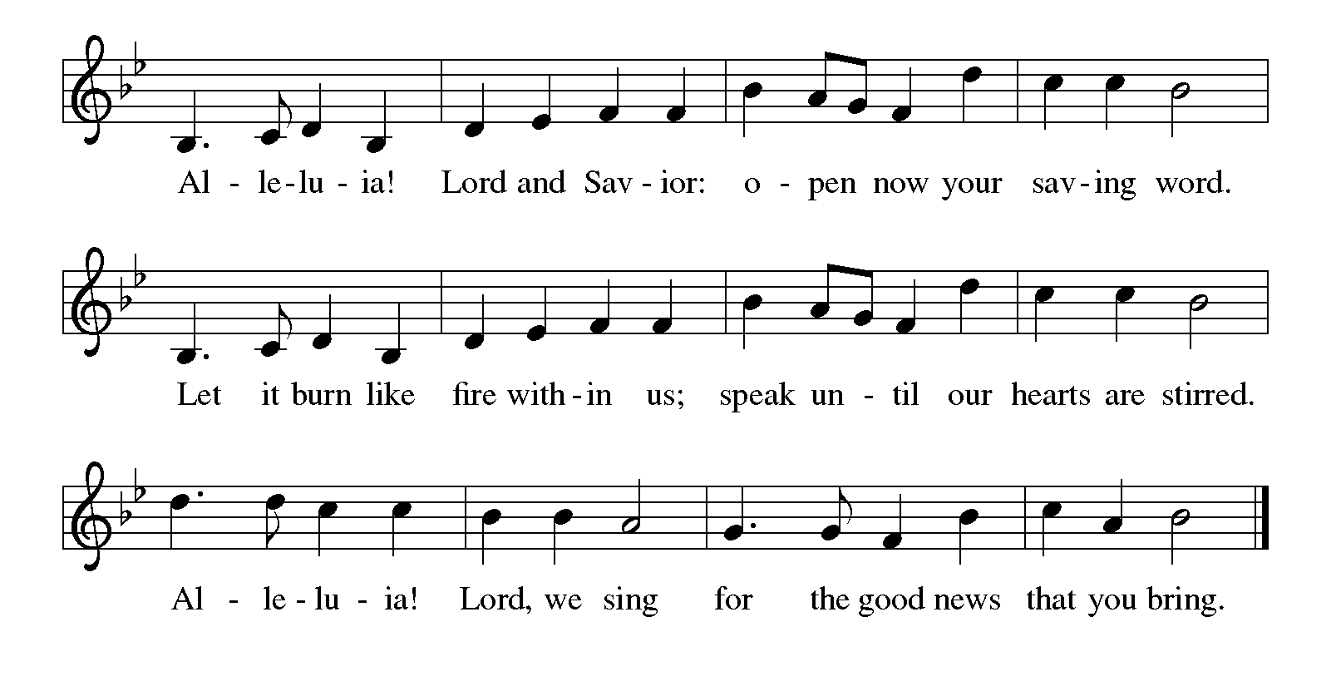

Gospel Luke 10:38-42
The holy gospel according to Luke.
Glory to you, O Lord
³⁸ Now as [Jesus and his disciples] went on their way, he entered a certain village where a woman named Martha welcomed him. ³⁹ She had a sister named Mary, who sat at Jesus’s feet and listened to what he was saying. ⁴⁰ But Martha was distracted by her many tasks, so she came to him and asked, “Lord, do you not care that my sister has left me to do all the work by myself? Tell her, then, to help me.” ⁴¹ But the Lord answered her, “Martha, Martha, you are worried and distracted by many things, ⁴² but few things are needed—indeed only one. Mary has chosen the better part, which will not be taken away from her.”

The gospel of the Lord.
Praise to you, O Christ.

CHILDREN’S MOMENT

SERMON Pastor Ken Scheck

hymn of the day “Jesus, the Very Thought of You” #754

cREED
I believe in God, the Father almighty,
creator of heaven and earth.
I believe in Jesus Christ, God’s only Son, our Lord,
who was conceived by the Holy Spirit,
born of the virgin Mary,
suffered under Pontius Pilate,
was crucified, died, and was buried;
he descended to the dead.*
On the third day he rose again;
he ascended into heaven,
he is seated at the right hand of the Father,
and he will come to judge the living and the dead.
I believe in the Holy Spirit,
the holy catholic church,
the communion of saints,
the forgiveness of sins,
the resurrection of the body,
and the life everlasting. Amen.

*Or, “he descended into hell,” another translation of this text in widespread use.

prayers of Intercession
In solidarity with all creation, we join our voice to the voice of the whole church and pray for the needs of the world.
A brief silence.
Inspire your church, like Sarah and Mary, to listen with eager longing for your words of life. Equip biblical interpreters and teachers with faithful discernment, that your word may be more fully known. We pray especially for St. Paul Lutheran Church in Greenville and their pastor Rev. Nan Dehnke. God of grace,
hear our prayer.
Every creature under heaven has been promised the hope of the gospel. From that promise, generate in humankind an eagerness to protect and care for creation. Bring healing to the earth with your words of life. God of grace,
hear our prayer.
Peel away the distractions, worries, and fears of all who govern the nations of the world. May your word of love and life dispel all other voices. Provide gracious hospitality in places where hostile forces hold sway. God of grace,
hear our prayer.
Speak your word of comfort to any who suffer pain, illness, grief, depression, or despair. Bring honor to any who experience slander and evil intent or are discredited by others. God of grace,
hear our prayer.
Enliven and uphold all siblings in Christ who strive to provide hospitality and safe spaces where everyone, without exception, can receive and be transformed by your word of life. God of grace,
hear our prayer.
For Abraham, Sarah, Hagar, Mary, Martha, and all the saints who attended to your word, we give thanks. Open our ears to your voice until that day when we realize the promise of the gospel with all creation. God of grace,
hear our prayer.
Trusting in your lovingkindness, we place our prayer and hope in you, in the name of Jesus Christ.
Amen.

PEACE
The peace of Christ be with you always.
And also with you.

OFFERING & OFFERING SONG
The joy of the Lord is my strength,
The joy of the Lord is my strength,
The joy of the Lord is my strength,
The joy of the Lord is my strength.

Offering Prayer
Let us pray.
God of all creation, all you have made is good, and your love endures forever. You bring forth bread from the earth and fruit from the vine. Nourish us with these gifts, that we might be for the world signs of your gracious presence in Jesus Christ, our Savior and Lord.
Amen.

DIALOGUE
The Lord be with you.
And also with you.
Lift up your hearts.
We lift them to the Lord.
Let us give thanks to the Lord our God.
It is right to give our thanks and praise.

PREFACE (Pastor)
It is indeed right, our duty and our joy,
that we should at all times and in all places
give thanks and praise to you, almighty and merciful God,
through our Savior Jesus Christ;
who on this day overcame death and the grave,
and by his glorious resurrection opened to us the way of everlasting life.
And so, with all the choirs of angels,
with the church on earth and the hosts of heaven,
we praise your name and join their unending hymn

holy, holy, holy
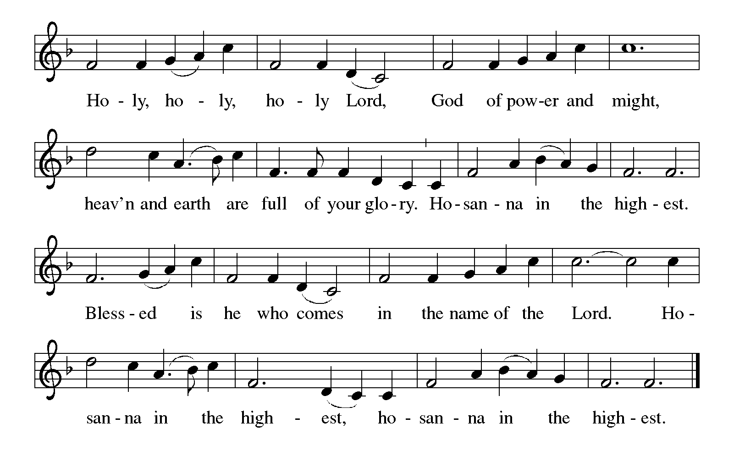
Thanksgiving at the Table
In the night in which he was betrayed,
our Lord Jesus took bread, and gave thanks;
broke it, and gave it to his disciples, saying:
Take and eat; this is my body, given for you.
Do this for the remembrance of me.

Again, after supper, he took the cup, gave thanks,
and gave it for all to drink, saying:
This cup is the new covenant in my blood,
shed for you and for all people for the forgiveness of sin.
Do this for the remembrance of me.

For as often as we eat of this bread and drink from this cup,
we proclaim the Lord’s death until he comes.

Lord’s Prayer
Gathered into one by the Holy Spirit, let us pray as Jesus taught us.
Our Father, who art in heaven,
hallowed be thy name,
thy kingdom come,
thy will be done,
on earth as it is in heaven.
Give us this day our daily bread;
and forgive us our trespasses,
as we forgive those
who trespass against us;
and lead us not into temptation,
but deliver us from evil.
For thine is the kingdom,
and the power, and the glory,
forever and ever. Amen.

INVITATION TO COMMUNION
Come to the banquet, for all is now ready.

COMMUNION *continuous
*People are welcome to kneel at the altar rail for a time of prayer after they receive their communion elements.
COMMUNION HYMNS

“You Satisfy the Hungry Heart” #484
“Here Is Bread” #483

PRAYER AFTER COMMUNION
Let us pray.
We give you thanks, almighty God, that you have refreshed us through the healing power of this gift of life. In your mercy, strengthen us through this gift, in faith toward you and in fervent love toward one another; for the sake of Jesus Christ our Lord.
Amen.

Sending
God blesses us and sends us in mission to the world.

Blessing
The Lord bless you and keep you.
The Lord’s face shine on you with grace and mercy.
The Lord look upon you with favor and ☩ give you peace.
Amen.
Sending SonG “O Savior, Precious Savior’’#820

Dismissal
Go in peace. Christ is with you.
Thanks be to God.

From sundaysandseasons.com. Copyright © 2017 Augsburg Fortress. All rights reserved.

Thank you to all who served in worship today!
Presiders: Pastor Ken Scheck Musician: Martha Yoder
Acolyte: Lexi Griffin Safety Person:
Elder: Buffy Meyers Trustee: Doug MacKenzie
Offering Counters: Paul Meade & Carlotta Willard



PRAYERS OF THE FAITHFUL

With thanks for all God’s blessings and his love for all people. Our Bishops, Craig Satterlee Elizabeth Eaton, and the congregations of the North/West Lower Michigan
Synod, and especially for St. Paul Lutheran Church in Greenville and their pastor Rev. Nan Dehnke.

Prayers for our friends, for all who are sick or hospitalized and for all health care workers who care for them. All those members of Zion’s family traveling; all those homebound or in frail health; all those suffering with quiet, unknown needs or worries. For those who serve on our behalf: public safety, utility workers, medical personnel, military personnel. For those who might be forgotten.

This week at Zion:
- VBS, 5-8pm Tuesday and Wednesday July 22-23
- Men’s Coffee, 8 AM, Wednesday, July 23
- Bulletin Deadline, Wednesday, July 23
- Newsletter Deadline, Wednesday July 23


ONLINE GIVING
Zion has received a QR code to facilitate online giving. If you are interested in donating online instead of bringing your donation to church, simply scan the QR code and it will direct you to the appropriate site. The code is on our website as well.

ANNOUNCEMENT
- Today- Semi-Annual Meeting – July 20th: This is an important meeting that includes the second vote on the new Constitution for Zion. This vote will ratify the new Constitution if approved. The new Constitution following the most recent ELCA model constitution. It also makes a number of changes including removing Boards and Committee structures and duties from the constitution and including them in church by-laws. This makes it easier to amend Board and Committee size and duties as needs in the church change.
- Today- Volunteer Recognition Sunday – July 20th: Our second annual Volunteer Recognition Sunday to honor everyone who helps make Zion a vibrant and strong congregation is being held in conjunction with the Semi-Annual meeting. Lunch will be provided following the semi-annual meeting. Watch for more information about this special day to show our appreciation to one another.
- This Week- Vacation Bible School: We are excited to announce this year’s VBS will be held on July 22-23, from 5 – 8 pm. Each day will start with family dinner followed by music, stories, crafts, games, a petting zoo one day and pony rides the next and a camp store for the kids to spend points they earn throughout the evening. Please share information with your family and friends. We also need workers. Please see the sign-up sheet in the Narthex. If you have questions, please talk with Karen, Martha, or Ruth.
- Sunday School Planning Meeting: If you have ideas for suggestions for Sunday school, we will meet on Sunday, August 3rd after church for a planning meeting. We want to create a fun year for our kiddos and need teachers, ideas and support! If you’re not able to attend, please share your ideas with a member of the Board of Education.

- Honduras Health for Life Event: We are invited to learn more about the ELCA Global Companions in Honduras and how we share ministry with them. The event was held at University Lutheran Church in East Lansing on June 21 and a second event will be held at Peace Lutheran in Gaylord on July 26 from 1-3 pm. Those attending will be provided a traditional Honduran meal of grilled chicken, rice, beans, tortillas, and more. There will be a virtual field trip and experience a week with Lutheran Church of Honduras and the Health for Life program. RSVPs are required. There is a sheet in the Narthex for you to indicate your interest and we will RSVP for the congregation. If you have questions, please see Martha.
- Woodland Homecoming Grand Marshals: Claude and Mary Smith have been announced as the 2025 Grand Marshals of the Woodland Homecoming Celebration this year! We are so happy for Claude and Mary on this very deserved honor!! Watch for more information on the details for their reception!
- Announcement and Newsletter Items: Please forward items for the bulletin announcements and the newsletter to the church email (Office@Zion.org). Please do not send items to people’s personal emails. Thank you.
- Door Locking Policy: Our door locking policy relies on having a volunteer(s) each Sunday to serve as the Safety Person of the Day. On Sundays where no one has volunteered, if someone arrives at church and is willing to be the Safety Person of the Day, we will follow the door locking policy. If no one steps forward to serve as the Safety Person of the Day, the doors will not be locked. Please consider volunteering for this important duty.

