**ZION LUTHERAN CHURCH, WOODLAND, MI**

**Seventh Sunday After Pentecost July 27, 2025**

**\*If you are listening in your car, please tune your radio to FM 87.7\***

(Please silence your cell phones while in the sanctuary. Thank you.)

**WELCOME AND ANNOUNCEMENTS**

**Gathering**

The Holy Spirit calls us together as the people of God.

**Confession and Forgiveness**

In the name of the Father,

and of the ☩ Son,

and of the Holy Spirit.

**Amen.**

Almighty God, to whom all hearts are open, all desires known, and from whom no secrets are hid: cleanse the thoughts of our hearts by the inspiration of your Holy Spirit, that we may perfectly love you and worthily magnify your holy name, through Jesus Christ our Lord.

**Amen.**

Let us confess our sin in the presence of God and of one another. Most merciful God,

**we confess that we are captive to sin and cannot free ourselves. We have sinned against you in thought, word, and deed, by what we have done and by what we have left undone. We have not loved you with our whole heart; we have not loved our neighbors as ourselves. For the sake of your Son, Jesus Christ, have mercy on us. Forgive us, renew us, and lead us, so that we may delight in your will and walk in your ways, to the glory of your holy name.**

**Amen.**

God, who is rich in mercy, loved us even when we were dead in sin, and made us alive together with Christ. By grace you have been saved. In the name of ☩ Jesus Christ, your sins are forgiven. Almighty God strengthen you with power through the Holy Spirit, that Christ may live in your hearts through faith.

**Amen.**

**Gathering Song*“Sweet Hour of Prayer”***

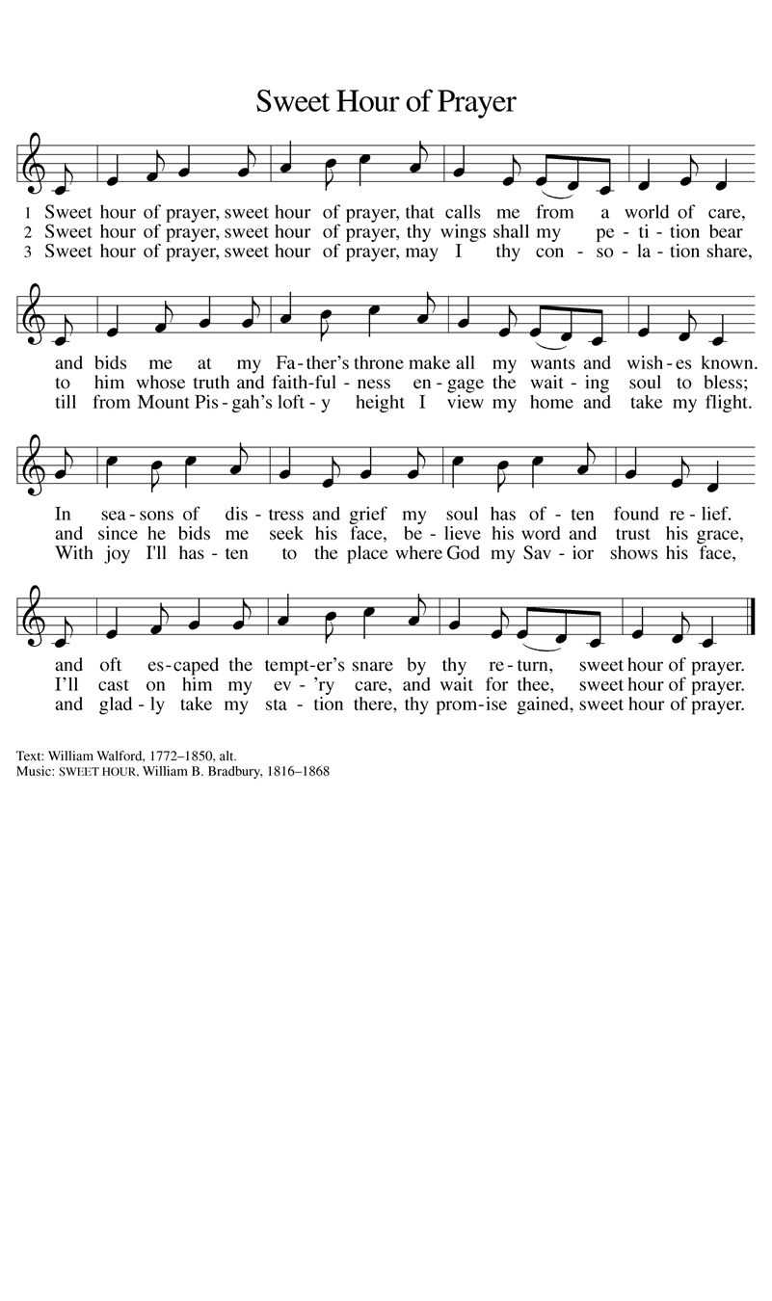

**GREETING**

The grace of our Lord Jesus Christ, the love of God, and the communion of the Holy Spirit be with you all.

**And also with you.**

**Prayer of the Day**

**Let us pray together.**

Almighty and ever-living God, you are always more ready to hear than we are to pray, and you gladly give more than we either desire or deserve. Pour upon us your abundant mercy. Forgive us those things that weigh on our conscience, and give us those good things that come only through your Son, Jesus Christ, our Savior and Lord.

**Amen.**

**First Reading**    **Genesis 18:20-32**

*A reading from Genesis.*

20 Then the Lord said, “How great is the outcry against Sodom and Gomorrah and how very grave their sin! 21 I must go down and see whether they have done altogether according to the outcry that has come to me, and if not, I will know.”  
  22 So the men turned from there and went toward Sodom, while Abraham remained standing before the Lord. 23 Then Abraham came near and said, “Will you indeed sweep away the righteous with the wicked? 24 Suppose there are fifty righteous within the city; will you then sweep away the place and not forgive it for the fifty righteous who are in it? 25 Far be it from you to do such a thing, to slay the righteous with the wicked, so that the righteous fare as the wicked! Far be that from you! Shall not the Judge of all the earth do what is just?” 26 And the Lord said, “If I find at Sodom fifty righteous in the city, I will forgive the whole place for their sake.” 27 Abraham answered, “Let me take it upon myself to speak to my lord, I who am but dust and ashes. 28 Suppose five of the fifty righteous are lacking? Will you destroy the whole city for lack of five?” And he said, “I will not destroy it if I find forty-five there.” 29 Again he spoke to him, “Suppose forty are found there.” He answered, “For the sake of forty I will not do it.” 30 Then he said, “Oh, do not let my lord be angry if I speak. Suppose thirty are found there.” He answered, “I will not do it, if I find thirty there.” 31 He said, “Let me take it upon myself to speak to my lord. Suppose twenty are found there.” He answered, “For the sake of twenty I will not destroy it.” 32 Then he said, “Oh, do not let my lord be angry if I speak just once more. Suppose ten are found there.” He answered, “For the sake of ten I will not destroy it.”

The Word of the Lord

**Thanks be to God.**

**Psalm Psalm 138**

1 I will give thanks to you, O Lord, with **|** my whole heart;  
  before the gods I will **|** sing your praise.  
 2 **I will bow down toward your holy temple and praise your name, because of your steadfast | love and faithfulness;**  
  **for you have glorified your name and your word a- | bove all things.**  
 3 When I called, you **|** answered me;  
  you increased my **|** strength within me.  
 4 **All the rulers of the earth will praise | you, O Lord,**  
  **when they have heard the words | of your mouth.**  
 5 They will sing of the ways **|** of the Lord,  
  that great is the glory **|** of the Lord.  
 6 **The Lord is high, yet cares | for the lowly,**  
  **perceiving the haughty | from afar.**  
 7 Though I walk in the midst of trouble, you **|** keep me safe;  
  you stretch forth your hand against the fury of my enemies; your right **|** hand shall save me.  
 8 **You will make good your pur- | pose for me;**  
  **O Lord, your steadfast love endures forever; do not abandon the works | of your hands.**

**Second Reading**  **Colossians 2:6-15**

A reading from Colossians.

6 As you therefore have received Christ Jesus the Lord, continue to walk in him, 7 rooted and built up in him and established in the faith, just as you were taught, abounding in thanksgiving.  
 8 Watch out that no one takes you captive through philosophy and empty deceit, according to human tradition, according to the elemental principles of the world, and not according to Christ. 9 For in him the whole fullness of deity dwells bodily, 10 and you have come to fullness in him, who is the head of every ruler and authority. 11 In him also you were circumcised with a spiritual circumcision, by the removal of the body of the flesh in the circumcision of Christ; 12 when you were buried with him in baptism, you were also raised with him through faith in the power of God, who raised him from the dead. 13 And when you were dead in trespasses and the uncircumcision of your flesh, God made you alive together with him, when he forgave us all our trespasses, 14 erasing the record that stood against us with its legal demands. He set this aside, nailing it to the cross. 15 He disarmed the rulers and authorities and made a public example of them, triumphing over them in it.

The Word of the Lord

**Thanks be to God.**

**

**Gospel** **Luke 11:1-13**

The holy gospel according to Luke.

**Glory to you, O Lord**

1 [Jesus] was praying in a certain place, and after he had finished, one of his disciples said to him, “Lord, teach us to pray, as John taught his disciples.”2 So he said to them, “When you pray, say:   
 Father, may your name be revered as holy.  
  May your kingdom come.  
  3 Give us each day our daily bread.  
  4 And forgive us our sins,  
   for we ourselves forgive everyone indebted to us.  
  And do not bring us to the time of trial.”  
  5 And he said to them, “Suppose one of you has a friend, and you go to him at midnight and say to him, ‘Friend, lend me three loaves of bread, 6 for a friend of mine has arrived, and I have nothing to set before him.’ 7 And he answers from within, ‘Do not bother me; the door has already been locked, and my children are with me in bed; I cannot get up and give you anything.’ 8 I tell you, even though he will not get up and give him anything out of friendship, at least because of his persistence he will get up and give him whatever he needs.  
  9 “So I say to you, Ask, and it will be given to you; search, and you will find; knock, and the door will be opened for you. 10 For everyone who asks receives, and everyone who searches finds, and for everyone who knocks, the door will be opened. 11 Is there anyone among you who, if your child asked for a fish, would give a snake instead of a fish? 12 Or if the child asked for an egg, would give a scorpion? 13 If you, then, who are evil, know how to give good gifts to your children, how much more will the heavenly Father give the Holy Spirit to those who ask him!”

The gospel of the Lord.

**Praise to you, O Christ.**

**CHILDREN’S MOMENT**

**SERMON Pastor Mike Anderson**

**hymn of the day “*Forgive Our Sins As We Forgive*” #605**

**cREED**

**I believe in God, the Father almighty,**

**creator of heaven and earth.**

**I believe in Jesus Christ, God’s only Son, our Lord,**

**who was conceived by the Holy Spirit,**

**born of the virgin Mary,**

**suffered under Pontius Pilate,**

**was crucified, died, and was buried;**

**he descended to the dead.\***

**On the third day he rose again;**

**he ascended into heaven,**

**he is seated at the right hand of the Father,**

**and he will come to judge the living and the dead.**

**I believe in the Holy Spirit,**

**the holy catholic church,**

**the communion of saints,**

**the forgiveness of sins,**

**the resurrection of the body,**

**and the life everlasting. Amen.**

*Or, “he descended into hell,” another translation of this text in widespread use.

**prayers of Intercession**

In solidarity with all creation, we join our voice to the voice of the whole church and pray for the needs of the world.

*A brief silence.*

Loving God, create in your church a desire for union with you in prayer. Raise up leaders to teach Christ’s devotion to prayer and model Christ’s way of prayer, until all people experience prayerful intimacy with you. **We pray especially for Grace Lutheran Church in Hastings and their pastor Rev. Kenneth Scheck**. God of grace,

**hear our prayer.**

Reveal to humanity the sacredness of all creation. With the breath of your Spirit, realign the balances of nature. Grant persistence in prayer and action for the sake of the earth, our common home. God of grace,

**hear our prayer.**

Teach rulers of the earth to sing of your ways, caring for the lowly and having no preference for the powerful. Direct the heart of every person to seek your will on earth as in heaven. God of grace,

**hear our prayer.**

To all whose prayers are cries for help, give your good gifts, and satisfy their deepest needs. Gather them to your constant, loving presence, that they may rest in the confidence of life with you. God of grace,

**hear our prayer.**

Center the ministries of this assembly on prayer and service. Guide our relationships in the wider community, being ready to assist those who seek help. Strengthen feeding, clothing, and housing ministries and community partnerships. God of grace,

**hear our prayer.**

We give thanks for all who have gone before us. May we trust your steadfast love and continue in hope until we are united with all your saints. God of grace,

**hear our prayer.**

Trusting in your lovingkindness, we place our prayer and hope in you, in the name of Jesus Christ.

**Amen.**

**PEACE**

The peace of Christ be with you always.

**And also with you.**

**OFFERING & OFFERING SONG**

The joy of the Lord is my strength,

The joy of the Lord is my strength,

The joy of the Lord is my strength,

The joy of the Lord is my strength.

**Offering Prayer**

Let us pray.

God of all creation, all you have made is good, and your love endures forever. You bring forth bread from the earth and fruit from the vine. Nourish us with these gifts, that we might be for the world signs of your gracious presence in Jesus Christ, our Savior and Lord.

**Amen.**

**DIALOGUE**

**The Lord be with you.**

**And also with you.**

**Lift up your hearts.**

**We lift them to the Lord.**

**Let us give thanks to the Lord our God.**

**It is right to give our thanks and praise.**

**PREFACE (Pastor)**

It is indeed right, our duty and our joy,

that we should at all times and in all places

give thanks and praise to you, almighty and merciful God,

through our Savior Jesus Christ;

who on this day overcame death and the grave,

and by his glorious resurrection opened to us the way of everlasting life.

And so, with all the choirs of angels,

with the church on earth and the hosts of heaven,

we praise your name and join their unending hymn

**holy, holy, holy**

**Thanksgiving at the Table**

In the night in which he was betrayed,

our Lord Jesus took bread, and gave thanks;

broke it, and gave it to his disciples, saying:

Take and eat; this is my body, given for you.

Do this for the remembrance of me.

Again, after supper, he took the cup, gave thanks,

and gave it for all to drink, saying:

This cup is the new covenant in my blood,

shed for you and for all people for the forgiveness of sin.

Do this for the remembrance of me.

For as often as we eat of this bread and drink from this cup,

we proclaim the Lord’s death until he comes.

**Lord’s Prayer**

Gathered into one by the Holy Spirit, let us pray as Jesus taught us.

**Our Father, who art in heaven,**

**hallowed be thy name,**

**thy kingdom come,**

**thy will be done,**

**on earth as it is in heaven.**

**Give us this day our daily bread;**

**and forgive us our trespasses,**

**as we forgive those**

**who trespass against us;**

**and lead us not into temptation,**

**but deliver us from evil.**

**For thine is the kingdom,**

**and the power, and the glory,**

**forever and ever. Amen.**

**INVITATION TO COMMUNION**

Come to the banquet, for all is now ready.

**COMMUNION \****continuous*

*\*People are welcome to kneel at the altar rail for a time of prayer after they receive their communion elements.*

**COMMUNION HYMNS**

**“*Eat This Bread, Drink This Cup*” #492**

**“*Jesus Loves Me!*” #595**

**PRAYER AFTER COMMUNION**

Let us pray.

We give you thanks, almighty God, that you have refreshed us through the healing power of this gift of life. In your mercy, strengthen us through this gift, in faith toward you and in fervent love toward one another; for the sake of Jesus Christ our Lord.

**Amen.**

**Sending**

God blesses us and sends us in mission to the world.

**Blessing**

The Lord bless you and keep you.

The Lord’s face shine on you with grace and mercy.

The Lord look upon you with favor and ☩ give you peace.

**Amen.**

**Sending SonG “*Seek Ye First*”**

**Dismissal**

Go in peace. Christ is with you.

**Thanks be to God.**

From sundaysandseasons.com. Copyright © 2017 Augsburg Fortress. All rights reserved.

**Thank you to all who served in worship today!**

**Presiders:** **Pastor Mike Anderson Musician: Jayne Flanigan**

**Acolyte: Levi Griffin Safety Person:**

**Elder: Naomi Wilson Trustee: Tom Krikke**

**Offering Counters:** **Doug MacKenzie & Mike Johnson**

**PRAYERS OF THE FAITHFUL**

With thanks for all God’s blessings and his love for all people. Our Bishops, Craig Satterlee Elizabeth Eaton, and the congregations of the North/West Lower Michigan

Synod, and especially for **Grace Lutheran Church in Hastings and their pastor Rev. Kenneth Scheck.**

Prayers for our friends, for all who are sick or hospitalized and for all health care workers who care for them. All those members of Zion’s family traveling; all those homebound or in frail health; all those suffering with quiet, unknown needs or worries. For those who serve on our behalf: public safety, utility workers, medical personnel, military personnel. For those who might be forgotten.

**This week at Zion:**

* Men’s Coffee, 8 AM, Wednesday, July 30
* Bulletin Deadline, Wednesday, July 30

**ONLINE GIVING**

Zion has received a QR code to facilitate online giving. If you are interested in donating online instead of bringing your donation to church, simply scan the QR code and it will direct you to the appropriate site. The code is on our website as well.

**ANNOUNCEMENT**

* **Vacation Bible School Thank You:** Thank you to everyone who volunteered and helped make this year's Vacation Bible School a great success.  Camp Firelight 2025 was a huge hit with the kids who enjoyed Bible Adventures, Music, Crafts, Games, a Petting Zoo and Pony Rides and fabulous meals each night.  We had 34 kids registered and about 32 who attended.  We received lots of very positive feedback.  Lots of great memories were made while learning that "Whenever I'm Afraid, I put my trust in You."  Psalm 56:3.
* **Art in the Park, August 2nd:** Zion will have a booth at Art in the Park this year.  We will be holding a drawing for backpacks.  We will also have a photo booth opportunity and have a small giveaway for kids.  Art in the Park is an all day event.  If you can help staff the booth at an time during the day, it would be appreciated.  There is a sign-up sheet in the Narthex.  If you have questions, please see Martha.
* **Back to School Bash, August 3rd:** Zion will again be helping host the Back to School Bash held Sunday afternoon.  We do not have our assignment yet, but are looking for volunteers to help!  Please let Martha know if you can help with this great community ministry.
* **Sunday School Planning Meeting:** If you have ideas for suggestions for Sunday school, we will meet on Sunday, August 3rd after church for a planning meeting. We want to create a fun year for our kiddos and need teachers, ideas and support! If you’re not able to attend, please share your ideas with a member of the Board of Education.
* **Woodland Homecoming Grand Marshals:** Claude and Mary Smith have been announced as the 2025 Grand Marshals of the Woodland Homecoming Celebration this year!  We are so happy for Claude and Mary on this very deserved honor!!  Watch for more information on the details for their reception!
* **Announcement and Newsletter Items:** Please forward items for the bulletin announcements and the newsletter to the church email (Office@Zion.org). Please do not send items to people’s personal emails**.** Thank you.
* **Door Locking Policy:** Our door locking policy relies on having a volunteer(s) each Sunday to serve as the Safety Person of the Day. On Sundays where no one has volunteered, if someone arrives at church and is willing to be the Safety Person of the Day, we will follow the door locking policy. If no one steps forward to serve as the Safety Person of the Day, the doors will not be locked. Please consider volunteering for this important duty.