ZION LUTHERAN CHURCH, WOODLAND, MI
Eighth Sunday After Pentecost August 3, 2025
*If you are listening in your car, please tune your radio to FM 87.7*
(Please silence your cell phones while in the sanctuary. Thank you.)


WELCOME AND ANNOUNCEMENTS

Gathering
The Holy Spirit calls us together as the people of God.

Confession and Forgiveness
In the name of the Father,
and of the ☩ Son,
and of the Holy Spirit.
Amen.

Almighty God, to whom all hearts are open, all desires known, and from whom no secrets are hid: cleanse the thoughts of our hearts by the inspiration of your Holy Spirit, that we may perfectly love you and worthily magnify your holy name, through Jesus Christ our Lord.
Amen.

Let us confess our sin in the presence of God and of one another. Most merciful God,
we confess that we are captive to sin and cannot free ourselves. We have sinned against you in thought, word, and deed, by what we have done and by what we have left undone. We have not loved you with our whole heart; we have not loved our neighbors as ourselves. For the sake of your Son, Jesus Christ, have mercy on us. Forgive us, renew us, and lead us, so that we may delight in your will and walk in your ways, to the glory of your holy name.
Amen.

God, who is rich in mercy, loved us even when we were dead in sin, and made us alive together with Christ. By grace you have been saved. In the name of ☩ Jesus Christ, your sins are forgiven. Almighty God strengthen you with power through the Holy Spirit, that Christ may live in your hearts through faith.
Amen.
Gathering Song “A Hymn of Glory Let Us Sing!” #393

GREETING
The grace of our Lord Jesus Christ, the love of God, and the communion of the Holy Spirit be with you all.
And also with you.

Prayer of the Day
Let us pray together.
Benevolent God, you are the source, the guide, and the goal of our lives. Teach us to love what is worth loving, to reject what is offensive to you, and to treasure what is precious in your sight, through Jesus Christ, our Savior and Lord.
Amen.

First Reading Ecclesiastes 1:2, 12-14; 2:18-23
A reading from Ecclesiastes.
² Vanity of vanities, says the Teacher,
vanity of vanities! All is vanity.
¹² I, the Teacher, was king over Israel in Jerusalem. ¹³ I applied my mind to seek and to search out by wisdom all that is done under heaven; it is an unhappy business that God has given to humans to be busy with. ¹⁴ I saw all the deeds that are done under the sun, and see, all is vanity and a chasing after wind.
^{2:18} I hated all my toil in which I had toiled under the sun, seeing that I must leave it to my successor, ¹⁹ and who knows whether he will be wise or foolish? Yet he will be master of all for which I toiled and used my wisdom under the sun. This also is vanity. ²⁰ So I turned and gave my heart up to despair concerning all the toil of my labors under the sun, ²¹ because sometimes one who has toiled with wisdom and knowledge and skill must leave all to be enjoyed by another who did not toil for it. This also is vanity and a great evil. ²² What do mortals get from all the toil and strain with which they toil under the sun? ²³ For all their days are full of pain, and their work is a vexation; even at night their minds do not rest. This also is vanity.
The word of the Lord.
Thanks be to God.

Psalm Psalm 49:1-12
¹ Hear this, | all you peoples;
give ear, all you who dwell | in the world,
² you of high de- | gree and low,
rich and | poor together.
³ My mouth shall | speak of wisdom,
and my heart shall meditate on | understanding.
⁴ I will incline my ear | to a proverb
and set forth my riddle up- | on the harp.
⁵ Why should I be afraid in | evil days,
when the wickedness of those at my | heels surrounds me,
⁶ the wickedness of those who put their trust in | their own prowess,
and boast of | their great riches?
⁷ One can never re- | deem another,
or give to God the ransom for an- | other’s life;
⁸ for the ransom of a life | is so great
that there would never be e- | nough to pay it,
⁹ in order to live forev- | er and ever
and never | see the grave.
¹⁰ For we see that the wise die also; like the dull and stu- | pid they perish
and leave their wealth to those who come | after them.
¹¹ Their graves shall be their homes forever, their dwelling places from generation to | generation,
though they had named lands af- | ter themselves.
¹² Even though honored, they cannot | live forever;
they are like the | beasts that perish.

Second Reading Colossians 3:1-11
A reading from Colossians.
¹ So if you have been raised with Christ, seek the things that are above, where Christ is, seated at the right hand of God. ² Set your minds on the things that are above, not on the things that are on earth, ³ for you have died, and your life is hidden with Christ in God. ⁴ When Christ who is your life is revealed, then you also will be revealed with him in glory.
⁵ Put to death, therefore, whatever in you is earthly: sexual immorality, impurity, passion, evil desire, and greed (which is idolatry). ⁶ On account of these the wrath of God is coming on those who are disobedient. ⁷ These are the ways you also once followed, when you were living that life. ⁸ But now you must get rid of all such things: anger, wrath, malice, slander, and abusive language from your mouth. ⁹ Do not lie to one another, seeing that you have stripped off the old self with its practices ¹⁰ and have clothed yourselves with the new self, which is being renewed in knowledge according to the image of its creator. ¹¹ In that renewal there is no longer Greek and Jew, circumcised and uncircumcised, barbarian, Scythian, enslaved and free, but Christ is all and in all!

The word of the Lord.
Thanks be to God.

Gospel Acclamation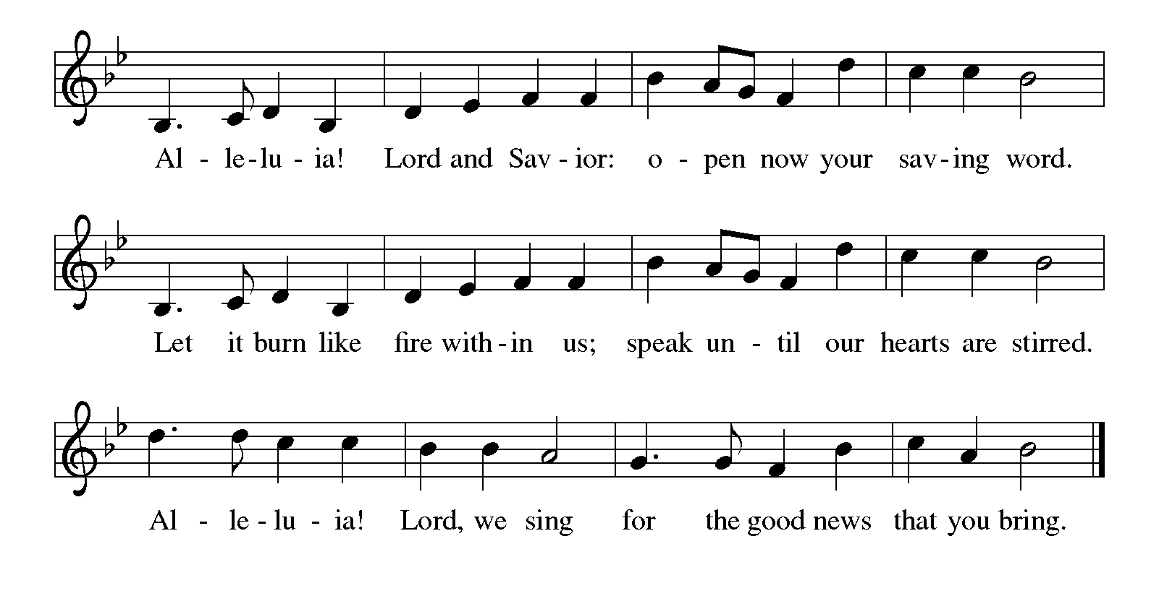

Gospel Luke 12:13-21
The holy gospel according to Luke.
Glory to you, O Lord
¹³ Someone in the crowd said to [Jesus,] “Teacher, tell my brother to divide the family inheritance with me.” ¹⁴ But he said to him, “Friend, who set me to be a judge or arbitrator over you?” ¹⁵ And he said to them, “Take care! Be on your guard against all kinds of greed, for one’s life does not consist in the abundance of possessions.” ¹⁶ Then he told them a parable: “The land of a rich man produced abundantly. ¹⁷ And he thought to himself, ‘What should I do, for I have no place to store my crops?’ ¹⁸ Then he said, ‘I will do this: I will pull down my barns and build larger ones, and there I will store all my grain and my goods. ¹⁹ And I will say to my soul, Soul, you have ample goods laid up for many years; relax, eat, drink, be merry.’ ²⁰ But God said to him, ‘You fool! This very night your life is being demanded of you. And the things you have prepared, whose will they be?’ ²¹ So it is with those who store up treasures for themselves but are not rich toward God.”

The gospel of the Lord.
Praise to you, O Christ.

CHILDREN’S MOMENT

SERMON

hymn of the day “Precious Lord, Take My Hand” #773

cREED
I believe in God, the Father almighty,
creator of heaven and earth.
I believe in Jesus Christ, God’s only Son, our Lord,
who was conceived by the Holy Spirit,
born of the virgin Mary,
suffered under Pontius Pilate,
was crucified, died, and was buried;
he descended to the dead.*
On the third day he rose again;
he ascended into heaven,
he is seated at the right hand of the Father,
and he will come to judge the living and the dead.
I believe in the Holy Spirit,
the holy catholic church,
the communion of saints,
the forgiveness of sins,
the resurrection of the body,
and the life everlasting. Amen.

*Or, “he descended into hell,” another translation of this text in widespread use.

prayers of Intercession
In solidarity with all creation, we join our voice to the voice of the whole church and pray for the needs of the world.
A brief silence.
Renew in your church a perspective of life beyond worldly pursuits. Build an enthusiasm to embrace life in Christ, so that Christ, the life of the world, is revealed to everyone. We especially for St. Matthew Lutheran Church and their pastor Rev. Leslie Nye.
God of grace,
hear our prayer.
Revitalize and protect the treasures of wild places. Teach all people to value the earth, winds, waters, trees, and animals, the gifts that make life possible on this planet. God of grace,
hear our prayer.
Speak wisdom to any in positions of power, that they cease practices of divisiveness, insult, and oppression. Clothe all people in your image, and establish equity and peace. God of grace,
hear our prayer.
Reveal your loving presence in the lives of people suffering hunger and need, illness and grief, pain and fear. Give strength to those who give care, and equip them with compassion as they make your love known. God of grace,
hear our prayer.
Store up in this congregation a full measure of gratitude and generosity. Guide the work of treasurers and all who attend to financial matters. Support those whose work in our community is difficult and demanding; make us mindful of the toil that goes unnoticed. God of grace,
hear our prayer.
Receive our thanks for the lives of your saints who now rest from their labors. Give us wisdom through their witness and encourage us in love as we continue our lives in the world. God of grace,
hear our prayer.
Trusting in your lovingkindness, we place our prayer and hope in you, in the name of Jesus Christ.
Amen.

PEACE
The peace of Christ be with you always.
And also with you.

OFFERING & OFFERING SONG
The joy of the Lord is my strength,
The joy of the Lord is my strength,
The joy of the Lord is my strength,
The joy of the Lord is my strength.

Offering Prayer
Let us pray.
God of all creation, all you have made is good, and your love endures forever. You bring forth bread from the earth and fruit from the vine. Nourish us with these gifts, that we might be for the world signs of your gracious presence in Jesus Christ, our Savior and Lord.
Amen.

Lord’s Prayer
Gathered into one by the Holy Spirit, let us pray as Jesus taught us.
Our Father, who art in heaven,
hallowed be thy name,
thy kingdom come,
thy will be done,
on earth as it is in heaven.
Give us this day our daily bread;
and forgive us our trespasses,
as we forgive those
who trespass against us;
and lead us not into temptation,
but deliver us from evil.
For thine is the kingdom,
and the power, and the glory,
forever and ever. Amen.

Thanksgiving for the Word
Praise and thanks to you, holy God, for by your Word you made all things; you spoke light into darkness, called forth beauty from chaos, and brought life into being. For you Word of life, O God,
We give you thanks and praise.
By your Word you called your people Israel to tell of your wonderful gifts; freedom from captivity, water on the desert journey, a pathway home from exile, wisdom for life with you. For your Word of life, O God,
We give you thanks and praise.
Through Jesus, your Word made flesh, you speak to us and call us to witness; forgiveness through the cross, life to those entombed by death, the way of your self-giving love. For your Word of live, O God,
We give you thanks and praise.
Send your Spirit of truth, O God; rekindle your gifts within use; renew our faith, increase our hope, and deepen our love, for the sake of a world in need. Faithful as your Word, O God, draw near to all who all on you; through Jesus Christ, our Savior and Lord, to whom with you and the Holy Spirit, be honor and glory forever.
Amen.

Sending
God blesses us and sends us in mission to the world.

Blessing
The Lord bless you and keep you.
The Lord’s face shine on you with grace and mercy.
The Lord look upon you with favor and ☩ give you peace.
Amen.

Sending SonG “What a Friend We Have in Jesus” #742

Dismissal
Go in peace. Christ is with you.
Thanks be to God.

From sundaysandseasons.com. Copyright © 2017 Augsburg Fortress. All rights reserved.

Thank you to all who served in worship today!
Presiders: Doug MacKenzie Musician: Jayne Flanigan
Acolyte: Kole Hokanson Safety Person:
Elder: Dan Utterback Trustee: Mike Johnson
Offering Counters: Mary Makley & Martha Yoder



PRAYERS OF THE FAITHFUL

With thanks for all God’s blessings and his love for all people. Our Bishops, Craig Satterlee Elizabeth Eaton, and the congregations of the North/West Lower Michigan
Synod, and especially for St. Matthew Lutheran Church and their pastor Rev. Leslie Nye.

Prayers for our friends, for all who are sick or hospitalized and for all health care workers who care for them. All those members of Zion’s family traveling; all those homebound or in frail health; all those suffering with quiet, unknown needs or worries. For those who serve on our behalf: public safety, utility workers, medical personnel, military personnel. For those who might be forgotten.

This week at Zion:
- Men’s Coffee, 8 AM, Wednesday, August 6
- Bulletin Deadline, Wednesday, August 6


ONLINE GIVING
Zion has received a QR code to facilitate online giving. If you are interested in donating online instead of bringing your donation to church, simply scan the QR code and it will direct you to the appropriate site. The code is on our website as well.

ANNOUNCEMENT

- Election of Presiding-Bishop Elect: On Wednesday, the ELCA general assembly elected Rev. Yehiel Curry as presiding bishop of the ELCA. Bishop-elect Curry was elected on the fifth ballot with 70.34% of the vote. We pray for Bishop-elect Curry and all of the leaders elected and re-elected at this assembly. May God grant them grace and guidance.
- Vacation Bible School Thank You: Thank you to everyone who volunteered and helped make this year's Vacation Bible School a great success. Camp Firelight 2025 was a huge hit with the kids who enjoyed Bible Adventures, Music, Crafts, Games, a Petting Zoo and Pony Rides and fabulous meals each night. We had 34 kids registered and about 32 who attended. We received lots of very positive feedback. Lots of great memories were made while learning that "Whenever I'm Afraid, I put my trust in You." Psalm 56:3.
- Back to School Bash, August 3rd: Zion will again be helping host the Back to School Bash held Sunday afternoon. We do not have our assignment yet, but are looking for volunteers to help! Please let Martha know if you can help with this great community ministry.
- Sunday School Planning Meeting: If you have ideas for suggestions for Sunday school, we will meet on Sunday, August 3rd after church for a planning meeting. We want to create a fun year for our kiddos and need teachers, ideas and support! If you’re not able to attend, please share your ideas with a member of the Board of Education.
- Woodland Homecoming Grand Marshals: Claude and Mary Smith have been announced as the 2025 Grand Marshals of the Woodland Homecoming Celebration this year! We are so happy for Claude and Mary on this very deserved honor!! Watch for more information on the details for their reception!
- Announcement and Newsletter Items: Please forward items for the bulletin announcements and the newsletter to the church email (Office@Zion.org). Please do not send items to people’s personal emails. Thank you.
- Door Locking Policy: Our door locking policy relies on having a volunteer(s) each Sunday to serve as the Safety Person of the Day. On Sundays where no one has volunteered, if someone arrives at church and is willing to be the Safety Person of the Day, we will follow the door locking policy. If no one steps forward to serve as the Safety Person of the Day, the doors will not be locked. Please consider volunteering for this important duty.

