ZION LUTHERAN CHURCH, WOODLAND, MI
Ninth Sunday After Pentecost August 10, 2025
*If you are listening in your car, please tune your radio to FM 87.7*
(Please silence your cell phones while in the sanctuary. Thank you.)
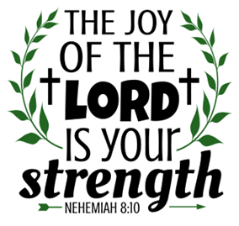

WELCOME AND ANNOUNCEMENTS

Gathering
The Holy Spirit calls us together as the people of God.

Confession and Forgiveness
In the name of the Father,
and of the ☩ Son,
and of the Holy Spirit.
Amen.

Almighty God, to whom all hearts are open, all desires known, and from whom no secrets are hid: cleanse the thoughts of our hearts by the inspiration of your Holy Spirit, that we may perfectly love you and worthily magnify your holy name, through Jesus Christ our Lord.
Amen.

Let us confess our sin in the presence of God and of one another. Most merciful God,
we confess that we are captive to sin and cannot free ourselves. We have sinned against you in thought, word, and deed, by what we have done and by what we have left undone. We have not loved you with our whole heart; we have not loved our neighbors as ourselves. For the sake of your Son, Jesus Christ, have mercy on us. Forgive us, renew us, and lead us, so that we may delight in your will and walk in your ways, to the glory of your holy name.
Amen.

God, who is rich in mercy, loved us even when we were dead in sin, and made us alive together with Christ. By grace you have been saved. In the name of ☩ Jesus Christ, your sins are forgiven. Almighty God strengthen you with power through the Holy Spirit, that Christ may live in your hearts through faith.
Amen.

Gathering Song “Wake, Awake, for Night Is Flying” #436

GREETING
The grace of our Lord Jesus Christ, the love of God, and the communion of the Holy Spirit be with you all.
And also with you.

Prayer of the Day
Let us pray together.
Almighty God, you sent your Holy Spirit to be the life and light of your church. Open our hearts to the riches of your grace, that we may be ready to receive you wherever you appear, through Jesus Christ, our Savior and Lord.
Amen.

First Reading Genesis 15:1-6
A reading from Genesis.
¹ After these things the word of the Lord came to Abram in a vision, “Do not be afraid, Abram, I am your shield; your reward shall be very great.” ² But Abram said, “O Lord God, what will you give me, for I continue childless, and the heir of my house is Eliezer of Damascus?” ³ And Abram said, “You have given me no offspring, so a slave born in my house is to be my heir.” ⁴ But the word of the Lord came to him, “This man shall not be your heir; no one but your very own issue shall be your heir.” ⁵ He brought him outside and said, “Look toward heaven and count the stars, if you are able to count them.” Then he said to him, “So shall your descendants be.” ⁶ And he believed the Lord, and the Lord reckoned it to him as righteousness.

The Word of the Lord
Thanks be to God.

Psalm Psalm 33:12-22

¹² Happy is the nation whose God | is the Lord!
Happy the people chosen to | be God’s heritage!
¹³ The Lord looks | down from heaven,
and sees all | humankind.
¹⁴ God sits firmly en- | throned and watches
all who dwell | on the earth.
¹⁵ God fashions | all their hearts
and observes | all their deeds.
¹⁶ A king is not saved by the size | of the army,
nor are warriors rescued by | their great strength.
¹⁷ The horse gives vain | hope for victory;
despite its great strength it | cannot save.
¹⁸ Truly, your eye is upon those who fear | you, O Lord,
upon those who wait for your | steadfast love,
¹⁹ to deliver their | lives from death,
and to keep them alive in | time of famine.
²⁰ Our innermost being waits for | you, O Lord,
our helper | and our shield.
²¹ Surely, our heart rejoic- | es in you,
for in your holy name we | put our trust.
²² Let your lovingkindness, O Lord, | be upon us,
even as we place our | hope in you.

Second Reading Hebrews 11:1-3, 8-16
A reading from Hebrews.
¹ Now faith is the assurance of things hoped for, the conviction of things not seen. ² Indeed, by faith our ancestors received approval. ³ By faith we understand that the worlds were prepared by the word of God, so that what is seen was made from things that are not visible.
⁸ By faith Abraham obeyed when he was called to set out for a place that he was to receive as an inheritance, and he set out, not knowing where he was going. ⁹ By faith he stayed for a time in the land he had been promised, as in a foreign land, living in tents, as did Isaac and Jacob, who were heirs with him of the same promise. ¹⁰ For he looked forward to the city that has foundations, whose architect and builder is God. ¹¹ By faith, with Sarah’s involvement, he received power of procreation, even though he was too old, because he considered him faithful who had promised. ¹² Therefore from one person, and this one as good as dead, descendants were born, “as many as the stars of heaven and as the innumerable grains of sand by the seashore.”
¹³ All of these died in faith without having received the promises, but from a distance they saw and greeted them. They confessed that they were strangers and foreigners on the earth, ¹⁴ for people who speak in this way make it clear that they are seeking a homeland. ¹⁵ If they had been thinking of the land that they had left behind, they would have had opportunity to return. ¹⁶ But as it is, they desire a better homeland, that is, a heavenly one. Therefore God is not ashamed to be called their God; indeed, he has prepared a city for them.

The Word of the Lord
Thanks be to God.
Gospel Acclamation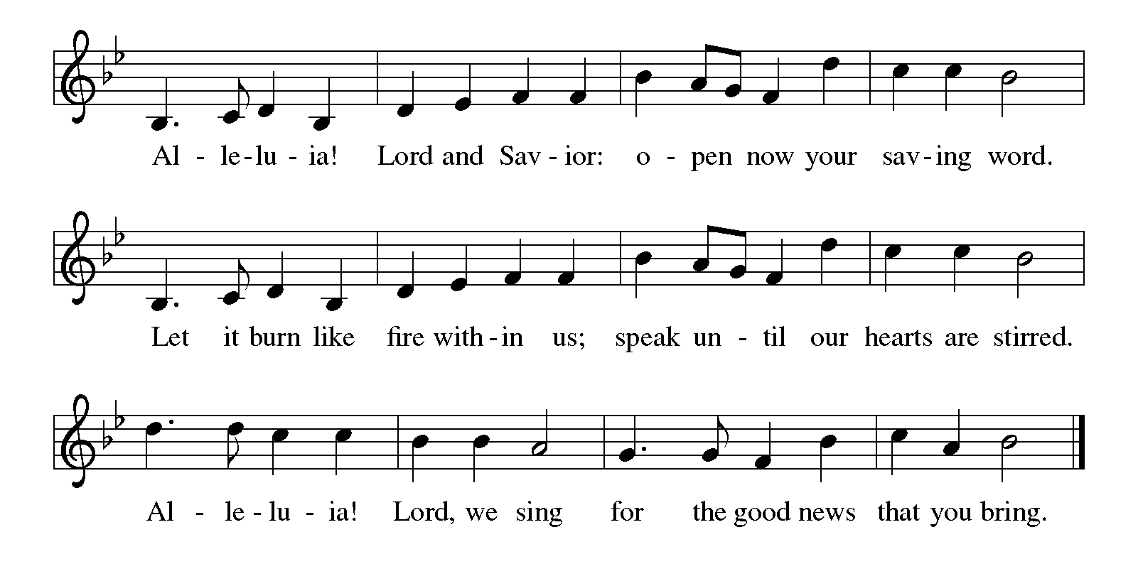

Gospel Luke 12:32-40

[Jesus said:] ³² “Do not be afraid, little flock, for it is your Father’s good pleasure to give you the kingdom. ³³ Sell your possessions and give alms. Make purses for yourselves that do not wear out, an unfailing treasure in heaven, where no thief comes near and no moth destroys. ³⁴ For where your treasure is, there your heart will be also.
³⁵ “Be dressed for action and have your lamps lit; ³⁶ be like those who are waiting for their master to return from the wedding banquet, so that they may open the door for him as soon as he comes and knocks. ³⁷ Blessed are those slaves whom the master finds alert when he comes; truly I tell you, he will fasten his belt and have them sit down to eat, and he will come and serve them. ³⁸ If he comes during the middle of the night or near dawn and finds them so, blessed are those slaves.
³⁹ “But know this: if the owner of the house had known at what hour the thief was coming, he would not have let his house be broken into. ⁴⁰ You also must be ready, for the Son of Man is coming at an hour you do not expect.”
The gospel of the Lord.
Praise to you, O Christ.

CHILDREN’S MOMENT

SERMON Pastor Mike Anderson

hymn of the day “O Master, Let Me Walk with You ” #818

cREED
I believe in God, the Father almighty,
creator of heaven and earth.
I believe in Jesus Christ, God’s only Son, our Lord,
who was conceived by the Holy Spirit,
born of the virgin Mary,
suffered under Pontius Pilate,
was crucified, died, and was buried;
he descended to the dead.*
On the third day he rose again;
he ascended into heaven,
he is seated at the right hand of the Father,
and he will come to judge the living and the dead.
I believe in the Holy Spirit,
the holy catholic church,
the communion of saints,
the forgiveness of sins,
the resurrection of the body,
and the life everlasting. Amen.

*Or, “he descended into hell,” another translation of this text in widespread use.

prayers of Intercession
In solidarity with all creation, we join our voice to the voice of the whole church and pray for the needs of the world.
A brief silence.
Keep the heart of your church set firmly in you so that, with lamps lit and attentive to Christ’s call at any time or place, your people are ready to respond with faithful action for the sake of the world. Pray especially for Trinity Lutheran Church in Hillsdale and their pastor Rev. Kara Shaw
God of grace,
hear our prayer.
Worlds were prepared by your word. Speak healing and protection upon the earth, especially where life and habitats are threatened. Guide the work of astronomers and all who teach us about the stars and galaxies. God of grace,
hear our prayer.
You know the actions and deeds of the nations. Turn humanity away from instruments of war and violence. Fashion the hearts of world leaders to work for peace. God of grace,
hear our prayer.
Let your lovingkindness be on those in need. Assure all who are afraid or experiencing great uncertainty that your promises are sure. God of grace,
hear our prayer.
Calm the fears of migrants and refugees who set out, not knowing where they go. Provide shelter, sustenance, protection from harm, and welcome. Bless the work of Global Refuge and other means of support and advocacy. God of grace,
hear our prayer.

PEACE
The peace of Christ be with you always.
And also with you.

OFFERING & OFFERING SONG
The joy of the Lord is my strength,
The joy of the Lord is my strength,
The joy of the Lord is my strength,
The joy of the Lord is my strength.

Offering Prayer
Let us pray.
God of all creation, all you have made is good, and your love endures forever. You bring forth bread from the earth and fruit from the vine. Nourish us with these gifts, that we might be for the world signs of your gracious presence in Jesus Christ, our Savior and Lord.
Amen.

DIALOGUE
The Lord be with you.
And also with you.
Lift up your hearts.
We lift them to the Lord.
Let us give thanks to the Lord our God.
It is right to give our thanks and praise.

PREFACE (Pastor)
It is indeed right, our duty and our joy,
that we should at all times and in all places
give thanks and praise to you, almighty and merciful God,
through our Savior Jesus Christ;
who on this day overcame death and the grave,
and by his glorious resurrection opened to us the way of everlasting life.
And so, with all the choirs of angels,
with the church on earth and the hosts of heaven,
we praise your name and join their unending hymn

holy, holy, holy
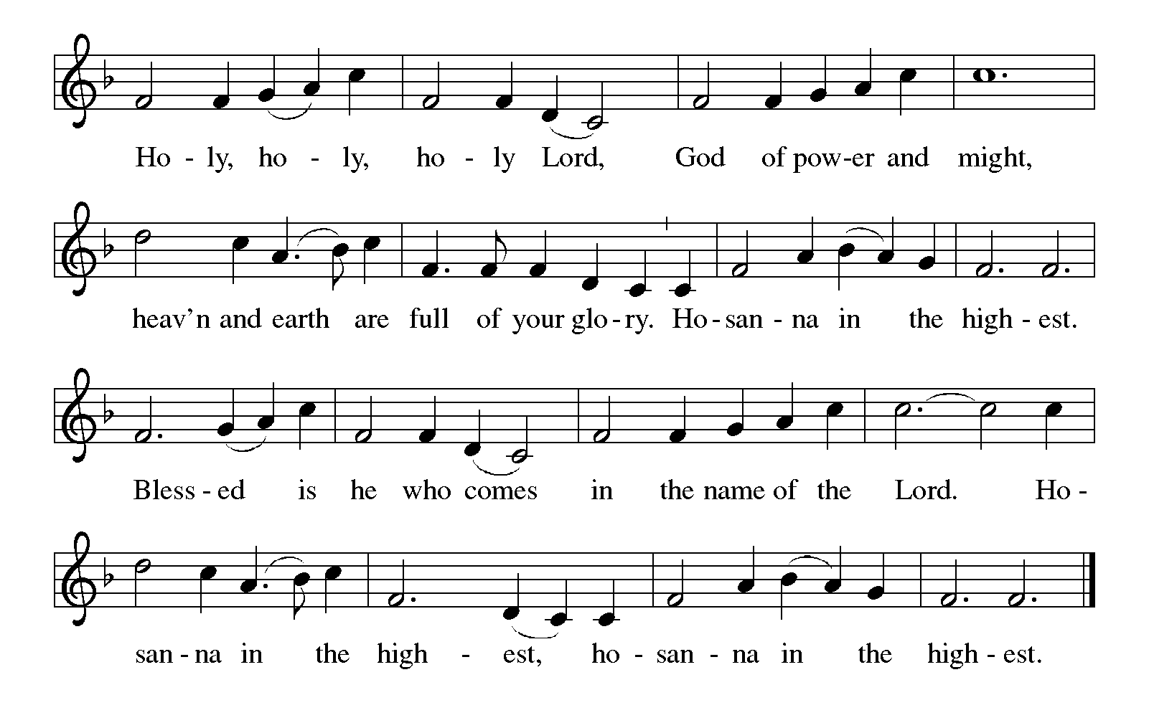

Thanksgiving at the Table
In the night in which he was betrayed,
our Lord Jesus took bread, and gave thanks;
broke it, and gave it to his disciples, saying:
Take and eat; this is my body, given for you.
Do this for the remembrance of me.

Again, after supper, he took the cup, gave thanks,
and gave it for all to drink, saying:
This cup is the new covenant in my blood,
shed for you and for all people for the forgiveness of sin.
Do this for the remembrance of me.

For as often as we eat of this bread and drink from this cup,
we proclaim the Lord’s death until he comes.

Lord’s Prayer
Gathered into one by the Holy Spirit, let us pray as Jesus taught us.
Our Father, who art in heaven,
hallowed be thy name,
thy kingdom come,
thy will be done,
on earth as it is in heaven.
Give us this day our daily bread;
and forgive us our trespasses,
as we forgive those
who trespass against us;
and lead us not into temptation,
but deliver us from evil.
For thine is the kingdom,
and the power, and the glory,
forever and ever. Amen.

INVITATION TO COMMUNION
Come to the banquet, for all is now ready.

COMMUNION *continuous
*People are welcome to kneel at the altar rail for a time of prayer after they receive their communion elements.

COMMUNION HYMNS
“Have No Fear, Little Flock ” #764

“Let Us Ever Walk with Jesus ” #802

PRAYER AFTER COMMUNION
Let us pray.
We give you thanks, almighty God, that you have refreshed us through the healing power of this gift of life. In your mercy, strengthen us through this gift, in faith toward you and in fervent love toward one another; for the sake of Jesus Christ our Lord.
Amen.

Sending
God blesses us and sends us in mission to the world.
Blessing
The Lord bless you and keep you.
The Lord’s face shine on you with grace and mercy.
The Lord look upon you with favor and ☩ give you peace.
Amen.
Sending SonG “O God, Our Help in Ages Past ”

Dismissal
Go in peace. Christ is with you.
Thanks be to God.

From sundaysandseasons.com. Copyright © 2017 Augsburg Fortress. All rights reserved.

Thank you to all who served in worship today!
Presiders: Pastor Mike Anderson Musician: Martha Yoder
Acolyte: Lexie Griffin Safety Person:
Elder: Buffy Meyers Trustee: Doug MacKenzie
Offering Counters: Diane Griffin & Carlotta Willard



PRAYERS OF THE FAITHFUL

With thanks for all God’s blessings and his love for all people. Our Bishops, Craig Satterlee Elizabeth Eaton, and the congregations of the North/West Lower Michigan
Synod, and especially for Trinity Lutheran Church in Hillsdale and their pastor Rev. Kara Shaw

Prayers for our friends, for all who are sick or hospitalized and for all health care workers who care for them. All those members of Zion’s family traveling; all those homebound or in frail health; all those suffering with quiet, unknown needs or worries. For those who serve on our behalf: public safety, utility workers, medical personnel, military personnel. For those who might be forgotten.

This week at Zion:
- Council Meeting 6:30PM, Tuesday, August 12
- Men’s Coffee, 8 AM, Wednesday, August 13
- Bulletin Deadline, Wednesday, August 13
- Women’s Breakfast, 9AM, Thursday, August 14
- Craft Night 5PM-9PM, Friday, August 15
- Backpack give away, August 14,15, 16


ONLINE GIVING
Zion has received a QR code to facilitate online giving. If you are interested in donating online instead of bringing your donation to church, simply scan the QR code and it will direct you to the appropriate site. The code is on our website as well.

ANNOUNCEMENT
- Election of Presiding-Bishop Elect: On Wednesday, the ELCA general assembly elected Rev. Yehiel Curry as presiding bishop of the ELCA. Bishop-elect Curry was elected on the fifth ballot with 70.34% of the vote. We pray for Bishop-elect Curry and all of the leaders elected and re-elected at this assembly. May God grant them grace and guidance.
- Woodland Homecoming Grand Marshals: Claude and Mary Smith have been announced as the 2025 Grand Marshals of the Woodland Homecoming Celebration this year! We are so happy for Claude and Mary on this very deserved honor!! Watch for more information on the details for their reception!
- Announcement and Newsletter Items: Please forward items for the bulletin announcements and the newsletter to the church email (Office@Zion.org). Please do not send items to people’s personal emails. Thank you.
- Door Locking Policy: Our door locking policy relies on having a volunteer(s) each Sunday to serve as the Safety Person of the Day. On Sundays where no one has volunteered, if someone arrives at church and is willing to be the Safety Person of the Day, we will follow the door locking policy. If no one steps forward to serve as the Safety Person of the Day, the doors will not be locked. Please consider volunteering for this important duty.

