**ZION LUTHERAN CHURCH, WOODLAND, MI**

**Tenth Sunday After Pentecost August 17, 2025**

**\*If you are listening in your car, please tune your radio to FM 87.7\***

(Please silence your cell phones while in the sanctuary. Thank you.)

**WELCOME AND ANNOUNCEMENTS**

**Gathering**

The Holy Spirit calls us together as the people of God.

**Confession and Forgiveness**

In the name of the Father,

and of the ☩ Son,

and of the Holy Spirit.

**Amen.**

Almighty God, to whom all hearts are open, all desires known, and from whom no secrets are hid: cleanse the thoughts of our hearts by the inspiration of your Holy Spirit, that we may perfectly love you and worthily magnify your holy name, through Jesus Christ our Lord.

**Amen.**

Let us confess our sin in the presence of God and of one another. Most merciful God,

**we confess that we are captive to sin and cannot free ourselves. We have sinned against you in thought, word, and deed, by what we have done and by what we have left undone. We have not loved you with our whole heart; we have not loved our neighbors as ourselves. For the sake of your Son, Jesus Christ, have mercy on us. Forgive us, renew us, and lead us, so that we may delight in your will and walk in your ways, to the glory of your holy name.**

**Amen.**

God, who is rich in mercy, loved us even when we were dead in sin, and made us alive together with Christ. By grace you have been saved. In the name of ☩ Jesus Christ, your sins are forgiven. Almighty God strengthen you with power through the Holy Spirit, that Christ may live in your hearts through faith.

**Amen.**

**Gathering Song*“How Firm a Foundation”* #796**

**GREETING**

The grace of our Lord Jesus Christ, the love of God, and the communion of the Holy Spirit be with you all.

**And also with you.**

**Prayer of the Day**

Let us pray together.

**O God, judge eternal, you love justice and hate oppression, and you call us to share your zeal for truth. Give us courage to take our stand with all victims of bloodshed and greed, and, following your servants and prophets, to look to the pioneer and perfecter of our faith, your Son, Jesus Christ, our Savior and Lord.**

**Amen.**

**First Reading**    **Jeremiah 23:23-29**

*A reading from Jeremiah.*

23 Am I a God near by, says the Lord, and not a God far off? 24 Who can hide in secret places so that I cannot see them? says the Lord. Do I not fill heaven and earth? says the Lord. 25 I have heard what the prophets have said who prophesy lies in my name, saying, “I have dreamed! I have dreamed!” 26 How long? Will the hearts of the prophets ever turn back—those who prophesy lies and who prophesy the deceit of their own heart? 27 They plan to make my people forget my name by their dreams that they tell one another, just as their ancestors forgot my name for Baal. 28 Let the prophet who has a dream tell the dream, but let the one who has my word speak my word faithfully. What has straw in common with wheat? says the Lord. 29 Is not my word like fire, says the Lord, and like a hammer that breaks a rock in pieces?

The Word of the Lord

**Thanks be to God.**

**Psalm Psalm 82**

1 God stands to charge the divine coun- **|** cil assembled,  
  giving judgment in the midst **|** of the gods:  
 2 **“How long will you | judge unjustly,**  
  **and show favor | to the wicked?**  
 3 Save the weak **|** and the orphan;  
  defend the hum- **|** ble and needy;  
 4 **rescue the weak | and the poor;**  
  **deliver them from the power | of the wicked.**  
 5 They do not know, neither do they understand; they wander a- **|** bout in darkness;  
  all the foundations of the **|** earth are shaken.  
 6 **Now I say to you, | ‘You are gods,**  
  **and all of you children of | the Most High;**  
 7 nevertheless, you shall **|** die like mortals,  
  and fall like **|** any prince.’ ”  
 8 **Arise, O God, and | rule the earth,**  
  **for you shall take all nations | for your own.**

**Second Reading**  **Hebrews 11:29-12:2**

A reading from Hebrews.

29 By faith the people passed through the Red Sea as if it were dry land, but when the Egyptians attempted to do so they were drowned. 30 By faith the walls of Jericho fell after they had been encircled for seven days. 31 By faith Rahab the prostitute did not perish with those who were disobedient, because she had received the spies in peace.  
  32 And what more should I say? For time would fail me to tell of Gideon, Barak, Samson, Jephthah, of David and Samuel and the prophets, 33 who through faith conquered kingdoms, administered justice, obtained promises, shut the mouths of lions, 34 quenched the power of fire, escaped the edge of the sword, were made strong out of weakness, became mighty in war, put foreign armies to flight. 35 Women received their dead by resurrection. Others were tortured, refusing to accept release, in order to obtain a better resurrection. 36 Others suffered mocking and flogging and even chains and imprisonment. 37 They were stoned to death; they were sawn in two; they were killed by the sword; they went about in skins of sheep and goats, destitute, persecuted, tormented 38 of whom the world was not worthy. They wandered in deserts and mountains and in caves and holes in the ground.  
  39 Yet all these, though they were commended for their faith, did not receive what was promised, 40 since God had provided something better so that they would not, apart from us, be made perfect.  
  
  12:1 Therefore, since we are surrounded by so great a cloud of witnesses, let us also lay aside every weight and the sin that clings so closely, and let us run with perseverance the race that is set before us, 2 looking to Jesus, the pioneer and perfecter of faith, who for the sake of the joy that was set before him endured the cross, disregarding its shame, and has taken his seat at the right hand of the throne of God.

The Word of the Lord

**Thanks be to God.**

**

**Gospel** **Luke 12:49-56**

The holy gospel according to Luke.

49 “I have come to cast fire upon the earth, and how I wish it were already ablaze! 50 I have a baptism with which to be baptized, and what constraint I am under until it is completed! 51 Do you think that I have come to bring peace to the earth? No, I tell you, but rather division! 52 From now on five in one household will be divided, three against two and two against three; 53 they will be divided:   
 father against son  
  and son against father,  
 mother against daughter  
  and daughter against mother,  
 mother-in-law against her daughter-in-law  
  and daughter-in-law against mother-in-law.”  
  
  54 He also said to the crowds, “When you see a cloud rising in the west, you immediately say, ‘It is going to rain,’ and so it happens. 55 And when you see the south wind blowing, you say, ‘There will be scorching heat,’ and it happens. 56 You hypocrites! You know how to interpret the appearance of earth and sky, but why do you not know how to interpret the present time?”

The gospel of the Lord.

**Praise to you, O Christ.**

**CHILDREN’S MOMENT**

**SERMON Pastor Ken Scheck**

**hymn of the day “*Just a* Closer Walk with Thee” #697**

**cREED**

**I believe in God, the Father almighty,**

**creator of heaven and earth.**

**I believe in Jesus Christ, God’s only Son, our Lord,**

**who was conceived by the Holy Spirit,**

**born of the virgin Mary,**

**suffered under Pontius Pilate,**

**was crucified, died, and was buried;**

**he descended to the dead.\***

**On the third day he rose again;**

**he ascended into heaven,**

**he is seated at the right hand of the Father,**

**and he will come to judge the living and the dead.**

**I believe in the Holy Spirit,**

**the holy catholic church,**

**the communion of saints,**

**the forgiveness of sins,**

**the resurrection of the body,**

**and the life everlasting. Amen.**

*Or, “he descended into hell,” another translation of this text in widespread use.

**prayers of Intercession**

Let us pray for the church, the creation, and the whole people of God, for God is near.

*A brief silence.*

Raise up faithful leaders for your church around the world. Inspire global missionaries with a spirit of accompaniment, as they walk alongside our partners in the gospel in solidarity, interdependence, and mutuality. We especially for **Good Shepherd Lutheran Church in Holland and their pastor Rev. Jessica Rivera-Walker**

Hear us, O God.

**Your mercy is great.**

Safeguard rivers and lakes from pollution. Sustain the work of conservationists, policy makers, and advocacy groups seeking to protect freshwater sources. Hear us, O God.

**Your mercy is great.**

Bridge divisions across partisan lines. Strengthen cooperative efforts among lawmakers who enact policies that protect our neighbors who are most vulnerable. Hear us, O God.

**Your mercy is great.**

Embrace all who suffer in isolation: for those who are incarcerated or detained, those who are fleeing from unsafe environments, and those who are sick or homebound. Hear us, O God.

**Your mercy is great.**

Guide the leaders of this congregation. In these late summer weeks, inspire their planning for a new program year ahead. Kindle in us a spirit of collaboration and support for their work. Hear us, O God.

**Your mercy is great.**

With thanksgiving, we remember the cloud of witnesses who surround us. By the example of their faith, enable us to run with perseverance the race set before us, until that day when we join their unending praise. Hear us, O God.

**Your mercy is great.**

Confident in God’s presence and promise, we entrust our prayers to the one who always receives them; through Jesus Christ, our wisdom and companion.

**Amen.**

**PEACE**

The peace of Christ be with you always.

**And also with you.**

**OFFERING & OFFERING SONG**

The joy of the Lord is my strength,

The joy of the Lord is my strength,

The joy of the Lord is my strength,

The joy of the Lord is my strength.

**Offering Prayer**

Let us pray.

God of all creation, all you have made is good, and your love endures forever. You bring forth bread from the earth and fruit from the vine. Nourish us with these gifts, that we might be for the world signs of your gracious presence in Jesus Christ, our Savior and Lord.

**Amen.**

**DIALOGUE**

**The Lord be with you.**

**And also with you.**

**Lift up your hearts.**

**We lift them to the Lord.**

**Let us give thanks to the Lord our God.**

**It is right to give our thanks and praise.**

**PREFACE (Pastor)**

It is indeed right, our duty and our joy,

that we should at all times and in all places

give thanks and praise to you, almighty and merciful God,

through our Savior Jesus Christ;

who on this day overcame death and the grave,

and by his glorious resurrection opened to us the way of everlasting life.

And so, with all the choirs of angels,

with the church on earth and the hosts of heaven,

we praise your name and join their unending hymn

**holy, holy, holy**

**Thanksgiving at the Table**

In the night in which he was betrayed,

our Lord Jesus took bread, and gave thanks;

broke it, and gave it to his disciples, saying:

Take and eat; this is my body, given for you.

Do this for the remembrance of me.

Again, after supper, he took the cup, gave thanks,

and gave it for all to drink, saying:

This cup is the new covenant in my blood,

shed for you and for all people for the forgiveness of sin.

Do this for the remembrance of me.

For as often as we eat of this bread and drink from this cup,

we proclaim the Lord’s death until he comes.

**Lord’s Prayer**

Gathered into one by the Holy Spirit, let us pray as Jesus taught us.

**Our Father, who art in heaven,**

**hallowed be thy name,**

**thy kingdom come,**

**thy will be done,**

**on earth as it is in heaven.**

**Give us this day our daily bread;**

**and forgive us our trespasses,**

**as we forgive those**

**who trespass against us;**

**and lead us not into temptation,**

**but deliver us from evil.**

**For thine is the kingdom,**

**and the power, and the glory,**

**forever and ever. Amen.**

**INVITATION TO COMMUNION**

Come to the banquet, for all is now ready.

**COMMUNION \****continuous*

*\*People are welcome to kneel at the altar rail for a time of prayer after they receive their communion elements.*

**COMMUNION HYMNS**

**“Have Thine Own Way, Lord”**

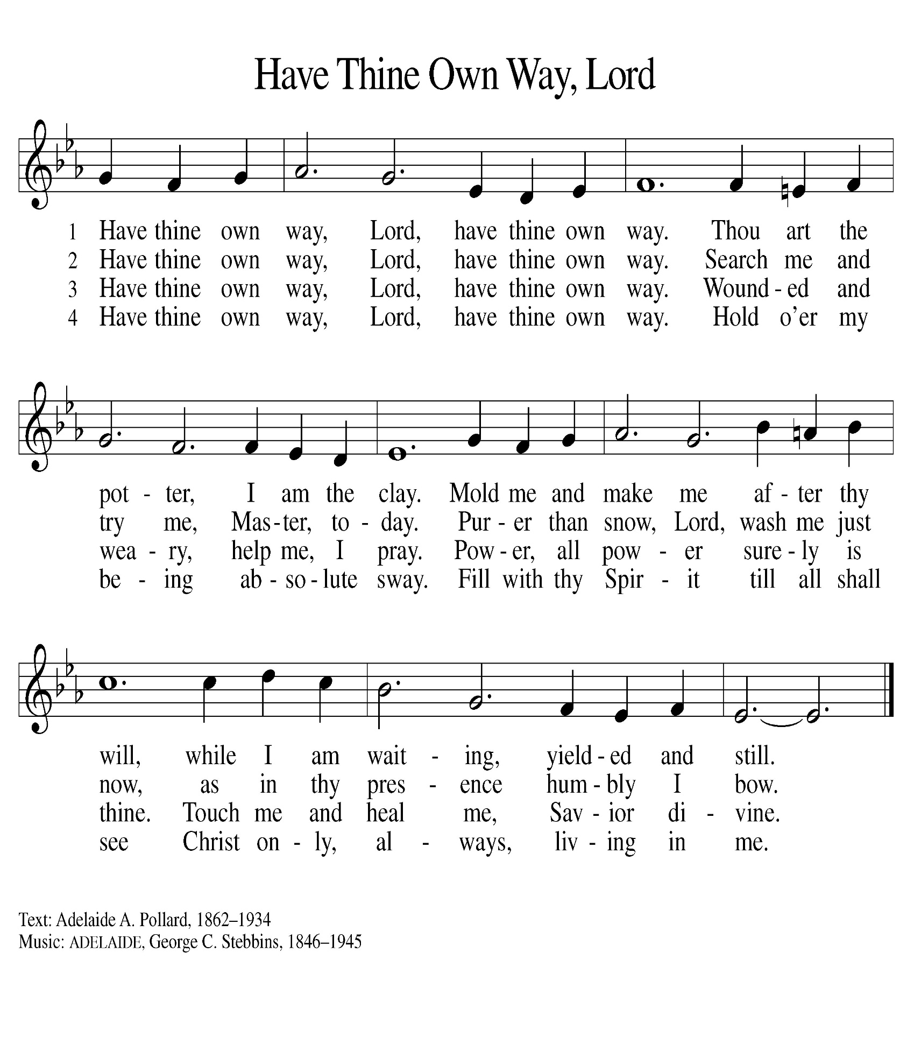

**“*Come, Let Us Eat* ” #491**

**PRAYER AFTER COMMUNION**

Let us pray.

We give you thanks, almighty God, that you have refreshed us through the healing power of this gift of life. In your mercy, strengthen us through this gift, in faith toward you and in fervent love toward one another; for the sake of Jesus Christ our Lord.

**Amen.**

**Sending**

God blesses us and sends us in mission to the world.

**Blessing**

The Lord bless you and keep you.

The Lord’s face shine on you with grace and mercy.

The Lord look upon you with favor and ☩ give you peace.

**Amen.**

**Sending SonG “*I Want to Walk as a Child of the Light* ” 815**

**Dismissal**

Go in peace. Christ is with you.

**Thanks be to God.**

From sundaysandseasons.com. Copyright © 2017 Augsburg Fortress. All rights reserved.

**Thank you to all who served in worship today!**

**Presiders:** **Pastor Ken Scheck Musician: Jayne Flanigan**

**Acolyte: Levi Griffin Safety Person:**

**Elder: Naomi Wilson Trustee: Tom Krikke**

**Offering Counters:** **Paul Meade & Carlotta Willard**

**PRAYERS OF THE FAITHFUL**

With thanks for all God’s blessings and his love for all people. Our Bishops, Craig Satterlee Elizabeth Eaton, and the congregations of the North/West Lower Michigan

Synod, and especially for **Good Shepherd Lutheran Church in Holland and their pastor Rev. Jessica Rivera-Walker.**

Prayers for our friends, for all who are sick or hospitalized and for all health care workers who care for them.. All those members of Zion’s family traveling; all those homebound or in frail health; all those suffering with quiet, unknown needs or worries. For those who serve on our behalf: public safety, utility workers, medical personnel, military personnel. For those who might be forgotten.

**This week at Zion:**

* Men’s Coffee, 8 AM, Wednesday, August 20
* Bulletin Deadline, Wednesday, August 20
* Witness Small group, 5:30, Tuesday, August 19, at Martha’s
* Disciple small group, 3:30, Thursday, August, 21, at Martha’sr

**ONLINE GIVING**

Zion has received a QR code to facilitate online giving. If you are interested in donating online instead of bringing your donation to church, simply scan the QR code and it will direct you to the appropriate site. The code is on our website as well.

**ANNOUNCEMENT**

* **Election of Presiding-Bishop Elect:**  On Wednesday, the ELCA general assembly elected Rev. Yehiel Curry as presiding bishop of the ELCA.  Bishop-elect Curry was elected on the fifth ballot with 70.34% of the vote.  We pray for Bishop-elect Curry and all of the leaders elected and re-elected at this assembly.  May God grant them grace and guidance.
* **Woodland Homecoming Grand Marshals:** Claude and Mary Smith have been announced as the 2025 Grand Marshals of the Woodland Homecoming Celebration this year!  We are so happy for Claude and Mary on this very deserved honor!!  Watch for more information on the details for their reception!
* **Announcement and Newsletter Items:** Please forward items for the bulletin announcements and the newsletter to the church email (Office@Zion.org). Please do not send items to people’s personal emails**.** Thank you.
* **Door Locking Policy:** Our door locking policy relies on having a volunteer(s) each Sunday to serve as the Safety Person of the Day. On Sundays where no one has volunteered, if someone arrives at church and is willing to be the Safety Person of the Day, we will follow the door locking policy. If no one steps forward to serve as the Safety Person of the Day, the doors will not be locked. Please consider volunteering for this important duty.
* **Installation Of Rev. Julie Schneider-Thomas:** The Rev. Julie Schneider-Thomas will be installed a bishop of the North/West Lower Michigan Synod on Saturday, September 13, 2025 at 4:00pm at Trinity Lutheran Church in Grand Rapids (2700 Fulton Street E).
* **Gift Box and Cards for Eric and Karen**: We are putting together a box filled with cards and goodies to help cheer up Karen and Eric Knight. Karen continues her lengthy hospital stay to address serious health issues. We know that cards and small treats and gifts can really help to lift spirits so helps us brighten Eric and Karen's day. There are cards on the table in the Narthex you can use, or you may bring your own. Also, if you would like to bring a treat or small gift that would be great.   Please bring your items by next Sunday, August 24th.  Thank you.
* **Are You Interested in Ordering a Lutheran Study Bible, Second Edition:**An updated and revised ELCA Study Bible has been released by Augsburg press.  This Bible features the NRSVue translation and introductions, notes, and articles written by more than seventy Lutheran pastors and teaching theologians.  It includes solid background material, unique Lutheran insights, and questions for reflection and discussion.  The *Lutheran Study Bible* contains 10-point biblical text and 7-point study notes.  The Bibles cost $32.99.  If you would like to order a copy, please sign up on the sheet in the narthex.  You can pay for your Bible by adding this to your offering or giving payment to Karen or Martha.  We will also be ordering some for use at the church.  With an order of 10, there is no shipping cost.  We would like to order these in early September.