ZION LUTHERAN CHURCH, WOODLAND, MI
Eleventh Sunday After Pentecost August 24, 2025
*If you are listening in your car, please tune your radio to FM 87.7*
(Please silence your cell phones while in the sanctuary. Thank you.)
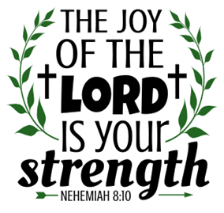

WELCOME AND ANNOUNCEMENTS

Gathering
The Holy Spirit calls us together as the people of God.

Confession and Forgiveness
In the name of the Father,
and of the ☩ Son,
and of the Holy Spirit.
Amen.

Almighty God, to whom all hearts are open, all desires known, and from whom no secrets are hid: cleanse the thoughts of our hearts by the inspiration of your Holy Spirit, that we may perfectly love you and worthily magnify your holy name, through Jesus Christ our Lord.
Amen.

Let us confess our sin in the presence of God and of one another. Most merciful God,
we confess that we are captive to sin and cannot free ourselves. We have sinned against you in thought, word, and deed, by what we have done and by what we have left undone. We have not loved you with our whole heart; we have not loved our neighbors as ourselves. For the sake of your Son, Jesus Christ, have mercy on us. Forgive us, renew us, and lead us, so that we may delight in your will and walk in your ways, to the glory of your holy name.
Amen.

God, who is rich in mercy, loved us even when we were dead in sin, and made us alive together with Christ. By grace you have been saved. In the name of ☩ Jesus Christ, your sins are forgiven. Almighty God strengthen you with power through the Holy Spirit, that Christ may live in your hearts through faith.
Amen.

Gathering Song “Morning Has Broken” #556

GREETING
The grace of our Lord Jesus Christ, the love of God, and the communion of the Holy Spirit be with you all.
And also with you.

Prayer of the Day
Let us pray together.
O God, mighty and immortal, you know that as fragile creatures surrounded by great dangers, we cannot by ourselves stand upright. Give us strength of mind and body, so that even when we suffer because of human sin, we may rise victorious through your Son, Jesus Christ, our Savior and Lord.
Amen.

First Reading Isaiah 58:9b-14
A reading from Isaiah.
^{9b} If you remove the yoke from among you,
the pointing of the finger, the speaking of evil,
¹⁰ if you offer your food to the hungry
and satisfy the needs of the afflicted,
then your light shall rise in the darkness
and your gloom be like the noonday.
¹¹ The Lord will guide you continually
and satisfy your needs in parched places
and make your bones strong,
and you shall be like a watered garden,
like a spring of water
whose waters never fail.
¹² Your ancient ruins shall be rebuilt;
you shall raise up the foundations of many generations;
you shall be called the repairer of the breach,
the restorer of streets to live in.
¹³ If you refrain from trampling the Sabbath,
from pursuing your own interests on my holy day;
if you call the Sabbath a delight
and the holy day of the Lord honorable;
if you honor it, not going your own ways,
serving your own interests or pursuing your own affairs;
¹⁴ then you shall take delight in the Lord,
and I will make you ride upon the heights of the earth;
I will feed you with the heritage of your ancestor Jacob,
for the mouth of the Lord has spoken.
The Word of the Lord
Thanks be to God.

Psalm Psalm 103:1-8

¹ Bless the Lord, | O my soul,
and all that is within me, bless God’s | holy name.
² Bless the Lord, | O my soul,
and forget not | all God’s benefits—
³ who forgives | all your sins
and heals all | your diseases;
⁴ who redeems your life | from the grave
and crowns you with steadfast | love and mercy; R
⁵ who satisfies your desires | with good things
so that your youth is renewed | like an eagle’s.
⁶ O Lord, you provide | vindication
and justice for all who | are oppressed.
⁷ You made known your | ways to Moses
and your works to the chil- | dren of Israel.
⁸ Lord, you are full of compas- | sion and mercy,
slow to anger and abounding in | steadfast love. R

Second Reading Hebrews 12:18-29
A reading from Hebrews.
¹⁸ You have not come to something that can be touched, a blazing fire, and darkness, and gloom, and a tempest, ¹⁹ and the sound of a trumpet, and a voice whose words made the hearers beg that not another word be spoken to them. ²⁰ (For they could not endure the order that was given, “If even an animal touches the mountain, it shall be stoned to death.” ²¹ Indeed, so terrifying was the sight that Moses said, “I tremble with fear.”) ²² But you have come to Mount Zion and to the city of the living God, the heavenly Jerusalem, and to innumerable angels in festal gathering, ²³ and to the assembly of the firstborn who are enrolled in heaven, and to God the judge of all, and to the spirits of the righteous made perfect, ²⁴ and to Jesus, the mediator of a new covenant, and to the sprinkled blood that speaks a better word than the blood of Abel.
²⁵ See that you do not refuse the one who is speaking, for if they did not escape when they refused the one who warned them on earth, how much less will we escape if we reject the one who warns from heaven! ²⁶ At that time his voice shook the earth, but now he has promised, “Yet once more I will shake not only the earth but also the heaven.” ²⁷ This phrase, “Yet once more,” indicates the removal of what is shaken—that is, created things—so that what cannot be shaken may remain. ²⁸ Therefore, since we are receiving a kingdom that cannot be shaken, let us show gratitude, by which we may offer to God an acceptable worship with reverence and awe, ²⁹ for indeed our God is a consuming fire.
The Word of the Lord
Thanks be to God.

Gospel Acclamation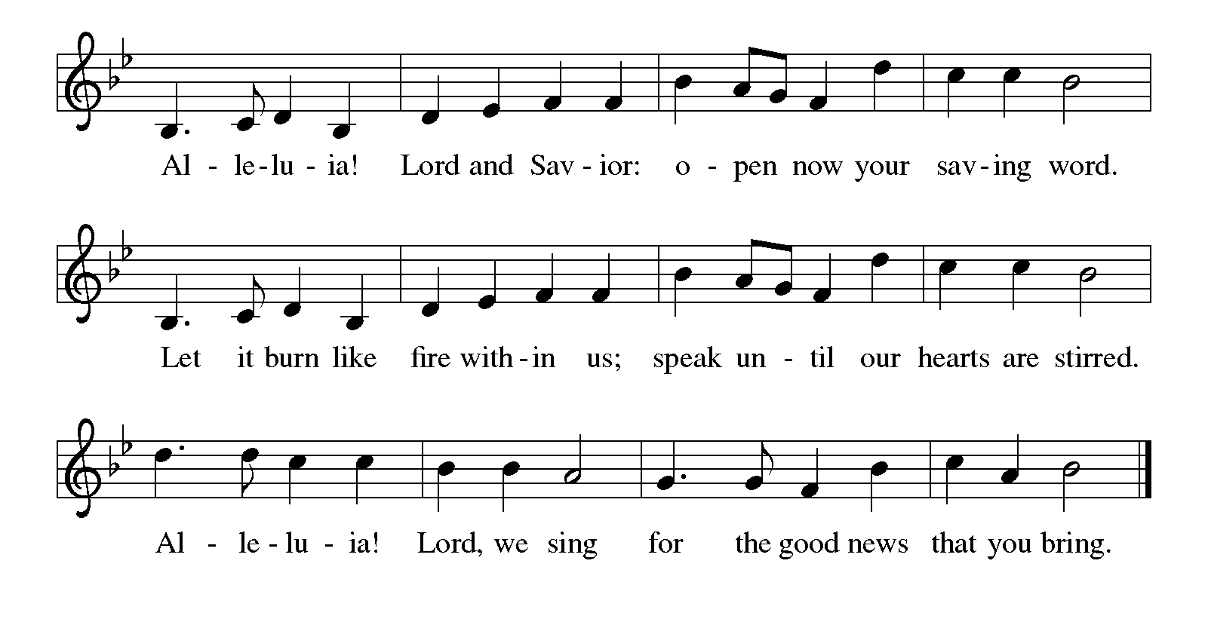

Gospel Luke 13:10-17

The holy gospel according to Luke.
¹⁰ Now [Jesus] was teaching in one of the synagogues on the Sabbath. ¹¹ And just then there appeared a woman with a spirit that had crippled her for eighteen years. She was bent over and was quite unable to stand up straight. ¹² When Jesus saw her, he called her over and said, “Woman, you are set free from your ailment.” ¹³ When he laid his hands on her, immediately she stood up straight and began praising God. ¹⁴ But the leader of the synagogue, indignant because Jesus had cured on the Sabbath, kept saying to the crowd, “There are six days on which work ought to be done; come on those days and be cured and not on the Sabbath day.” ¹⁵ But the Lord answered him and said, “You hypocrites! Does not each of you on the Sabbath untie his ox or his donkey from the manger and lead it to water? ¹⁶ And ought not this woman, a daughter of Abraham whom Satan bound for eighteen long years, be set free from this bondage on the Sabbath day?” ¹⁷ When he said this, all his opponents were put to shame, and the entire crowd was rejoicing at all the wonderful things being done by him.

The gospel of the Lord.
Praise to you, O Christ.

CHILDREN’S MOMENT

SERMON Pastor Mike Anderson

hymn of the day “As Rain From The Clouds” #508

cREED
I believe in God, the Father almighty,
creator of heaven and earth.
I believe in Jesus Christ, God’s only Son, our Lord,
who was conceived by the Holy Spirit,
born of the virgin Mary,
suffered under Pontius Pilate,
was crucified, died, and was buried;
he descended to the dead.*
On the third day he rose again;
he ascended into heaven,
he is seated at the right hand of the Father,
and he will come to judge the living and the dead.
I believe in the Holy Spirit,
the holy catholic church,
the communion of saints,
the forgiveness of sins,
the resurrection of the body,
and the life everlasting. Amen.

*Or, “he descended into hell,” another translation of this text in widespread use.

prayers of Intercession
Let us pray for the church, the creation, and the whole people of God, for God is near.
A brief silence.
You call your church to proclaim liberation and freedom to all. Give wisdom to bishops, synod councils and staff, and congregation leaders as they pursue a more just and equitable church and society. We pray especially for Peace Lutheran Church in Holland and their Supply Pastors.
Hear us, O God.
Your mercy is great.
You inspire all creation to sing and bless your holy name. Send healing rains to parched places and relief to flooded lands. Lead us to enact policies to rebuild ruined ecosystems and habitats. Hear us, O God.
Your mercy is great.
You work vindication and justice for all who are oppressed. Strengthen the resolve of world leaders and local officials in the way of love and mercy, so that all persons may experience abundant life. Hear us, O God.
Your mercy is great.
You satisfy your people with good things. In your steadfast love, receive the cries of all who are bent over under the weight of addiction, isolation, and mental or physical illness. Manifest your healing presence in their midst. Hear us, O God.
Your mercy is great.
You call us to delight in the sabbath. Invigorate worship planners and leaders with creativity to aid this assembly in fresh and faithful prayer and praise. Enable all who gather here to be nourished and renewed. Hear us, O God.
Your mercy is great.
With all your apostles, prophets, and saints, we give thanks and bless your holy name. As they now rest from their labors, guide us by the witness of their lives to pursue your reign, which can never be shaken. Hear us, O God.
Your mercy is great.
Confident in God’s presence and promise, we entrust our prayers to the one who always receives them; through Jesus Christ, our wisdom and companion.
Amen.

PEACE
The peace of Christ be with you always.
And also with you.

OFFERING & OFFERING SONG
The joy of the Lord is my strength,
The joy of the Lord is my strength,
The joy of the Lord is my strength,
The joy of the Lord is my strength.

Offering Prayer
Let us pray.
God of all creation, all you have made is good, and your love endures forever. You bring forth bread from the earth and fruit from the vine. Nourish us with these gifts, that we might be for the world signs of your gracious presence in Jesus Christ, our Savior and Lord.
Amen.

DIALOGUE
The Lord be with you.
And also with you.
Lift up your hearts.
We lift them to the Lord.
Let us give thanks to the Lord our God.
It is right to give our thanks and praise.

PREFACE (Pastor)
It is indeed right, our duty and our joy,
that we should at all times and in all places
give thanks and praise to you, almighty and merciful God,
through our Savior Jesus Christ;
who on this day overcame death and the grave,
and by his glorious resurrection opened to us the way of everlasting life.
And so, with all the choirs of angels,
with the church on earth and the hosts of heaven,
we praise your name and join their unending hymn

holy, holy, holy
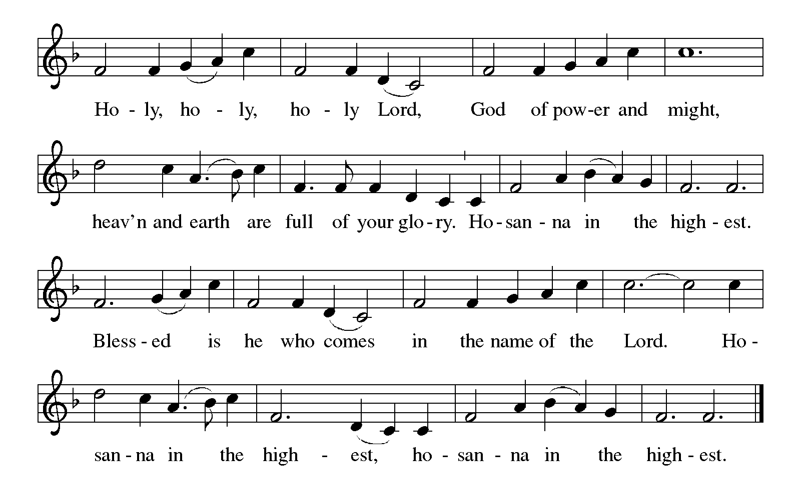

Thanksgiving at the Table
In the night in which he was betrayed,
our Lord Jesus took bread, and gave thanks;
broke it, and gave it to his disciples, saying:
Take and eat; this is my body, given for you.
Do this for the remembrance of me.

Again, after supper, he took the cup, gave thanks,
and gave it for all to drink, saying:
This cup is the new covenant in my blood,
shed for you and for all people for the forgiveness of sin.
Do this for the remembrance of me.

For as often as we eat of this bread and drink from this cup,
we proclaim the Lord’s death until he comes.

Lord’s Prayer
Gathered into one by the Holy Spirit, let us pray as Jesus taught us.
Our Father, who art in heaven,
hallowed be thy name,
thy kingdom come,
thy will be done,
on earth as it is in heaven.
Give us this day our daily bread;
and forgive us our trespasses,
as we forgive those
who trespass against us;
and lead us not into temptation,
but deliver us from evil.
For thine is the kingdom,
and the power, and the glory,
forever and ever. Amen.

INVITATION TO COMMUNION
Come to the banquet, for all is now ready.

COMMUNION *continuous
*People are welcome to kneel at the altar rail for a time of prayer after they receive their communion elements.

COMMUNION HYMNS
“Come, Ye Disconsolate” #607
“Come to the Table” #481
PRAYER AFTER COMMUNION
Let us pray.
We give you thanks, almighty God, that you have refreshed us through the healing power of this gift of life. In your mercy, strengthen us through this gift, in faith toward you and in fervent love toward one another; for the sake of Jesus Christ our Lord.
Amen.

Sending
God blesses us and sends us in mission to the world.
Blessing
The Lord bless you and keep you.
The Lord’s face shine on you with grace and mercy.
The Lord look upon you with favor and ☩ give you peace.
Amen.

Sending SonG “Oh, for a Thousand Tongues to Sing” 886

Dismissal
Go in peace. Christ is with you.
Thanks be to God.

From sundaysandseasons.com. Copyright © 2017 Augsburg Fortress. All rights reserved.

Thank you to all who served in worship today!
Presiders: Pastor Mike Anderson Musician: Jayne Flanigan
Acolyte: Kole Hokanson Safety Person:
Elder: Dan Utterback Trustee: Mike Johnson
Offering Counters: Doug MacKenzie & Mike Johnson



PRAYERS OF THE FAITHFUL

With thanks for all God’s blessings and his love for all people. Our Bishops, Craig Satterlee Elizabeth Eaton, and the congregations of the North/West Lower Michigan
Synod, and especially for Peace Lutheran Church in Holland and their Supply Pastors.

Prayers for our friends, for all who are sick or hospitalized and for all health care workers who care for them. All those members of Zion’s family traveling; all those homebound or in frail health; all those suffering with quiet, unknown needs or worries. For those who serve on our behalf: public safety, utility workers, medical personnel, military personnel. For those who might be forgotten.

This week at Zion:
- The Disciples Small Group, Martha’s, 2 pm, Tuesday, August 26.
- Newsletter deadline, Wednesday, August 27
- Men’s Coffee, 8 AM, Wednesday, August 27
- Bulletin Deadline, Wednesday, August 27

ONLINE GIVING
Zion has received a QR code to facilitate online giving. If you are interested in donating online instead of bringing your donation to church, simply scan the QR code and it will direct you to the appropriate site. The code is on our website as well.

ANNOUNCEMENT

- Installation Of Rev. Julie Schneider-Thomas: The Rev. Julie Schneider-Thomas will be installed a bishop of the North/West Lower Michigan Synod on Saturday, September 13, 2025 at 4:00pm at Trinity Lutheran Church in Grand Rapids (2700 Fulton Street E).
- Gift Box and Cards for Eric and Karen: We are putting together a box filled with cards and goodies to help cheer up Karen and Eric Knight. Karen continues her lengthy hospital stay to address serious health issues. We know that cards and small treats and gifts can really help to lift spirits so helps us brighten Eric and Karen's day. There are cards on the table in the Narthex you can use, or you may bring your own. Also, if you would like to bring a treat or small gift that would be great. Please bring your items by next Sunday, August 24th. Thank you.
- Are You Interested in Ordering a Lutheran Study Bible, Second Edition: An updated and revised ELCA Study Bible has been released by Augsburg press. This Bible features the NRSVue translation and introductions, notes, and articles written by more than seventy Lutheran pastors and teaching theologians. It includes solid background material, unique Lutheran insights, and questions for reflection and discussion. The Lutheran Study Bible contains 10-point biblical text and 7-point study notes. The Bibles cost $32.99. If you would like to order a copy, please sign up on the sheet in the narthex. You can pay for your Bible by adding this to your offering or giving payment to Karen or Martha. We will also be ordering some for use at the church. With an order of 10, there is no shipping cost. We would like to order these in early September.
- Woodland Homecoming Grand Marshals: Claude and Mary Smith have been announced as the 2025 Grand Marshals of the Woodland Homecoming Celebration this year! We are so happy for Claude and Mary on this very deserved honor!! Watch for more information on the details for their reception!
- Announcement and Newsletter Items: Please forward items for the bulletin announcements and the newsletter to the church email (Office@Zion.org). Please do not send items to people’s personal emails. Thank you.
- Door Locking Policy: Our door locking policy relies on having a volunteer(s) each Sunday to serve as the Safety Person of the Day. On Sundays where no one has volunteered, if someone arrives at church and is willing to be the Safety Person of the Day, we will follow the door locking policy. If no one steps forward to serve as the Safety Person of the Day, the doors will not be locked. Please consider volunteering for this important duty.

