**First Day of Sunday School**

It’s back to school time! Please join us Sunday, September 14th for the first day of Sunday School. We will celebrate with:

9:30 – breakfast for youth and adult Sunday School classes. Yogurt, fruit, juice, milk, and cereal will be provided by youth classes and pastries will be provided by the adult classes.

Potluck after worship – Everyone is welcome to attend both!



**Sunday School Teachers Needed**

Once again, we will have a sign-up sheet for Sunday School teachers for our youth 1st – 6th grade. Please prayerfully consider leading these students in their faith. Curriculum is provided.

The Preschool to Kindegarten class is being taught by Mary Makley once again.

**Thank You**

Thank you for all of your prayers and concerns following my episode and illness at church last Sunday.  I so appreciate everyone who assisted in getting me from the sanctuary to the car, who came and gave me a hug or said a kind word and prayer for me as I was leaving.   I returned home on Thursday, following time in the hospital and a rehabilitation facility.   No one is really sure what caused the episode.   I am tired and have some recuperating to do, but so glad to be in my own home.  God is good and He answers our prayers.  Thank you again.  Caroline Brecheisen

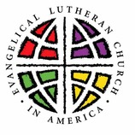

**Installation of Rev. Julie Schneider-Thomas as Mitten Synod Bishop**

The Rev. Julie Schneider-Thomas will be installed as bishop of the North/West Lower Michigan Synod on Saturday 13, 2025 at 4:00pm at Trinity Lutheran Church in Grand Rapids (2700 Fulton Street East).

**Lutheran Study Bible Second Edition**

An updated and revised ELCA Study Bible has been released by Augsburg Press. This Bible features the NRSVue translation and introductions, notes, and articles written by more than seventy Lutheran pastors and teaching theologians. It includes solid background material, unique Lutheran insights, and questions for reflection and discussion. The *Lutheran Study Bible* contains 10-point biblical text and 7-point study notes. The Bible cost $32.99. If you would like to order a copy, please sign up on the sheet in the narthex. You can pay for your Bible by adding this to your offering or giving payment to Karen or Martha. We will also be ordering some for use at the church. With an order of 10, there is no shipping cost. We would like to order these in early September.

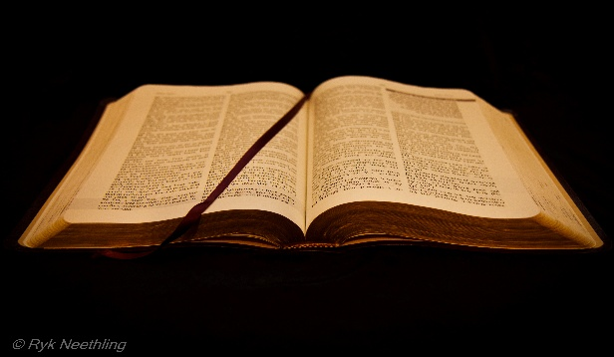

**LWR Care Kits**

This year Zion will be donating Personal Care Kits and Baby Care Kits to Lutheran World Relief. Carol Engle coordinates the Personal Care Kits and the Board of Evangelism will be coordinating the Baby Care Kits. Watch for more information and a display table in the Fellowship Hall.

**Volunteers**

**Cleaning Committee**

Martha Yoder

Cheyenne Wallace

Ruth and Jimmy Hindman

**Coffee Fellowship**

Volunteers

**SPECIALS**

**SUNDAYS IN AUGUST**

**September 7 – Service of the Word**

Worship Leader Doug Mackenzie

Acolyte:

Elder: Naomi Wilson

Trustee: Tom Krikke

Offering Counters: Diane Griffin and Carlotta Willard

Musician: Martha Yoder

**September 14 - Communion**

Pastor Mike Anderson

Acolyte: Kole Hokanson

Elder: Dan Utterback

Trustee: Mike Johnson

Offering Counters: Paul Meade and Carlotta Willard

Musician: Martha Yoder

**September 21 - Communion**

Pastor Ken Scheck

Acolyte:

Elder: Buffy Meyers

Trustee: Doug Mackenzie

Offering Counters: Doug Mackenzie and Mike Johnson

Musician: Jayne Flanigan

**September 28 -**

Acolyte:

Elder: Naomi Wilson

Trustee: Tom Krikke

Offering Counters: Mary Makley and Martha Yoder

Musician: Jayne Flanigan