ZION LUTHERAN CHURCH, WOODLAND, MI
Fourteenth Sunday After Pentecost September 14, 2025
*If you are listening in your car, please tune your radio to FM 87.7*
(Please silence your cell phones while in the sanctuary. Thank you.)


WELCOME AND ANNOUNCEMENTS

Gathering
The Holy Spirit calls us together as the people of God.

Confession and Forgiveness
In the name of the Father,
and of the ☩ Son,
and of the Holy Spirit.
Amen.

Almighty God, to whom all hearts are open, all desires known, and from whom no secrets are hid: cleanse the thoughts of our hearts by the inspiration of your Holy Spirit, that we may perfectly love you and worthily magnify your holy name, through Jesus Christ our Lord.
Amen.

Let us confess our sin in the presence of God and of one another. Most merciful God,
we confess that we are captive to sin and cannot free ourselves. We have sinned against you in thought, word, and deed, by what we have done and by what we have left undone. We have not loved you with our whole heart; we have not loved our neighbors as ourselves. For the sake of your Son, Jesus Christ, have mercy on us. Forgive us, renew us, and lead us, so that we may delight in your will and walk in your ways, to the glory of your holy name.
Amen.

God, who is rich in mercy, loved us even when we were dead in sin, and made us alive together with Christ. By grace you have been saved. In the name of ☩ Jesus Christ, your sins are forgiven. Almighty God strengthen you with power through the Holy Spirit, that Christ may live in your hearts through faith.
Amen.

Gathering Song “Lord, I Lift Your Name on High” #875

GREETING
The grace of our Lord Jesus Christ, the love of God, and the communion of the Holy Spirit be with you all.
And also with you.

Prayer of the Day
Let us pray together.
O God, overflowing with mercy and compassion, you lead back to yourself all those who go astray. Preserve your people in your loving care, that we may reject whatever is contrary to you and may follow all things that sustain our life in your Son, Jesus Christ, our Savior and Lord.
Amen.

First Reading Exodus 32:7-14
A reading from Exodus.
⁷ The Lord said to Moses, “Go down at once! Your people, whom you brought up out of the land of Egypt, have acted perversely; ⁸ they have been quick to turn aside from the way that I commanded them; they have cast for themselves an image of a calf and have worshiped it and sacrificed to it and said, ‘These are your gods, O Israel, who brought you up out of the land of Egypt!’ ” ⁹ The Lord said to Moses, “I have seen this people, how stiff-necked they are. ¹⁰ Now let me alone so that my wrath may burn hot against them and I may consume them, and of you I will make a great nation.”
¹¹ But Moses implored the Lord his God and said, “O Lord, why does your wrath burn hot against your people, whom you brought out of the land of Egypt with great power and with a mighty hand? ¹² Why should the Egyptians say, ‘It was with evil intent that he brought them out to kill them in the mountains and to consume them from the face of the earth’? Turn from your fierce wrath; change your mind and do not bring disaster on your people. ¹³ Remember Abraham, Isaac, and Israel, your servants, how you swore to them by your own self, saying to them, ‘I will multiply your descendants like the stars of heaven, and all this land that I have promised I will give to your descendants, and they shall inherit it forever.’ ” ¹⁴ And the Lord changed his mind about the disaster that he planned to bring on his people.

Thanks be to God.

Psalm Psalm 103:1-8
¹ Have mercy on me, O God, according to your | steadfast love;
in your great compassion blot out | my offenses.
² Wash me through and through | from my wickedness,
and cleanse me | from my sin.
³ For I know | my offenses,
and my sin is ev- | er before me.
⁴ Against you only have I sinned and done what is evil | in your sight;
so you are justified when you speak and right | in your judgment.
⁵ Indeed, I was born | steeped in wickedness,
a sinner from my | mother’s womb.
⁶ Indeed, you delight in truth | deep within me,
and would have me know wisdom | deep within.
⁷ Remove my sins with hyssop, and I | shall be clean;
wash me, and I shall be pur- | er than snow.
⁸ Let me hear | joy and gladness;
that the body you have broken | may rejoice.
⁹ Hide your face | from my sins,
and blot out | all my wickedness.
¹⁰ Create in me a clean | heart, O God,
and renew a right spir- | it within me.

Second Reading 1 Timothy 1:12-17
A reading from Timothy.
¹² I am grateful to Christ Jesus our Lord, who has strengthened me, because he considered me faithful and appointed me to his service, ¹³ even though I was formerly a blasphemer, a persecutor, and a man of violence. But I received mercy because I had acted ignorantly in unbelief, ¹⁴ and the grace of our Lord overflowed for me with the faith and love that are in Christ Jesus. ¹⁵ The saying is sure and worthy of full acceptance: that Christ Jesus came into the world to save sinners—of whom I am the foremost. ¹⁶ But for that very reason I received mercy, so that in me, as the foremost, Jesus Christ might display the utmost patience as an example to those who would come to believe in him for eternal life. ¹⁷ To the King of the ages, immortal, invisible, the only God, be honor and glory forever and ever. Amen.

The Word of the Lord
Thanks be to God.

Gospel Acclamation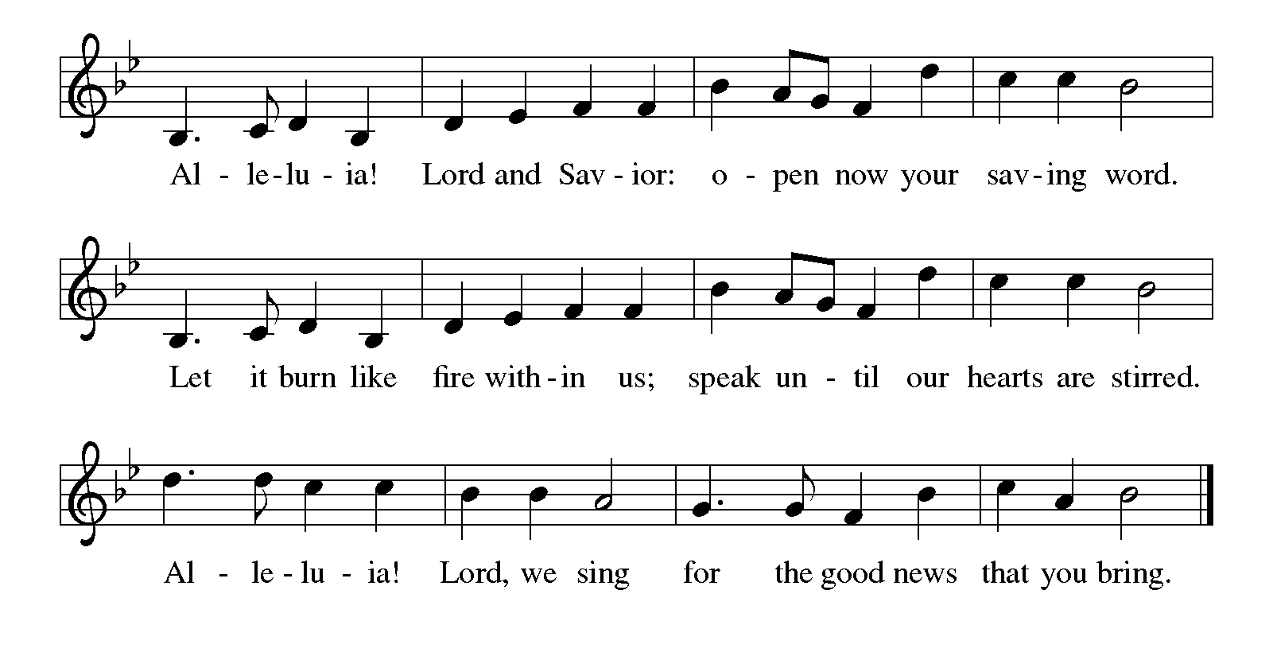

Gospel Luke 15:1-10
The holy gospel according to Luke.
¹ Now all the tax collectors and sinners were coming near to listen to [Jesus.] ² And the Pharisees and the scribes were grumbling and saying, “This fellow welcomes sinners and eats with them.”
³ So he told them this parable: ⁴ “Which one of you, having a hundred sheep and losing one of them, does not leave the ninety-nine in the wilderness and go after the one that is lost until he finds it? ⁵ And when he has found it, he lays it on his shoulders and rejoices. ⁶ And when he comes home, he calls together his friends and neighbors, saying to them, ‘Rejoice with me, for I have found my lost sheep.’ ⁷ Just so, I tell you, there will be more joy in heaven over one sinner who repents than over ninety-nine righteous persons who need no repentance.
⁸ “Or what woman having ten silver coins, if she loses one of them, does not light a lamp, sweep the house, and search carefully until she finds it? ⁹ And when she has found it, she calls together her friends and neighbors, saying, ‘Rejoice with me, for I have found the coin that I had lost.’ ¹⁰ Just so, I tell you, there is joy in the presence of the angels of God over one sinner who repents.”

The gospel of the Lord.
Praise to you, O Christ.

CHILDREN’S MOMENT

SERMON Pastor Mike Anderson

hymn of the day “Amazing Grace, How Sweet The Sound” #779

cREED
I believe in God, the Father almighty,
creator of heaven and earth.
I believe in Jesus Christ, God’s only Son, our Lord,
who was conceived by the Holy Spirit,
born of the virgin Mary,
suffered under Pontius Pilate,
was crucified, died, and was buried;
he descended to the dead.*
On the third day he rose again;
he ascended into heaven,
he is seated at the right hand of the Father,
and he will come to judge the living and the dead.
I believe in the Holy Spirit,
the holy catholic church,
the communion of saints,
the forgiveness of sins,
the resurrection of the body,
and the life everlasting. Amen.

*Or, “he descended into hell,” another translation of this text in widespread use.

prayers of Intercession
Gracious God, we come to you in prayer for the church, the world, and all in need.
A brief silence.
Merciful God, pour out your grace upon your church. Forgive us for the times when we have been unfaithful, and renew our commitment to your gospel of love. Empower us to live as a community of mercy. We pray especially for Lutheran Church of the Savior in Kalamazoo, and their pastor Rev. Alexander Steward. God of grace,
receive our prayer.
Merciful God, we ask forgiveness for the ways we have neglected and harmed this earth and its creatures. Confirm our commitment to care for all you have made, and grant us wisdom and strength to take action toward restoring your creation to its fullness. God of grace,
receive our prayer.
Merciful God, govern all who hold positions of power and authority. Instruct them to make just decisions that serve the common good. Make them instruments of your mercy in the world, working to heal divisions and promote peace. God of grace,
receive our prayer.
Merciful God, we lift up all who suffer. Bring healing, comfort, and peace to those who are sick, grieving, or in pain. May they find healing through your love and the care of those around them. Give us compassionate hearts to accompany those who are hurting and courage to work for justice and mercy. God of grace,
receive our prayer.
Merciful God, bind us together as a community of forgiveness and love. Supply us with humility to seek forgiveness when we have wronged one another and generosity to extend mercy when we have been wronged. God of grace,
receive our prayer.
Merciful God, we remember in love those who have departed this life. Console those who mourn, and give them the hope of resurrection. God of grace,
receive our prayer.
We entrust these prayers to you, O God, in the name of Jesus Christ, our redeemer and friend.
Amen.

PEACE
The peace of Christ be with you always.
And also with you.

OFFERING & OFFERING SONG
The joy of the Lord is my strength,
The joy of the Lord is my strength,
The joy of the Lord is my strength,
The joy of the Lord is my strength.

Offering Prayer
Let us pray.
God of all creation, all you have made is good, and your love endures forever. You bring forth bread from the earth and fruit from the vine. Nourish us with these gifts, that we might be for the world signs of your gracious presence in Jesus Christ, our Savior and Lord.
Amen.

DIALOGUE
The Lord be with you.
And also with you.
Lift up your hearts.
We lift them to the Lord.
Let us give thanks to the Lord our God.
It is right to give our thanks and praise.

PREFACE (Pastor)
It is indeed right, our duty and our joy,
that we should at all times and in all places
give thanks and praise to you, almighty and merciful God,
through our Savior Jesus Christ;
who on this day overcame death and the grave,
and by his glorious resurrection opened to us the way of everlasting life.
And so, with all the choirs of angels,
with the church on earth and the hosts of heaven,
we praise your name and join their unending hymn

holy, holy, holy
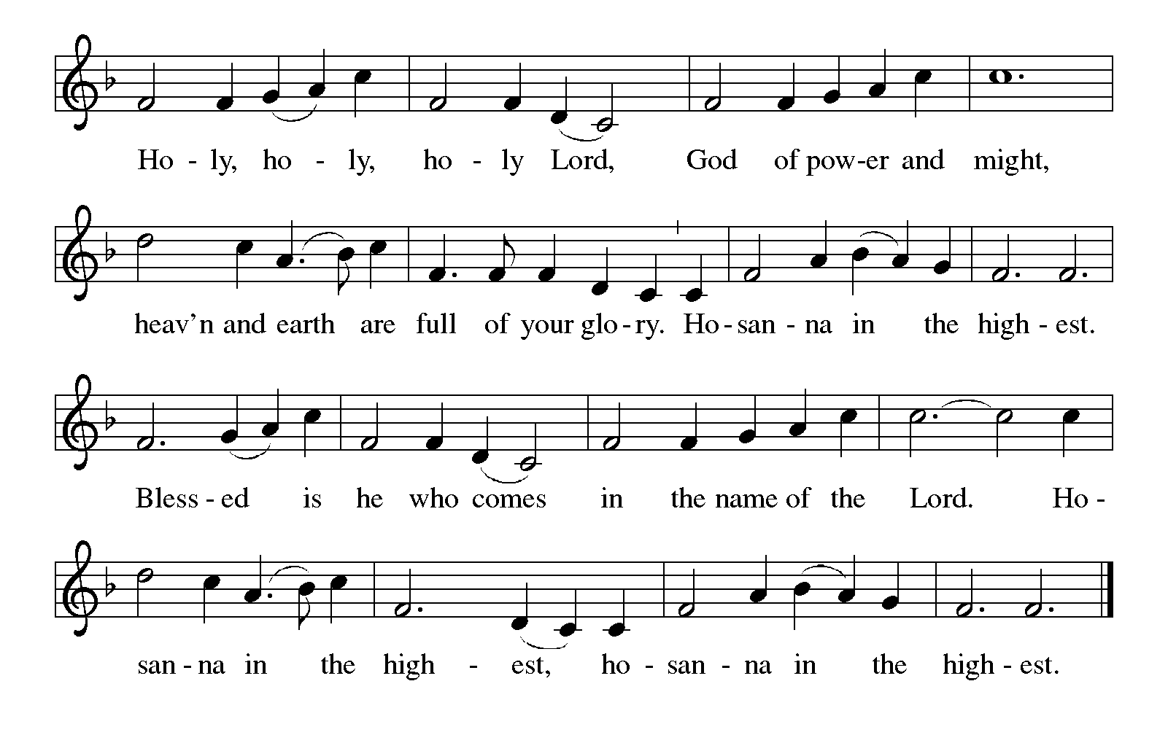

Thanksgiving at the Table
In the night in which he was betrayed,
our Lord Jesus took bread, and gave thanks;
broke it, and gave it to his disciples, saying:
Take and eat; this is my body, given for you.
Do this for the remembrance of me.

Again, after supper, he took the cup, gave thanks,
and gave it for all to drink, saying:
This cup is the new covenant in my blood,
shed for you and for all people for the forgiveness of sin.
Do this for the remembrance of me.

For as often as we eat of this bread and drink from this cup,
we proclaim the Lord’s death until he comes.

Lord’s Prayer
Gathered into one by the Holy Spirit, let us pray as Jesus taught us.
Our Father, who art in heaven,
hallowed be thy name,
thy kingdom come,
thy will be done,
on earth as it is in heaven.
Give us this day our daily bread;
and forgive us our trespasses,
as we forgive those
who trespass against us;
and lead us not into temptation,
but deliver us from evil.
For thine is the kingdom,
and the power, and the glory,
forever and ever. Amen.

INVITATION TO COMMUNION
Come to the banquet, for all is now ready.

COMMUNION *continuous
*People are welcome to kneel at the altar rail for a time of prayer after they receive their communion elements.

COMMUNION HYMNS

“Jesus, Keep Me Near the Cross” #335

“In the Singing” #466

PRAYER AFTER COMMUNION
Let us pray.
We give you thanks, almighty God, that you have refreshed us through the healing power of this gift of life. In your mercy, strengthen us through this gift, in faith toward you and in fervent love toward one another; for the sake of Jesus Christ our Lord.
Amen.

Sending
God blesses us and sends us in mission to the world.
Blessing
The Lord bless you and keep you.
The Lord’s face shine on you with grace and mercy.
The Lord look upon you with favor and ☩ give you peace.
Amen.

Sending SonG “When I Survey the Wondrous Cross” 803

Dismissal
Go in peace. Christ is with you.
Thanks be to God.

From sundaysandseasons.com. Copyright © 2017 Augsburg Fortress. All rights reserved.

Thank you to all who served in worship today!
Presiders: Pastor Mike Anderson Musician: Martha Yoder
Acolyte: Kole Hokanson Safety Person:
Elder: Dan Utterback Trustee: Mike Johnson
Offering Counters: Paul Meade & Carlotta Willard



PRAYERS OF THE FAITHFUL

With thanks for all God’s blessings and his love for all people. Our Bishops, Craig Satterlee Elizabeth Eaton, and the congregations of the North/West Lower Michigan
Synod, and especially for Lutheran Church of the Savior in Kalamazoo, and their pastor Rev. Alexander Steward.

Prayers for our friends, for all who are sick or hospitalized and for all health care workers who care for them. All those members of Zion’s family traveling; all those homebound or in frail health; all those suffering with quiet, unknown needs or worries. For those who serve on our behalf: public safety, utility workers, medical personnel, military personnel. For those who might be forgotten.

This week at Zion:
- The Disciples Small Group, Martha’s, 2 pm, Tuesday, September 16.
- Men’s Coffee, 8 AM, Wednesday, September 17
- Bulletin Deadline, Wednesday, September 17

ONLINE GIVING
Zion has received a QR code to facilitate online giving. If you are interested in donating online instead of bringing your donation to church, simply scan the QR code and it will direct you to the appropriate site. The code is on our website as well.

ANNOUNCEMENT
- Special Congregational Meeting: There will be a special congregational meeting on September 28 to vote on the purchase of screens for the sanctuary. Please mark your calendar and plan to attend.
- Zion has received funds from Thrivent Financial to make Lutheran World Relief kits. Jerry Engle was granted $250.00 to help purchase supplies for the Baby Care Kits. The Board of Evangelism is working on that project. See their information on what you donate.
Carol Engle also applied and was approved for a grant of $250.00 for Personal Care Kits. She also received $64.00 from Thrivent's Choice Dollars program. She has purchased items needed to assemble the kits. We will have an Action Team event on Sunday, September 28th in the Fellowship Hall following worship. We will be assembling some of the personal care kits. Carol has purchased the supplies needed for this project. Her goal is 70 kits. We do need yarn to tie the kits, so if there and any knitters that have extra yarn, that would be helpful. If you wish to donate to this project, you may donate funds for a kit, which costs about $8.00 each or help with the shipping expenses. It costs $1.50 per kit to have them shipped. You may mark your offering envelopes with the amount you wish to contribute. We will have the Baby Care and the Personal Care Kits displayed in the Sanctuary on Sunday, October 5th. They will then be packed and taken to St. Matthew's Church in Grand Rapids on October 18th.They will be taken by semi-truck to a warehouse in Maryland. We will need about 15 medium-sized cardboard boxes to ship the completed kits.
- Thrivent Financial has donated many Live Generous T-shirts. They are displayed in the Fellowship Hall. Please take all you want. There is a variety of sizes and colors.
- Are You Interested in Ordering a Lutheran Study Bible, Second Edition: An updated and revised ELCA Study Bible has been released by Augsburg press. This Bible features the NRSVue translation and introductions, notes, and articles written by more than seventy Lutheran pastors and teaching theologians. It includes solid background material, unique Lutheran insights, and questions for reflection and discussion. The Lutheran Study Bible contains 10-point biblical text and 7-point study notes. The Bibles cost $32.99. If you would like to order a copy, please sign up on the sheet in the narthex. You can pay for your Bible by adding this to your offering or giving payment to Karen or Martha. We will also be ordering some for use at the church. With an order of 10, there is no shipping cost. We would like to order these in early September.
- Announcement and Newsletter Items: Please forward items for the bulletin announcements and the newsletter to the church email (Office@Zion.org). Please do not send items to people’s personal emails. Thank you.
- Door Locking Policy: Our door locking policy relies on having a volunteer(s) each Sunday to serve as the Safety Person of the Day. On Sundays where no one has volunteered, if someone arrives at church and is willing to be the Safety Person of the Day, we will follow the door locking policy. If no one steps forward to serve as the Safety Person of the Day, the doors will not be locked. Please consider volunteering for this important duty.

