ZION LUTHERAN CHURCH, WOODLAND, MI
Fifteenth Sunday After Pentecost September 21, 2025
*If you are listening in your car, please tune your radio to FM 87.7*
(Please silence your cell phones while in the sanctuary. Thank you.)


WELCOME AND ANNOUNCEMENTS

Gathering
The Holy Spirit calls us together as the people of God.

Confession and Forgiveness
In the name of the Father,
and of the ☩ Son,
and of the Holy Spirit.
Amen.

Almighty God, to whom all hearts are open, all desires known, and from whom no secrets are hid: cleanse the thoughts of our hearts by the inspiration of your Holy Spirit, that we may perfectly love you and worthily magnify your holy name, through Jesus Christ our Lord.
Amen.

Let us confess our sin in the presence of God and of one another. Most merciful God,
we confess that we are captive to sin and cannot free ourselves. We have sinned against you in thought, word, and deed, by what we have done and by what we have left undone. We have not loved you with our whole heart; we have not loved our neighbors as ourselves. For the sake of your Son, Jesus Christ, have mercy on us. Forgive us, renew us, and lead us, so that we may delight in your will and walk in your ways, to the glory of your holy name.
Amen.

God, who is rich in mercy, loved us even when we were dead in sin, and made us alive together with Christ. By grace you have been saved. In the name of ☩ Jesus Christ, your sins are forgiven. Almighty God strengthen you with power through the Holy Spirit, that Christ may live in your hearts through faith.
Amen.

Gathering Song “We Give Thee but Thine Own” #686

GREETING
The grace of our Lord Jesus Christ, the love of God, and the communion of the Holy Spirit be with you all.
And also with you.

Prayer of the Day
Let us pray together.
God among us, we gather in the name of your Son to learn love for one another. Keep our feet from evil paths. Turn our minds to your wisdom and our hearts to the grace revealed in your Son, Jesus Christ, our Savior and Lord.
Amen.

First Reading Amos 8:4-7
A reading from Amos.
⁴ Hear this, you who trample on the needy,
and bring to ruin the poor of the land,
⁵ saying, “When will the new moon be over
so that we may sell grain,
and the Sabbath,
so that we may offer wheat for sale?
We will make the ephah smaller and the shekel heavier
and practice deceit with false balances,
⁶ buying the poor for silver
and the needy for a pair of sandals
and selling the sweepings of the wheat.”
⁷ The Lord has sworn by the pride of Jacob:
Surely I will never forget any of their deeds.

The word of the Lord
Thanks be to God.

Psalm Psalm 113

¹ Hallelujah! Give praise, you servants | of the Lord;
praise the name | of the Lord.
² Let the name of the | Lord be blessed,
from this time forth for- | evermore.
³ From the rising of the sun to its | going down
let the name of the | Lord be praised.
⁴ The Lord is high a- | bove all nations;
God’s glory a- | bove the heavens.
⁵ Who is like the | Lord our God,
who sits en- | throned on high,
⁶ but stoops | to behold
the heavens | and the earth?
⁷ The Lord takes up the weak out | of the dust
and lifts up the poor | from the ashes,
⁸ enthroning them | with the rulers,
with the rulers | of the people.
⁹ The Lord makes the woman of a | childless house
to be a joyful mother of children. | Hallelujah!

Second Reading 1 Timothy 1:12-17
A reading from 1 Timothy.
¹ First of all, then, I urge that supplications, prayers, intercessions, and thanksgivings be made for everyone, ² for kings and all who are in high positions, so that we may lead a quiet and peaceable life in all godliness and dignity. ³ This is right and acceptable before God our Savior, ⁴ who desires everyone to be saved and to come to the knowledge of the truth. ⁵ For
there is one God;
there is also one mediator between God and humankind,
Christ Jesus, himself human,
⁶ who gave himself a ransom for all
—this was attested at the right time.⁷ For this I was appointed a herald and an apostle (I am telling the truth; I am not lying), a teacher of the gentiles in faith and truth.

The Word of the Lord
Thanks be to God.

Gospel Acclamation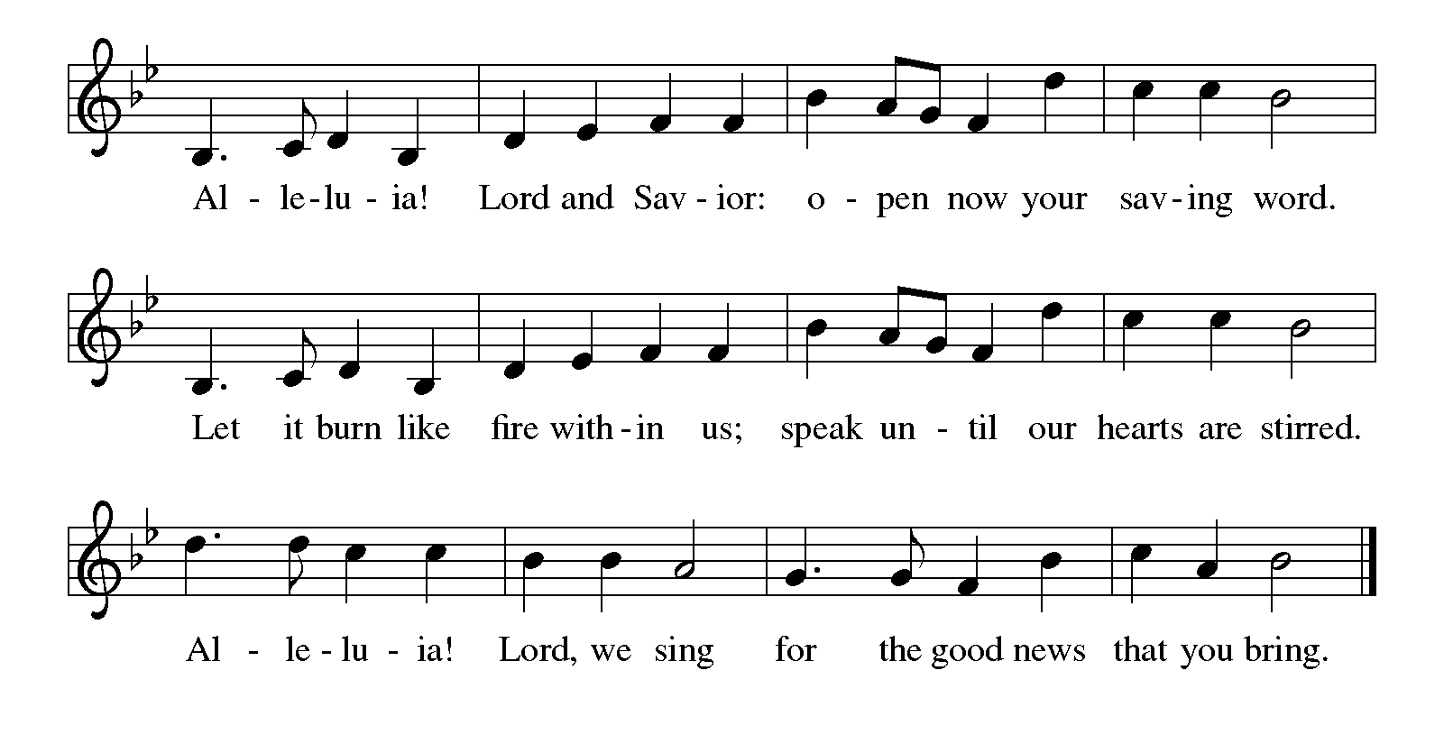

Gospel Luke 16:1-13
The holy gospel according to Luke.
¹ Then Jesus said to the disciples, “There was a rich man who had a manager, and charges were brought to him that this man was squandering his property. ² So he summoned him and said to him, ‘What is this that I hear about you? Give me an accounting of your management because you cannot be my manager any longer.’ ³ Then the manager said to himself, ‘What will I do, now that my master is taking the position away from me? I am not strong enough to dig, and I am ashamed to beg. ⁴ I have decided what to do so that, when I am dismissed as manager, people may welcome me into their homes.’ ⁵ So, summoning his master’s debtors one by one, he asked the first, ‘How much do you owe my master?’ ⁶ He answered, ‘A hundred jugs of olive oil.’ He said to him, ‘Take your bill, sit down quickly, and make it fifty.’ ⁷ Then he asked another, ‘And how much do you owe?’ He replied, ‘A hundred containers of wheat.’ He said to him, ‘Take your bill and make it eighty.’ ⁸ And his master commended the dishonest manager because he had acted shrewdly, for the children of this age are more shrewd in dealing with their own generation than are the children of light. ⁹ And I tell you, make friends for yourselves by means of dishonest wealth so that when it is gone they may welcome you into the eternal homes.
¹⁰ “Whoever is faithful in a very little is faithful also in much, and whoever is dishonest in a very little is dishonest also in much. ¹¹ If, then, you have not been faithful with the dishonest wealth, who will entrust to you the true riches? ¹² And if you have not been faithful with what belongs to another, who will give you what is your own? ¹³ No slave can serve two masters, for a slave will either hate the one and love the other or be devoted to the one and despise the other. You cannot serve God and wealth.”

The gospel of the Lord.
Praise to you, O Christ.
CHILDREN’S MOMENT

SERMON Pastor Ken Scheck

hymn of the day “As Saints Of Old” #695

cREED
I believe in God, the Father almighty,
creator of heaven and earth.
I believe in Jesus Christ, God’s only Son, our Lord,
who was conceived by the Holy Spirit,
born of the virgin Mary,
suffered under Pontius Pilate,
was crucified, died, and was buried;
he descended to the dead.*
On the third day he rose again;
he ascended into heaven,
he is seated at the right hand of the Father,
and he will come to judge the living and the dead.
I believe in the Holy Spirit,
the holy catholic church,
the communion of saints,
the forgiveness of sins,
the resurrection of the body,
and the life everlasting. Amen.

*Or, “he descended into hell,” another translation of this text in widespread use.

prayers of Intercession
Gracious God, we come to you in prayer for the church, the world, and all in need.
A brief silence.
O God, teach your church to act in solidarity with the poor, frustrating the efforts of those who trample on the needy and practicing justice in our own life and community. We especially for Trinity Lutheran in Kalamazoo, and their pastor Rev. Ken Johnson. God of grace,
receive our prayer.
Almighty Creator, we pray for an end to the misuse of the earth and its resources, that all people may benefit from your abundant gifts and that our stewardship of creation would be marked by justice and sustainability. God of grace,
receive our prayer.
Holy One, embolden elected leaders to pursue policies of economic justice for the benefit of all, especially those who are most vulnerable and marginalized. Persuade them by your example of generosity and compassion. God of grace,
receive our prayer.
Compassionate God, we pray for all facing illness, those near death, or those grieving the loss of loved ones. May they find comfort and strength in your love. Prepare us to surround them with your healing care. God of grace,
receive our prayer.
God of love, motivate our congregation to enact economic justice through tangible action, prioritizing the needs of our community and sharing resources generously through our outreach and justice ministries. God of grace,
receive our prayer.
Gracious God, we give thanks for the saints who now join the heavenly chorus in praising your name. Lift us up from the dust of grief and remind us of your promise of new life. God of grace,
receive our prayer.
We entrust these prayers to you, O God, in the name of Jesus Christ, our redeemer and friend.
Amen.

PEACE
The peace of Christ be with you always.
And also with you.

OFFERING & OFFERING SONG
The joy of the Lord is my strength,
The joy of the Lord is my strength,
The joy of the Lord is my strength,
The joy of the Lord is my strength.

Offering Prayer
Let us pray.
God of all creation, all you have made is good, and your love endures forever. You bring forth bread from the earth and fruit from the vine. Nourish us with these gifts, that we might be for the world signs of your gracious presence in Jesus Christ, our Savior and Lord.
Amen.

DIALOGUE
The Lord be with you.
And also with you.
Lift up your hearts.
We lift them to the Lord.
Let us give thanks to the Lord our God.
It is right to give our thanks and praise.

PREFACE (Pastor)
It is indeed right, our duty and our joy,
that we should at all times and in all places
give thanks and praise to you, almighty and merciful God,
through our Savior Jesus Christ;
who on this day overcame death and the grave,
and by his glorious resurrection opened to us the way of everlasting life.
And so, with all the choirs of angels,
with the church on earth and the hosts of heaven,
we praise your name and join their unending hymn

holy, holy, holy
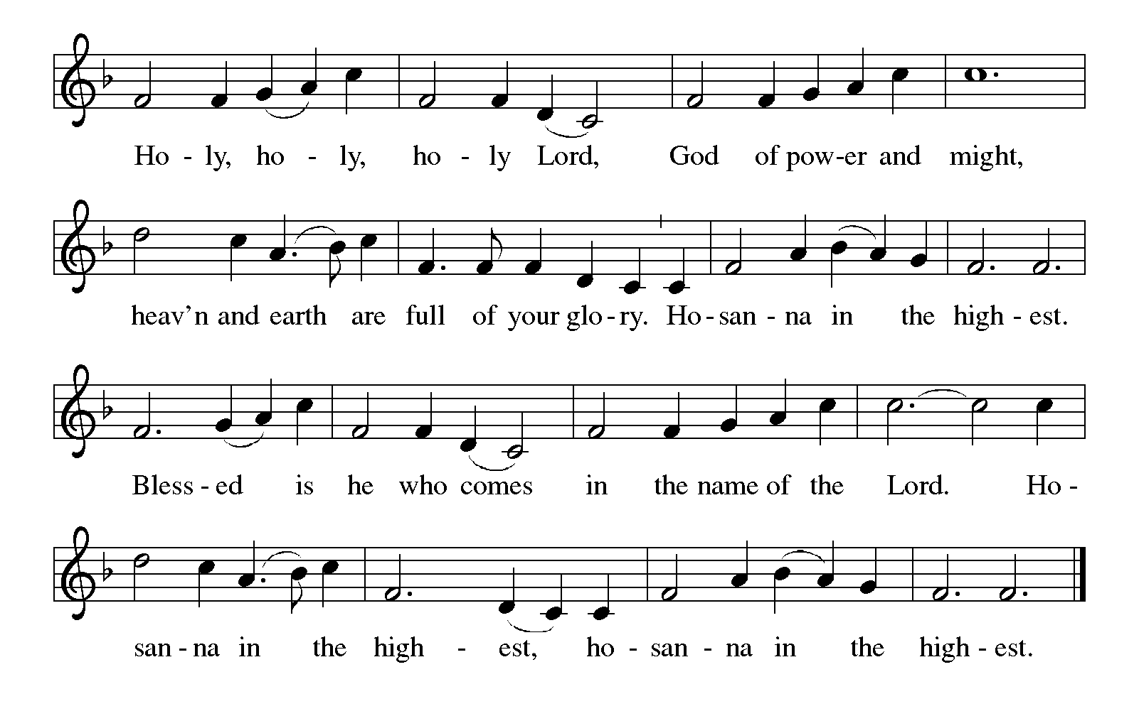

Thanksgiving at the Table
In the night in which he was betrayed,
our Lord Jesus took bread, and gave thanks;
broke it, and gave it to his disciples, saying:
Take and eat; this is my body, given for you.
Do this for the remembrance of me.

Again, after supper, he took the cup, gave thanks,
and gave it for all to drink, saying:
This cup is the new covenant in my blood,
shed for you and for all people for the forgiveness of sin.
Do this for the remembrance of me.

For as often as we eat of this bread and drink from this cup,
we proclaim the Lord’s death until he comes.

Lord’s Prayer
Gathered into one by the Holy Spirit, let us pray as Jesus taught us.
Our Father, who art in heaven,
hallowed be thy name,
thy kingdom come,
thy will be done,
on earth as it is in heaven.
Give us this day our daily bread;
and forgive us our trespasses,
as we forgive those
who trespass against us;
and lead us not into temptation,
but deliver us from evil.
For thine is the kingdom,
and the power, and the glory,
forever and ever. Amen.

INVITATION TO COMMUNION
Come to the banquet, for all is now ready.

COMMUNION *continuous
*People are welcome to kneel at the altar rail for a time of prayer after they receive their communion elements.

COMMUNION HYMNS

“We Are an Offering” #692

“Be Thou My Vision” #793

PRAYER AFTER COMMUNION
Let us pray.
We give you thanks, almighty God, that you have refreshed us through the healing power of this gift of life. In your mercy, strengthen us through this gift, in faith toward you and in fervent love toward one another; for the sake of Jesus Christ our Lord.
Amen.

Sending
God blesses us and sends us in mission to the world.
Blessing
The Lord bless you and keep you.
The Lord’s face shine on you with grace and mercy.
The Lord look upon you with favor and ☩ give you peace.
Amen.

Sending SonG “Let Justice Flow like Streams” #717

Dismissal
Go in peace. Christ is with you.
Thanks be to God.

From sundaysandseasons.com. Copyright © 2017 Augsburg Fortress. All rights reserved.

Thank you to all who served in worship today!
Presiders: Pastor Ken Scheck Musician: Jayne Flanigan
Acolyte: Safety Person:
Elder: Buffy Meyers Trustee: Doug MacKenzie
Offering Counters: Doug MacKenzie & Mike Johnson



PRAYERS OF THE FAITHFUL

With thanks for all God’s blessings and his love for all people. Our Bishops, Craig Satterlee Elizabeth Eaton, and the congregations of the North/West Lower Michigan
Synod, and especially for Trinity Lutheran in Kalamazoo, and their pastor Rev. Ken Johnson.

Prayers for our friends, for all who are sick or hospitalized and for all health care workers who care for them. All those members of Zion’s family traveling; all those homebound or in frail health; all those suffering with quiet, unknown needs or worries. For those who serve on our behalf: public safety, utility workers, medical personnel, military personnel. For those who might be forgotten.

This week at Zion:
- Men’s Coffee, 8 AM, Wednesday, September 24
- Bulletin Deadline, Wednesday, September 24

ONLINE GIVING
Zion has received a QR code to facilitate online giving. If you are interested in donating online instead of bringing your donation to church, simply scan the QR code and it will direct you to the appropriate site. The code is on our website as well.

ANNOUNCEMENT
- Thrivent Action Team Project: Zion will have the Thrivent Action Team Project next Sunday, September 28th, following our potluck lunch. We will be assembling some of the Personal Care Kits. Thrivent Financial has given Zion a grant of $250.00 plus $64.00 from their Choice Dollars program to purchase items needed to assemble the kits. We have also received donations from members of our congregation. Our goal now is 80 kits. On Sunday, October 5th, all the Baby Care and Personal Care Kits will be displayed in the Sanctuary. The following week, they will be boxed and on October 18th, taken to a semi-truck at St. Matthew's Church in Grand Rapids. The truck will take them to a warehouse in Maryland and then they will be sent overseas where needed most. We also have a variety of free Give Generously T-shirts. Please take as many as you would like and you may take shirts for friends also. Zion is blessed to be able to provide these kits to others in need.
- Special Congregational Meeting: There will be a special congregational meeting on September 28 to vote on the purchase of screens for the sanctuary. Please mark your calendar and plan to attend.
- Zion has received funds from Thrivent Financial to make Lutheran World Relief kits. Jerry Engle was granted $250.00 to help purchase supplies for the Baby Care Kits. The Board of Evangelism is working on that project. See their information on what you donate. Carol Engle also applied and was approved for a grant of $250.00 for Personal Care Kits. She also received $64.00 from Thrivent's Choice Dollars program. She has purchased items needed to assemble the kits. We will have an Action Team event on Sunday, September 28th in the Fellowship Hall following worship. We will be assembling some of the personal care kits. Carol has purchased the supplies needed for this project. Her goal is 70 kits. We do need yarn to tie the kits, so if there and any knitters that have extra yarn, that would be helpful. If you wish to donate to this project, you may donate funds for a kit, which costs about $8.00 each or help with the shipping expenses. It costs $1.50 per kit to have them shipped. You may mark your offering envelopes with the amount you wish to contribute. We will have the Baby Care and the Personal Care Kits displayed in the Sanctuary on Sunday, October 5th. They will then be packed and taken to St. Matthew's Church in Grand Rapids on October 18th.They will be taken by semi-truck to a warehouse in Maryland. We will need about 15 medium-sized cardboard boxes to ship the completed kits.
- Announcement and Newsletter Items: Please forward items for the bulletin announcements and the newsletter to the church email (Office@Zion.org). Please do not send items to people’s personal emails. Thank you.
- Door Locking Policy: Our door locking policy relies on having a volunteer(s) each Sunday to serve as the Safety Person of the Day. On Sundays where no one has volunteered, if someone arrives at church and is willing to be the Safety Person of the Day, we will follow the door locking policy. If no one steps forward to serve as the Safety Person of the Day, the doors will not be locked. Please consider volunteering for this important duty.

