ZION LUTHERAN CHURCH, WOODLAND, MI
Sixteenth Sunday After Pentecost September 28, 2025
*If you are listening in your car, please tune your radio to FM 87.7*
(Please silence your cell phones while in the sanctuary. Thank you.)


WELCOME AND ANNOUNCEMENTS

Gathering
The Holy Spirit calls us together as the people of God.

Confession and Forgiveness
In the name of the Father,
and of the ☩ Son,
and of the Holy Spirit.
Amen.

Almighty God, to whom all hearts are open, all desires known, and from whom no secrets are hid: cleanse the thoughts of our hearts by the inspiration of your Holy Spirit, that we may perfectly love you and worthily magnify your holy name, through Jesus Christ our Lord.
Amen.

Let us confess our sin in the presence of God and of one another. Most merciful God,
we confess that we are captive to sin and cannot free ourselves. We have sinned against you in thought, word, and deed, by what we have done and by what we have left undone. We have not loved you with our whole heart; we have not loved our neighbors as ourselves. For the sake of your Son, Jesus Christ, have mercy on us. Forgive us, renew us, and lead us, so that we may delight in your will and walk in your ways, to the glory of your holy name.
Amen.

God, who is rich in mercy, loved us even when we were dead in sin, and made us alive together with Christ. By grace you have been saved. In the name of ☩ Jesus Christ, your sins are forgiven. Almighty God strengthen you with power through the Holy Spirit, that Christ may live in your hearts through faith.
Amen.

Gathering Song “Gather Us In” #532

GREETING
The grace of our Lord Jesus Christ, the love of God, and the communion of the Holy Spirit be with you all.
And also with you.

Prayer of the Day
Let us pray together.
O God, rich in mercy, you look with compassion on this troubled world. Feed us with your grace, and grant us the treasure that comes only from you, through Jesus Christ, our Savior and Lord.
Amen.

First Reading Amos 6:1a, 4-7
A reading from Amos.

^{1a} Woe to those who are at ease in Zion
and for those who feel secure on Mount Samaria.
⁴ Woe to those who lie on beds of ivory
and lounge on their couches
and eat lambs from the flock
and calves from the stall,
⁵ who sing idle songs to the sound of the harp
and like David improvise on instruments of music,
⁶ who drink wine from bowls
and anoint themselves with the finest oils
but are not grieved over the ruin of Joseph!
⁷ Therefore they shall now be the first to go into exile,
and the revelry of the loungers shall pass away.
The word of the Lord.
Thanks be to God.

Psalm Psalm 146
¹ Hal- | lelujah!
Praise the Lord, | O my soul!
² I will praise the Lord as long | as I live;
I will sing praises to my God while I | have my being.
³ Put not your | trust in rulers,
in mortals in whom there | is no help.
⁴ When they breathe their last, they re- | turn to earth,
and in that day | their thoughts perish.
⁵ Happy are they who have the God of Jacob | for their help,
whose hope is in the | Lord their God;
⁶ who made heaven and earth, the seas, and all that | is in them;
who keeps promis- | es forever;
⁷ who gives justice to those who are oppressed, and food to | those who hunger.
The Lord sets the | captive free.
⁸ The Lord opens the eyes of the blind; the Lord lifts up those who | are bowed down;
the Lord | loves the righteous.
⁹ The Lord cares | for the stranger;
the Lord sustains the orphan and widow, but frustrates the way | of the wicked.
¹⁰ The Lord shall | reign forever,
your God, O Zion, throughout all generations. | Hallelujah!

Second Reading 1 Timothy 6:6-19
A reading from 1 Timothy.
⁶ Of course, there is great gain in godliness combined with contentment, ⁷ for we brought nothing into the world, so that we can take nothing out of it, ⁸ but if we have food and clothing, we will be content with these. ⁹ But those who want to be rich fall into temptation and are trapped by many senseless and harmful desires that plunge people into ruin and destruction. ¹⁰ For the love of money is a root of all kinds of evil, and in their eagerness to be rich some have wandered away from the faith and pierced themselves with many pains.
¹¹ But as for you, man of God, shun all this; pursue righteousness, godliness, faith, love, endurance, gentleness. ¹² Fight the good fight of the faith; take hold of the eternal life to which you were called and for which you made the good confession in the presence of many witnesses. ¹³ In the presence of God, who gives life to all things, and of Christ Jesus, who in his testimony before Pontius Pilate made the good confession, I charge you ¹⁴ to keep the commandment without spot or blame until the manifestation of our Lord Jesus Christ, ¹⁵ which he will bring about at the right time—he who is the blessed and only Sovereign, the King of kings and Lord of lords. ¹⁶ It is he alone who has immortality and dwells in unapproachable light, whom no one has ever seen or can see; to him be honor and eternal dominion. Amen.
¹⁷ As for those who in the present age are rich, command them not to be haughty or to set their hopes on the uncertainty of riches but rather on God, who richly provides us with everything for our enjoyment. ¹⁸ They are to do good, to be rich in good works, generous, and ready to share, ¹⁹ thus storing up for themselves the treasure of a good foundation for the future, so that they may take hold of the life that really is life.

The word of the Lord.
Thanks be to God.

Gospel Acclamation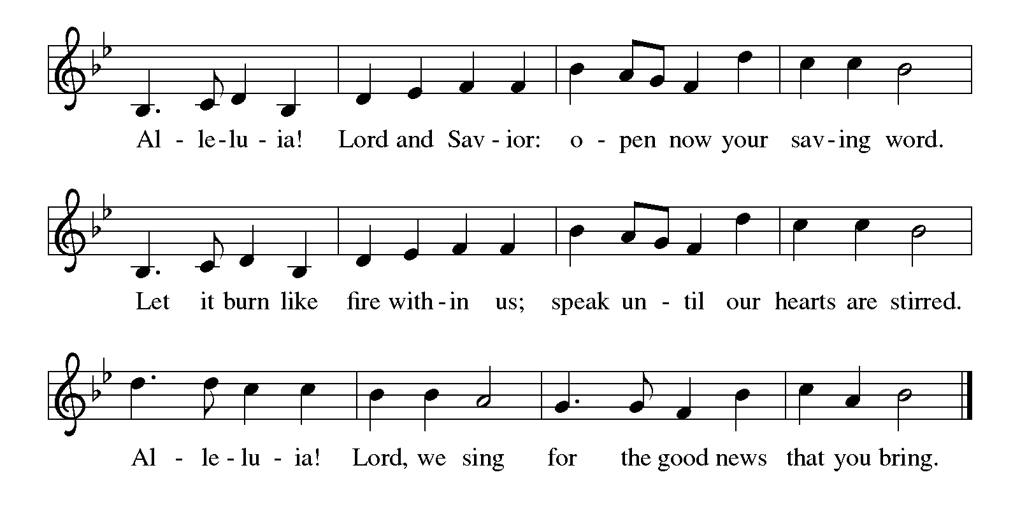

Gospel Luke 16:19-31
The holy gospel according to Luke.
Glory to you, O Lord
[Jesus said:] ¹⁹ “There was a rich man who was dressed in purple and fine linen and who feasted sumptuously every day. ²⁰ And at his gate lay a poor man named Lazarus, covered with sores, ²¹ who longed to satisfy his hunger with what fell from the rich man’s table; even the dogs would come and lick his sores. ²² The poor man died and was carried away by the angels to be with Abraham. The rich man also died and was buried. ²³ In Hades, where he was being tormented, he lifted up his eyes and saw Abraham far away with Lazarus by his side. ²⁴ He called out, ‘Father Abraham, have mercy on me, and send Lazarus to dip the tip of his finger in water and cool my tongue, for I am in agony in these flames.’ ²⁵ But Abraham said, ‘Child, remember that during your lifetime you received your good things and Lazarus in like manner evil things, but now he is comforted here, and you are in agony. ²⁶ Besides all this, between you and us a great chasm has been fixed, so that those who might want to pass from here to you cannot do so, and no one can cross from there to us.’ ²⁷ He said, ‘Then I beg you, father, to send him to my father’s house ²⁸ for I have five brothers—that he may warn them, so that they will not also come into this place of torment.’ ²⁹ Abraham replied, ‘They have Moses and the prophets; they should listen to them.’ ³⁰ He said, ‘No, father Abraham, but if someone from the dead goes to them, they will repent.’ ³¹ He said to him, ‘If they do not listen to Moses and the prophets, neither will they be convinced even if someone rises from the dead.’ ”

The gospel of the Lord.
Praise to you, O Christ.

CHILDREN’S MOMENT

SERMON Paul Meade

hymn of the day “The Church of Christ, in Every Age” #729

cREED

I believe in God, the Father almighty,
creator of heaven and earth.
I believe in Jesus Christ, God’s only Son, our Lord,
who was conceived by the Holy Spirit,
born of the virgin Mary,
suffered under Pontius Pilate,
was crucified, died, and was buried;
he descended to the dead.*
On the third day he rose again;
he ascended into heaven,
he is seated at the right hand of the Father,
and he will come to judge the living and the dead.
I believe in the Holy Spirit,
the holy catholic church,
the communion of saints,
the forgiveness of sins,
the resurrection of the body,
and the life everlasting. Amen.

*Or, “he descended into hell,” another translation of this text in widespread use.

prayers of Intercession
Gracious God, we come to you in prayer for the church, the world, and all in need.
A brief silence.
We pray for the church, that it would remain faithful to the gospel, always striving to serve the needs of those who are oppressed and rejecting the complacency that comes from wealth. We pray especially for Bethany Lutheran Church and their pastor Rev. Zac Nelson.
God of grace,
receive our prayer.
We pray for creation, that the nations work together to protect and restore the earth, preserving the beauty of the planet for future generations and honoring the gift of your creation. God of grace,
receive our prayer.
We pray for those in positions of authority, that they govern with justice and compassion, recognizing the dignity of all people and working to promote peace and
prosperity for all. God of grace,
receive our prayer.
We pray for people in any need. Give them your assurance and courage when the path forward is not clear. Liberate us from all that binds us, lift us up when we are bowed down, and show us your love. God of grace,
receive our prayer.
We pray for this congregation, that we would be strengthened to build a world where all can thrive. Incite us to advocate for fair wages and just policies, and guide us in building a community of mutual support. God of grace,
receive our prayer.
We remember in thanksgiving the faithful departed. Inspire us by their example to love and serve our neighbors, and bring us to eternal life. God of grace,
receive our prayer.
We entrust these prayers to you, O God, in the name of Jesus Christ, our redeemer and friend.
Amen.

PEACE
The peace of Christ be with you always.
And also with you.

OFFERING & OFFERING SONG
The joy of the Lord is my strength,
The joy of the Lord is my strength,
The joy of the Lord is my strength,
The joy of the Lord is my strength.

Offering Prayer
Let us pray.
God of all creation, all you have made is good, and your love endures forever. You bring forth bread from the earth and fruit from the vine. Nourish us with these gifts, that we might be for the world signs of your gracious presence in Jesus Christ, our Savior and Lord.
Amen.

Lord’s Prayer
Gathered into one by the Holy Spirit, let us pray as Jesus taught us.
Our Father, who art in heaven,
hallowed be thy name,
thy kingdom come,
thy will be done,
on earth as it is in heaven.
Give us this day our daily bread;
and forgive us our trespasses,
as we forgive those
who trespass against us;
and lead us not into temptation,
but deliver us from evil.
For thine is the kingdom,
and the power, and the glory,
forever and ever. Amen.

Thanksgiving for the Word
Praise and thanks to you, holy God, for by your Word you made all things; you spoke light into darkness, called forth beauty from chaos, and brought life into being. For your Word of life, O God,
We give you thanks and praise.
By your Word you called your people Israel to tell of your wonderful gifts; freedom from captivity, water on the desert journey, a pathway home from exile, wisdom for life with you. For your Word of life, O God,
We give you thanks and praise.
Through Jesus, your Word made flesh, you speak to us and call us to witness; forgiveness through the cross, life to those entombed by death, the way of your self-giving love. For your Word of life, O God,
We give you thanks and praise.
Send your Spirit of truth, O God; rekindle your gifts within use; renew our faith, increase our hope, and deepen our love, for the sake of a world in need. Faithful as your Word, O God, draw near to all who fall on you; through Jesus Christ, our Savior and Lord, to whom with you and the Holy Spirit, be honor and glory forever.
Amen.

Sending
God blesses us and sends us in mission to the world.

Blessing
The Lord bless you and keep you.
The Lord’s face shine on you with grace and mercy.
The Lord look upon you with favor and ☩ give you peace.
Amen.

Sending SonG “Canticle of the Turning” #723

Dismissal
Go in peace. Christ is with you.
Thanks be to God.

From sundaysandseasons.com. Copyright © 2017 Augsburg Fortress. All rights reserved.

Thank you to all who served in worship today!
Presiders: Paul Mead Musician: Jayne Flanigan
Acolyte: Aliyanna Morado Safety Person:
Elder: Naomi Willson Trustee: Tom Krikke
Offering Counters: Mary Makley & Carlotta Willard



PRAYERS OF THE FAITHFUL

With thanks for all God’s blessings and his love for all people. Our Bishops, Craig Satterlee Elizabeth Eaton, and the congregations of the North/West Lower Michigan
Synod, and especially for Bethany Lutheran Church and their pastor Rev. Zac Nelson.

Prayers for our friends, for all who are sick or hospitalized and for all health care workers who care for them. All those members of Zion’s family traveling; all those homebound or in frail health; all those suffering with quiet, unknown needs or worries. For those who serve on our behalf: public safety, utility workers, medical personnel, military personnel. For those who might be forgotten.

This week at Zion:
- Men’s Coffee, 8 AM, Wednesday, October 1
- Bulletin Deadline, Wednesday, October 1


ONLINE GIVING
Zion has received a QR code to facilitate online giving. If you are interested in donating online instead of bringing your donation to church, simply scan the QR code and it will direct you to the appropriate site. The code is on our website as well.

ANNOUNCEMENT

- Today is Zion's Lutheran World Relief day to assemble Personal Care Kits. We will do this Thrivent Action Team project after our potluck lunch in the Fellowship Hall. We have 72 kits to assemble. Please stay and help make a few. We also have a variety of youth and adult Live Generously t-shirts. Please take as many as you would like and you may take shirts for friends too. We are blessed to share with others in need. Next Sunday, October 5th, we will display the Baby Care and Personal Care Kits in the sanctuary.
- Thrivent Action Team Project: Zion will have the Thrivent Action Team Project next Sunday, September 28th, following our potluck lunch. We will be assembling some of the Personal Care Kits. Thrivent Financial has given Zion a grant of $250.00 plus $64.00 from their Choice Dollars program to purchase items needed to assemble the kits. We have also received donations from members of our congregation. Our goal now is 80 kits. On Sunday, October 5th, all the Baby Care and Personal Care Kits will be displayed in the Sanctuary. The following week, they will be boxed and on October 18th, taken to a semi-truck at St. Matthew's Church in Grand Rapids. The truck will take them to a warehouse in Maryland and then they will be sent overseas where needed most. We also have a variety of free Give Generously
T-shirts. Please take as many as you would like and you may take shirts for friends also. Zion is blessed to be able to provide these kits to others in need.
- Special Congregational Meeting: There will be a special congregational meeting on September 28 to vote on the purchase of screens for the sanctuary. Please mark your calendar and plan to attend.
- Announcement and Newsletter Items: Please forward items for the bulletin announcements and the newsletter to the church email (Office@Zion.org). Please do not send items to people’s personal emails. Thank you.
- Door Locking Policy: Our door locking policy relies on having a volunteer(s) each Sunday to serve as the Safety Person of the Day. On Sundays where no one has volunteered, if someone arrives at church and is willing to be the Safety Person of the Day, we will follow the door locking policy. If no one steps forward to serve as the Safety Person of the Day, the doors will not be locked. Please consider volunteering for this important duty.

