ZION LUTHERAN CHURCH, WOODLAND, MI
Seventeenth Sunday After Pentecost October 5, 2025
*If you are listening in your car, please tune your radio to FM 87.7*
(Please silence your cell phones while in the sanctuary. Thank you.)


WELCOME AND ANNOUNCEMENTS
Blessings of the Personal Care and Baby Care kits.

Gathering
The Holy Spirit calls us together as the people of God.

Confession and Forgiveness
In the name of the Father,
and of the ☩ Son,
and of the Holy Spirit.
Amen.

Almighty God, to whom all hearts are open, all desires known, and from whom no secrets are hid: cleanse the thoughts of our hearts by the inspiration of your Holy Spirit, that we may perfectly love you and worthily magnify your holy name, through Jesus Christ our Lord.
Amen.

Let us confess our sin in the presence of God and of one another. Most merciful God,
we confess that we are captive to sin and cannot free ourselves. We have sinned against you in thought, word, and deed, by what we have done and by what we have left undone. We have not loved you with our whole heart; we have not loved our neighbors as ourselves. For the sake of your Son, Jesus Christ, have mercy on us. Forgive us, renew us, and lead us, so that we may delight in your will and walk in your ways, to the glory of your holy name.
Amen.

God, who is rich in mercy, loved us even when we were dead in sin, and made us alive together with Christ. By grace you have been saved. In the name of ☩ Jesus Christ, your sins are forgiven. Almighty God strengthen you with power through the Holy Spirit, that Christ may live in your hearts through faith.
Amen.

Gathering Song “God Is Here!” #526

GREETING
The grace of our Lord Jesus Christ, the love of God, and the communion of the Holy Spirit be with you all.
And also with you.

Prayer of the Day
Let us pray together.
Benevolent, merciful God: When we are empty, fill us. When we are weak in faith, strengthen us. When we are cold in love, warm us, that with fervor we may love our neighbors and serve them for the sake of your Son, Jesus Christ, our Savior and Lord.
Amen.

First Reading Habakkuk 1:1-4; 2:1-4
A reading from Habakkuk.
¹ The oracle that the prophet Habakkuk saw.
² O Lord, how long shall I cry for help,
and you will not listen?
Or cry to you “Violence!”
and you will not save?
³ Why do you make me see wrongdoing
and look at trouble?
Destruction and violence are before me;
strife and contention arise.
⁴ So the law becomes slack,
and justice never prevails.
The wicked surround the righteous;
therefore judgment comes forth perverted.
^{2:1}I will stand at my watchpost
and station myself on the rampart;
I will keep watch to see what he will say to me
and what he will answer concerning my complaint.
² Then the Lord answered me and said:
Write the vision;
make it plain on tablets,
so that a runner may read it.
³ For there is still a vision for the appointed time;
it speaks of the end and does not lie.
If it seems to tarry, wait for it;
it will surely come; it will not delay.
⁴ Look at the proud!
Their spirit is not right in them,
but the righteous live by their faithfulness.

The word of the Lord
Thanks be to God.

Psalm Psalm 37:1-9
¹ Do not be provoked by | evildoers;
do not be jealous of those | who do wrong.
² For they shall soon wither | like the grass,
and like the green grass | fade away.
³ Put your trust in the Lord | and do good;
dwell in the land and | find safe pasture.
⁴ Take delight | in the Lord,
who shall give you your | heart’s desire.
⁵ Commit your way to the Lord; put your trust | in the Lord,
and see what | God will do.
⁶ The Lord will make your vindication as clear | as the light
and the justice of your case like the | noonday sun.
⁷ Be still before the Lord and wait | patiently.
Do not be provoked by the one who prospers, the one who succeeds in | evil schemes.
⁸ Refrain from anger, leave | rage alone;
do not be provoked; it leads on- | ly to evil.
⁹ For evildoers shall | be cut off,
but those who hope in the Lord shall pos- | sess the land.

Second Reading 1 Timothy 1:12-17
A reading from 1 Timothy.

¹ Paul, an apostle of Christ Jesus by the will of God, for the sake of the promise of life that is in Christ Jesus,
² To Timothy, my beloved child:
Grace, mercy, and peace from God the Father and Christ Jesus our Lord.
³ I am grateful to God—whom I worship with a clear conscience, as my ancestors did—when I remember you constantly in my prayers night and day. ⁴ Recalling your tears, I long to see you so that I may be filled with joy. ⁵ I am reminded of your sincere faith, a faith that lived first in your grandmother Lois and your mother Eunice and now, I am sure, lives in you. ⁶ For this reason I remind you to rekindle the gift of God that is within you through the laying on of my hands, ⁷ for God did not give us a spirit of cowardice but rather a spirit of power and of love and of self-discipline.
⁸ Do not be ashamed, then, of the testimony about our Lord or of me his prisoner, but join with me in suffering for the gospel, in the power of God, ⁹ who saved us and called us with a holy calling, not according to our works but according to his own purpose and grace, and this grace was given to us in Christ Jesus before the ages began, ¹⁰ but it has now been revealed through the appearing of our Savior Jesus Christ, who abolished death and brought life and immortality to light through the gospel. ¹¹ For this gospel I was appointed a herald and an apostle and a teacher, ¹² and for this reason I suffer as I do. But I am not ashamed, for I know the one in whom I have put my trust, and I am sure that he is able to guard until that day the deposit I have entrusted to him. ¹³ Hold to the standard of sound teaching that you have heard from me, in the faith and love that are in Christ Jesus. ¹⁴ Guard the good deposit entrusted to you, with the help of the Holy Spirit living in us.

The Word of the Lord
Thanks be to God.

Gospel Acclamation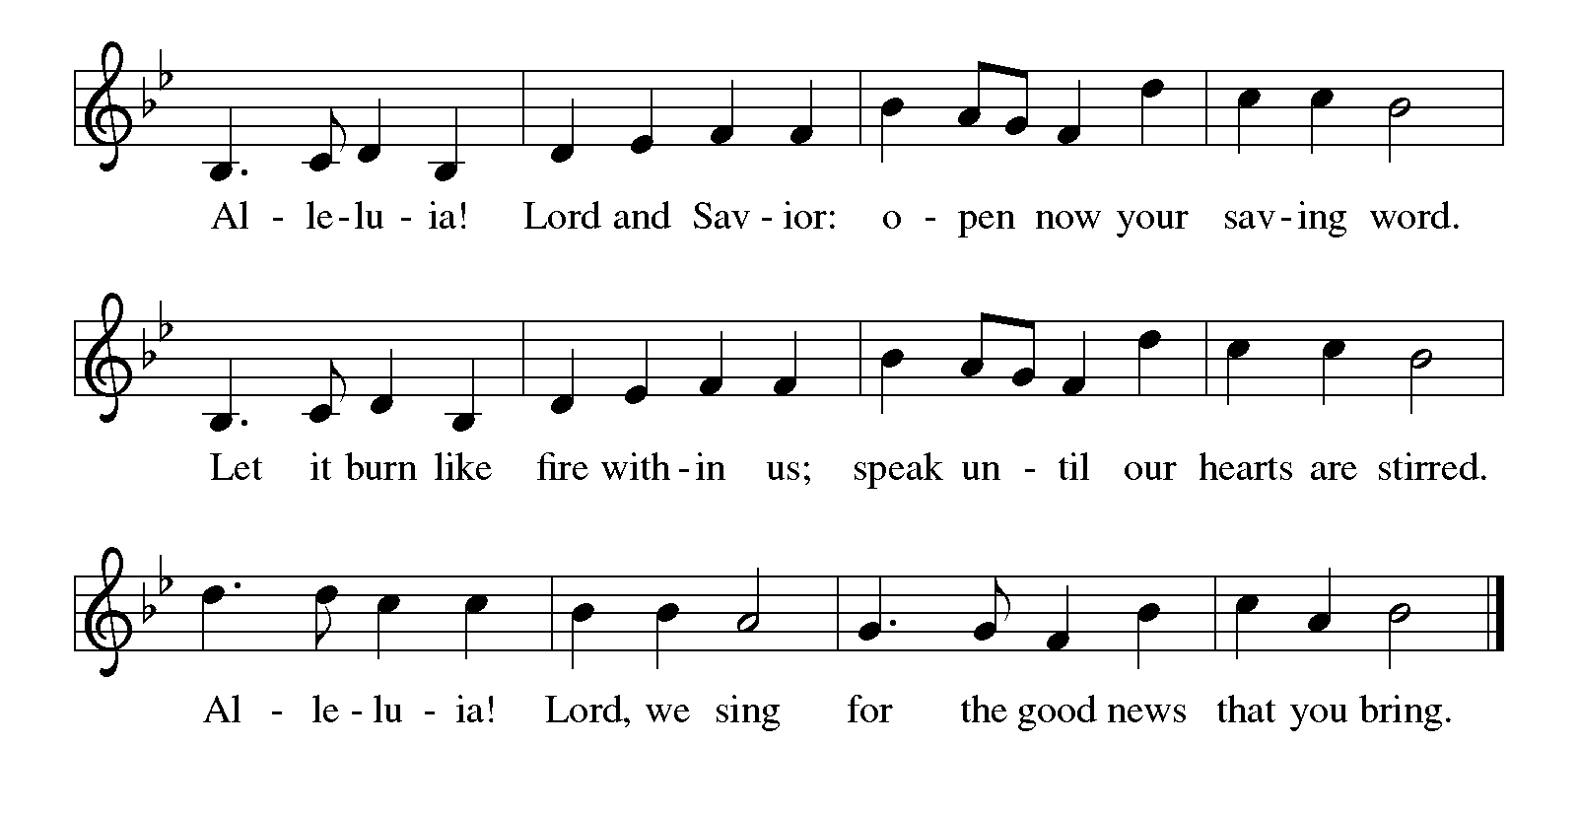

Gospel Luke 17:5-10
The holy gospel according to Luke.
⁵ The apostles said to the Lord, “Increase our faith!” ⁶ The Lord replied, “If you had faith the size of a mustard seed, you could say to this mulberry tree, ‘Be uprooted and planted in the sea,’ and it would obey you.
⁷ “Who among you would say to your slave who has just come in from plowing or tending sheep in the field, ‘Come here at once and take your place at the table’? ⁸ Would you not rather say to him, ‘Prepare supper for me; put on your apron and serve me while I eat and drink; later you may eat and drink’? ⁹ Do you thank the slave for doing what was commanded? ¹⁰ So you also, when you have done all that you were ordered to do, say, ‘We are worthless slaves; we have done only what we ought to have done!’ ”

The gospel of the Lord.
Praise to you, O Christ.
CHILDREN’S MOMENT

SERMON Pastor David Sprang

hymn of the day “How Firm a Foundation” #796

cREED
I believe in God, the Father almighty,
creator of heaven and earth.
I believe in Jesus Christ, God’s only Son, our Lord,
who was conceived by the Holy Spirit,
born of the virgin Mary,
suffered under Pontius Pilate,
was crucified, died, and was buried;
he descended to the dead.*
On the third day he rose again;
he ascended into heaven,
he is seated at the right hand of the Father,
and he will come to judge the living and the dead.
I believe in the Holy Spirit,
the holy catholic church,
the communion of saints,
the forgiveness of sins,
the resurrection of the body,
and the life everlasting. Amen.

*Or, “he descended into hell,” another translation of this text in widespread use.

prayers of Intercession
Renewed in God’s everlasting grace, let us pray for the church, the world, and all creation.
A brief silence.
O God of the church, you give the church a treasure in Jesus Christ. Draw us into the gift of faith passed down from generation to generation. Remind your people that faith the size of a mustard seed is enough. We pray especially for Mamrelund Lutheran in Kent City and their pastor Rev. Rob Johnson. God of grace,
receive our prayer.
O God of creation, you nourish the earth with grace and mercy. Bring favorable weather during the harvest season and sustain all creation along with all who labor in the field. Ensure the welfare of animal companions whose presence offers comfort, safety, and joy. God of grace,
receive our prayer.
O God of nations and communities, you govern and guard the world. Give leaders and people in authority a spirit of making just and righteous laws. Bring peace to countries affected by war and violence. God of grace,
receive our prayer.
O God of those in need, you care for those who are sick, oppressed, bereaved, lonely, and poor. Come to the help of all in need.
Help us to trust that you will come to us at the right time. God of grace,
receive our prayer.
O God of this congregation, you nurture our faith. Thank you for those of all ages who teach, lead, and learn in this congregation and beyond. Give growth to the seeds of faith watered by faithful examples of baptismal living. God of grace,
receive our prayer.
Here other intercessions may be offered.
O God of ages past, thank you for the witness of those who have died in faith. May the faith of those who now rest in your merciful arms, like Lois and Eunice, shape our faith in your Son, Jesus Christ. God of grace,
receive our prayer.
We offer our prayers, O God, trusting in your everlasting grace and mercy, through Jesus Christ our Lord.
Amen.

PEACE
The peace of Christ be with you always.
And also with you.

OFFERING & OFFERING SONG
The joy of the Lord is my strength,
The joy of the Lord is my strength,
The joy of the Lord is my strength,
The joy of the Lord is my strength.

Offering Prayer
Let us pray.
God of all creation, all you have made is good, and your love endures forever. You bring forth bread from the earth and fruit from the vine. Nourish us with these gifts, that we might be for the world signs of your gracious presence in Jesus Christ, our Savior and Lord.
Amen.

DIALOGUE
The Lord be with you.
And also with you.
Lift up your hearts.
We lift them to the Lord.
Let us give thanks to the Lord our God.
It is right to give our thanks and praise.

PREFACE (Pastor)
It is indeed right, our duty and our joy,
that we should at all times and in all places
give thanks and praise to you, almighty and merciful God,
through our Savior Jesus Christ;
who on this day overcame death and the grave,
and by his glorious resurrection opened to us the way of everlasting life.
And so, with all the choirs of angels,
with the church on earth and the hosts of heaven,
we praise your name and join their unending hymn

holy, holy, holy
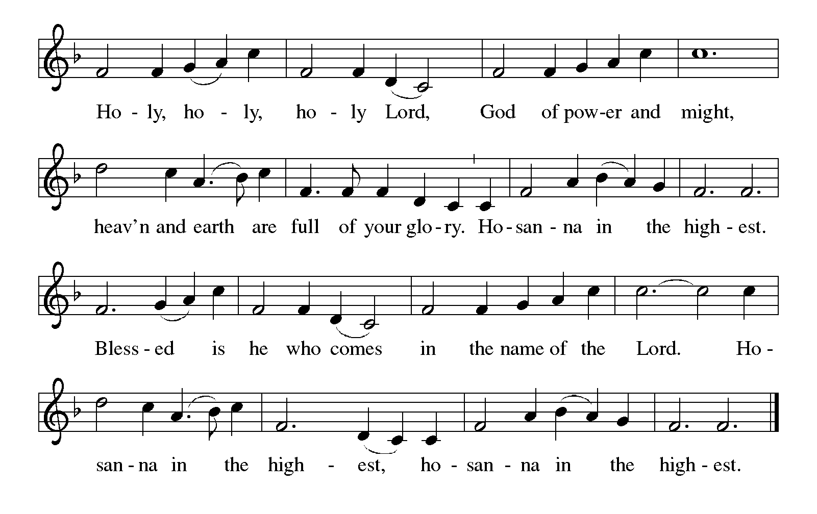

Thanksgiving at the Table
In the night in which he was betrayed,
our Lord Jesus took bread, and gave thanks;
broke it, and gave it to his disciples, saying:
Take and eat; this is my body, given for you.
Do this for the remembrance of me.

Again, after supper, he took the cup, gave thanks,
and gave it for all to drink, saying:
This cup is the new covenant in my blood,
shed for you and for all people for the forgiveness of sin.
Do this for the remembrance of me.

For as often as we eat of this bread and drink from this cup,
we proclaim the Lord’s death until he comes.

Lord’s Prayer
Gathered into one by the Holy Spirit, let us pray as Jesus taught us.
Our Father, who art in heaven,
hallowed be thy name,
thy kingdom come,
thy will be done,
on earth as it is in heaven.
Give us this day our daily bread;
and forgive us our trespasses,
as we forgive those
who trespass against us;
and lead us not into temptation,
but deliver us from evil.
For thine is the kingdom,
and the power, and the glory,
forever and ever. Amen.

INVITATION TO COMMUNION
Come to the banquet, for all is now ready.

COMMUNION *continuous
*People are welcome to kneel at the altar rail for a time of prayer after they receive their communion elements.

COMMUNION HYMNS

“We Walk by Faith” #635

“My Faith Looks Up to Thee” #759

PRAYER AFTER COMMUNION
Let us pray.
We give you thanks, almighty God, that you have refreshed us through the healing power of this gift of life. In your mercy, strengthen us through this gift, in faith toward you and in fervent love toward one another; for the sake of Jesus Christ our Lord.
Amen.

Sending
God blesses us and sends us in mission to the world.
Blessing
The Lord bless you and keep you.
The Lord’s face shine on you with grace and mercy.
The Lord look upon you with favor and ☩ give you peace.
Amen.

Sending SonG “Lord, Dismiss Us with Your Blessing” #545

Dismissal
Go in peace. Christ is with you.
Thanks be to God.

From sundaysandseasons.com. Copyright © 2017 Augsburg Fortress. All rights reserved.

Thank you to all who served in worship today!
Presiders: Pastor David Sprang Musician: Martha Yoder
Acolyte: Kole Hokanson Safety Person:
Elder: Dan Utterback Trustee: Mike Johnson
Offering Counters: Diane Griffin & Carlotta Willard



PRAYERS OF THE FAITHFUL

With thanks for all God’s blessings and his love for all people. Our Bishops, Craig Satterlee Elizabeth Eaton, and the congregations of the North/West Lower Michigan
Synod, and especially for Mamrelund Lutheran in Kent City and their pastor Rev. Rob Johnson.

Prayers for our friends, for all who are sick or hospitalized and for all health care workers who care for them. All those members of Zion’s family traveling; all those homebound or in frail health; all those suffering with quiet, unknown needs or worries. For those who serve on our behalf: public safety, utility workers, medical personnel, military personnel. For those who might be forgotten.

This week at Zion:
- Men’s Coffee, 8 AM, Wednesday, October 8
- Bulletin Deadline, Wednesday, October 8

ONLINE GIVING
Zion has received a QR code to facilitate online giving. If you are interested in donating online instead of bringing your donation to church, simply scan the QR code and it will direct you to the appropriate site. The code is on our website as well.

ANNOUNCEMENT
- Baby Care and Personal Care Kits. Today is Zion's Lutheran World Relief Baby Care and Personal Care Kits Dedication Day. Jerry Engle was given a grant of $250.00 from Thrivent Financial. These funds, plus other donations, were used to purchase the supplies needed to assemble 25 kits. The Board of Evangelism held its Action Team Day on Thursday, September 11th. Thank you to all who helped with this project. Carol Engle was approved for a grant for $250.00 plus was given another $64.00 from Thrivent's Choice Dollars program. These funds plus other donations were used to purchase items to complete 101 Personal Care Kits. That Action Team Day was held last Sunday, September 28th. A huge thank you to the girls, boys and adults who donated funds and time to complete these two special projects. Zion is blessed to be able to share with others in need. All the kits will be delivered to St. Matthew's Church in Grand Rapids on Saturday, October 18th.
- Announcement and Newsletter Items: Please forward items for the bulletin announcements and the newsletter to the church email (Office@Zion.org). Please do not send items to people’s personal emails. Thank you.
- Door Locking Policy: Our door locking policy relies on having a volunteer(s) each Sunday to serve as the Safety Person of the Day. On Sundays where no one has volunteered, if someone arrives at church and is willing to be the Safety Person of the Day, we will follow the door locking policy. If no one steps forward to serve as the Safety Person of the Day, the doors will not be locked. Please consider volunteering for this important duty.

