ZION LUTHERAN CHURCH, WOODLAND, MI
Eighteenth Sunday After Pentecost October 12, 2025
*If you are listening in your car, please tune your radio to FM 87.7*
(Please silence your cell phones while in the sanctuary. Thank you.)
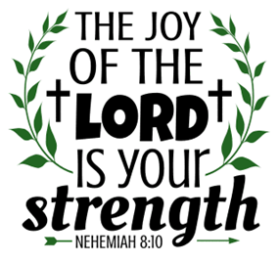

WELCOME AND ANNOUNCEMENTS

Gathering
The Holy Spirit calls us together as the people of God.

Confession and Forgiveness
In the name of the Father,
and of the ☩ Son,
and of the Holy Spirit.
Amen.

Almighty God, to whom all hearts are open, all desires known, and from whom no secrets are hid: cleanse the thoughts of our hearts by the inspiration of your Holy Spirit, that we may perfectly love you and worthily magnify your holy name, through Jesus Christ our Lord.
Amen.

Let us confess our sin in the presence of God and of one another. Most merciful God,
we confess that we are captive to sin and cannot free ourselves. We have sinned against you in thought, word, and deed, by what we have done and by what we have left undone. We have not loved you with our whole heart; we have not loved our neighbors as ourselves. For the sake of your Son, Jesus Christ, have mercy on us. Forgive us, renew us, and lead us, so that we may delight in your will and walk in your ways, to the glory of your holy name.
Amen.

God, who is rich in mercy, loved us even when we were dead in sin, and made us alive together with Christ. By grace you have been saved. In the name of ☩ Jesus Christ, your sins are forgiven. Almighty God strengthen you with power through the Holy Spirit, that Christ may live in your hearts through faith.
Amen.

Gathering Song “Praise, My Soul, the God of Heaven” #864

GREETING
The grace of our Lord Jesus Christ, the love of God, and the communion of the Holy Spirit be with you all.
And also with you.

Prayer of the Day
Let us pray together.
Almighty and most merciful God, your bountiful goodness fills all creation. Keep us safe from all that may hurt us, that, whole and well in body and spirit, we may with grateful hearts accomplish all that you would have us do, through Jesus Christ, our Savior and Lord.
Amen.

First Reading 2 Kings 5:1-3, 7-15c
A reading from 2 Kings.
¹ Naaman, commander of the army of the king of Aram, was a great man and in high favor with his master because by him the Lord had given victory to Aram. The man, though a mighty warrior, suffered from a skin disease. ² Now the Arameans on one of their raids had taken a young girl captive from the land of Israel, and she served Naaman’s wife. ³ She said to her mistress, “If only my lord were with the prophet who is in Samaria! He would cure him of his skin disease.”
⁷ When the king of Israel read the letter, he tore his clothes and said, “Am I God, to give death or life, that this man sends word to me to cure a man of his skin disease? Just look and see how he is trying to pick a quarrel with me.”
⁸ But when Elisha the man of God heard that the king of Israel had torn his clothes, he sent a message to the king, “Why have you torn your clothes? Let him come to me, that he may learn that there is a prophet in Israel.” ⁹ So Naaman came with his horses and chariots and halted at the entrance of Elisha’s house. ¹⁰ Elisha sent a messenger to him, saying, “Go, wash in the Jordan seven times, and your flesh shall be restored, and you shall be clean.” ¹¹ But Naaman became angry and went away, saying, “I thought that for me he would surely come out and stand and call on the name of the Lord his God and would wave his hand over the spot and cure the skin disease! ¹² Are not Abana and Pharpar, the rivers of Damascus, better than all the waters of Israel? Could I not wash in them and be clean?” He turned and went away in a rage. ¹³ But his servants approached and said to him, “Father, if the prophet had commanded you to do something difficult, would you not have done it? How much more, when all he said to you was, ‘Wash, and be clean’?” ¹⁴ So he went down and immersed himself seven times in the Jordan, according to the word of the man of God; his flesh was restored like the flesh of a young boy, and he was clean.
^{15a, b, c} Then he returned to the man of God, he and all his company; he came and stood before him and said, “Now I know that there is no God in all the earth except in Israel.”

The word of the Lord
Thanks be to God.

Psalm Psalm 111

I will give thanks to the Lord with my whole heart.
¹ Hallelujah! I will give thanks to the Lord with | my whole heart,
in the assembly of the upright, in the | congregation.
² Great are your | works, O Lord,
pondered by all who de- | light in them.
³ Majesty and splendor | mark your deeds,
and your righteousness en- | dures forever.
⁴ You cause your wonders to | be remembered;
you are gracious and full | of compassion.
⁵ You give food to | those who fear you,
remembering forev- | er your covenant.
⁶ You have shown your people the power | of your works
in giving them the lands | of the nations.
⁷ The works of your hands are faithful- | ness and justice;
all of your pre- | cepts are sure.
⁸ They stand fast forev- | er and ever,
because they are done in | truth and equity.
⁹ You sent redemption to your people and commanded your cove- | nant forever;
holy and awesome | is your name.
¹⁰ The fear of the Lord is the begin- | ning of wisdom;
all who practice this have a good understanding. God’s praise en- | dures forever.

Second Reading 2 Timothy 2:8-15
A reading from 2 Timothy.

⁸ Remember Jesus Christ, raised from the dead, a descendant of David—that is my gospel, ⁹ for which I suffer hardship, even to the point of being chained like a criminal. But the word of God is not chained. ¹⁰ Therefore I endure everything for the sake of the elect, so that they may also obtain the salvation that is in Christ Jesus, with eternal glory. ¹¹ The saying is sure:
If we have died with him, we will also live with him;
¹² if we endure, we will also reign with him;
if we deny him, he will also deny us;
¹³ if we are faithless, he remains faithful—
he cannot deny himself.
¹⁴ Remind them of this, and warn them before the Lord that they are to avoid wrangling over words, which does no good but only ruins those who are listening. ¹⁵ Do your best to present yourself to God as one approved by him, a worker who has no need to be ashamed, rightly explaining the word of truth.

The Word of the Lord
Thanks be to God.

Gospel Acclamation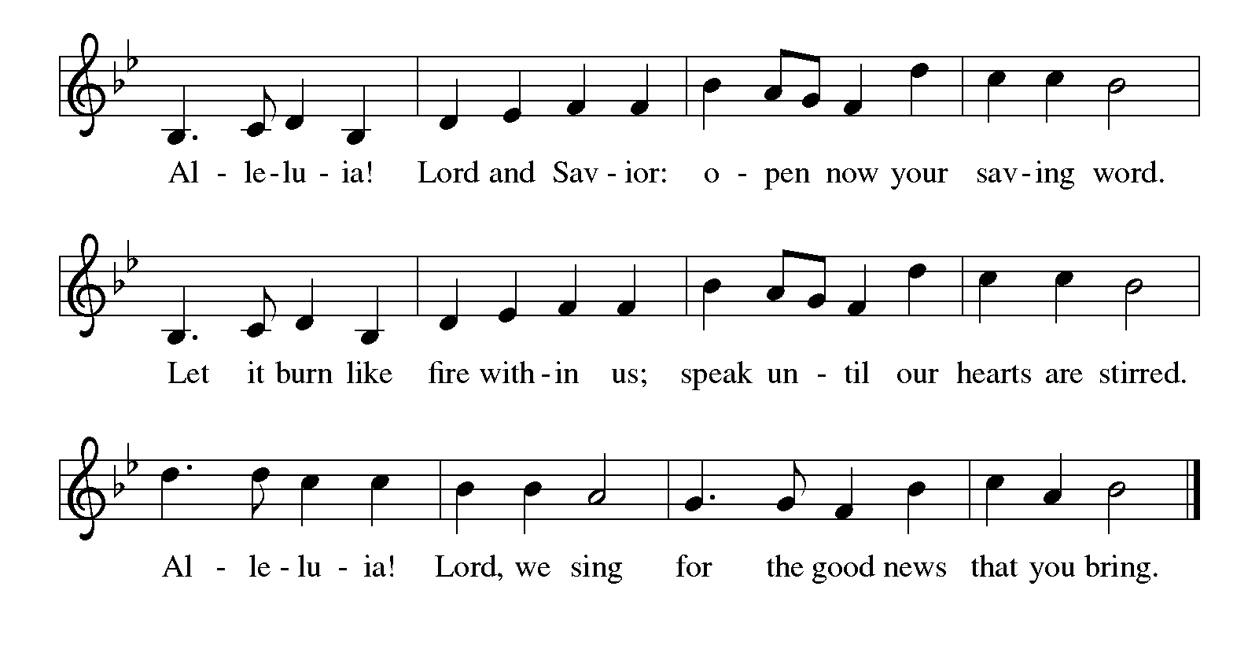

Gospel Luke 17:11-19
The holy gospel according to Luke.

¹¹ On the way to Jerusalem Jesus was going through the region between Samaria and Galilee. ¹² As he entered a village, ten men with a skin disease approached him. Keeping their distance, ¹³ they called out, saying, “Jesus, Master, have mercy on us!” ¹⁴ When he saw them, he said to them, “Go and show yourselves to the priests.” And as they went, they were made clean. ¹⁵ Then one of them, when he saw that he was healed, turned back, praising God with a loud voice. ¹⁶ He prostrated himself at Jesus’s feet and thanked him. And he was a Samaritan. ¹⁷ Then Jesus asked, “Were not ten made clean? So where are the other nine? ¹⁸ Did none of them return to give glory to God except this foreigner?” ¹⁹ Then he said to him, “Get up and go on your way; your faith has made you well.”

The gospel of the Lord.
Praise to you, O Christ.

CHILDREN’S MOMENT

SERMON Pastor Mike Anderson

hymn of the day “We Come To You For Healing, Lord” #617

cREED
I believe in God, the Father almighty,
creator of heaven and earth.
I believe in Jesus Christ, God’s only Son, our Lord,
who was conceived by the Holy Spirit,
born of the virgin Mary,
suffered under Pontius Pilate,
was crucified, died, and was buried;
he descended to the dead.*
On the third day he rose again;
he ascended into heaven,
he is seated at the right hand of the Father,
and he will come to judge the living and the dead.
I believe in the Holy Spirit,
the holy catholic church,
the communion of saints,
the forgiveness of sins,
the resurrection of the body,
and the life everlasting. Amen.

*Or, “he descended into hell,” another translation of this text in widespread use.

prayers of Intercession
Renewed in God’s everlasting grace, let us pray for the church, the world, and all creation.
Gracious God, you lead your people to faith. Remind the church that your word flows into the world. By your Spirit, teach the church to share the word of God for the sake of the world. We Pray especially for Lutheran Church of the Savior in Kalamazoo and their pastor Rev. Ken Johnson. God of grace,
receive our prayer.
Creating God, you provided cleansing and healing waters for Naaman. Water the earth’s lands in parched places. Restore clean water to all communities, and guide the work of all who advocate for safe and abundant water supplies. God of grace,
receive our prayer.
Righteous One, you bring justice and wholeness throughout the world, and your righteousness endures forever. By your spirit, guide leaders of all nations and lands to right relationship with you and with one another. God of grace,
receive our prayer.
Merciful God, you know the needs of your people. Show mercy to those suffering in the world. Comfort those in need of your healing. God of grace,
receive our prayer.
Life-giving God, you free us by your word. Help us, by your Spirit, to be transformed to live your word of freedom honestly and uprightly in our teaching, preaching, and serving. God of grace,
receive our prayer.
Holy God, thank you for the witness of those who have died in faith. Guide us to trust in the baptismal promise of resurrection in Christ. God of grace,
receive our prayer.
We offer our prayers, O God, trusting in your everlasting grace and mercy, through Jesus Christ our Lord.
Amen.

PEACE
The peace of Christ be with you always.
And also with you.

OFFERING & OFFERING SONG
The joy of the Lord is my strength,
The joy of the Lord is my strength,
The joy of the Lord is my strength,
The joy of the Lord is my strength.

Offering Prayer
Let us pray.
God of all creation, all you have made is good, and your love endures forever. You bring forth bread from the earth and fruit from the vine. Nourish us with these gifts, that we might be for the world signs of your gracious presence in Jesus Christ, our Savior and Lord.
Amen.

DIALOGUE
The Lord be with you.
And also with you.
Lift up your hearts.
We lift them to the Lord.
Let us give thanks to the Lord our God.
It is right to give our thanks and praise.

PREFACE (Pastor)
It is indeed right, our duty and our joy,
that we should at all times and in all places
give thanks and praise to you, almighty and merciful God,
through our Savior Jesus Christ;
who on this day overcame death and the grave,
and by his glorious resurrection opened to us the way of everlasting life.
And so, with all the choirs of angels,
with the church on earth and the hosts of heaven,
we praise your name and join their unending hymn

holy, holy, holy
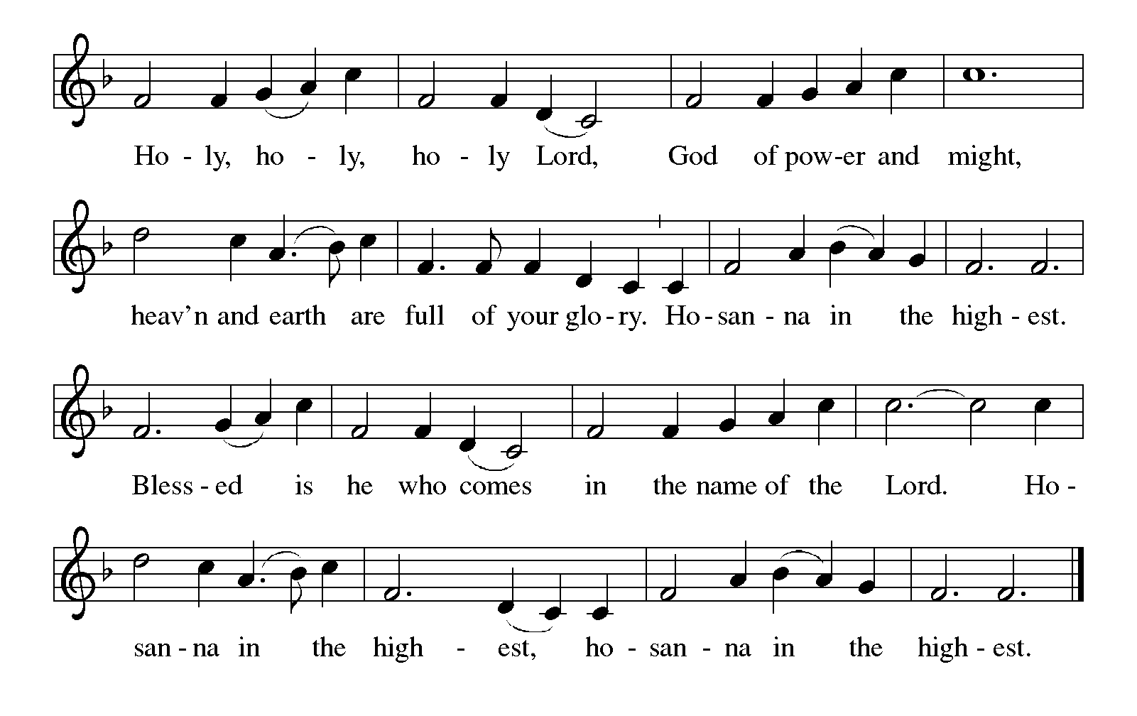

Thanksgiving at the Table
In the night in which he was betrayed,
our Lord Jesus took bread, and gave thanks;
broke it, and gave it to his disciples, saying:
Take and eat; this is my body, given for you.
Do this for the remembrance of me.

Again, after supper, he took the cup, gave thanks,
and gave it for all to drink, saying:
This cup is the new covenant in my blood,
shed for you and for all people for the forgiveness of sin.
Do this for the remembrance of me.

For as often as we eat of this bread and drink from this cup,
we proclaim the Lord’s death until he comes.

Lord’s Prayer
Gathered into one by the Holy Spirit, let us pray as Jesus taught us.
Our Father, who art in heaven,
hallowed be thy name,
thy kingdom come,
thy will be done,
on earth as it is in heaven.
Give us this day our daily bread;
and forgive us our trespasses,
as we forgive those
who trespass against us;
and lead us not into temptation,
but deliver us from evil.
For thine is the kingdom,
and the power, and the glory,
forever and ever. Amen.

INVITATION TO COMMUNION
Come to the banquet, for all is now ready.

COMMUNION *continuous
*People are welcome to kneel at the altar rail for a time of prayer after they receive their communion elements.

COMMUNION HYMNS

“Great Is Thy Faithfulness” #733

“Jesus Loves Me!” #595

PRAYER AFTER COMMUNION
Let us pray.
We give you thanks, almighty God, that you have refreshed us through the healing power of this gift of life. In your mercy, strengthen us through this gift, in faith toward you and in fervent love toward one another; for the sake of Jesus Christ our Lord.
Amen.

Sending
God blesses us and sends us in mission to the world.

Blessing
The Lord bless you and keep you.
The Lord’s face shine on you with grace and mercy.
The Lord look upon you with favor and ☩ give you peace.
Amen.

Sending SonG “Go, My Children, with My Blessing” #543

Dismissal
Go in peace. Christ is with you.
Thanks be to God.
From sundaysandseasons.com. Copyright © 2017 Augsburg Fortress. All rights reserved.

Thank you to all who served in worship today!
Presiders: Pastor Mike Anderson Musician: Jayne Flanigan
Acolyte: Aliyanna Morado Safety Person:
Elder: Buffy Meyers Trustee: Doug MacKenzie
Offering Counters: Paul Meade & Carlotta Willard



PRAYERS OF THE FAITHFUL

With thanks for all God’s blessings and his love for all people. Our Bishops, Julie Schneider-Thomas, Yehiel Curry, and the congregations of the North/West Lower Michigan Synod, and especially for Lutheran Church of the Savior in Kalamazoo and their pastor Rev. Ken Johnson.

Prayers for our friends, for all who are sick or hospitalized and for all health care workers who care for them. All those members of Zion’s family traveling; all those homebound or in frail health; all those suffering with quiet, unknown needs or worries. For those who serve on our behalf: public safety, utility workers, medical personnel, military personnel. For those who might be forgotten.

This week at Zion:
- Charity Circle, Marie Brodbeck’s, Sunday, October 19th at 2 pm
- Men’s Coffee, 8 AM, Wednesday, October 15
- Bulletin Deadline, Wednesday, October 15
- Disciple Group, Martha’s, Wednesday, October 15 at 10 am

ONLINE GIVING
Zion has received a QR code to facilitate online giving. If you are interested in donating online instead of bringing your donation to church, simply scan the QR code and it will direct you to the appropriate site. The code is on our website as well.

ANNOUNCEMENT

- Baptisms October 19th: We welcome Natasha Miller, Norman Miller, Terry Miller, Paytan Martinex, and William Peake into the family of Christ through baptism on October 19th. This is a Sunday when worship starts at 11:00 am. Please join us to support and welcome these people as they join the body of Christ.
- Halloween Party October 19th: Join us for a Halloween Party following worship on October 19th. Please sign-up in the narthex so we know how many to plan for. We will be having a planned potluck and look for signup sheets for items needed, also.
- Shut-In Bags: There are Harvest-Halloween shut-in bags in the fellowship hall. There are 10 bags, 3 are couples. Please bring a treat, card or other seasonal item for the bags. We will be asking for volunteers to distribute the bags on October 19th.
- Altar Flowers: If you are interested in putting flowers on the altar in memory of a loved one, please let Mary Makley know.
- Thank you: Thank you to Carol and Jerry Engle, Carlotta Willard, Karen Heise, Ruth and Jimmy Hindman and Martha Yoder for packing and getting the personal care kits and baby care kits ready for shipment. The boxes will be delivered to St. Matthews Church in Grand Rapids on October 18. From there our kits will be used by Lutheran World Relief anywhere where they are needed in the world! Thank you to everyone who contributed to this ministry project.
- Announcement and Newsletter Items: Please forward items for the bulletin announcements and the newsletter to the church email (Office@Zion.org). Please do not send items to people’s personal emails. Thank you.
- Door Locking Policy: Our door locking policy relies on having a volunteer(s) each Sunday to serve as the Safety Person of the Day. On Sundays where no one has volunteered, if someone arrives at church and is willing to be the Safety Person of the Day, we will follow the door locking policy. If no one steps forward to serve as the Safety Person of the Day, the doors will not be locked. Please consider volunteering for this important duty.

