ZION LUTHERAN CHURCH, WOODLAND, MI
Nineteenth Sunday After Pentecost October 19, 2025
*If you are listening in your car, please tune your radio to FM 87.7*
(Please silence your cell phones while in the sanctuary. Thank you.)
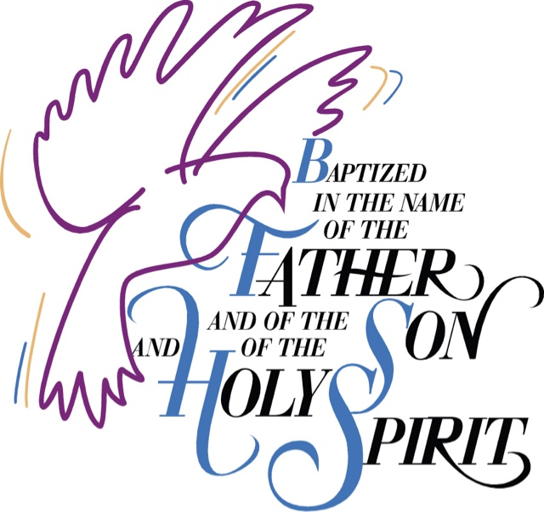
This Photo by Unknown Author is licensed under CC BY-NC-ND

WELCOME AND ANNOUNCEMENTS

Gathering
The Holy Spirit calls us together as the people of God.

Confession and Forgiveness
In the name of the Father,
and of the ☩ Son,
and of the Holy Spirit.
Amen.

Almighty God, to whom all hearts are open, all desires known, and from whom no secrets are hid: cleanse the thoughts of our hearts by the inspiration of your Holy Spirit, that we may perfectly love you and worthily magnify your holy name, through Jesus Christ our Lord.
Amen.

Let us confess our sin in the presence of God and of one another. Most merciful God,
we confess that we are captive to sin and cannot free ourselves. We have sinned against you in thought, word, and deed, by what we have done and by what we have left undone. We have not loved you with our whole heart; we have not loved our neighbors as ourselves. For the sake of your Son, Jesus Christ, have mercy on us. Forgive us, renew us, and lead us, so that we may delight in your will and walk in your ways, to the glory of your holy name.
Amen.

God, who is rich in mercy, loved us even when we were dead in sin, and made us alive together with Christ. By grace you have been saved. In the name of ☩ Jesus Christ, your sins are forgiven. Almighty God strengthen you with power through the Holy Spirit, that Christ may live in your hearts through faith.
Amen.

Gathering Song “Rise Up, O Saints of God!” #669

GREETING
The grace of our Lord Jesus Christ, the love of God, and the communion of the Holy Spirit be with you all.
And also with you.

Prayer of the Day
Let us pray together.
O Lord God, tireless guardian of your people, you are always ready to hear our cries. Teach us to rely day and night on your care. Inspire us to seek your enduring justice for all this suffering world, through Jesus Christ, our Savior and Lord.
Amen.

First Reading Genesis 32:22-31
A reading from Genesis.
²² The same night [Jacob] got up and took his two wives, his two maids, and his eleven children and crossed the ford of the Jabbok. ²³ He took them and sent them across the stream, and likewise everything that he had. ²⁴ Jacob was left alone, and a man wrestled with him until daybreak. ²⁵ When the man saw that he did not prevail against Jacob, he struck him on the hip socket, and Jacob’s hip was put out of joint as he wrestled with him. ²⁶ Then he said, “Let me go, for the day is breaking.” But Jacob said, “I will not let you go, unless you bless me.” ²⁷ So he said to him, “What is your name?” And he said, “Jacob.” ²⁸ Then the man said, “You shall no longer be called Jacob, but Israel, for you have striven with God and with humans and have prevailed.” ²⁹ Then Jacob asked him, “Please tell me your name.” But he said, “Why is it that you ask my name?” And there he blessed him. ³⁰ So Jacob called the place Peniel, saying, “For I have seen God face to face, yet my life is preserved.” ³¹ The sun rose upon him as he passed Penuel, limping because of his hip.

The word of the Lord
Thanks be to God.

Psalm Psalm 111

¹ I lift up my eyes | to the hills;
from where is my | help to come?
² My help comes | from the Lord,
the maker of heav- | en and earth.
³ The Lord will not let your | foot be moved
nor will the one who watches over you | fall asleep.
⁴ Behold, the keep- | er of Israel
will neither slum- | ber nor sleep;
⁵ the Lord watches | over you;
the Lord is your shade at | your right hand;
⁶ the sun will not strike | you by day,
nor the | moon by night.
⁷ The Lord will preserve you | from all evil
and will | keep your life.
⁸ The Lord will watch over your going out and your | coming in,
from this time forth for- | evermore.

Second Reading 2 Timothy 3:14-4:5
A reading from 2 Timothy.
¹⁴ But as for you, continue in what you have learned and firmly believed, knowing from whom you learned it ¹⁵ and how from childhood you have known sacred writings that are able to instruct you for salvation through faith in Christ Jesus. ¹⁶ All scripture is inspired by God and is useful for teaching, for reproof, for correction, and for training in righteousness, ¹⁷ so that the person of God may be proficient, equipped for every good work.
^{4:1} In the presence of God and of Christ Jesus, who is to judge the living and the dead, and in view of his appearing and his kingdom, I solemnly urge you: ² proclaim the message; be persistent whether the time is favorable or unfavorable; convince, rebuke, and encourage with the utmost patience in teaching. ³ For the time is coming when people will not put up with sound teaching, but, having their ears tickled, they will accumulate for themselves teachers to suit their own desires ⁴ and will turn away from listening to the truth and wander away to myths. ⁵ As for you, be sober in everything, endure suffering, do the work of an evangelist, carry out your ministry fully.

The Word of the Lord
Thanks be to God.

Gospel Acclamation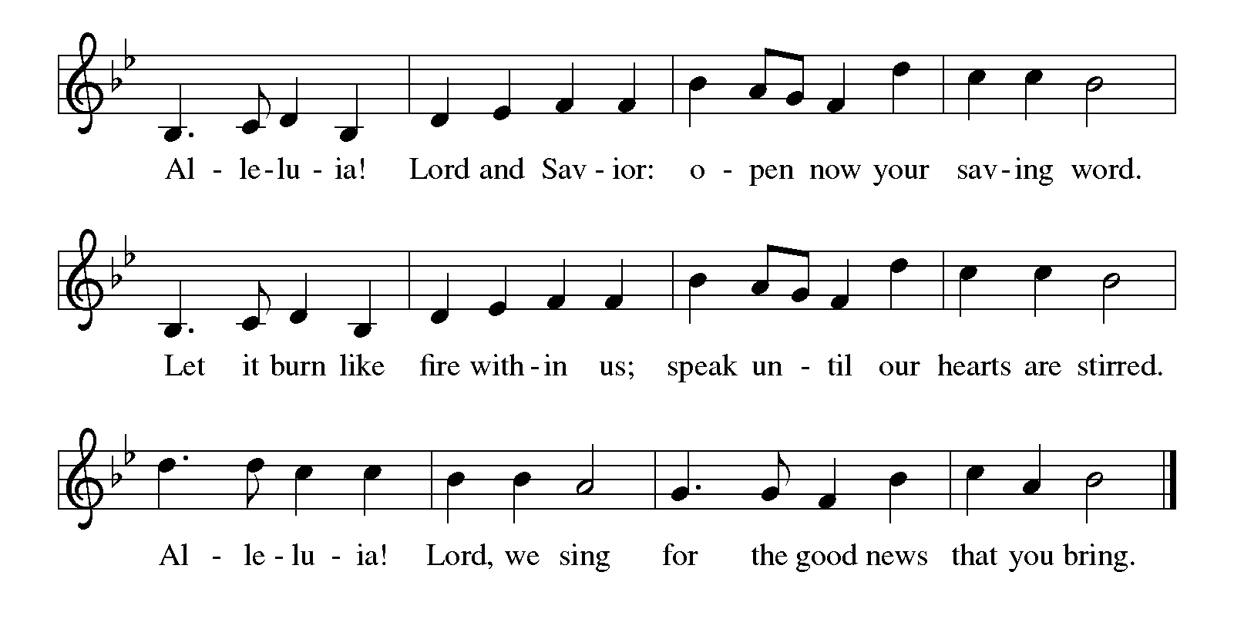

Gospel Luke 18:1-8
The holy gospel according to Luke.
¹ Then Jesus told them a parable about their need to pray always and not to lose heart. ² He said, “In a certain city there was a judge who neither feared God nor had respect for people. ³ In that city there was a widow who kept coming to him and saying, ‘Grant me justice against my accuser.’ ⁴ For a while he refused, but later he said to himself, ‘Though I have no fear of God and no respect for anyone, ⁵ yet because this widow keeps bothering me, I will grant her justice, so that she may not wear me out by continually coming.’ ” ⁶ And the Lord said, “Listen to what the unjust judge says. ⁷ And will not God grant justice to his chosen ones who cry to him day and night? Will he delay long in helping them? ⁸ I tell you, he will quickly grant justice to them. And yet, when the Son of Man comes, will he find faith on earth?”

The gospel of the Lord.
Praise to you, O Christ.

CHILDREN’S MOMENT

SERMON Pastor Ken Scheck

hymn of the day “God, Who Stretched The Spangled Heavens” #771

HOLY BAPTISM
- Natasha Miller
- Norman Miller
- Terry Miller
- Paytan Martinez
- William Peake
- Kyle Peake, Sponsor

PRESENTATION
In Holy Baptism our gracious heavenly Father liberates us from sin and death by joining us to the death and resurrection of our Lord Jesus Christ. We are born children of a fallen humanity; in the waters of Baptism we are reborn children of God and inheritors of eternal life. By water and the Holy Spirit we are made members of the Church which is the body of Christ. As we live with him and with his people, we grow in faith, love, and obedience to the will of God.

Parents and Sponsor together: We present Natasha Miller, Norman Miller, Terry Miller, Paytan Martinez and William Peake to receive the Sacrament of Holy Baptism.

Natasha, Norman, Terry, Paytan and William, called by the Holy Spirit, trusting in the grace and love of God, do you desire to be baptized into Christ?

Response: I do.

Parent and Sponsor, do you promise to nurture these individuals in the Christian faith as you are empowered by God’s Spirit, and to help them live in the covenant of baptism and in communion with the church?

Parents and Sponsor answer: I do.

People of God, do you promise to support Natasha, Norman, Terry, Paytan and William and pray for them in their new life in Christ?

Congregation: We do.

PROFESSION OF FAITH
I ask you to profess your faith in Christ Jesus, reject sin, and confess the faith of the church.

Do you renounce the devil and all the forces that defy God?
Response: I renounce them.

Do you renounce the powers of this world that rebel against God?
Response: I renounce them.

I ask you to profess your faith in Christ Jesus, reject sin, and confess the faith of the church, the faith in which we baptize. Do you renounce all the forces of evil, the devil, and all his empty promises?
Response: I do.

Do you believe in God the Father?
I believe in God, the Father almighty,
creator of heaven and earth.

Do you believe in Jesus Christ, the Son of God?
I believe in Jesus Christ, his only Son, our Lord.
He was conceived by the power of the Holy Spirit
and born of the virgin Mary.
He suffered under Pontius Pilate,
was crucified, died, and was buried.
He descended into hell.*
On the third day he rose again.
He ascended into heaven,
and is seated at the right hand of the Father.
He will come again to judge the living and the dead.

Do you believe in God the Holy Spirit?
I believe in the Holy Spirit,
the holy catholic church,
the communion of saints,
the forgiveness of sins,
the resurrection of the body,
and the life everlasting. Amen

THANKSGIVING AT THE FONT

By the baptism of his own death and resurrection your beloved Son has set us free from the bondage to sin and death and has opened the way to the joy and freedom of everlasting life. He made water a sign of the kingdom and of cleansing and rebirth. In obedience to his command, we make disciples of all nations, baptizing them in the name of the Father, and of the Son, and of the Holy Spirit.

Pour out your Holy Spirit, so that the individuals who is here to be baptized may be given new life. Wash away the sin of all those who are cleansed by this water and bring them forth as inheritors of your glorious kingdom.

To you be given praise and honor and worship through your Son, Jesus Christ our Lord, in the unity of the Holy Spirit, now and forever.
Amen

BAPTISM
Natasha, Norman, Terry, Paytan and William, I baptize you in the name of the Father, and of the Son, and of the Holy Spirit. Amen

Let us pray.
God, the Father of our Lord Jesus Christ, we give you thanks for freeing your children from the power of sin and for raising them up to a new life through this holy sacrament. Pour your Holy Spirit upon them: the spirit of wisdom and understanding, the spirit of counsel and might, the spirit of knowledge and the fear of the Lord, the spirit of joy in your presence.
Amen

Natasha, Norman, Terry, Paytan and William, each a Child of God, you have been sealed by the Holy Spirit and marked with the cross of Christ forever.
Amen

A lighted candle is given to the baptized.

Jesus said, I am the light of the world. Whoever follows me will have the light of life.

WELCOME

Let us welcome the newly baptized.
Through Baptism, God has made Natasha, Norman, Terry, Paytan and William a member of the priesthood we all share in Christ Jesus, that we may proclaim the praise of God and bear his creative and redeeming Word to all the world.
We welcome you into the Lord’s family. We receive you as a fellow member of the body of Christ, child of the same heavenly Father, and worker with us in the kingdom of God. You belong to Christ, in whom you have been baptized. Alleluia.

prayers of Intercession
Renewed in God’s everlasting grace, let us pray for the church, the world, and all creation.
A brief silence.
We pray for the church universal. O God, who unites the church across the globe, bring unity and peace to a world divided by hatred and opposition. Turn our hearts toward the gospel of Jesus Christ. We pray especially for Advent Lutheran in Lake Ann and their pastor Rev. Rosanne Anderson. God of grace,
receive our prayer.
We pray for creation. O God, who made heaven and earth, draw us to the beauty of the whole creation. Turn us toward a right relationship with the entire cosmos. God of grace,
receive our prayer.
We pray for all nations, states, cities, and towns. O God, you rule over all the earth. Grant our elected officials humility in their decision-making for the sake of the entire world. God of grace,
receive our prayer.
We pray for those who suffer in body, mind, or spirit. O God, who heals and strengthens, our help comes from you in times of need. Support, comfort, and heal those who suffer. God of grace,
receive our prayer.
We pray for. O God, who guides this congregation, encourage us to share the good news of Jesus Christ. Nurture our relationships with the community, that we serve and advocate for those who come to us in need. God of grace,
receive our prayer.
We offer thanksgiving for the faithful departed. O God, whose promises never end, we thank you for all the saints who have shown us the way of your Son, Jesus Christ. God of grace,
receive our prayer.
We offer our prayers, O God, trusting in your everlasting grace and mercy, through Jesus Christ our Lord.
Amen.

PEACE
The peace of Christ be with you always.
And also with you.

OFFERING & OFFERING SONG
The joy of the Lord is my strength,
The joy of the Lord is my strength,
The joy of the Lord is my strength,
The joy of the Lord is my strength.

Offering Prayer
Let us pray.
God of all creation, all you have made is good, and your love endures forever. You bring forth bread from the earth and fruit from the vine. Nourish us with these gifts, that we might be for the world signs of your gracious presence in Jesus Christ, our Savior and Lord.
Amen.

DIALOGUE
The Lord be with you.
And also with you.
Lift up your hearts.
We lift them to the Lord.
Let us give thanks to the Lord our God.
It is right to give our thanks and praise.

PREFACE (Pastor)
It is indeed right, our duty and our joy,
that we should at all times and in all places
give thanks and praise to you, almighty and merciful God,
through our Savior Jesus Christ;
who on this day overcame death and the grave,
and by his glorious resurrection opened to us the way of everlasting life.
And so, with all the choirs of angels,
with the church on earth and the hosts of heaven,
we praise your name and join their unending hymn

holy, holy, holy
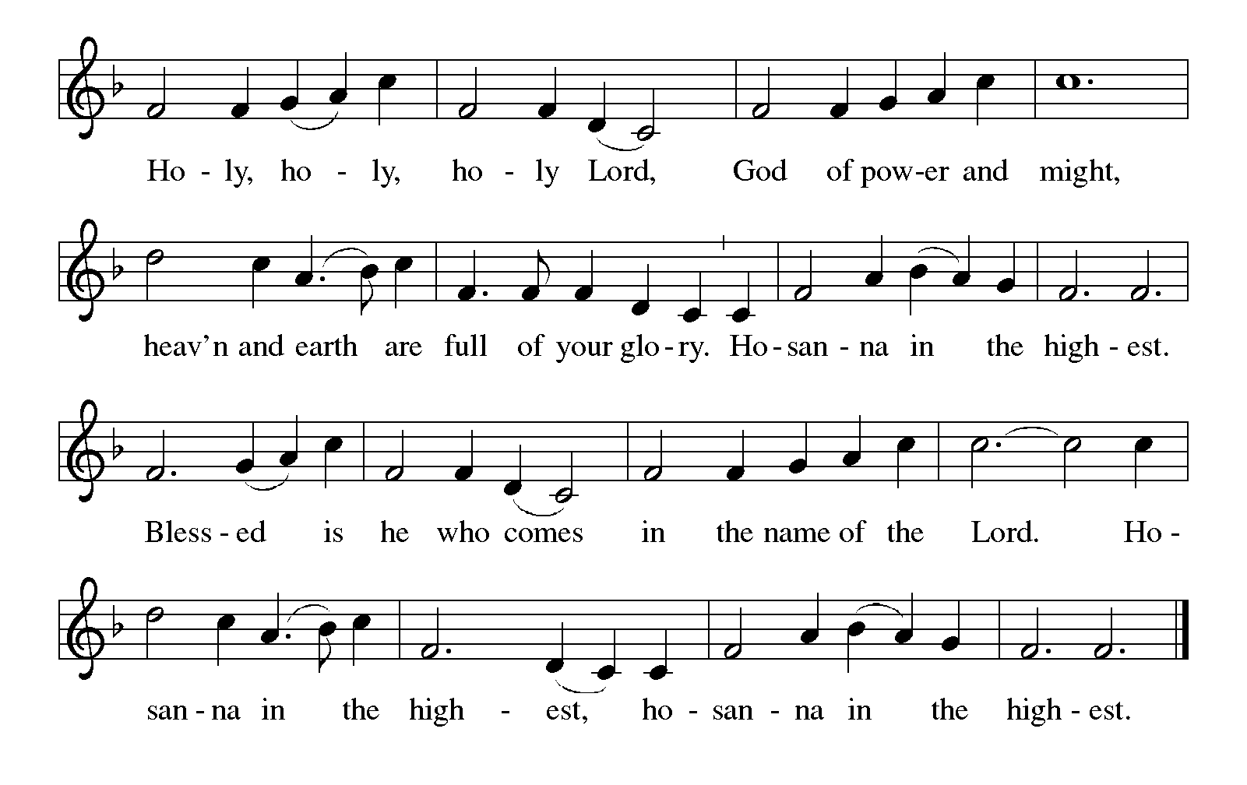

Thanksgiving at the Table
In the night in which he was betrayed,
our Lord Jesus took bread, and gave thanks;
broke it, and gave it to his disciples, saying:
Take and eat; this is my body, given for you.
Do this for the remembrance of me.

Again, after supper, he took the cup, gave thanks,
and gave it for all to drink, saying:
This cup is the new covenant in my blood,
shed for you and for all people for the forgiveness of sin.
Do this for the remembrance of me.

For as often as we eat of this bread and drink from this cup,
we proclaim the Lord’s death until he comes.

Lord’s Prayer
Gathered into one by the Holy Spirit, let us pray as Jesus taught us.
Our Father, who art in heaven,
hallowed be thy name,
thy kingdom come,
thy will be done,
on earth as it is in heaven.
Give us this day our daily bread;
and forgive us our trespasses,
as we forgive those
who trespass against us;
and lead us not into temptation,
but deliver us from evil.
For thine is the kingdom,
and the power, and the glory,
forever and ever. Amen.

INVITATION TO COMMUNION
Come to the banquet, for all is now ready.

COMMUNION *continuous
*People are welcome to kneel at the altar rail for a time of prayer after they receive their communion elements.

COMMUNION HYMNS

“Give Me Jesus” #770

“Just As I Am, Without One Plea” #592

PRAYER AFTER COMMUNION
Let us pray.
We give you thanks, almighty God, that you have refreshed us through the healing power of this gift of life. In your mercy, strengthen us through this gift, in faith toward you and in fervent love toward one another; for the sake of Jesus Christ our Lord.
Amen.

Sending
God blesses us and sends us in mission to the world.

Blessing
The Lord bless you and keep you.
The Lord’s face shine on you with grace and mercy.
The Lord look upon you with favor and ☩ give you peace.
Amen.

Sending SonG “We Are Baptized in Christ Jesus” #451

Dismissal
Go in peace. Christ is with you.
Thanks be to God.
From sundaysandseasons.com. Copyright © 2017 Augsburg Fortress. All rights reserved.

Thank you to all who served in worship today!
Presiders: Pastor Ken Scheck Musician: Jayne Flanigan
Acolyte: Safety Person:
Elder: Naomi Wilson Trustee: Tom Krikke
Offering Counters: Doug MacKenzie & Mike Johnson


PRAYERS OF THE FAITHFUL

With thanks for all God’s blessings and his love for all people. Our Bishops, Julie Schneider-Thomas, Yehiel Curry, and the congregations of the North/West Lower Michigan Synod, and especially for Advent Lutheran in Lake Ann and their pastor Rev. Rosanne Anderson.

Prayers for our friends, for all who are sick or hospitalized and for all health care workers who care for them. All those members of Zion’s family traveling; all those homebound or in frail health; all those suffering with quiet, unknown needs or worries. For those who serve on our behalf: public safety, utility workers, medical personnel, military personnel. For those who might be forgotten.

This week at Zion:
- Charity Circle, Marie Brodbeck’s, Sunday, October 19th at 2 pm
- Men’s Coffee, 8 AM, Wednesday, October 15
- Bulletin Deadline, Wednesday, October 15
- Disciple Group, Martha’s, Wednesday, October 22 at 10 am
- Newsletter Deadline, Thursday, October 23

ONLINE GIVING
Zion has received a QR code to facilitate online giving. If you are interested in donating online instead of bringing your donation to church, simply scan the QR code and it will direct you to the appropriate site. The code is on our website as well.

ANNOUNCEMENT

- Baptisms: Today we welcome Natasha Miller, Norman Miller, Terry Miller, Paytan Martinez, and William Peake into the family of Christ through baptism. Please support and welcome these people as they join the body of Christ.
- Halloween Party: Join us for a Halloween Party following worship on October 19th. Please sign-up in the narthex so we know how many to plan for. We will be having a planned potluck and look for signup sheets for items needed, also.
- Shut-In Bags: There are Harvest-Halloween shut-in bags in the fellowship hall. There are 10 bags, 3 are couples. Please bring a treat, card or other seasonal item for the bags. We will be asking for volunteers to distribute the bags today.
- Altar Flowers: If you are interested in putting flowers on the altar in memory of a loved one, please let Mary Makley know.
- Announcement and Newsletter Items: Please forward items for the bulletin announcements and the newsletter to the church email (Office@Zion.org). Please do not send items to people’s personal emails. Thank you.
- Door Locking Policy: Our door locking policy relies on having a volunteer(s) each Sunday to serve as the Safety Person of the Day. On Sundays where no one has volunteered, if someone arrives at church and is willing to be the Safety Person of the Day, we will follow the door locking policy. If no one steps forward to serve as the Safety Person of the Day, the doors will not be locked. Please consider volunteering for this important duty.

