ZION LUTHERAN CHURCH, WOODLAND, MI
Reformation Sunday October 26, 2025
*If you are listening in your car, please tune your radio to FM 87.7*
(Please silence your cell phones while in the sanctuary. Thank you.)
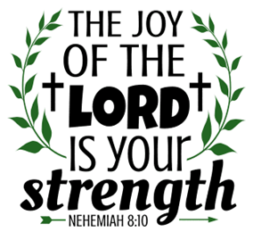

WELCOME AND ANNOUNCEMENTS

Gathering
The Holy Spirit calls us together as the people of God.

Confession and Forgiveness
In the name of the Father,
and of the ☩ Son,
and of the Holy Spirit.
Amen.

Almighty God, to whom all hearts are open, all desires known, and from whom no secrets are hid: cleanse the thoughts of our hearts by the inspiration of your Holy Spirit, that we may perfectly love you and worthily magnify your holy name, through Jesus Christ our Lord.
Amen.

Let us confess our sin in the presence of God and of one another. Most merciful God,
we confess that we are captive to sin and cannot free ourselves. We have sinned against you in thought, word, and deed, by what we have done and by what we have left undone. We have not loved you with our whole heart; we have not loved our neighbors as ourselves. For the sake of your Son, Jesus Christ, have mercy on us. Forgive us, renew us, and lead us, so that we may delight in your will and walk in your ways, to the glory of your holy name.
Amen.

God, who is rich in mercy, loved us even when we were dead in sin, and made us alive together with Christ. By grace you have been saved. In the name of ☩ Jesus Christ, your sins are forgiven. Almighty God strengthen you with power through the Holy Spirit, that Christ may live in your hearts through faith.
Amen.
Gathering Song “A Mighty Fortress Is Our God” #504

GREETING
The grace of our Lord Jesus Christ, the love of God, and the communion of the Holy Spirit be with you all.
And also with you.

Prayer of the Day
Let us pray together.
Almighty God, gracious Lord, we thank you that your Holy Spirit renews the church in every age. Pour out your Holy Spirit on your faithful people. Keep them steadfast in your word, protect and comfort them in times of trial, defend them against all enemies of the gospel, and bestow on the church your saving peace, through Jesus Christ, our Savior and Lord, who lives and reigns with you and the Holy Spirit, one God, now and forever.
Amen.

First Reading Jeremiah 31:31-34A
A reading from Jeremiah.

³¹ The days are surely coming, says the Lord, when I will make a new covenant with the house of Israel and the house of Judah. ³² It will not be like the covenant that I made with their ancestors when I took them by the hand to bring them out of the land of Egypt—a covenant that they broke, though I was their husband, says the Lord. ³³ But this is the covenant that I will make with the house of Israel after those days, says the Lord: I will put my law within them, and I will write it on their hearts, and I will be their God, and they shall be my people. ³⁴ No longer shall they teach one another or say to each other, “Know the Lord,” for they shall all know me, from the least of them to the greatest, says the Lord, for I will forgive their iniquity and remember their sin no more.

The word of the Lord
Thanks be to God.

Psalm Psalm 46

¹ God is our ref- | uge and strength,
a very present | help in trouble.
² Therefore we will not fear, though the | earth be moved,
and though the mountains shake in the depths | of the sea;
³ though its waters | rage and foam,
and though the mountains tremble | with its tumult.
⁴ There is a river whose streams make glad the cit- | y of God,
the holy habitation of | the Most High.
⁵ God is in the midst of the city; it shall | not be shaken;
God shall help it at the | break of day.
⁶ The nations rage, and the | kingdoms shake;
God speaks, and the earth | melts away.
⁷ The Lord of | hosts is with us;
the God of Jacob | is our stronghold.
⁸ Come now, regard the works | of the Lord,
what desolations God has brought up- | on the earth;
⁹ behold the one who makes war to cease in | all the world;
who breaks the bow, and shatters the spear, and burns the | shields with fire.
¹⁰ “Be still, then, and know that | I am God;
I will be exalted among the nations; I will be exalted | in the earth.”
¹¹ The Lord of | hosts is with us;
the God of Jacob | is our stronghold.

Second Reading Romans 3:19-28
A reading from Romans.

¹⁹ Now we know that, whatever the law says, it speaks to those who are under the law, so that every mouth may be silenced and the whole world may be held accountable to God. ²⁰ For no human will be justified before him by deeds prescribed by the law, for through the law comes the knowledge of sin.
²¹ But now, apart from the law, the righteousness of God has been disclosed and is attested by the Law and the Prophets, ²² the righteousness of God through the faith of Jesus Christ for all who believe. For there is no distinction, ²³ since all have sinned and fall short of the glory of God; ²⁴ they are now justified by his grace as a gift, through the redemption that is in Christ Jesus, ²⁵ whom God put forward as a sacrifice of atonement by his blood, effective through faith. He did this to demonstrate his righteousness, because in his divine forbearance he had passed over the sins previously committed; ²⁶ it was to demonstrate at the present time his own righteousness, so that he is righteous and he justifies the one who has the faith of Jesus.
²⁷ Then what becomes of boasting? It is excluded. Through what kind of law? That of works? No, rather through the law of faith. ²⁸ For we hold that a person is justified by faith apart from works prescribed by the law.

The Word of the Lord
Thanks be to God.

Gospel Acclamation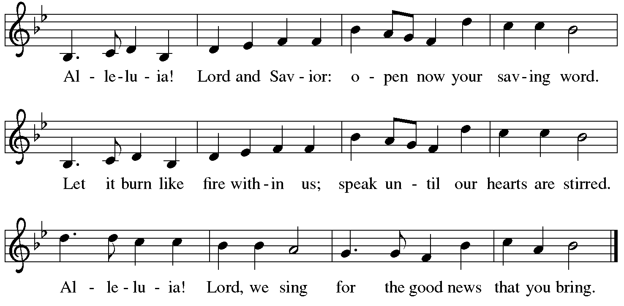

Gospel John 8:31-36
The holy gospel according to John.

³¹ Jesus said to the Jews who had believed in him, “If you continue in my word, you are truly my disciples, ³² and you will know the truth, and the truth will make you free.” ³³ They answered him, “We are descendants of Abraham and have never been slaves to anyone. What do you mean by saying, ‘You will be made free’?”
³⁴ Jesus answered them, “Very truly, I tell you, everyone who commits sin is a slave to sin. ³⁵ The slave does not have a permanent place in the household; the son has a place there forever. ³⁶ So if the Son makes you free, you will be free indeed.”

The gospel of the Lord.
Praise to you, O Christ.

CHILDREN’S MOMENT

SERMON Pastor Mike Anderson

hymn of the day “Built On A Rock” #652

cREED
I believe in God, the Father almighty,
creator of heaven and earth.
I believe in Jesus Christ, God’s only Son, our Lord,
who was conceived by the Holy Spirit,
born of the virgin Mary,
suffered under Pontius Pilate,
was crucified, died, and was buried;
he descended to the dead.*
On the third day he rose again;
he ascended into heaven,
he is seated at the right hand of the Father,
and he will come to judge the living and the dead.
I believe in the Holy Spirit,
the holy catholic church,
the communion of saints,
the forgiveness of sins,
the resurrection of the body,
and the life everlasting. Amen.

*Or, “he descended into hell,” another translation of this text in widespread use.

prayers of Intercession
Renewed in God’s everlasting grace, let us pray for the church, the world, and all creation.
A brief silence.
Free your church, O God, with grace, mercy, and love to be transformed by your word. Direct your church to be united in word and deed so that all creation knows the uniting and transforming power of the gospel. We pray especially for Bethlehem Lutheran in Lansing and their pastor Matt Smith. God of grace,
receive our prayer.
Renew creation, O God, so that all living creatures thrive together. Guide those who work to restore and renew creation. Preserve and care for endangered species throughout the world. God of grace,
receive our prayer.
Bring peace among the nations, O God, so violence and terror are not the norm on your earth. Inspire leaders of communities to work for peace and justice. Unite our politicians with a common mission and purpose. God of grace,
receive our prayer.
Heal all who suffer, O God, and bring them peace. Draw near to people who are incarcerated. Give hope to people experiencing housing or employment insecurity, oppression, or discrimination. Heal those who are ill. Be our stronghold at all times. God of grace,
receive our prayer.
Forgive us our sins, O God, and grant us your grace. Move us to understanding and reconciliation between people of other faiths and other Christian traditions in our community. Mend hurt feelings and heal wounds we have caused one another. God of grace,
receive our prayer.
We give you thanks, O God, for the life and witness of all your saints. Give us hope in your son’s victory through the cross. God of grace,
receive our prayer.
We offer our prayers, O God, trusting in your everlasting grace and mercy, through Jesus Christ our Lord.
Amen.

PEACE
The peace of Christ be with you always.
And also with you.

OFFERING & OFFERING SONG
The joy of the Lord is my strength,
The joy of the Lord is my strength,
The joy of the Lord is my strength,
The joy of the Lord is my strength.

Offering Prayer
Let us pray.
God of all creation, all you have made is good, and your love endures forever. You bring forth bread from the earth and fruit from the vine. Nourish us with these gifts, that we might be for the world signs of your gracious presence in Jesus Christ, our Savior and Lord.
Amen.

DIALOGUE
The Lord be with you.
And also with you.
Lift up your hearts.
We lift them to the Lord.
Let us give thanks to the Lord our God.
It is right to give our thanks and praise.

PREFACE (Pastor)
It is indeed right, our duty and our joy,
that we should at all times and in all places
give thanks and praise to you, almighty and merciful God,
through our Savior Jesus Christ;
who on this day overcame death and the grave,
and by his glorious resurrection opened to us the way of everlasting life.
And so, with all the choirs of angels,
with the church on earth and the hosts of heaven,
we praise your name and join their unending hymn

holy, holy, holy
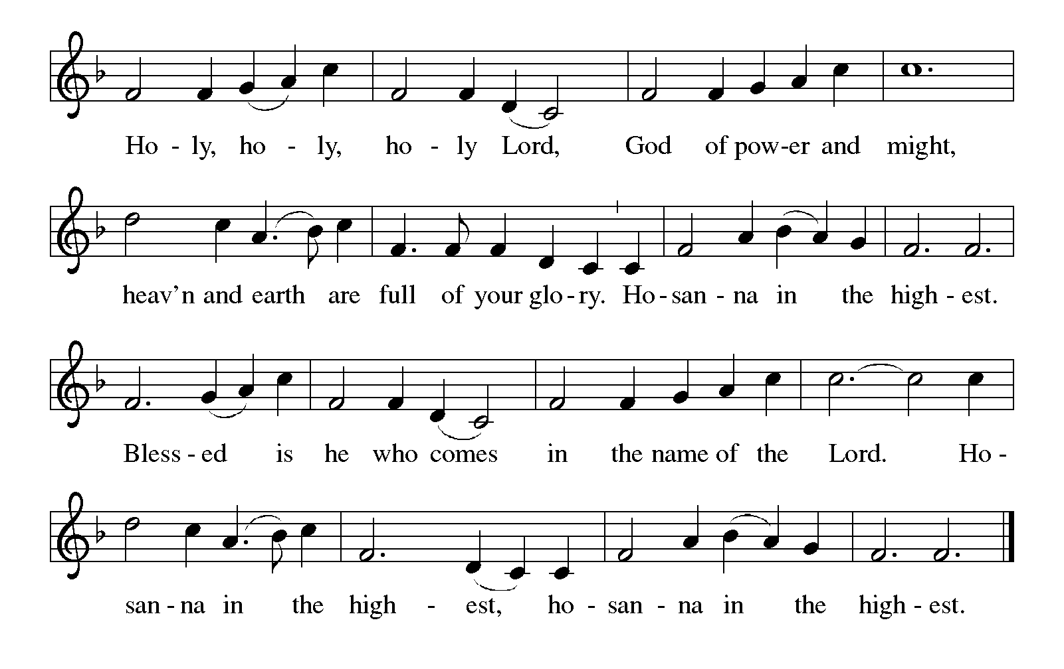

Thanksgiving at the Table
In the night in which he was betrayed,
our Lord Jesus took bread, and gave thanks;
broke it, and gave it to his disciples, saying:
Take and eat; this is my body, given for you.
Do this for the remembrance of me.

Again, after supper, he took the cup, gave thanks,
and gave it for all to drink, saying:
This cup is the new covenant in my blood,
shed for you and for all people for the forgiveness of sin.
Do this for the remembrance of me.

For as often as we eat of this bread and drink from this cup,
we proclaim the Lord’s death until he comes.

Lord’s Prayer
Gathered into one by the Holy Spirit, let us pray as Jesus taught us.
Our Father, who art in heaven,
hallowed be thy name,
thy kingdom come,
thy will be done,
on earth as it is in heaven.
Give us this day our daily bread;
and forgive us our trespasses,
as we forgive those
who trespass against us;
and lead us not into temptation,
but deliver us from evil.
For thine is the kingdom,
and the power, and the glory,
forever and ever. Amen.

INVITATION TO COMMUNION
Come to the banquet, for all is now ready.

COMMUNION *continuous
*People are welcome to kneel at the altar rail for a time of prayer after they receive their communion elements.

COMMUNION HYMNS

“Listen, God Is Calling” #513

“Let Us Break Bread Together” #471

PRAYER AFTER COMMUNION
Let us pray.
We give you thanks, almighty God, that you have refreshed us through the healing power of this gift of life. In your mercy, strengthen us through this gift, in faith toward you and in fervent love toward one another; for the sake of Jesus Christ our Lord.
Amen.

Sending
God blesses us and sends us in mission to the world.

Blessing
The Lord bless you and keep you.
The Lord’s face shine on you with grace and mercy.
The Lord look upon you with favor and ☩ give you peace.
Amen.

Sending SonG “The Church's One Foundation” #654

Dismissal
Go in peace. Christ is with you.
Thanks be to God.
From sundaysandseasons.com. Copyright © 2017 Augsburg Fortress. All rights reserved.

Thank you to all who served in worship today!
Presiders: Pastor Mike Anderson Musician: Martha Yoder
Acolyte: Kole Hokanson Safety Person:
Elder: Dan Utterback Trustee: Mike Johnson
Offering Counters: Mary Makley & Martha Yoder



PRAYERS OF THE FAITHFUL

With thanks for all God’s blessings and his love for all people. Our Bishops, Julie Schneider-Thomas, Yehiel Curry, and the congregations of the North/West Lower Michigan Synod, and especially for Bethlehem Lutheran in Lansing and their pastor Matt Smith.

Prayers for our friends, for all who are sick or hospitalized and for all health care workers who care for them. All those members of Zion’s family traveling; all those homebound or in frail health; all those suffering with quiet, unknown needs or worries. For those who serve on our behalf: public safety, utility workers, medical personnel, military personnel. For those who might be forgotten.

This week at Zion:

- Men’s Coffee, 8 AM, Wednesday, October 29
- Bulletin Deadline, Wednesday, October 29


ONLINE GIVING
Zion has received a QR code to facilitate online giving. If you are interested in donating online instead of bringing your donation to church, simply scan the QR code and it will direct you to the appropriate site. The code is on our website as well.

ANNOUNCEMENT
- Today: Lunch after worship for Pastor Appreciation for Paster Mike Anderson and Vicki. Lunch is hosted by the Board of Evangelism. Please stay for this time of fellowship
- Altar Flowers: If you are interested in putting flowers on the altar in memory of a loved one, please let Mary Makley know.
- Announcement and Newsletter Items: Please forward items for the bulletin announcements and the newsletter to the church email (Office@Zion.org). Please do not send items to people’s personal emails. Thank you.
- Door Locking Policy: Our door locking policy relies on having a volunteer(s) each Sunday to serve as the Safety Person of the Day. On Sundays where no one has volunteered, if someone arrives at church and is willing to be the Safety Person of the Day, we will follow the door locking policy. If no one steps forward to serve as the Safety Person of the Day, the doors will not be locked. Please consider volunteering for this important duty.

