ZION LUTHERAN CHURCH, WOODLAND, MI
Twenty First Sunday After Pentecost November 2, 2025
*If you are listening in your car, please tune your radio to FM 87.7*
(Please silence your cell phones while in the sanctuary. Thank you.)



ZLCW THANKOFFERING SERVICE
NOVEMBER 2, 2025

Welcome and Announcements

Gathering Hymn – Lift High the Cross - 660

Thanksgiving for Baptism
We gather in the name of our creator, redeemer +, and sustainer.
Amen.

Joined to Christ and named as God’s beloved, we give thanks for the gift of baptism that roots us in life, renews us in strength, and frees us to be bold.

We give you thanks, O God,
For at the beginning of time, your creative spirit moved over the waters, your Word brought new life, and you called it good.
We give you thanks, O God, for waters that sustain and heal.
You revealed a spring of water to Hagar, saving her and her son Ishmael.
You brought your people out of the waters of the Exodus, leading Miriam to shout out in song.
You held Moses in the River Nile, where Pharaoh’s daughter would find him and care for him as her own.
You kept the party going when, at Mary’s request, Jesus turned water into wine at a wedding.
You led a Samaritan woman to a well, where she would be met by Jesus’ grace and given living water that lasts.

Even today, you shower us with life, and we praise you. With your living water, sustain our souls, show us empathy and welcome, give us strength, and lead us by your divine spark to lives of compassion and mercy.
Amen.
Greeting
The grace of our Lord Jesus, the love of God, and the communion of the Holy Spirit be with you all. And also with you.
Hymn of Praise – I Want to Walk as a Child of the Light – 815 (first 2 verses)

Prayer (written by Zarah Van Dyk ‘26)
God of Glory, we are gathered today in your presence to celebrate and give thanks for all of the gifts and talents given to women. While we recognize the abundance we have, we also recognize the struggles of women in our own country and around the world. Sometimes these struggles are voiced or are internal conflicts that only You know about. Lord, bring peace and joy to our hearts today. Allow us to fully absorb the presence of you and of the community of strong women surrounding us. Amen.

Readings
First Lesson: Naomi and Ruth (soul). Ruth 1:7-16
Ruth is a story of deep faithfulness, empathy, and compassion amid adversity. The story's soul demonstrates the power of love to triumph over hopelessness and to bridge great differences. For women like Ruth and Noami, whose empathy heals generational wounds, we give thanks.
⁷So Naomi set out from the place where she had been living, she and her two daughters-in- law, and they went on their way to go back to the land of Judah. ⁸But Naomi said to her two daughters-in-law, "Go back each of you to your mother's house. May the LORD deal kindly with you, as you have dealt with the dead and with me. ⁹The LORD grant that you may find security, each of you in the house of your husband." Then she kissed them, and they wept aloud. ¹⁰They said to her, "No, we will return with you to your people." ¹¹But Naomi said, "Turn back, my daughters, why will you go with me?...No, my daughters, it has been far more bitter for me than for you, because the hand of the LORD has turned against me." ¹⁴Then they wept aloud again. Orpah kissed her mother-in-law, but Ruth clung to her.
¹⁵So Naomi said, "See, your sister-in-law has gone back to her people and to her gods; return after your sister-in-law." ¹⁶But Ruth said,
"Do not press me to leave you
or to turn back from following you!
Where you go, I will go;
where you lodge, I will lodge,
your people shall be my people,
and your God my God.
Holy Wisdom, Living Word.
Thanks be to God.

Psalm 139 Verses 1 to 14 (read alternative verses reader and congregation reads bold)
O Lord, you have searched me and known me.
² You know when I sit down and when I rise up;
you discern my thoughts from far away.
³ You search out my path and my lying down
and are acquainted with all my ways.
⁴ Even before a word is on my tongue,
O Lord, you know it completely.
⁵ You hem me in, behind and before,
and lay your hand upon me.
⁶ Such knowledge is too wonderful for me;
it is so high that I cannot attain it.
⁷ Where can I go from your spirit?
Or where can I flee from your presence?
⁸ If I ascend to heaven, you are there;
if I make my bed in Sheol, you are there.
⁹ If I take the wings of the morning
and settle at the farthest limits of the sea,
¹⁰ even there your hand shall lead me,
and your right hand shall hold me fast.
¹¹ If I say, “Surely the darkness shall cover me,
and night wraps itself around me,”^{[a]}
¹² even the darkness is not dark to you;
the night is as bright as the day,
for darkness is as light to you.
¹³ For it was you who formed my inward parts;
you knit me together in my mother’s womb.
¹⁴ I praise you, for I am fearfully and wonderfully made.
Wonderful are your works; that I know very well.

Second Lesson: Lydia (Faith) Acts 16:11-15
Lydia is one of the women we encounter in the book of Acts. She is a business person selling purple cloth, which was a very expensive commodity in her time. Paul and Timothy encounter this gentile woman and she and her household were baptized.

11 We therefore set sail from Troas and took a straight course to Samothrace, the following day to Neapolis, 12 and from there to Philippi, which is the leading city of the district of Macedonia and a Roman colony. We remained in the city for some days. 13 On the Sabbath day we went outside the gate by the river, where we supposed there was a place of prayer, and we sat down and spoke to the women who gathered there. 14 A certain women named Lydia, a worshiper of God, was listening to us; she was from the city Thyatira and a dealer in purple cloth. The Lord opened her to listen eagerly to what was said by Paul. 15 When she and her household were baptized, she urged us saying, “If you have judged me to be faithful to the Lord, come and stay at my home.” And she prevailed upon us.

The Word of the Lord
Thanks be to God

Gospel Acclamation
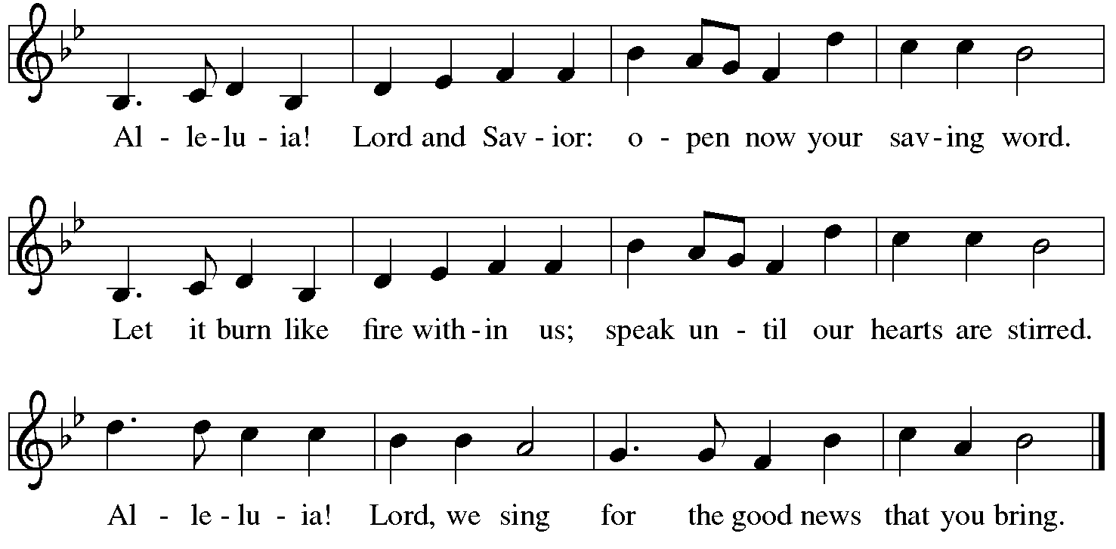

Gospel: The women who bled for twelve years (strength). Matthew 9:18-25
Through a bold woman, Jesus demonstrates God’s mercy and power by accepting the unacceptable and curing the incurable. Even the dead receive new life. For unnamed women who fight to be seen and heard, we give thanks.
The Holy Gospel according to Matthew, the ninth chapter.
Glory to you, O Lord.
18 While [Jesus] was saying these things to them, suddenly a leader came in and knelt before him, saying, “My daughter has just died, but come and lay your hand on her, and she will live.” 19 And Jesus got up and followed him, with his disciples. 20 Then suddenly a woman who had been suffering from a flow of blood for twelve years came up behind him and touched the fringe of his cloak, 21 for she was saying to herself, “If I only touch his cloak, I will be made well.” 22 Jesus turned, and seeing her he said, “Take heart, daughter; your faith has made you well.” And the woman was made well from that moment. 23 When Jesus came to the leader’s house and saw the flute players and the crowd making a commotion, 24 he said, “Go away, for the girl is not dead but sleeping.” And they laughed at him. 25 But when the crowd had been put outside, he went in and took her by the hand, and the girl got up.
After the Gospel is shared:
The Gospel, the Good News made real for you.
Praise to you, O Christ!

Children’s Moment

Message – Jolene Griffin

Hymn of the Day – Let Us Ever Walk With Jesus – 802

CREED
I believe in God, the Father almighty,
Creator of heaven and earth.
I believe in Jesus Christ, God’s only Son, our Lord,
born of the Virgin Mary,
suffered under Pontius Pilot,
was crucified, died, and was buried;
he descended to the dead,*
On the third day he rose again;
he ascended into heaven,
he is seated at the right hand of the Father,
and he will come to judge the living and the dead.
I believe in the Holy Spirit,
the holy catholic church,
the communion of saints,
the forgiveness of sins,
the resurrection of the body,
and the life everlasting. Amen.
- Or, “he descended into hell” another translation of this text in widespread use

PRAYERS OF INTERCESSION
In solidarity with your people from every nation and knit together with all of creation, we boldly pray for the church, our world, and all those in need. We pray especially for Grace Lutheran Church in Lansing, and their pastor Rev. Byan Schneider-Thomas. God our soul,
Hear our prayer.
Inspire your church, like Ruth and Naomi, to extend arms of compassion and empathy in times of challenge. Equip communities to be welcoming, to show mercy, and to lean into relationships so that all people may know your care. God our soul,
Hear our prayer.
Guide leaders to reflect the spark of your divine wisdom. Open eyes to see the goodness of your created world and encourage the tender care of those cast aside. Reveal yourself in unexpected places and in the leadership of those called to help. God our Spark,
Hear our prayer.
Bring healing, like the woman who bled for twelve years, to all who are suffering. Give strength to the weary, uplift the lowly, and amplify the voices of those quieted. Breathe new life into forgotten places, end wars, rejuvenate lands, and uplift spirits. Be our stronghold at all times. God our Strength,
Hear our prayer.
Trusting in your love for us, we offer these prayers and whatever else weighs heavy upon us to you, in the name of Jesus. Amen.

PEACE
The peace of Christ be with you always.
And also with you.

THANKOFFERING - Taken at this time.

OFFERING PRAYER
God of Abundance,
You create goodness in everything we offer. Use these gifts to bless the world. Strengthen ministries, empower leaders, and inspire generosity so that all may know your love. Reveal this love to us once again as we gather at your table that we might embody your compassionate care in all we do. Amen.

LORD’S PRAYER
Our Father, who art in heaven
hallowed be thy name,
thy kingdom come,
thy will be done
on earth as it is in heaven.
Give us this day our daily bread;
and forgive us our trespasses,
as we forgive those who trespass against
and lead us not into temptation,
but deliver us from evil.
For thine is the kingdom,
and the power, and the glory,
forever and ever. Amen.

Blessing (written by Carter Horman‘28)
Receive the blessing of God who breathes creativity into every soul and lights up every vision with purpose.
Bless the women of the world with the strength that they need, with empathy that brings us together, and with gratitude that moves us all forward.
May your love be our guide, and your justice our song that we sing and live out each day.

Sending Hymn – Peace Like a River – 785

Sending
Go in peace to love and serve the Lord!
All: Thanks be to God!

Thank you to all who served in worship today!
Presiders: Jolene Griffin Musician: Martha Yoder
Acolyte: Aliyanna Morado Safety Person:
Elder: Buffy Meyers Trustee: Doug MacKenzie
Offering Counters: Mary Makley & Diane Griffin



PRAYERS OF THE FAITHFUL

With thanks for all God’s blessings and his love for all people. Our Bishops, Julie Schneider-Thomas, Yehiel Curry, and the congregations of the North/West Lower Michigan Synod, and especially for Grace Lutheran Church in Lansing, and their pastor Rev. Byan Schneider-Thomas.

Prayers for our friends, for all who are sick or hospitalized and for all health care workers who care for them. All those members of Zion’s family traveling; all those homebound or in frail health; all those suffering with quiet, unknown needs or worries. For those who serve on our behalf: public safety, utility workers, medical personnel, military personnel. For those who might be forgotten.

This week at Zion:
- Men’s Coffee, 8 AM, Wednesday, November, 5
- Bulletin Deadline, Wednesday, November, 5


ONLINE GIVING
Zion has received a QR code to facilitate online giving. If you are interested in donating online instead of bringing your donation to church, simply scan the QR code and it will direct you to the appropriate site. The code is on our website as well.

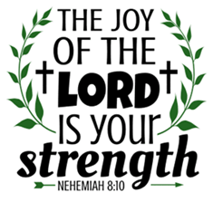
ANNOUNCEMENT
- Pray Without Ceasing: Our Pray Without Ceasing services will resume next Sunday, November 9th following worship. We have not held services the past two Sundays or today due to conflicts with other church activities following worship. Everyone is invited to participate in this special time of prayer.
- Pastor Mike Anderson: Pastor Anderson was very appreciative of the card, gift card, and lunch provided to recognize him last Sunday. He said, "Thank you for the privilege of being at Zion. I cannot tell you enough how impressed I am with Zion people." We appreciate Pastor Mike's leading us in worship the past few months.
- Special Congregational Meeting: A special congregational meeting will be held on November 16th to seek tentative approval for discussions regarding a shared ministry with Pastor Ken Scheck and Grace Lutheran Church, Hastings. Details about the shared ministry and the financial costs will be provided at the meeting. The meeting wil be immediately following worship. If you have questions, please talk with Paul Meade or a member of the church council.
- Zion Christmas Tree Farm and Market Ministry: Our free Christmas ministry will be on November 14 and 15 this year. If you can lend a hand to set up prior to the event or help with the event that would be very appreciated. There is a sign-up sheet in the Narthex along with a flyer with more details. If you have questions, please talk with Martha, Karen or Ruth. Thank you.
- Festival of Tables, November 8th, 9 am to 12 noon: The Lakewood Community Women is sponsoring a free Festival of Tables on November 8th at Clarksville Bible Church. The morning will include viewing the tables decorated in fall themes, enjoying brunch, listening to two local women, Barb Bosworth and Jessi Trierweiler, speak on harvest blessings. All women are invited to attend. The Zion Coffee Fellowship women are sponsoring a table, “Thank You for the Birds so Sweet.” There is room at the table for you! If interested there is a sign-up sheet in the narthex. If you have questions, please talk with Martha, Karen, or Ruth.
- Altar Flowers: If you are interested in putting flowers on the altar in memory of a loved one, please let Mary Makley know.
- Announcement and Newsletter Items: Please forward items for the bulletin announcements and the newsletter to the church email (Office@Zion.org). Please do not send items to people’s personal emails. Thank you.
- Door Locking Policy: Our door locking policy relies on having a volunteer(s) each Sunday to serve as the Safety Person of the Day. On Sundays where no one has volunteered, if someone arrives at church and is willing to be the Safety Person of the Day, we will follow the door locking policy. If no one steps forward to serve as the Safety Person of the Day, the doors will not be locked. Please consider volunteering for this important duty.

