 |  |  |  |  |  | 1 All Saints’ Day
2 Thankoffering Service – 10:30  Sunday School 9:15 am  POTLUCK | 3 | 4 | 5 Mens Breakfast  Bulletin Deadline | 6 | 7 | 8
9 Communion Pastor Frank Rothfuss 10:30 am Sunday School 9:15 am | 10  | 11 Veteran’s Day  Council 6:30pm  Circle 1pm | 12 Mens Breakfast  Bulletin Deadline | 13 | 14 Church – Christmas Tree Farm set up  Nov. 9th to 15th | 15 
16 Communion Pastor Ken Scheck 11am Sunday School 9:15 am | 17 | 18 | 19 Mens Breakfast  Bulletin Deadline | 20  Womens Breakfast 9am  C & R Lake Odessa  Newsletter Deadline | 21 | 22
23 Service 10:30 Sunday School 9:15 am | 24 | 25 | 26 Mens Breakfast  Bulletin Deadline | 27 Thanksgiving  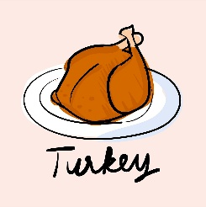 | 28 | 29
30 Service 10:30
Sunday School 9:15am

