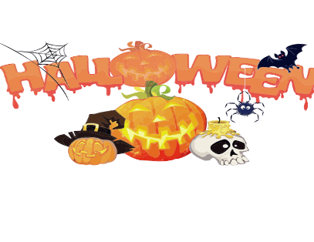
HALLOWEEN PARTY
We will be having a Halloween Party following worship on October 19th. Please sign up in the narthex, so we know how many to plan for. We will be having a planned potluck and look for signup sheets for items needed, also. The table format of trick or treating will be also in the Fellowship Hall for the kids. If you want to have a table for handing out a treat, creating a craft or playing a game, let Dawn B. or Buffy M. know, so we can arrange the tables. Hope to see all of you there!
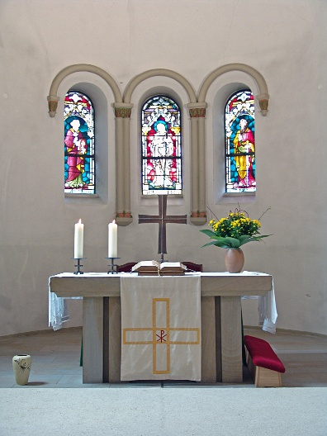
ALTAR FLOWERS
If you are interested in putting flowers on the altar in memory of a loved one, please let Mary Makley know.

SHUT-IN BAGS
There are Harvest/Halloween shut-in bags are in the fellowship hall. There are bags total and three of these are couple bags. Please bring treats, cards or other seasonal items for the bags. We will be asking volunteers to distribute these bags Sunday, October 19th.

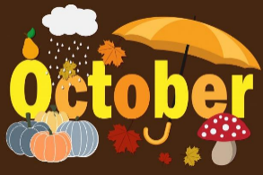

REFORMATION DAY
Reformation Day, 31 October, commemorates the occasion in 1517 when Martin Luther nailed his Ninety-Five Theses on the door of the Castle Church in Wittenberg, Germany, as a sign of protest. He wanted to initiate an academic debate because he opposed the prevailing view that salvation from sin was possible through absolution in the form of a payment of money. Instead, he insisted on justification through faith. (credit: Lutheran World Foundation).
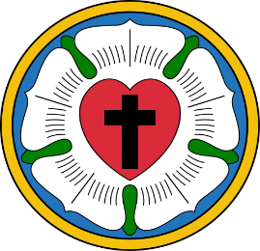

OCTOBER CLEANING
Dan & Cindy Utterback
Doug Makley
Mary Makley

SERVING COFFEE FELLOWSHIP
Dawn Brodbeck
Doug Makley
Buffy Meyers

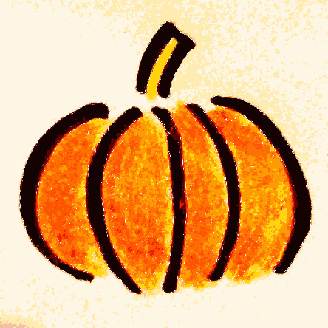

Those Who Serve
October 5 – Communion 10:30 am
Rev. David Sprang
Acolyte: Kole Hokanson
Elder: Dan Utterback
Trustee: Mike Johnson
Musician: Martha Yoder
Counters: Diane Griffin & Carlotta Willard

October 12 Communion 10:30am
Rev. Mike Anderson
Acolyte: Aliyanna Morado
Elder: Buffy Meyers
Trustee: Doug Mackensie
Musician: Jayne Flanigan
Counters: Paul Meade & Carlotta Willard

October 19 Communion 11 am
Rev. Ken Scheck
Acolyte:
Elder: Naomi Wilson
Trustee: Tom Krikke
Musician: Jayne Flanigan
Counters: Doug Mackenzie & Mike Johnson

October 26 Communion 10:30 am
Rev. Mike Anderson
Acolyte: Kole Hokanson
Elder: Dan Utterback
Trustee: Mike Johnson
Musician: Martha Yoder
Counters: Mary Makley & Martha Yoder

