ZION LUTHERAN CHURCH, WOODLAND, MI
Twenty Third Sunday November 16, 2025
*If you are listening in your car, please tune your radio to FM 87.7*
(Please silence your cell phones while in the sanctuary. Thank you.)


WELCOME AND ANNOUNCEMENTS

Gathering
The Holy Spirit calls us together as the people of God.

Confession and Forgiveness
In the name of the Father,
and of the ☩ Son,
and of the Holy Spirit.
Amen.

Almighty God, to whom all hearts are open, all desires known, and from whom no secrets are hid: cleanse the thoughts of our hearts by the inspiration of your Holy Spirit, that we may perfectly love you and worthily magnify your holy name, through Jesus Christ our Lord.
Amen.

Let us confess our sin in the presence of God and of one another. Most merciful God,
we confess that we are captive to sin and cannot free ourselves. We have sinned against you in thought, word, and deed, by what we have done and by what we have left undone. We have not loved you with our whole heart; we have not loved our neighbors as ourselves. For the sake of your Son, Jesus Christ, have mercy on us. Forgive us, renew us, and lead us, so that we may delight in your will and walk in your ways, to the glory of your holy name.
Amen.

God, who is rich in mercy, loved us even when we were dead in sin, and made us alive together with Christ. By grace you have been saved. In the name of ☩ Jesus Christ, your sins are forgiven. Almighty God strengthen you with power through the Holy Spirit, that Christ may live in your hearts through faith.
Amen.

Gathering Song “Through the Night of Doubt and Sorrow” #327

GREETING
The grace of our Lord Jesus Christ, the love of God, and the communion of the Holy Spirit be with you all.
And also with you.

Prayer of the Day
Let us pray together.
O God, the protector of all who trust in you, without you nothing is strong, nothing is holy. Embrace us with your mercy, that with you as our ruler and guide, we may live through what is temporary without losing what is eternal, through Jesus Christ, our Savior and Lord.
Amen.

First Reading Malachi 4:1-2a
A reading from Malachi.
¹ See, the day is coming, burning like an oven, when all the arrogant and all evildoers will be stubble; the day that comes shall burn them up, says the Lord of hosts, so that it will leave them neither root nor branch. ^{2a} But for you who revere my name the sun of righteousness shall rise, with healing in its wings.
The word of the Lord
Thanks be to God.

Psalm Psalm 98

¹ Sing a new song to the Lord, who has done | marvelous things,
whose right hand and holy arm have | won the victory.
² O Lord, you have made | known your victory,
you have revealed your righteousness in the sight | of the nations.
³ You remember your steadfast love and faithfulness to the | house of Israel;
all the ends of the earth have seen the victory | of our God.
⁴ Shout with joy to the Lord, | all you lands;
lift up your voice, re- | joice, and sing.
⁵ Sing to the Lord | with the harp,
with the harp and the | voice of song.
⁶ With trumpets and the sound | of the horn
shout with joy before the | king, the Lord.
⁷ Let the sea roar, and | all that fills it,
the world and those who | dwell therein.
⁸ Let the rivers | clap their hands,
and let the hills ring out with joy before the Lord, who comes to | judge the earth.
⁹ The Lord will judge the | world with righteousness
and the peo- | ples with equity.

Second Reading 2 Thessalonians 3:6-13
A reading from 2 Thessalonians.
⁶ Now we command you, brothers and sisters, in the name of our Lord Jesus Christ, to keep away from every brother or sister living irresponsibly and not according to the tradition that they received from us. ⁷ For you yourselves know how you ought to imitate us; we were not irresponsible when we were with you, ⁸ and we did not eat anyone’s bread without paying for it, but with toil and labor we worked night and day so that we might not burden any of you. ⁹ This was not because we do not have that right but in order to give you an example to imitate. ¹⁰ For even when we were with you, we gave you this command: anyone unwilling to work should not eat. ¹¹ For we hear that some of you are living irresponsibly, mere busybodies, not doing any work. ¹² Now such persons we command and exhort in the Lord Jesus Christ to do their work quietly and to earn their own living. ¹³ Brothers and sisters, do not be weary in doing what is right.

The Word of the Lord
Thanks be to God.

Gospel Acclamation

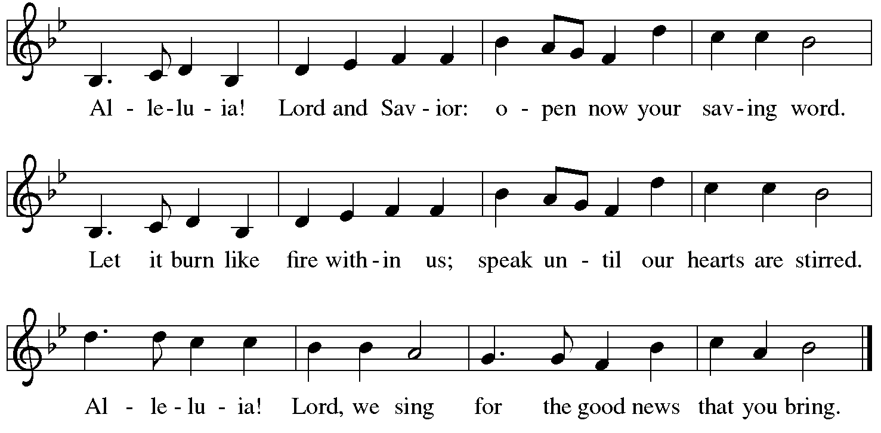
Gospel Luke 21:5-19
The holy gospel according to Luke.
⁵ When some were speaking about the temple, how it was adorned with beautiful stones and gifts dedicated to God, [Jesus] said, ⁶ “As for these things that you see, the days will come when not one stone will be left upon another; all will be thrown down.”
⁷ They asked him, “Teacher, when will this be, and what will be the sign that this is about to take place?” ⁸ And he said, “Beware that you are not led astray, for many will come in my name and say, ‘I am he!’ and, ‘The time is near!’ Do not go after them.
⁹ “When you hear of wars and insurrections, do not be terrified, for these things must take place first, but the end will not follow immediately.” ¹⁰ Then he said to them, “Nation will rise against nation and kingdom against kingdom; ¹¹ there will be great earthquakes and in various places famines and plagues, and there will be dreadful portents and great signs from heaven.
¹² “But before all this occurs, they will arrest you and persecute you; they will hand you over to synagogues and prisons, and you will be brought before kings and governors because of my name. ¹³ This will give you an opportunity to testify. ¹⁴ So make up your minds not to prepare your defense in advance, ¹⁵ for I will give you words and a wisdom that none of your opponents will be able to withstand or contradict. ¹⁶ You will be betrayed even by parents and siblings, by relatives and friends, and they will put some of you to death. ¹⁷ You will be hated by all because of my name. ¹⁸ But not a hair of your head will perish. ¹⁹ By your endurance you will gain your souls.”

The gospel of the Lord.
Praise to you, O Christ.

CHILDREN’S MOMENT

SERMON Pastor Ken Scheck

hymn of the day “My Hope Is Built On Nothing Less” #596

cREED
I believe in God, the Father almighty,
creator of heaven and earth.
I believe in Jesus Christ, God’s only Son, our Lord,
who was conceived by the Holy Spirit,
born of the virgin Mary,
suffered under Pontius Pilate,
was crucified, died, and was buried;
he descended to the dead.*
On the third day he rose again;
he ascended into heaven,
he is seated at the right hand of the Father,
and he will come to judge the living and the dead.
I believe in the Holy Spirit,
the holy catholic church,
the communion of saints,
the forgiveness of sins,
the resurrection of the body,
and the life everlasting. Amen.

*Or, “he descended into hell,” another translation of this text in widespread use.

prayers of Intercession
Gathered with one voice, we offer our prayers for the church, the world, and all who are in need.
A brief silence.
God of roots and branches, defend the leaders of your church as they proclaim the gospel using discernment, wisdom, and brave testimony. Keep all the baptized on righteous paths in response to Christ’s call. We pray especially for Emanuel Lutheran and their pastor Rev. Domingo Shriver. Hear us, O God.
Your mercy is great.
God of roaring seas, in a world of earthquake, famine, and plague, use your mighty power to nurture the land and all that lives upon it. Restore peoples and places experiencing natural disasters. Strengthen organizations who provide aid to any in crisis. Hear us, O God.
Your mercy is great.
God of victory, among quests for power, guide those in government, courts, law enforcement agencies, and the military. Turn them from war and violence to actions of care that build up the common good. Hear us, O God.
Your mercy is great.
God of healing, where injustice and exploitation result in populations that are marginalized or underserved, accompany those abandoned by friends, hurt by family, and harmed by violence or oppression. Care for all who are ill, anxious, or in pain of any kind.
God of new songs, in a congregation of faithful believers, energize us for compassionate service and delight us through worship and inspired prayer. Encourage your people in building equitable community where all are valued. Hear us, O God.
Your mercy is great.
God of every generation, we remember the saints with steadfast love and faithfulness. Confident in Christ’s victory over death, may we be inspired by the example of the faithful. Hear us, O God.
Your mercy is great.
We offer these and all our prayers to you, O God, trusting in your grace and unyielding love; through Jesus Christ, our Lord.
Amen.

PEACE
The peace of Christ be with you always.
And also with you.

OFFERING & OFFERING SONG
The joy of the Lord is my strength,
The joy of the Lord is my strength,
The joy of the Lord is my strength,
The joy of the Lord is my strength.

Offering Prayer
Let us pray.
God of all creation, all you have made is good, and your love endures forever. You bring forth bread from the earth and fruit from the vine. Nourish us with these gifts, that we might be for the world signs of your gracious presence in Jesus Christ, our Savior and Lord.
Amen.

DIALOGUE
The Lord be with you.
And also with you.
Lift up your hearts.
We lift them to the Lord.
Let us give thanks to the Lord our God.
It is right to give our thanks and praise.

PREFACE (Pastor)
It is indeed right, our duty and our joy,
that we should at all times and in all places
give thanks and praise to you, almighty and merciful God,
through our Savior Jesus Christ;
who on this day overcame death and the grave,
and by his glorious resurrection opened to us the way of everlasting life.
And so, with all the choirs of angels,
with the church on earth and the hosts of heaven,
we praise your name and join their unending hymn
holy, holy, holy
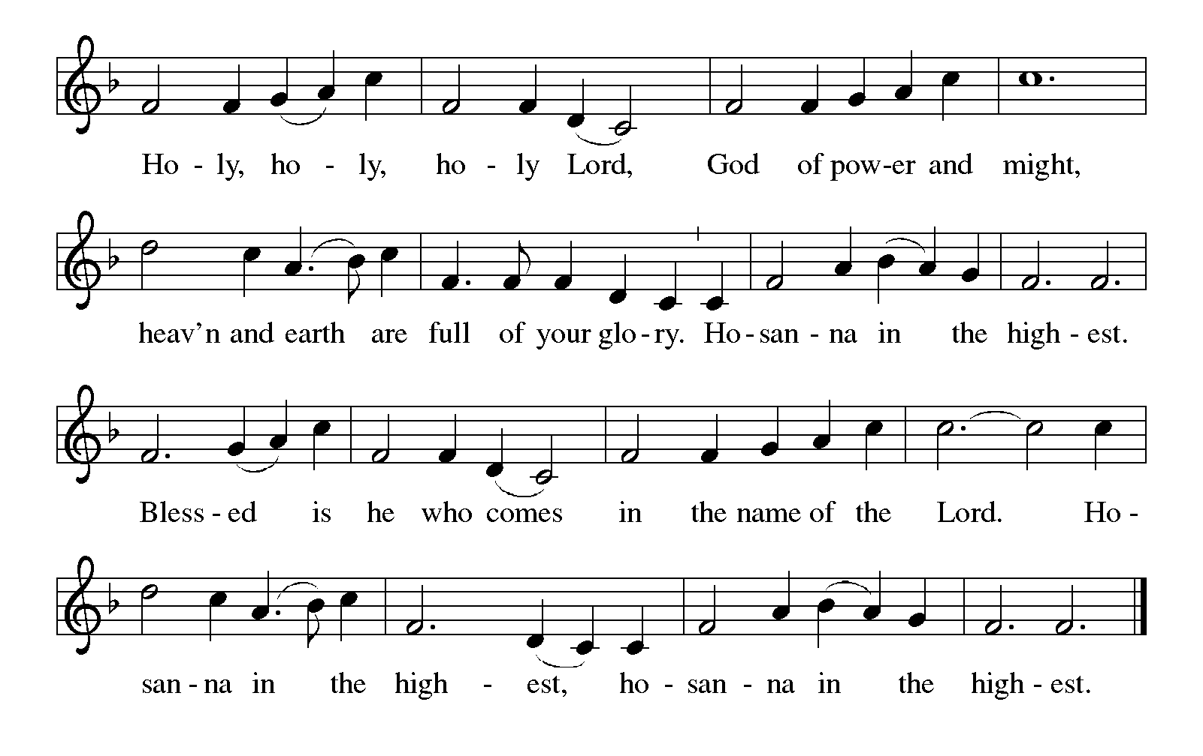
Thanksgiving at the Table
In the night in which he was betrayed,
our Lord Jesus took bread, and gave thanks;
broke it, and gave it to his disciples, saying:
Take and eat; this is my body, given for you.
Do this for the remembrance of me.

Again, after supper, he took the cup, gave thanks,
and gave it for all to drink, saying:
This cup is the new covenant in my blood,
shed for you and for all people for the forgiveness of sin.
Do this for the remembrance of me.

For as often as we eat of this bread and drink from this cup,
we proclaim the Lord’s death until he comes.

Lord’s Prayer
Gathered into one by the Holy Spirit, let us pray as Jesus taught us.
Our Father, who art in heaven,
hallowed be thy name,
thy kingdom come,
thy will be done,
on earth as it is in heaven.
Give us this day our daily bread;
and forgive us our trespasses,
as we forgive those
who trespass against us;
and lead us not into temptation,
but deliver us from evil.
For thine is the kingdom,
and the power, and the glory,
forever and ever. Amen.

INVITATION TO COMMUNION
Come to the banquet, for all is now ready.

COMMUNION *continuous
*People are welcome to kneel at the altar rail for a time of prayer after they receive their communion elements.

COMMUNION HYMNS

“Eat This Bread, Drink This Cup” #492

“As the Grains of Wheat” #465

PRAYER AFTER COMMUNION
Let us pray.
We give you thanks, almighty God, that you have refreshed us through the healing power of this gift of life. In your mercy, strengthen us through this gift, in faith toward you and in fervent love toward one another; for the sake of Jesus Christ our Lord.
Amen.

Sending
God blesses us and sends us in mission to the world.

Blessing
The Lord bless you and keep you.
The Lord’s face shine on you with grace and mercy.
The Lord look upon you with favor and ☩ give you peace.
Amen.

Sending SonG “When Peace Like a River” #785

Dismissal
Go in peace. Christ is with you.
Thanks be to God.
From sundaysandseasons.com. Copyright © 2017 Augsburg Fortress. All rights reserved.

Thank you to all who served in worship today!
Presiders: Pastor Ken Scheck Musician: Jayne Flanigan
Acolyte: Kole Hokanson Safety Person:
Elder: Dan Utterback Trustee: Mike Johnson
Offering Counters: Doug MacKenzie & Mike Johnson



PRAYERS OF THE FAITHFUL

With thanks for all God’s blessings and his love for all people. Our Bishops, Julie Schneider-Thomas, Yehiel Curry, and the congregations of the North/West Lower Michigan Synod, and especially for Emanuel Lutheran and their pastor Rev. Domingo Shriver.

Prayers for our friends, for all who are sick or hospitalized and for all health care workers who care for them. All those members of Zion’s family traveling; all those homebound or in frail health; all those suffering with quiet, unknown needs or worries. For those who serve on our behalf: public safety, utility workers, medical personnel, military personnel. For those who might be forgotten.

This week at Zion:
- Men’s Coffee, 8 AM, Wednesday, November 19
- Bulletin Deadline, Wednesday, November 19
- Women’s Coffee Fellowship, C&R, 9 AM, Thursday, November 20
- Newsletter Deadline, Thursday, November 20


ONLINE GIVING
Zion has received a QR code to facilitate online giving. If you are interested in donating online instead of bringing your donation to church, simply scan the QR code and it will direct you to the appropriate site. The code is on our website as well.

ANNOUNCEMENT
- Flowers on the Altar: The flowers on the altar today are in memory of Phyllis Baitinger. Today would be our mother ‘s and grandmother’s 100th birthday.
- Thank You From Pastor Scheck: Thank you people of God at Zion Lutheran church. I was surprised at the Pastor Appreciation and the birthday gift. It went toward a new kitchen faucet. Thank you, Thank you, Thank you. Pastor Ken
- Thank you from Pastor Anderson: Thank you Kind Friends. Thank you for being so wonderful and loving to Vicki and I. I will continue to pray for you. Michael Anderson
- Gloria Anderson has moved into Green Acres, Independent Living in Ionia. Here is her new address and telephone number. Gloria Anderson: 2554 Commerce Lane, Apt. 109 Ionia, MI 48846. Phone #: 616.527.0474
- Special Congregational Meeting Date Change: The special congregational meeting is being changed to next Sunday, November 23rd immediately following worship. Your Zion Council is meeting with Pastor Ken and the Council from Grace this week and we will have more complete information to share after that meeting. If you have questions, please talk with Paul Meade.
- Advent Devotional Booklets: Advent devotion books are in your mailboxes for the Advent Season. We hope these special devotions make the time from the beginning to Advent to Christmas more meaningful for you.
- Altar Flowers: If you are interested in putting flowers on the altar in memory of a loved one, please let Mary Makley know.
- Announcement and Newsletter Items: Please forward items for the bulletin announcements and the newsletter to the church email (Office@Zion.org). Please do not send items to people’s personal emails. Thank you.
- Door Locking Policy: Our door locking policy relies on having a volunteer(s) each Sunday to serve as the Safety Person of the Day. On Sundays where no one has volunteered, if someone arrives at church and is willing to be the Safety Person of the Day, we will follow the door locking policy. If no one steps forward to serve as the Safety Person of the Day, the doors will not be locked. Please consider volunteering for this important duty.

