ZION LUTHERAN CHURCH, WOODLAND, MI
The Last Sunday after Pentecost Sunday November 23, 2025
Christ the King Sunday
*If you are listening in your car, please tune your radio to FM 87.7*
(Please silence your cell phones while in the sanctuary. Thank you.)


WELCOME AND ANNOUNCEMENTS

Gathering
The Holy Spirit calls us together as the people of God.

Confession and Forgiveness
In the name of the Father,
and of the ☩ Son,
and of the Holy Spirit.
Amen.

Almighty God, to whom all hearts are open, all desires known, and from whom no secrets are hid: cleanse the thoughts of our hearts by the inspiration of your Holy Spirit, that we may perfectly love you and worthily magnify your holy name, through Jesus Christ our Lord.
Amen.

Let us confess our sin in the presence of God and of one another. Most merciful God,
we confess that we are captive to sin and cannot free ourselves. We have sinned against you in thought, word, and deed, by what we have done and by what we have left undone. We have not loved you with our whole heart; we have not loved our neighbors as ourselves. For the sake of your Son, Jesus Christ, have mercy on us. Forgive us, renew us, and lead us, so that we may delight in your will and walk in your ways, to the glory of your holy name.
Amen.

God, who is rich in mercy, loved us even when we were dead in sin, and made us alive together with Christ. By grace you have been saved. In the name of ☩ Jesus Christ, your sins are forgiven. Almighty God strengthen you with power through the Holy Spirit, that Christ may live in your hearts through faith.
Amen.

Gathering Song “Blessing and Honor” #854

GREETING
The grace of our Lord Jesus Christ, the love of God, and the communion of the Holy Spirit be with you all.
And also with you.

Prayer of the Day
Let us pray together.
O God, our true life, to serve you is freedom, and to know you is unending joy. We worship you, we glorify you, we give thanks to you for your great glory. Abide with us, reign in us, and make this world into a fit habitation for your divine majesty, through Jesus Christ, our Savior and Lord, who lives and reigns with you and the Holy Spirit, one God, now and forever. Amen.

First Reading Jeremiah 23:1-6
A reading from Jeremiah.
¹ Woe to the shepherds who destroy and scatter the sheep of my pasture! says the Lord. ² Therefore thus says the Lord, the God of Israel, concerning the shepherds who shepherd my people: It is you who have scattered my flock and have driven them away, and you have not attended to them. So I will attend to you for your evil doings, says the Lord. ³ Then I myself will gather the remnant of my flock out of all the lands where I have driven them, and I will bring them back to their fold, and they shall be fruitful and multiply. ⁴ I will raise up shepherds over them who will shepherd them, and they shall no longer fear or be dismayed, nor shall any be missing, says the Lord.
⁵ The days are surely coming, says the Lord, when I will raise up for David a righteous Branch, and he shall reign as king and deal wisely and shall execute justice and righteousness in the land. ⁶ In his days Judah will be saved, and Israel will live in safety. And this is the name by which he will be called: “The Lord is our righteousness.”

The word of the Lord.
Thanks be to God.

Psalm Psalm 46
¹ God is our ref- | uge and strength,
a very present | help in trouble.
² Therefore we will not fear, though the | earth be moved,
and though the mountains shake in the depths | of the sea;
³ though its waters | rage and foam,
and though the mountains tremble | with its tumult.
⁴ There is a river whose streams make glad the cit- | y of God,
the holy habitation of | the Most High.
⁵ God is in the midst of the city; it shall | not be shaken;
God shall help it at the | break of day.
⁶ The nations rage, and the | kingdoms shake;
God speaks, and the earth | melts away.
⁷ The Lord of | hosts is with us;
the God of Jacob | is our stronghold.
⁸ Come now, regard the works | of the Lord,
what desolations God has brought up- | on the earth;
⁹ behold the one who makes war to cease in | all the world;
who breaks the bow, and shatters the spear, and burns the | shields with fire.
¹⁰ “Be still, then, and know that | I am God;
I will be exalted among the nations; I will be exalted | in the earth.”
¹¹ The Lord of | hosts is with us;
the God of Jacob | is our stronghold.

Second Reading Colossians 1:11-20
A reading from Colossians.
¹¹ May you be made strong with all the strength that comes from his glorious power, so that you may have all endurance and patience, joyfully ¹² giving thanks to the Father, who has enabled you to share in the inheritance of the saints in the light. ¹³ He has rescued us from the power of darkness and transferred us into the kingdom of his beloved Son, ¹⁴ in whom we have redemption, the forgiveness of sins.
¹⁵ He is the image of the invisible God, the firstborn of all creation, ¹⁶ for in him all things in heaven and on earth were created, things visible and invisible, whether thrones or dominions or rulers or powers—all things have been created through him and for him. ¹⁷ He himself is before all things, and in him all things hold together. ¹⁸ He is the head of the body, the church; he is the beginning, the firstborn from the dead, so that he might come to have first place in everything. ¹⁹ For in him all the fullness of God was pleased to dwell, ²⁰ and through him God was pleased to reconcile to himself all things, whether on earth or in heaven, by making peace through the blood of his cross.

The Word of the Lord
Thanks be to God.
Gospel Acclamation

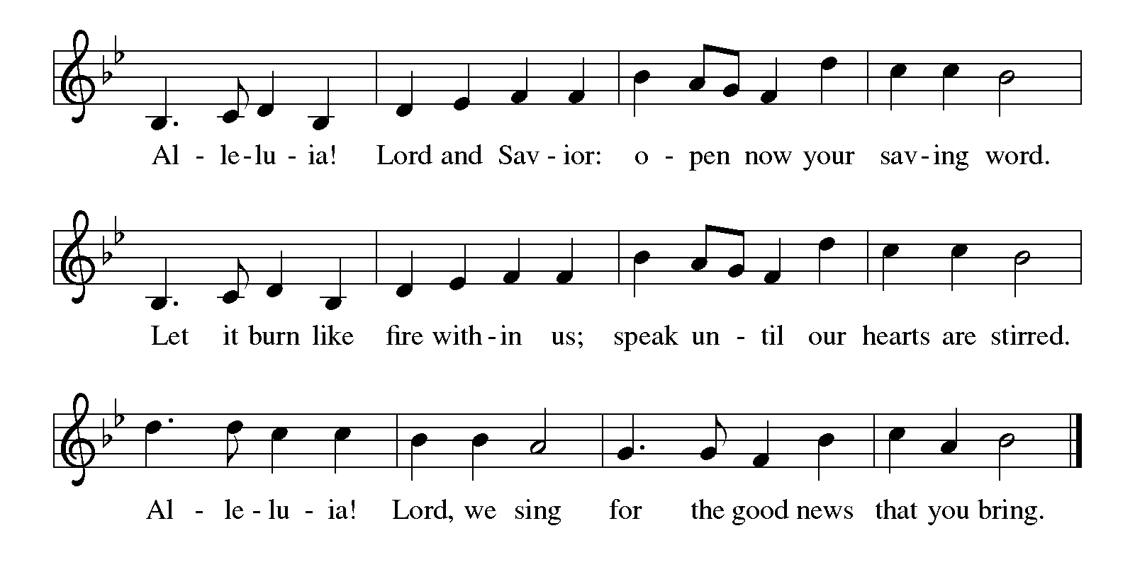

Gospel Luke 23:33-43
The holy gospel according to Luke.
Glory to You O Lord.
³³ When they came to the place that is called The Skull, they crucified Jesus there with the criminals, one on his right and one on his left. ³⁴ [[Then Jesus said, “Father, forgive them, for they do not know what they are doing.”]] And they cast lots to divide his clothing. ³⁵ And the people stood by watching, but the leaders scoffed at him, saying, “He saved others; let him save himself if he is the Messiah of God, his chosen one!” ³⁶ The soldiers also mocked him, coming up and offering him sour wine ³⁷ and saying, “If you are the King of the Jews, save yourself!” ³⁸ There was also an inscription over him, “This is the King of the Jews.”
³⁹ One of the criminals who were hanged there kept deriding him and saying, “Are you not the Messiah? Save yourself and us!” ⁴⁰ But the other rebuked him, saying, “Do you not fear God, since you are under the same sentence of condemnation? ⁴¹ And we indeed have been condemned justly, for we are getting what we deserve for our deeds, but this man has done nothing wrong.” ⁴² Then he said, “Jesus, remember me when you come in your kingdom.” ⁴³ He replied, “Truly I tell you, today you will be with me in paradise.”

The gospel of the Lord.
Praise to you, O Christ.

CHILDREN’S MOMENT

SERMON Pastor Jim Couser

hymn of the day “Jesus Shall Reign” #434

cREED
I believe in God, the Father almighty,
creator of heaven and earth.
I believe in Jesus Christ, God’s only Son, our Lord,
who was conceived by the Holy Spirit,
born of the virgin Mary,
suffered under Pontius Pilate,
was crucified, died, and was buried;
he descended to the dead.*
On the third day he rose again;
he ascended into heaven,
he is seated at the right hand of the Father,
and he will come to judge the living and the dead.
I believe in the Holy Spirit,
the holy catholic church,
the communion of saints,
the forgiveness of sins,
the resurrection of the body,
and the life everlasting. Amen.

*Or, “he descended into hell,” another translation of this text in widespread use.

prayers of Intercession
Gathered with one voice, we offer our prayers for the church, the world, and all who are in need.
A brief silence.
We pray for the church in the world, its leaders, and its mission to share the good news of healing and restoration. Inspire us to embody the beloved community in ways that faithfully witness to the Holy Spirit. We pray especially for Victory Lutheran in Ludington and their pastor Rev. Ron Iris. Hear us, O God.
Your mercy is great.
We pray for the trembling mountains and glad streams of creation. Preserve and renew your coastlines, deep seas, forests, and grasslands. Guide all who tend flocks or care for creatures of all kinds. Hear us, O God.
Your mercy is great.
We pray for leaders and advocates in government, civic life, and public safety. Support equity across the globe, and heal division with accountability and truth. Hear us, O God.
Your mercy is great.
We pray for any who are hungry, living in poverty or desperation, weary in body or spirit, or sick.
Your mercy is great.
We pray for this part of the body of Christ gathered around word and sacrament. Bring us into authentic community where all ages are valued and experience God’s faithfulness together. Hear us, O God.
Your mercy is great.
We give thanks for all who have died in faith. May we remember them faithfully until we are gathered with you in the paradise you promise. Hear us, O God.
Your mercy is great.
We offer these and all our prayers to you, O God, trusting in your grace and unyielding love; through Jesus Christ, our Lord.
Amen.

PEACE
The peace of Christ be with you always.
And also with you.

OFFERING & OFFERING SONG
The joy of the Lord is my strength,
The joy of the Lord is my strength,
The joy of the Lord is my strength,
The joy of the Lord is my strength.

Offering Prayer
Let us pray.
God of all creation, all you have made is good, and your love endures forever. You bring forth bread from the earth and fruit from the vine. Nourish us with these gifts, that we might be for the world signs of your gracious presence in Jesus Christ, our Savior and Lord.
Amen.

DIALOGUE
The Lord be with you.
And also with you.
Lift up your hearts.
We lift them to the Lord.
Let us give thanks to the Lord our God.
It is right to give our thanks and praise.

PREFACE (Pastor)
It is indeed right, our duty and our joy,
that we should at all times and in all places
give thanks and praise to you, almighty and merciful God,
through our Savior Jesus Christ;
who on this day overcame death and the grave,
and by his glorious resurrection opened to us the way of everlasting life.
And so, with all the choirs of angels,
with the church on earth and the hosts of heaven,
we praise your name and join their unending hymn

holy, holy, holy
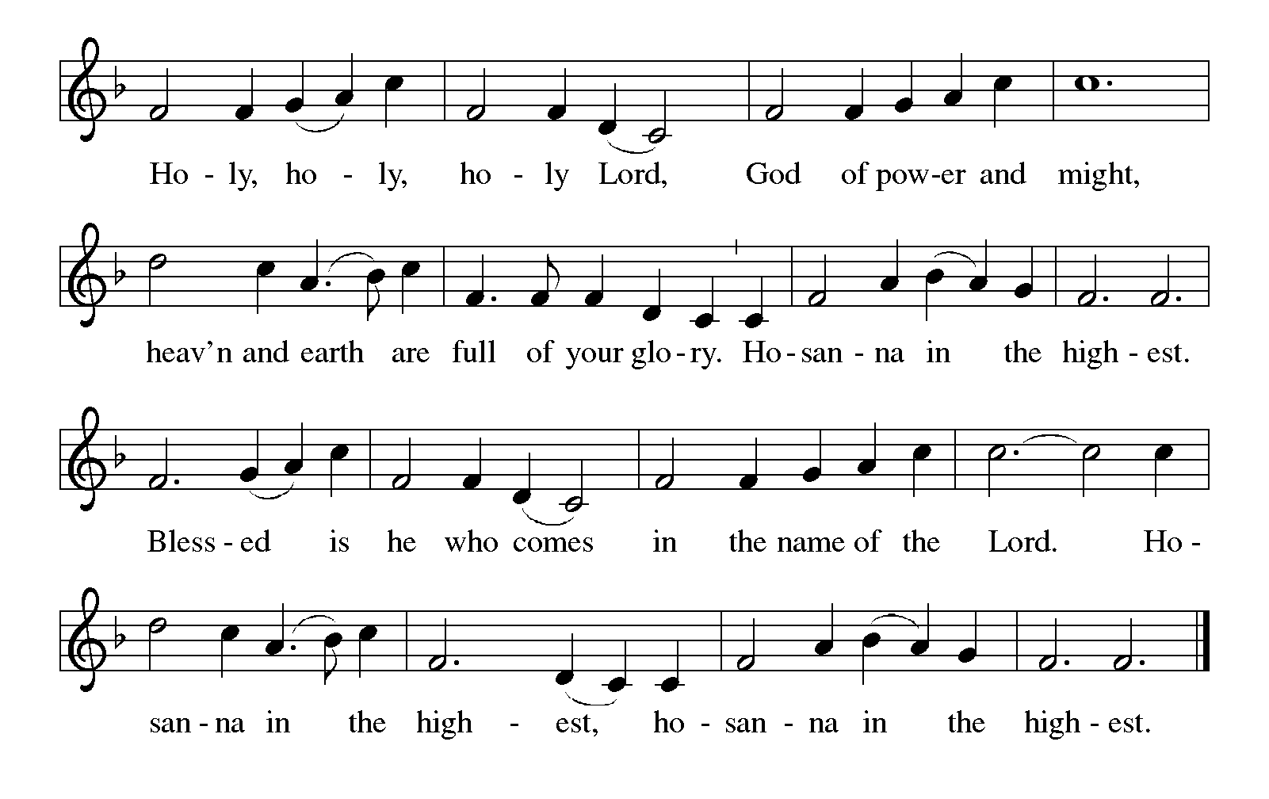

Thanksgiving at the Table
In the night in which he was betrayed,
our Lord Jesus took bread, and gave thanks;
broke it, and gave it to his disciples, saying:
Take and eat; this is my body, given for you.
Do this for the remembrance of me.

Again, after supper, he took the cup, gave thanks,
and gave it for all to drink, saying:
This cup is the new covenant in my blood,
shed for you and for all people for the forgiveness of sin.
Do this for the remembrance of me.

For as often as we eat of this bread and drink from this cup,
we proclaim the Lord’s death until he comes.

Lord’s Prayer
Gathered into one by the Holy Spirit, let us pray as Jesus taught us.
Our Father, who art in heaven,
hallowed be thy name,
thy kingdom come,
thy will be done,
on earth as it is in heaven.
Give us this day our daily bread;
and forgive us our trespasses,
as we forgive those
who trespass against us;
and lead us not into temptation,
but deliver us from evil.
For thine is the kingdom,
and the power, and the glory,
forever and ever. Amen.

INVITATION TO COMMUNION
Come to the banquet, for all is now ready.

COMMUNION *continuous
*People are welcome to kneel at the altar rail for a time of prayer after they receive their communion elements.

COMMUNION HYMNS
“Jesus, Remember Me” #616 (3x)
“Beautiful Savior” #838

PRAYER AFTER COMMUNION
Let us pray.
We give you thanks, almighty God, that you have refreshed us through the healing power of this gift of life. In your mercy, strengthen us through this gift, in faith toward you and in fervent love toward one another; for the sake of Jesus Christ our Lord.
Amen.

Sending
God blesses us and sends us in mission to the world.

Blessing
The Lord bless you and keep you.
The Lord’s face shine on you with grace and mercy.
The Lord look upon you with favor and ☩ give you peace.
Amen.

Sending SonG “Crown Him with Many Crowns” #855

Dismissal
Go in peace. Christ is with you.
Thanks be to God.
From sundaysandseasons.com. Copyright © 2017 Augsburg Fortress. All rights reserved.

Thank you to all who served in worship today!
Presiders: Pastor Jim Couser Musician: Martha Yoder
Acolyte: Aliyanna Morado Safety Person:
Elder: Buffy Meyers Trustee: Doug MacKenzie
Offering Counters: Mary Makley & Martha Yoder



PRAYERS OF THE FAITHFUL

With thanks for all God’s blessings and his love for all people. Our Bishops, Julie Schneider-Thomas, Yehiel Curry, and the congregations of the North/West Lower Michigan Synod, and especially for Victory Lutheran in Ludington and their pastor Rev. Ron Iris.

Prayers for our friends, for all who are sick or hospitalized and for all health care workers who care for them. All those members of Zion’s family traveling; all those homebound or in frail health; all those suffering with quiet, unknown needs or worries. For those who serve on our behalf: public safety, utility workers, medical personnel, military personnel. For those who might be forgotten.

This week at Zion:
- Today, Community Thanksgiving Service, 6 pm, Congregational Church
- Men’s Coffee, 8 AM, Wednesday, November 26
- Bulletin Deadline, Wednesday, November 26
- Happy Thanksgiving! Thursday, November 27


ONLINE GIVING
Zion has received a QR code to facilitate online giving. If you are interested in donating online instead of bringing your donation to church, simply scan the QR code and it will direct you to the appropriate site. The code is on our website as well.

ANNOUNCEMENT
- Church Decorating: We will be decorating the church next Sunday, November 30th after worship. If you can stay to help, it would be appreciated.
- Special Offerings: We have several special offerings this time of the year. The Thanksgiving offering goes to the Lakewood Area Ministerial Association. The Advent offering goes to Manna's Market and the Christmas offering goes to the Lakewood Community Council. Thank you for your generosity.
- Christmas Eve Service: Pastor Ken Scheck will lead our Christmas Eve Service. Our service will start at 5 pm. The earlier time makes it possible for Pastor Ken to also lead Christmas Eve Service at Grace Lutheran in Hastings at 7 pm. Mark your calendar and plan to attend this special service!
- Lakewood Community Council Christmas Basket Project 2025: In preparation for delivery of the Christmas baskets, we begin our drive for warm hats, gloves/mittens and socks in all sizes. Boxes are under the mailboxes in the west hall. Cash donations may be given to help with food and meat donations, so earmarked in your offering. Gifts for children have been purchased via a Thrivent Action Grant. After worship, November 30, Mary Smith is seeking help from children to wrap these gifts Apples have been purchased from Heidi’s Orchard by another Thrivent Action Grant. See Claude if you can help with the apples. Helpers are needed also for delivery on Saturday, December. See the November newsletter for more information.
- Gloria Anderson has moved into Green Acres, Independent Living in Ionia. Here is her new address and telephone number. Gloria Anderson: 2554 Commerce Lane, Apt. 109 Ionia, MI 48846. Phone #: 616.527.0474
- Special Congregational Meeting Today: The special congregational meeting will be held following worship today. This meeting will share information regarding the joint council meeting with Grace to develop a recommendation for shared ministry and to seek your vote in favor of moving forward If you have questions, please talk with Paul Meade.
- Advent Devotional Booklets: Advent devotion books are in your mailboxes for the Advent Season. We hope these special devotions make the time from the beginning to Advent to Christmas more meaningful for you.
- Altar Flowers: If you are interested in putting flowers on the altar in memory of a loved one, please let Mary Makley know.
- Announcement and Newsletter Items: Please forward items for the bulletin announcements and the newsletter to the church email (Office@Zion.org). Please do not send items to people’s personal emails. Thank you.
- Door Locking Policy: Our door locking policy relies on having a volunteer(s) each Sunday to serve as the Safety Person of the Day. On Sundays where no one has volunteered, if someone arrives at church and is willing to be the Safety Person of the Day, we will follow the door locking policy. If no one steps forward to serve as the Safety Person of the Day, the doors will not be locked. Please consider volunteering for this important duty.

