ZION LUTHERAN CHURCH, WOODLAND, MI
First Sunday of Advent November 30, 2025
*If you are listening in your car, please tune your radio to FM 87.7*
(Please silence your cell phones while in the sanctuary. Thank you.)
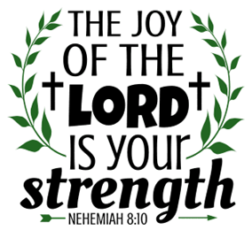

WELCOME AND ANNOUNCEMENTS

Gathering
The Holy Spirit calls us together as the people of God.

LIGHTING OF THE ADVENT WREATH: HOPE Claude & Mary Smith
Today we light the first candle of Advent, the candle of Hope.
We put our hope in the one to come, the promised one who comes from God to bring good news of salvation. We hope in the one who will lead us to walk in the light of the LORD. We hope he will not let us live in dark valleys, but on the high mountain of God. We light this candle in Hope.
On this day, we remember to hopefully look for the coming of Christ.

HYMN: Light One Candle to Watch for Messiah, Verse 1 HYMN #240

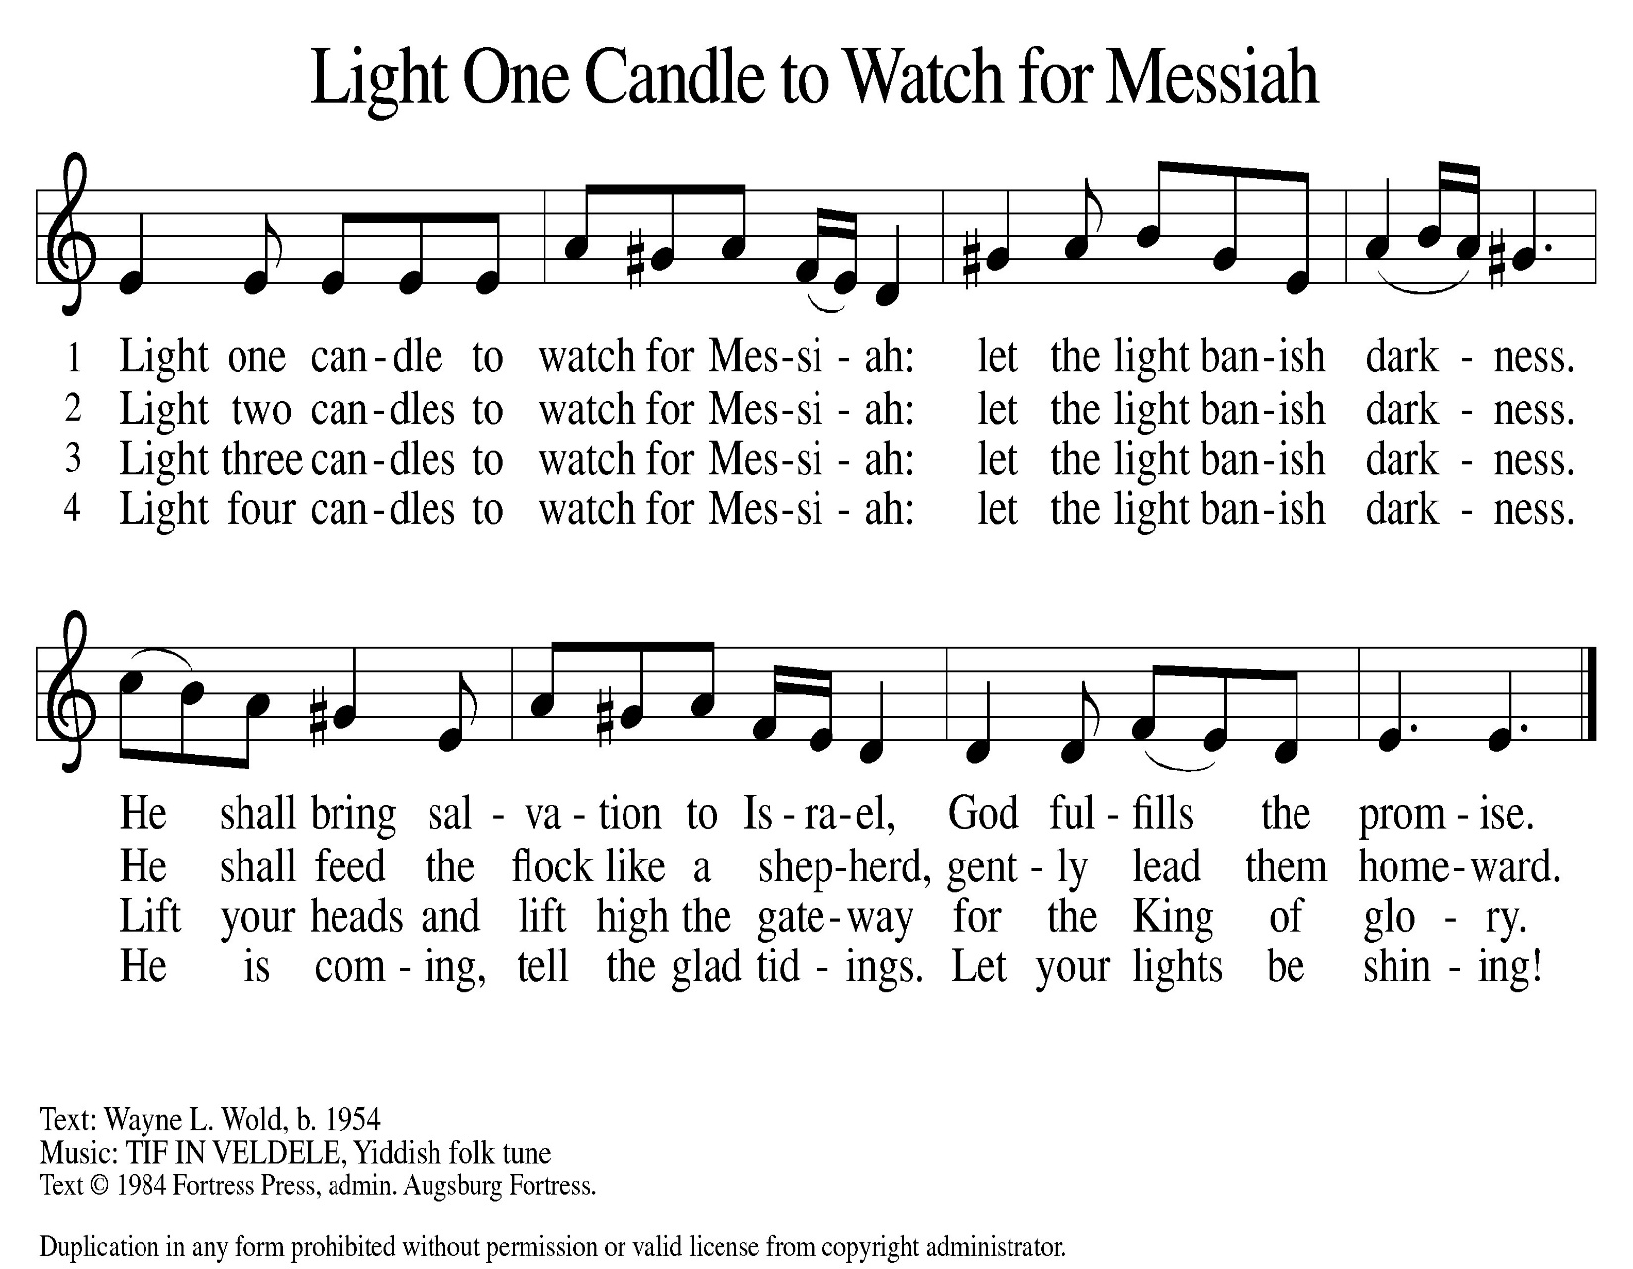

Confession and Forgiveness
In the name of the Father,
and of the ☩ Son,
and of the Holy Spirit.
Amen.

Almighty God, to whom all hearts are open, all desires known, and from whom no secrets are hid: cleanse the thoughts of our hearts by the inspiration of your Holy Spirit, that we may perfectly love you and worthily magnify your holy name, through Jesus Christ our Lord.
Amen.

Let us confess our sin in the presence of God and of one another. Most merciful God,
we confess that we are captive to sin and cannot free ourselves. We have sinned against you in thought, word, and deed, by what we have done and by what we have left undone. We have not loved you with our whole heart; we have not loved our neighbors as ourselves. For the sake of your Son, Jesus Christ, have mercy on us. Forgive us, renew us, and lead us, so that we may delight in your will and walk in your ways, to the glory of your holy name.
Amen.

God, who is rich in mercy, loved us even when we were dead in sin, and made us alive together with Christ. By grace you have been saved. In the name of ☩ Jesus Christ, your sins are forgiven. Almighty God strengthen you with power through the Holy Spirit, that Christ may live in your hearts through faith.
Amen.
Gathering Song “My Lord, What a Morning ” #438

GREETING
The grace of our Lord Jesus Christ, the love of God, and the communion of the Holy Spirit be with you all.
And also with you.

Prayer of the Day
Let us pray together.
Stir up your power, Lord Christ, and come. By your merciful protection save us from the threatening dangers of our sins, and enlighten our walk in the way of your salvation, for you live and reign with the Father and the Holy Spirit, one God, now and forever.
Amen.

“All Earth Is Hopeful, Toda La Tierra”

First Reading Isaiah 2:1-5
A reading from Isaiah.
¹ The word that Isaiah son of Amoz saw concerning Judah and Jerusalem.
² In days to come
the mountain of the Lord’s house
shall be established as the highest of the mountains
and shall be raised above the hills;
all the nations shall stream to it.
³ Many peoples shall come and say,
“Come, let us go up to the mountain of the Lord,
to the house of the God of Jacob,
that he may teach us his ways
and that we may walk in his paths.”
For out of Zion shall go forth instruction
and the word of the Lord from Jerusalem.
⁴ He shall judge between the nations
and shall arbitrate for many peoples;
they shall beat their swords into plowshares
and their spears into pruning hooks;
nation shall not lift up sword against nation;
neither shall they learn war any more.
⁵ O house of Jacob,
come, let us walk
in the light of the Lord!

The word of the Lord.
Thanks be to God.
Psalm
(Read Responsively) Psalm 122
¹ I was glad when they | said to me,
“Let us go to the house | of the Lord.”
² Now our | feet are standing
within your gates, | O Jerusalem.
³ Jerusalem is built | as a city
that is at unity | with itself;
⁴ to which the tribes go up, the tribes | of the Lord,
the assembly of Israel, to praise the name | of the Lord.
⁵ For there are the | thrones of judgment,
the thrones of the | house of David.
⁶ Pray for the peace | of Jerusalem:
“May they pros- | per who love you.
⁷ Peace be with- | in your walls
and quietness with- | in your towers.
⁸ For the sake of my kindred | and companions,
I pray for | your prosperity.
⁹ Because of the house of the | Lord our God,
I will seek to | do you good.”

Second Reading Romans 13:11-14
A reading from Romans.

¹¹ Besides this, you know what time it is, how it is already the moment for you to wake from sleep. For salvation is nearer to us now than when we became believers; ¹² the night is far gone; the day is near. Let us then throw off the works of darkness and put on the armor of light; ¹³ let us walk decently as in the day, not in reveling and drunkenness, not in illicit sex and licentiousness, not in quarreling and jealousy. ¹⁴ Instead, put on the Lord Jesus Christ, and make no provision for the flesh, to gratify its desires.

The Word of the Lord
Thanks be to God.

Gospel Acclamation

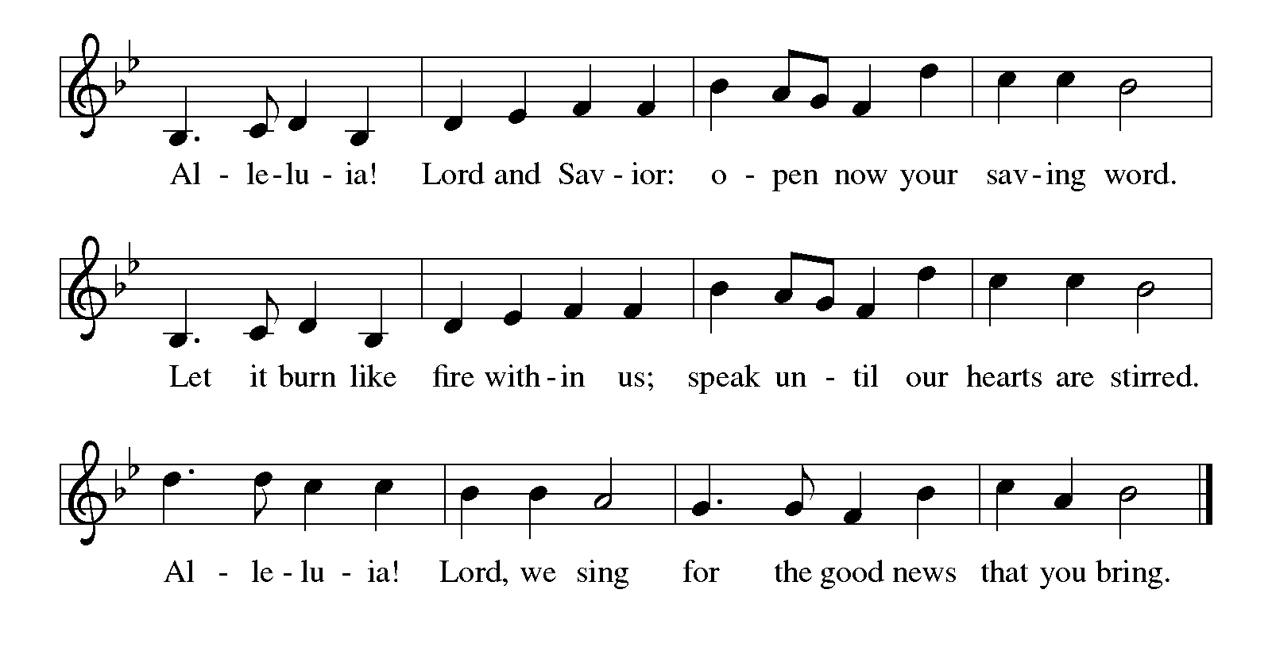

Gospel Luke 23:33-43
The holy gospel according to Luke.
Glory to You O Lord.
³⁶ “About that day and hour no one knows, neither the angels of heaven, nor the Son, but only the Father. ³⁷ For as the days of Noah were, so will be the coming of the Son of Man. ³⁸ For as in the days before the flood they were eating and drinking, marrying and giving in marriage, until the day Noah entered the ark, ³⁹ and they knew nothing until the flood came and swept them all away, so, too, will be the coming of the Son of Man. ⁴⁰ Then two will be in the field; one will be taken, and one will be left. ⁴¹ Two women will be grinding meal together; one will be taken, and one will be left. ⁴² Keep awake, therefore, for you do not know on what day your Lord is coming. ⁴³ But understand this: if the owner of the house had known in what part of the night the thief was coming, he would have stayed awake and would not have let his house be broken into. ⁴⁴ Therefore you also must be ready, for the Son of Man is coming at an hour you do not expect.”

The gospel of the Lord.
Praise to you, O Christ.

CHILDREN’S MOMENT

SERMON Presider: Doug Mackenzie

hymn of the day “My Soul Proclaims Your Greatness” #251

cREED
We believe in one God,
the Father, the Almighty,
maker of heaven and earth,
of all that is, seen and unseen.
We believe in one Lord, Jesus Christ,
the only Son of God,
eternally begotten of the Father,
God from God, Light from Light,
true God from true God,
begotten, not made,
of one Being with the Father;
through him all things were made.
For us and for our salvation
he came down from heaven,
was incarnate of the Holy Spirit and the virgin Mary
and became truly human.
For our sake he was crucified under Pontius Pilate;
he suffered death and was buried.
On the third day he rose again
in accordance with the scriptures;
he ascended into heaven
and is seated at the right hand of the Father.
He will come again in glory to judge the living and the dead,
and his kingdom will have no end.
We believe in the Holy Spirit, the Lord, the giver of life,
who proceeds from the Father and the Son,*
who with the Father and the Son is worshiped and glorified,
who has spoken through the prophets.
We believe in one holy catholic and apostolic church.
We acknowledge one baptism for the forgiveness of sins.
We look for the resurrection of the dead,
and the life of the world to come. Amen.

*Or, “who proceeds from the Father.” The phrase “and the Son” is a later addition to the creed.

prayers of Intercession
(Please Be Seated)
In our waiting and watching, we come to you in prayer, O God, trusting your promise to renew the church, the nations, and the whole creation.
A brief silence.
God of the people, we come seeking wisdom and instruction. Uphold and strengthen lay leaders, teachers, deacons, pastors, and bishops. Teach us your ways and lead us in your paths. We pray especially for and especially for Trinity Lutheran Church in Manton and their pastor Rev Rosanne Anderson.
God of grace,
hear our prayer.
God of the earth, we seek your goodness in the grandeur of creation. Empower us to care for forests and oceans, as we see you in the world around us. God of grace,
hear our prayer.
God of the nations, grant wisdom to leaders, judges, and mediators. Cast out words of hate and transform them into words for building up community. Remake implements of war to sow peace. God of grace,
hear our prayer.
God of healing, bring comfort and strength. We pray for our kindred and companions who are ill or despairing. Surround all with care and consolation. God of grace,
hear our prayer.
God of new possibilities, when addiction wounds, jealousy tears down, and relationships fray, show us how to journey with one another. Nurture therapists, counselors, and sponsors in their care for others. Comfort all in need of your tender care.
God of grace,
hear our prayer.
God of all time, build up our lives that we would reflect your grace. At the last, bring us with all the saints to your holy city where peace and goodness make a home. God of grace,
hear our prayer.
Draw near to us, O God, as we commend all for whom we pray, trusting in your mercy through Jesus Christ, Emmanuel.
Amen.

PEACE
The peace of Christ be with you always.
And also with you.

OFFERING & OFFERING SONG
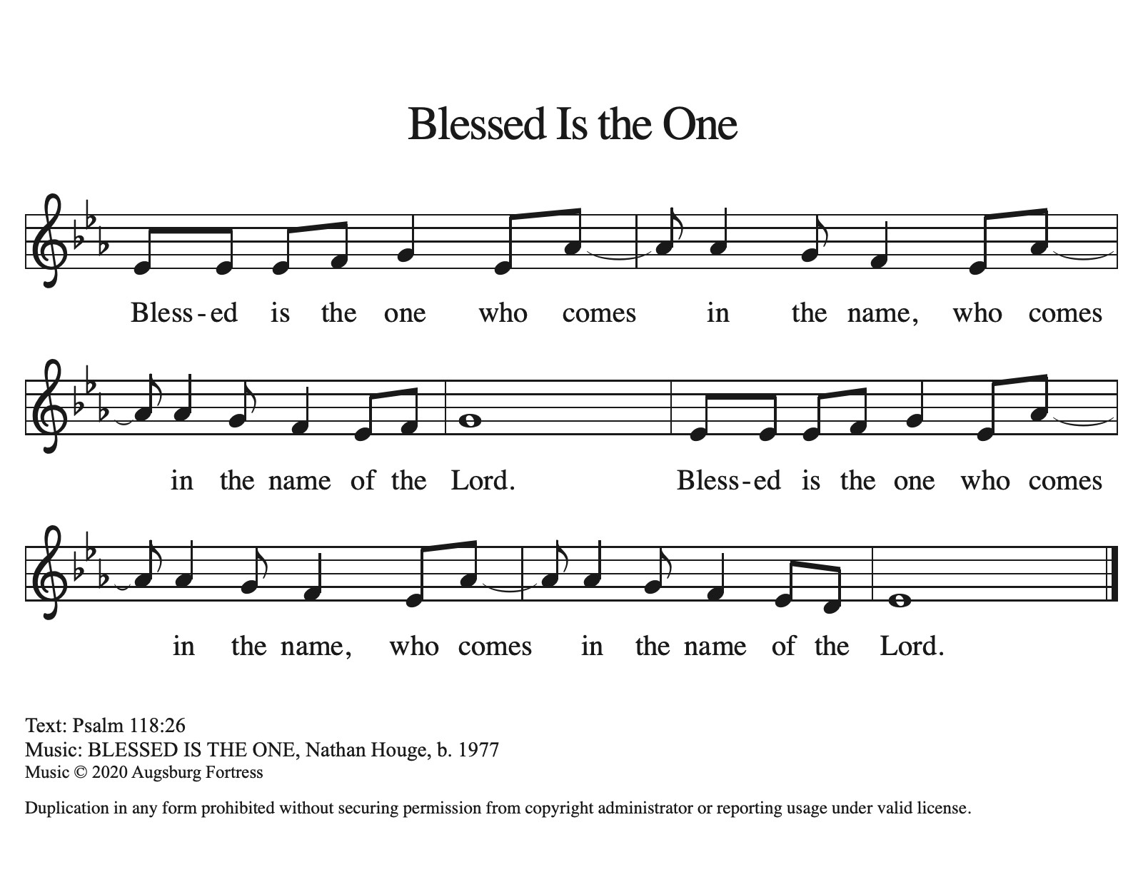

Offering Prayer
Let us pray.
God of all creation, all you have made is good, and your love endures forever. You bring forth bread from the earth and fruit from the vine. Nourish us with these gifts, that we might be for the world signs of your gracious presence in Jesus Christ, our Savior and Lord.
Amen.

Lord’s Prayer
Gathered into one by the Holy Spirit, let us pray as Jesus taught us.
Our Father, who art in heaven,
hallowed be thy name,
thy kingdom come,
thy will be done,
on earth as it is in heaven.
Give us this day our daily bread;
and forgive us our trespasses,
as we forgive those
who trespass against us;
and lead us not into temptation,
but deliver us from evil.
For thine is the kingdom,
and the power, and the glory,
forever and ever. Amen.

Thanksgiving for the Word
Praise and thanks to you, holy God, for by your Word you made all things; you spoke light into darkness, called forth beauty from chaos, and brought life into being. For you Word of life, O God,
We give you thanks and praise.
By your Word you called your people Israel to tell of your wonderful gifts; freedom from captivity, water on the desert journey, a pathway home from exile, wisdom for life with you. For your Word of life, O God,
We give you thanks and praise.
Through Jesus, your Word made flesh, you speak to us and call us to witness; forgiveness through the cross, life to those entombed by death, the way of your self-giving love. For your Word of live, O God,
We give you thanks and praise.
Send your Spirit of truth, O God; rekindle your gifts within use; renew our faith, increase our hope, and deepen our love, for the sake of a world in need. Faithful as your Word, O God, draw near to all who all on you; through Jesus Christ, our Savior and Lord, to whom with you and the Holy Spirit, be honor and glory forever.
Amen.
Sending
God blesses us and sends us in mission to the world.

Blessing
The Lord bless you and keep you.
The Lord’s face shine on you with grace and mercy.
The Lord look upon you with favor and ☩ give you peace.
Amen.

Sending SonG “Rejoice, Rejoice, Believers” #244

Dismissal
Go in peace. Christ is with you.
Thanks be to God.
From sundaysandseasons.com. Copyright © 2017 Augsburg Fortress. All rights reserved.

Thank you to all who served in worship today!
Presiders: Presider: Doug Mackenzie Musician: Martha Yoder
Acolyte: Safety Person:
Elder: Naomi Wilson Trustee: Tom Krikke
Offering Counters: Diane Griffin & Carlotta Willard



PRAYERS OF THE FAITHFUL

With thanks for all God’s blessings and his love for all people. Our Bishops, Julie Schneider-Thomas, Yehiel Curry, and the congregations of the North/West Lower Michigan Synod, and especially for Trinity Lutheran Church in Manton and their pastor Rev Rosanne Anderson.

Prayers for our friends, for all who are sick or hospitalized and for all health care workers who care for them. All those members of Zion’s family traveling; all those homebound or in frail health; all those suffering with quiet, unknown needs or worries. For those who serve on our behalf: public safety, utility workers, medical personnel, military personnel. For those who might be forgotten.

This week at Zion:
- Men’s Coffee, 8 AM, Wednesday, December 3
- Bulletin Deadline, Wednesday, December 3


ONLINE GIVING
Zion has received a QR code to facilitate online giving. If you are interested in donating online instead of bringing your donation to church, simply scan the QR code and it will direct you to the appropriate site. The code is on our website as well.

ANNOUNCEMENT
- The Zion Lutheran Church Women would like to thank you all for the generous donations for our annual Thankoffering service. We received a total of $ 535.00. These funds will be sent to the Women of the ELCA to help with their many projects. If anyone needs a tax receipt, contact Carol Engle.
- Church Decorating: We will be decorating the church today Sunday, November 30th after worship. If you can stay to help, it would be appreciated.
- Special Offerings: We have several special offerings this time of the year. The Thanksgiving offering goes to the Lakewood Area Ministerial Association. The Advent offering goes to Manna's Market and the Christmas offering goes to the Lakewood Community Council. Thank you for your generosity.
- Christmas Eve Service: Pastor Ken Scheck will lead our Christmas Eve Service. Our service will start at 5 pm. The earlier time makes it possible for Pastor Ken to also lead Christmas Eve Service at Grace Lutheran in Hastings at 7 pm. Mark your calendar and plan to attend this special service!
- Lakewood Community Council Christmas Basket Project 2025: In preparation for delivery of the Christmas baskets, we begin our drive for warm hats, gloves/mittens and socks in all sizes. Boxes are under the mailboxes in the west hall. Cash donations may be given to help with food and meat donations, so earmarked in your offering. Gifts for children have been purchased via a Thrivent Action Grant. After worship, November 30, Mary Smith is seeking help from children to wrap these gifts Apples have been purchased from Heidi’s Orchard by another Thrivent Action Grant. See Claude if you can help with the apples. Helpers are needed also for delivery on Saturday, December. See the November newsletter for more information.
- Advent Devotional Booklets: Advent devotion books are in your mailboxes for the Advent Season. We hope these special devotions make the time from the beginning to Advent to Christmas more meaningful for you.
- Altar Flowers: If you are interested in putting flowers on the altar in memory of a loved one, please let Mary Makley know.
- Announcement and Newsletter Items: Please forward items for the bulletin announcements and the newsletter to the church email (Office@Zion.org). Please do not send items to people’s personal emails. Thank you.
- Door Locking Policy: Our door locking policy relies on having a volunteer(s) each Sunday to serve as the Safety Person of the Day. On Sundays where no one has volunteered, if someone arrives at church and is willing to be the Safety Person of the Day, we will follow the door locking policy. If no one steps forward to serve as the Safety Person of the Day, the doors will not be locked. Please consider volunteering for this important duty.

